Telehealth: Mental Health Services, Law and Ethics, and other Important Considerations (Meets CA BBS Telehealth Coursework Requirements) CE Course 3 CE Units/Hours
© 2023 by Aspira Continuing Education. All rights reserved. No part of this material may be transmitted or reproduced in any form, or by any means, mechanical or electronic without written permission of Aspira Continuing Education.

Course Disclaimer: The contents of this course in its entirety are for informational purposes only and are in no way intended as a replacement for legal advice. In no event shall Aspira Continuing Education or its content providers be liable for any claims or damages resulting from the use of or inability to use this course or the content, whether based on warranty, contract, tort, or any other legal theory, and whether or not we are advised of the possibility of such damages and is not liable for any personal injury caused by the use or misuse of any information contained throughout the following course.

Course Objectives: In addition to the course objectives listed below, this course addresses the following content areas related to law and professional ethics:

Assessment
Professional practice issues

- Explain at least two legal and regulatory frameworks governing the provision of telehealth services, including federal and state laws and regulations, as well as professional guidelines and standards.
- Discusss at least two ethical considerations related to the provision of mental health services via telehealth
- Identify at least two best practices for delivering mental health services via telehealth.

Table of Contents

- Introduction… 4
1A. Definitions… 4
1B. Benefits of Telehealth… 7
- Evidence Based Practice and What the Research Tells Us… 10
2A. Screening and Assessment… 11
2B. Crisis Services……………………………………………………….. 17
- Guidance for Implementing Evidence-Based Practices… 19
3A. Individual Level Considerations… 20
3A1. Client Level Considerations… 20
3A2. Provider Level Considerations… 22
- Resources for Evaluation and Quality Improvement… 26
4A. Types of Evaluations… 26
- Legal and Ethical Considerations… 30
5A. Federal Laws and Regulations… 30
5B. State Laws and Regulations… 31
5C. BBS and California State Regulations… 33
5D. Telehealth outside of California… 39
5E. Ethical Considerations… 40
- Bibliography… 45

- Introduction

1A. Definitions
Telehealth is the use of telecommunication technologies and electronic information to provide care and facilitate client-provider interactions. It is comprised of two forms:
➡ Two-way, synchronous, interactive client-provider communication through
audio and video equipment (also referred to as telemedicine).
➡ Asynchronous client-provider interactions using various forms of technology (further described in the chart below).

Serious mental illness (SMI) is defined as a mental, behavioral, or emotional disorder among adults aged 18 and older resulting in serious functional impairment, which substantially interferes with or limits one or more major life activities.

Substance use disorder (SUD) is a diagnosis that applies when the recurrent use of alcohol or drugs causes clinically significant impairment, including health problems, disability, and failure to meet major responsibilities at work, school, or home.

Co-occurring disorder (COD) refers to the coexistence of both a substance use and mental disorder.

Telehealth is a mode of service delivery that has been used in clinical settings for over 60 years and empirically studied for just over 20 years. Telehealth is not an intervention itself, but rather a mode of delivering services. This mode of service delivery increases access to screening, assessment, treatment, recovery supports, crisis support, and medication management across diverse behavioral health and primary care settings. Practitioners can offer telehealth through synchronous and asynchronous methods.

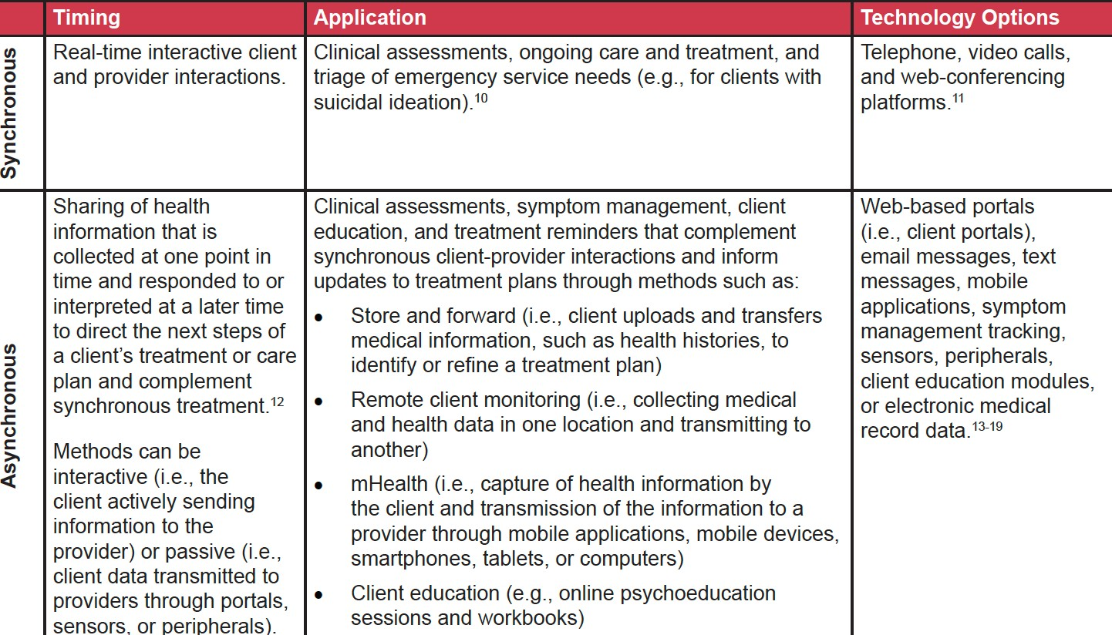

Background
Telehealth can connect clients and providers in multiple locations such as at a home, private space in a clinical setting, or another location in the community. The graphic below depicts examples of ways to connect using telehealth, but there are many ways to deliver and receive care that address connectivity barriers and client preferences.

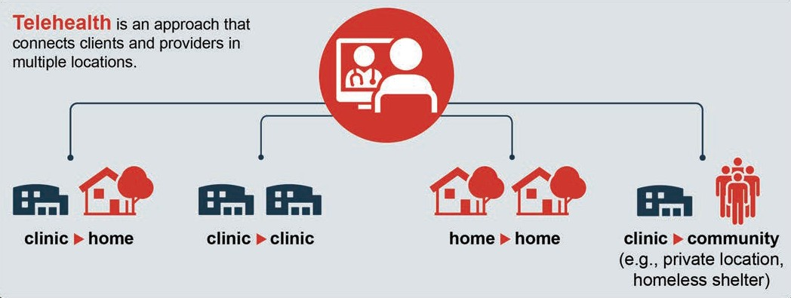

A variety of providers (e.g., psychiatrists, primary care providers, mental health counselors, social workers, psychologists, addiction counselors, case managers, opioid treatment providers, peer workers) can implement telehealth methods. In addition, practitioners can use telehealth with a hybrid approach for increased flexibility. For instance, a client can receive both in-person and telehealth visits throughout their treatment process depending on their needs and preferences.
Telehealth methods can be implemented during public health emergencies (e.g., pandemics, infectious disease outbreaks, wildfires, flooding, tornadoes, hurricanes) to extend networks of providers (e.g., tapping into out-of-state providers to increase capacity). They can also expand capacity to provide direct client care when in-person, face-to-face interactions are not possible due to geographic barriers or a lack of providers or treatments in a given area. However, implementation of telehealth methods should not be reserved for emergencies or to serve as a bridge between providers and rural or underserved areas. Telehealth can be integrated into an organization’s standard practices, providing low-barrier pathways for clients and providers to connect to and assess treatment needs, create treatment plans, initiate treatment, and provide long-term continuity of care.
SMI and SUD impact millions of Americans. However, for a variety of reasons and despite a perceived need, many do not seek treatment. Among adults aged 18 or older, 5.2 percent (13.1 million people) had an SMI. Of those, 47.7 percent (6.2 million people) reported an unmet need for mental health services in the past year.
Among people aged 12 or older, 7.4 percent (20.4 million people) reported experiencing a SUD. Among people aged 12 or older, 7.8 percent (21.6 million people) needed substance use treatment in the past year. Of these 21.6 million people, 12.2 percent (2.6 million) received substance use treatment at a specialty facility.
Telehealth has the potential to address this treatment gap, making treatment services more accessible and convenient, improving health outcomes, and reducing health disparities. Clients experiencing SMI and SUD have traditionally been excluded from both treatments delivered through telehealth and research evaluating the efficacy of telehealth among people experiencing SMI and SUD. However, telehealth is a tool that providers can use for all clients.
Appropriate and additional upfront work, provider-client agreements, and safeguards can ensure that clients experiencing SMI and SUD benefit from services delivered via telehealth. Providers can use assessments (further discussed in later chapters) to identify their clients’ specific barriers to participating in telehealth appointments (e.g., access and comfort with technology, ability to have

private or confidential conversations, safety of the home environment) and inform conversations with their clients on strategies to address these barriers.

1B. Benefits of Telehealth
Telehealth supports team-based care and its interrelated care objectives. The Quadruple Aim is a conceptual framework to understand, measure, and optimize health system performance. The Quadruple Aim organizes benefits of telehealth into four categories:
- Improved provider experience
- Improved client experience
- Improved population health
- Decreased costs
Provider experience. Providers may improve the quality of care they provide and experience the following benefits from implementing telehealth methods:

- Provision of timely client care.
- Providers may have increased flexibility in appointment scheduling by using telehealth.
- They can extend care beyond a clinic’s normal operating hours and its four walls and leverage “virtual walk-in visits.”
- Increased flexibility can help clinics to more effectively manage client “no- shows” and cancellations.

Effective and efficient coordination of care. An estimated 40 to 60 percent of civilian clients (not inclusive of military populations) with mental and substance use disorders are currently treated in primary care offices rather than specialty care settings. Providers can use telehealth methods for tele-consultation, tele- supervision, and tele-education to coordinate, integrate, and improve care (e.g., through the “hub and spoke” model).

Reduction in workforce shortages. This is especially true for underserved and rural areas.

Ability to assess client’s home environment. Rather than rely on a client’s report of their home and living conditions, telehealth makes it possible for providers to see, with appropriate permission, inside a client’s home, meet family support systems, and determine if an in-person visit at a person’s home is needed.

Ability to share information for psychoeducation and assessment. Psychoeducation, or the didactic communication of information to the client about therapeutic intervention or diagnosis, can be done through screensharing, thus allowing the clinician to seamlessly display videos, slideshows, and other visuals to the client. Mental health and substance use assessments can also be done this way, allowing the clinician to track the client’s responses in real-time.

Efficient connections to crisis services. In emergencies, telehealth providers can instruct clients to call emergency response systems (e.g., 911, 988) while the providers remain connected via telephone or video. Enhanced 911 (E911) automatically provides emergency dispatchers with the location of the client, rather than the client needing to provide their address to the dispatcher.
Reductions in provider burnout. Provider burnout is a pervasive issue in the healthcare field and exacerbated by numerous factors, including time pressures, fast-paced environments, family responsibilities, and time-consuming documentation. Telehealth may lead to reductions in provider stress and burnout through promoting more manageable schedules, greater flexibility, and reductions in commute time.

Client experience. Clients may experience many benefits receiving mental health and substance use treatment by telehealth:
➡ Increased access to experienced providers and high-quality care. Through telehealth, clients can access experienced providers that may be geographically distant from their homes. Through telehealth modalities, clients can access providers with expertise in their particular conditions and treatment plans that can provide care appropriate for their culture, race, gender, sexual orientation, and lived experience.
➡ Improved access to and continuity of care. Telehealth provides a mechanism
to increase access to quality care and reduce travel costs for clients, increasing the likelihood that clients will see their provider regularly and attend scheduled appointments.

➡ Increased convenience that removes traditional barriers to care,
including: Geographic barriers (e.g., transportation and distance to providers). Telehealth increases the opportunity for individuals in remote locations to access the care they need.
➡ Psychological barriers. Clients who experience anxiety about leaving their
homes to access treatment (e.g., clients experiencing panic disorder or agoraphobia) are able to receive care in a safe environment.

➡ Accessibility. Individuals with physical, visual, or hearing impairments and clients who are isolated (e.g., older adults) or incarcerated are able to access needed health care through use of telehealth.
➡ Employment. The use of telehealth allows clients to receive care while not
requiring them to take significant leave from employment or other essential activities.
➡ Childcare and caregiver responsibilities. Receiving home-based telehealth can help to reduce the burden of finding childcare. For family caregivers, telehealth technologies, such as remote monitoring, can relieve some caregiver responsibilities, thereby decreasing stress and improving quality of life.
➡ Team-based services and group-based interventions. Team-based and coordinated care is critical to high-quality client treatment. However, geographic distances between providers and clients can limit communication. Telehealth enhances team-based care across geographic barriers by remotely connecting multiple providers with a client, promoting provider collaboration and the exchange of health information. Similarly, telehealth improves access to group-based interventions, which demonstrate similar treatment outcomes as in-person groups.
➡ Reduction in stigma associated with experiencing SMI and SUD and accessing treatment. Through telehealth, clients can disclose their SUD and/ or SMI from the privacy of their own home. In rural communities with fewer behavioral health providers, telehealth can connect clients with providers in other geographic locations, which can increase their privacy and protect their anonymity when accessing care.
➡ Satisfaction with care consistent with in-person treatment. Despite some initial client hesitancy towards using telehealth, clients often report comparable satisfaction between telehealth and in-person care.

Population health. Treatments delivered through telehealth have been shown to improve health outcomes, including improved quality of life and access to health care. For people experiencing SMI, telehealth has the potential to improve quality of life and general mental health, reduce depressive symptoms, build more confidence in managing depression, and increase satisfaction with mental health and coping skills (when compared to treatment offered in-person only). For people experiencing SUD, treatments delivered through telehealth have resulted in reductions in alcohol consumption, increased tobacco cessation, and increased engagement and retention in opioid use disorder treatment.

Costs. In rural communities in particular, implementing telehealth services reduces organizational costs by replacing the budget for a full-time, onsite behavioral health provider with as needed hourly fees.

Implementation of Telehealth
While the use of telehealth as a mode of service delivery is increasing, providers, clients, and healthcare settings continue to experience challenges related to adoption and implementation. For example, uptake of telehealth can be hindered by disparities in access to appropriate and needed technology.
Recent advances in technology and access to personal computing devices and mobile phones have led to a rapid increase in the application of telehealth across the continuum of care (i.e., assessment, treatment, medication management/ monitoring, recovery supports). Both providers and clients need access to appropriate technology to benefit from synchronous or asynchronous telehealth. Practitioners can provide synchronous SMI and SUD treatment through relatively low-tech options, including telephones, smartphones, tablets, and laptops.
The age, usability, and functionality of clients’ devices may inhibit their use (e.g., ability to utilize various mHealth applications, appropriate data plans).
Additionally, clients may be sharing devices with family members or others in a household, limiting the types of data a client would want to store or share through a device. For providers, some clinics struggle to have enough laptops to support staff working from home or outside of typical shared office space, and may not have updated devices or software systems to utilize available telehealth applications.
Barriers associated with access to technology are compounded by challenges experienced on multiple, interrelated levels.

Evidence Based Practice and What the Research Tells Us
The goal of this section is to present the evidence for specific telehealth-delivered treatments for individuals with SMI, SUD, and co-occurring disorders (CODs).
While telehealth modalities for SMI or SUD may be synchronous (real-time) or asynchronous (non-urgent communication between clients and providers), the evidence review in this chapter focuses on synchronous interventions to treat SMI or SUD. In addition to treatments via telehealth modalities, this chapter also provides information on ways programs can provide telehealth-delivered services along the continuum of care for SMI and SUD, which includes screening and

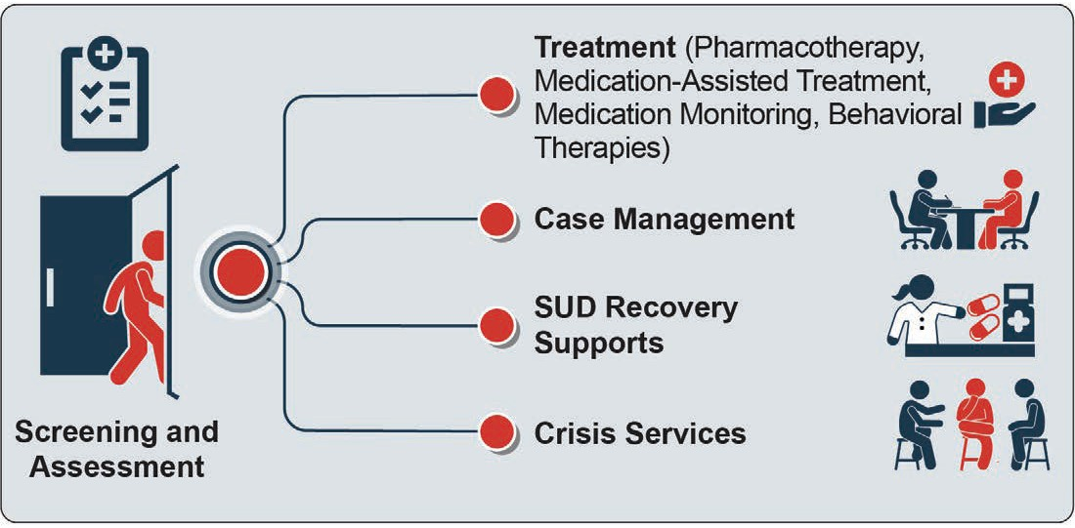

assessment, medication management, case management, recovery support, and crisis services.

2A. Screening and Assessment
Screening and assessment for SMI and SUD are the first steps to effective treatment and can be effectively conducted using synchronous and asynchronous telehealth modalities.
SMI: Synchronous screenings and assessments for mental disorders conducted via videoconferencing modalities have similar reliability and accuracy to in-person screening and assessment. Asynchronous tools that are completed by a client and later reviewed by and discussed with a provider can increase access to screening and assessment when no clinician is available.
SUD: Providers can administer screening tools to assess risk of SUD using telehealth. Early evidence suggests computer-based assessment tools for SUD may increase engagement in the screening process, as well as response accuracy.
However, confirmation and diagnosis of SUD through telehealth has limited evidence. This is largely due to the 2008 Ryan Haight Online Pharmacy Consumer Protection Act, which, prior to the COVID-19 pandemic, required in-person evaluations before providing medication-assisted treatment (MAT).

Telehealth modalities can be used to connect clients, care teams, and support systems during the creation and implementation of an individualized care plan by:

- Increasing the diversity of specialists (in terms of clinical specialty and geographic location) that can be consulted for diagnosis, assessment, and treatment
- Engaging administrative staff (via patient portals), clinicians, and providers (via electronic health records and videoconferencing consultations) and support networks such as friends and family (via videoconferencing and social media) in various components of treatment

Once a diagnosis is made, clients and providers can determine together the appropriateness of various telehealth modalities and identify when telehealth, in- person, or a hybrid approach will best meet the client’s treatment goals.
Appropriateness of telehealth may depend on several factors, including the:
- Nature and complexity of the intervention and the client’s condition
- Client’s comfort with technology and telehealth appointments
- Ease and preferences of accessing in-person services or using technology
- Designing and updating the care plan is a collaborative and iterative process between client and provider, and involves a conversation on client comfort, preferences, and goals

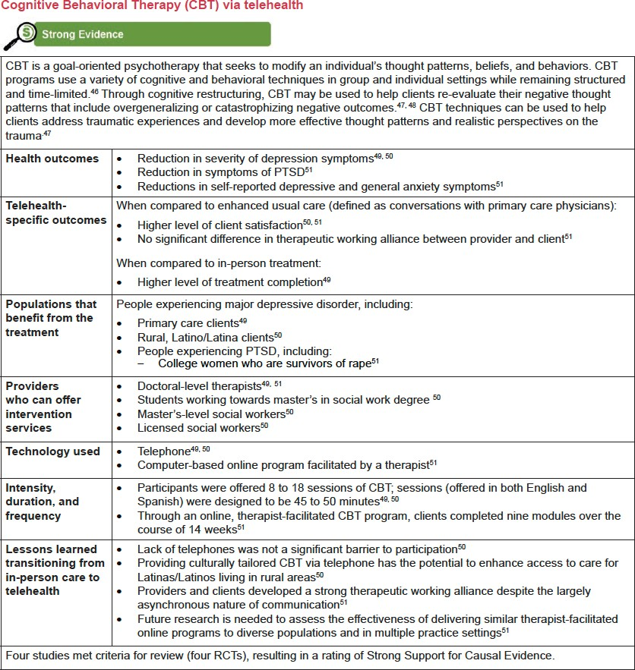

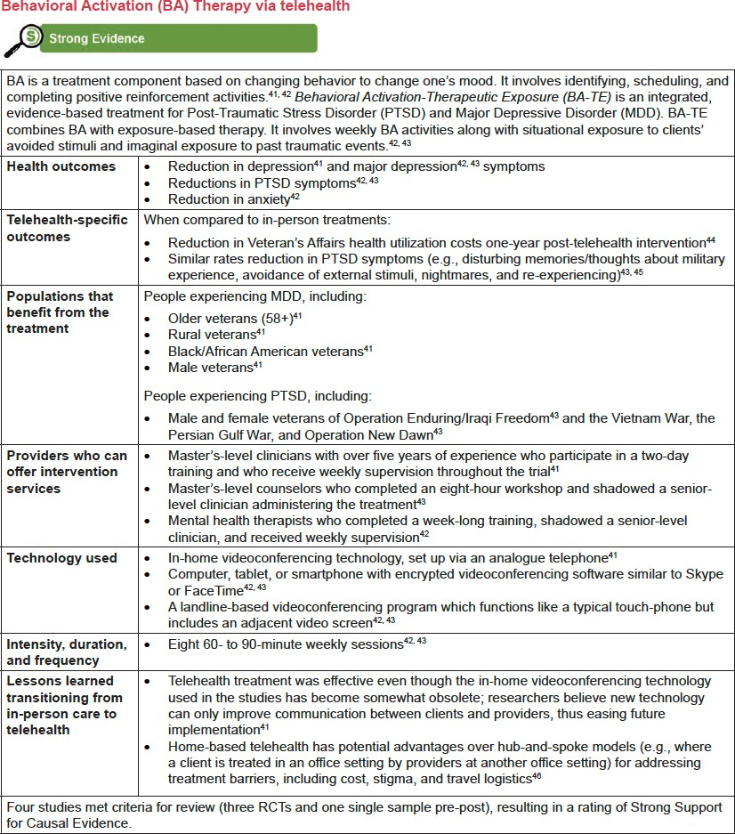

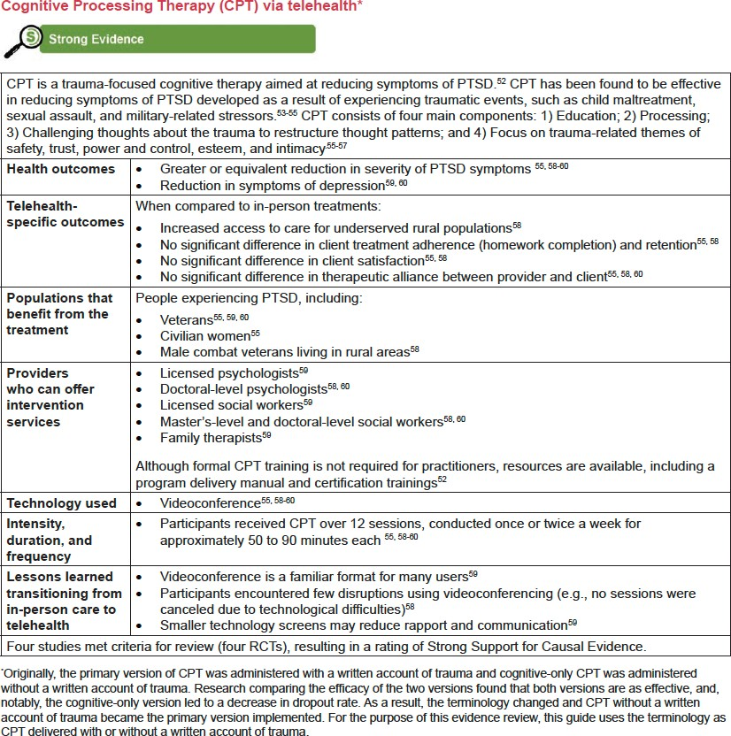

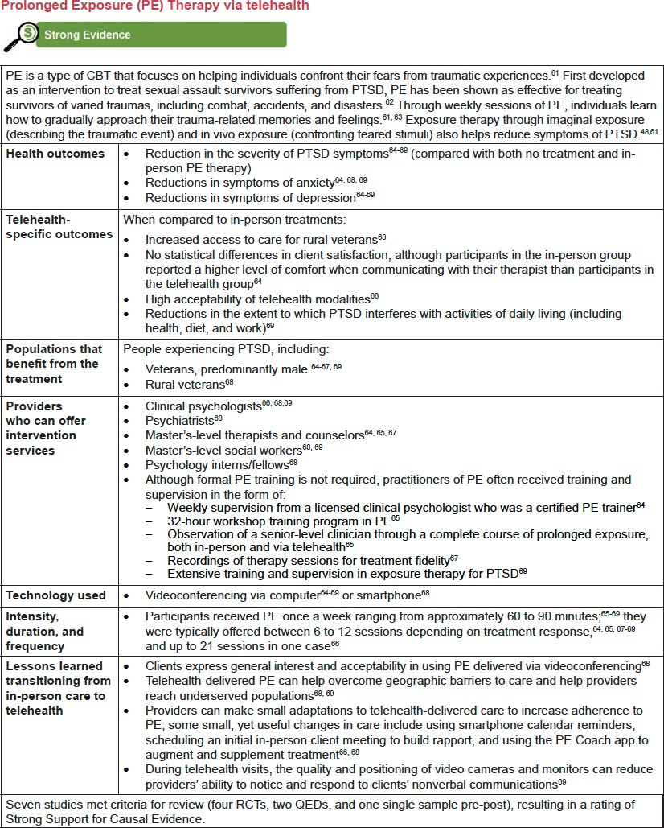

Crisis Services

Telehealth modalities can increase the availability of needed crisis services, ensuring these services are available to anyone, anywhere, at any time, and that there is a “no-wrong-door” approach for entry into services. Crisis services are an effective strategy for suicide prevention and resolving acute mental health and substance use crises, as well as for reducing psychiatric hospital bed overuse, inappropriate use of emergency departments, inappropriate use of law enforcement resources, and the fragmentation of mental health care.

Suicide Screening and Assessment
Telehealth modalities provide an effective alternative to in-person suicide screening and assessment. The following suicide screening and assessment tools can be implemented through telehealth modalities:
The Ask Suicide-Screening Question Toolkit (ASQ) from the National Institute of Mental Health (NIMH) is an evidence-based, 20-second, four-question suicide screening tool.78 The Collaborative Assessment and Management of Suicidality (CAMS) is an evidence- based intervention to assess, treat, and manage clients with suicidal ideation in a range of clinical settings.

- Columbia-Suicide Severity Rating Scale (C-SSRS), also known as the Columbia Protocol, can be used to determine whether someone is at risk for suicide, assess the severity and immediacy of that risk, and gauge the level of support the person needs.88
If a client is at risk of imminent harm:
✴ Assess immediate danger. If the client is in immediate danger and the provider is unable to detain or physically intervene, the provider must contact emergency services.
✴ Identify the client’s location in case emergency services are necessary.
✴ Work with other care providers (e.g., suicide prevention coordinators) when contacting emergency services. Remain connected with the client as the client connects with emergency services or while arranging hospitalization.89
✴ Support clients as they navigate the triage process at an emergency department.
Treatment programs should have safety protocols to mitigate risks and create a workflow to support the client; providers should determine the suicide risk level with criteria that identify the appropriate clinical response.

Evidence review supported conclusions related to treatment outcomes:
➡Telehealth is effective across the continuum of care for SMI and SUD, including screening and assessment, treatments, including pharmacotherapy, medication management, and behavioral therapies, case management, recovery supports, and crisis services.
➡Evidence-based treatments for SMI and SUD, traditionally provided face-to-
face, are also effective when delivered using telehealth and have outcomes
comparable to in-person service delivery.
➡Therapeutic services provided using telehealth modalities generate positive outcomes for the client, including engagement in treatment, retention in care, and
client satisfaction, which in turn lead to improved long-term health outcomes.
➡Positive outcomes are dependent on the provider and client having the necessary resources to conduct telehealth well, including training and technology.

Additionally, several conclusions related to healthcare access and utilization can be made from this evidence-review:
➡Use of telehealth modalities increases individuals’ and communities’ access to trained providers and evidence-based practices that may otherwise be unavailable to them.
➡When geographic and other access barriers (e.g., transportation, mobility, and
obligations like employment and caretaking responsibilities) prevent individuals
from accessing services, telehealth fills a treatment gap and improves health outcomes.
➡Some clients may prefer to receive services wholly or partially by telehealth, and
any of the treatment practices presented in this chapter may be part of an overall
treatment plan that includes a hybrid of telehealth and in-person services.

However, research on the telehealth application of evidence-based practices has been limited for the following reasons:
- Evidence review limitations. While there may be innovative behavioral therapies currently delivered via telehealth for specific conditions, this evidence review relies on specific types of published research to determine the strength of evidence. Included studies must be either randomized controlled trials, use a

quasi-experimental design, or use a pre-post design with a strong counterfactual; therefore, innovative treatments and interventions that have not been studied with such rigorous methods are excluded.

- Limitations of the literature. While telehealth has been used for numerous other conditions, individuals experiencing SMI and SUD have traditionally been regarded as having complex conditions and therefore excluded from telehealth research. With limited implementation of telehealth for people with SMI and SUD, it offered fewer opportunities for researching treatment to treat those conditions. Some providers have been reluctant to offer telehealth in the past, in part due to negative views towards the modality and perception of clients’ experiences with telehealth, which has slowed access to telehealth for individuals experiencing SMI or SUD.

- Need examination of asynchronous forms of treatment. This evidence review demonstrated strong evidence to support synchronous interventions to support telehealth-delivered, evidence-based treatments. However, more research is needed to determine the effectiveness of asynchronous treatments, which can be effective complementary tools to synchronous virtual or in-person treatment by increasing client engagement, promoting healthy behaviors, reducing feelings of stigma, and increasing access to treatment. Text messages, online chat features, email, and social networking sites can also be used to facilitate ongoing communication outside of face-to-face sessions.

While there are limitations to the research, telehealth is a key strategy to increasing and ensuring access to care for people living with SMI, SUD, or COD. Future research could expand beyond telehealth efficacy and focus on implementation and evaluation considerations, including provider/patient buy-in, necessary technological infrastructure, and methods of quality improvement.

Guidance for Implementing Evidence-Based Practices
Before using telehealth modalities for screening, assessing, treating, and supporting people with serious mental illness (SMI) and substance use disorder (SUD), clinicians should consider several important implementation factors. The implementation considerations and strategies discussed in this section can be broadly applied for the treatment of any mental illness.
This chapter presents implementation considerations and strategies to facilitate effective implementation on multiple, interrelated levels.

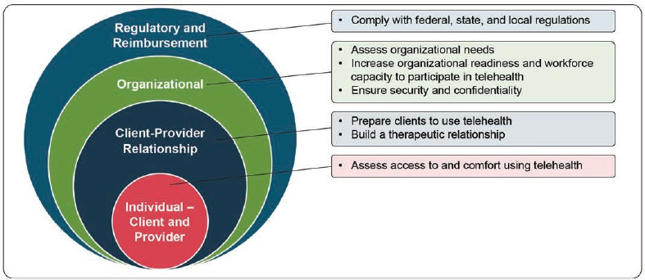

This section starts with factors focused on the individual level, including the client and provider. It then identifies considerations and strategies across the interpersonal client-provider relationship, the organization, and the policy and regulatory landscape.

3A. Individual-Level Considerations
Client-Level
Clients have different levels of:
✤Comfort or willingness to engage with telehealth
✤Access to technology or high-speed Internet
✤Apprehension about using technology or concern about privacy risks

The recent proliferation of smartphones provides a convenient way for many to engage in telehealth. Access to smartphones allows for both synchronous videoconferencing for telehealth-based therapy, as well as asynchronous apps to support medication monitoring, symptom recording, and messaging between the client and provider.

Strategies to increase client access to and comfort using telehealth
➡Increase access to mobile phones and Internet – In addition to a fast and stable Internet connection, clients need tablets, computers, or smartphones that support face-to-face videoconferencing or eHealth app services. Technical difficulties, such as low image resolution, audio delays, or other glitches in communication can disrupt the regular flow of conversation between the provider and client.4, 5 Providers can supply devices and signal boosters to clients who need them.6 However, purchasing phones and maintaining Internet access involves significant start-up and maintenance costs.

Clients who do not have smartphones, tablets, or computers have reported high satisfaction using the telephone for psychotherapy.
➡ Increase awareness of telehealth – Post signage about telehealth in waiting or exam rooms, share promotional materials during the visit or as part of the after- visit summary, or provide telehealth demonstrations.
➡ Discuss the individual-level benefits of telehealth – Clients may experience benefits that go beyond SMI or SUD outcomes. For example, for clients who experience physical limitations (e.g., chronic pain or mobility-related challenges), have panic disorders, or are more comfortable in environments they can predict and control, telehealth modalities can help them focus on their care in a safe and comfortable setting of their choosing.
➡ Conduct a health technology trial-run – While many technologies are designed to be easy to use, people who have less comfort with technology may struggle with telehealth platforms, devices, and applications and worry about technical problems that could occur. Test the connection and interface before a first session to reduce technology anxiety and manage minor issues. Assign an IT or other staff member to set up a brief pre-appointment with the client to work through the functionalities of their telehealth appointment and help the client overcome any challenges. This staff member can demonstrate how to use the program or app and give tips about how to use the device to interface with the program (e.g., how to effectively “tap” to press start or stop), how to use the camera, how to record or view recordings, and how to upload and delete files.
➡ “Let’s try it and see if you like it” – Prior to engaging in telehealth, clients may have fears or concerns about the experience and the care they will receive in a virtual format. Testing out the technology, encouraging clients to try out various synchronous forms of communication, and reminding clients that they

can discontinue telehealth at any time can support client engagement in telehealth visits.
Provider-level
Provider reticence to adopt telehealth can occur for several reasons, including concerns related to poor therapeutic relationship, less commitment from the client to therapy, and technological difficulties affecting the therapeutic experience.
However, acceptability studies have found many benefits to therapy using telehealth.

Strategies to increase provider comfort with telehealth
➡ Review the literature on the efficacy and effectiveness of telehealth (see previous sections).
➡ Provide trainings – Increase digital literacy through trainings to increase comfort and familiarity with various digital platforms. Use training time to get input from providers on what works and what can be improved.
➡ Identify individual provider-level benefits – Individual providers may find that through telehealth, they are able to create flexible work schedules, expand the number and kinds of clients they work with, and reduce provider burnout.
➡ Engage clinical and IT staff to support telehealth – Using telehealth coordinators or trained medical assistants to schedule and provide reminders for telehealth visits can improve no-show rates and provide needed technical assistance. Providing available staff to effectively manage technical difficulties can also improve provider acceptance of telehealth.

Interpersonal Client-Provider Relationship Considerations
Client-provider relationships are essential to successful treatment. However, telehealth can be challenging to building an effective therapeutic relationship. Client-provider pre-work (i.e., discussions, planning, and training prior to beginning treatment) and special attention to building therapeutic alliances can help overcome barriers to developing strong client-provider relationships.

Strategies for providers to prepare clients for telehealth
- Assess client for appropriateness to engage in telehealth – Relationships between clients and providers begin with screening and assessment prior to starting treatment or therapy. Telehealth modalities may not be appropriate for all clients at all points of their treatment plans. Some treatment and follow-up care requires in-person visits (e.g., urine drug screenings for clients on medication for SUD). Some clients may respond differently to in-person versus videoconference therapy and may benefit from a hybrid or in-person approach.

Screening and assessing clients for their readiness to participate in and conduct appropriate activities using telehealth modalities can inform both care planning and delivery. In addition, it can mitigate client challenges through careful preparation and structured conversations.

- Conduct a thorough informed consent process – Use tools such as the easy- to-understand telehealth consent form template developed by the Agency for Healthcare Research and Quality (AHRQ). The informed consent process includes the following key pieces: What is telehealth: Explain what telehealth is and why you are using it for the client’s care.

- Potential privacy concerns: The presence of family members, caregivers, or roommates in the home during a telehealth visit could hinder a client’s ability to fully engage in the visit. Remind the client to be in a private space, away from other people, and assure the client that their conversation is private on the provider’s side. Ensure the client knows how to mute the audio and disable video in case they want privacy during disruptions.
- Patient communications: Notify clients about how electronic client communications are stored and who may access these communications.

- Backup plan: Discuss protocols in the case that technology fails or clients need a higher level of care.

- Develop a telehealth checklist for the provider to use prior to each visit – A checklist can be a convenient way to ensure the provider has followed appropriate procedures and shared relevant information with the client.

Special Considerations
Some clients may have difficulty engaging in tele-health, including those with hearing loss, disabilities, or language barriers.
The National Association of the Deaf has resources for accessibility for clients who are deaf and hard of hearing.
The American Psychological Association has a tip sheet about using telehealth with persons with disabilities.
Providing translation services can help ensure equitable access to health care. Many existing translation services already occur over the phone. Consider ways to expand translation services for use in telehealth.

- Discuss ways to ensure client privacy during sessions – To guarantee privacy, consider making it a practice to clarify the client’s location and who is in the virtual room in case someone is off-camera. This action can affirm your commitment to the client’s privacy.

Strategies for building therapeutic relationship
Providing treatment through telehealth modalities will impact the way a provider builds therapeutic alliance (the relationship developed between the provider and client in working toward the goals of therapy) during the screening and consent process and during treatment. The strategies below help to ensure a client’s commitment to therapy, address technological difficulties impacting the therapeutic experience, and mitigate the potential for a client to feel as though conversations are “impersonal.”
➡ Acknowledge differences between in-person and virtual visits – Slight audio or video lags may disrupt natural communication, which may affect rapport- building. Use traditional tools and strategies to build the therapeutic relationship and implement additional strategies to overcome challenges to building rapport over video, such as using exaggerated non-verbal cues.
➡ Start with small talk – Create a similar environment to that of an in-person visit by asking about a person’s day, the weather, or other light topics to warm up the conversation and build familiarity through a virtual visit.
➡ Meet in person when needed – This strategy may be less feasible during pandemics or natural disasters, but may be useful in certain circumstances, such as meeting first while in a hospital setting. In-person meetings are not essential to successful telehealth visits, but can be used at the discretion of the client and
Inform the Client of Telehealth Norms
Provide the client with an overview of expected norms and behaviors for telehealth.
- The camera angle and quality, screen size, and other factors can limit the ability to read a client’s behavior. Ask the client to adjust the camera angle, if possible, to aid in reading non-verbal cues.
- While the session may be taking place in the client’s home, ask that the client dress appropriately.
- Remind clients not to multi-task while engaging in the session, such as texting or using the Internet. Empower the client to share if they are having difficulties hearing or engaging with the provider.
- Remind the client that while the provider may be taking notes or documenting in the medical record, the provider’s attention is focused on the client

provider. Requiring in-person visits can create a barrier to seeking or accessing care, so the decision to have in-person visits should be made in collaboration with the client.

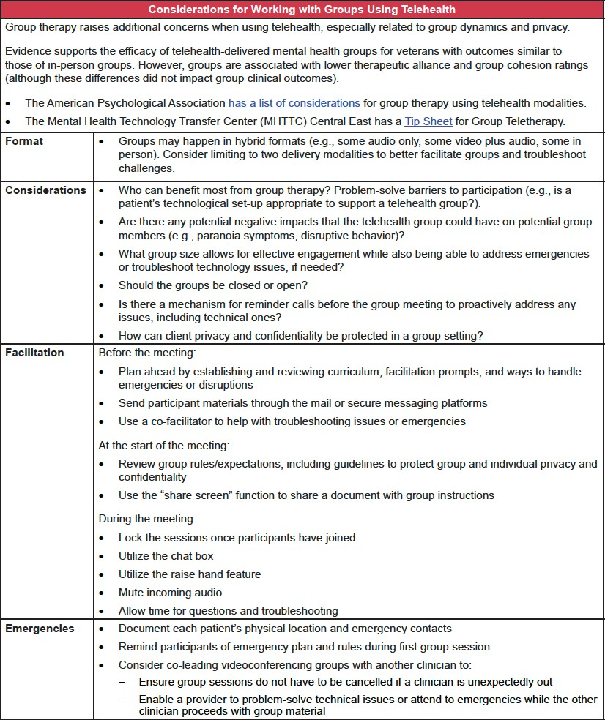

Resources for Evaluation and Quality Improvement
Evaluating an intervention can answer critical questions about how well a practice has been implemented and determine what may or may not be working. Evaluation can also show how clients benefit from a practice. This information can be helpful in making practice adjustments, if necessary, and demonstrating the value of a practice or program to justify its continuation and secure additional funding. In addition, stakeholders can use information gathered through evaluation to encourage implementation of that practice in other settings or communities.
This chapter provides an overview of approaches to evaluate implementation of and results from treatments for clients with serious mental illness (SMI) and substance use disorder (SUD) delivered using telehealth modalities. People with SMI and SUD have often been excluded from telehealth research studies, but, as demonstrated in Chapters 1 through 4 of this guide, telehealth is effective for people with SMI and SUD.
To evaluate telehealth-delivered practices and programs, both the treatment (e.g., cognitive behavioral therapy) and the modality (e.g., synchronous telehealth videoconference) need to be evaluated. Ideally, patients would see a reduction in symptomology because of the practice, and a high level of retention, acceptability, or satisfaction with the modality. Additionally, both treatment providers and clients should be engaged in the generation of evaluation tools and plans to ensure data collection tools are appropriate for the evaluated communities and to secure buy- in. Reporting findings back to providers and clients should be prioritized to promote transparency and inform care choices.

4A. Types of Evaluations
Researchers typically conduct evaluation before a treatment is implemented to determine its feasibility (formative evaluation), during implementation (process evaluation and CQI), and after the treatment has been delivered to at least one client (outcome and impact evaluations). All four types of evaluation are necessary to assess a treatment’s effectiveness.

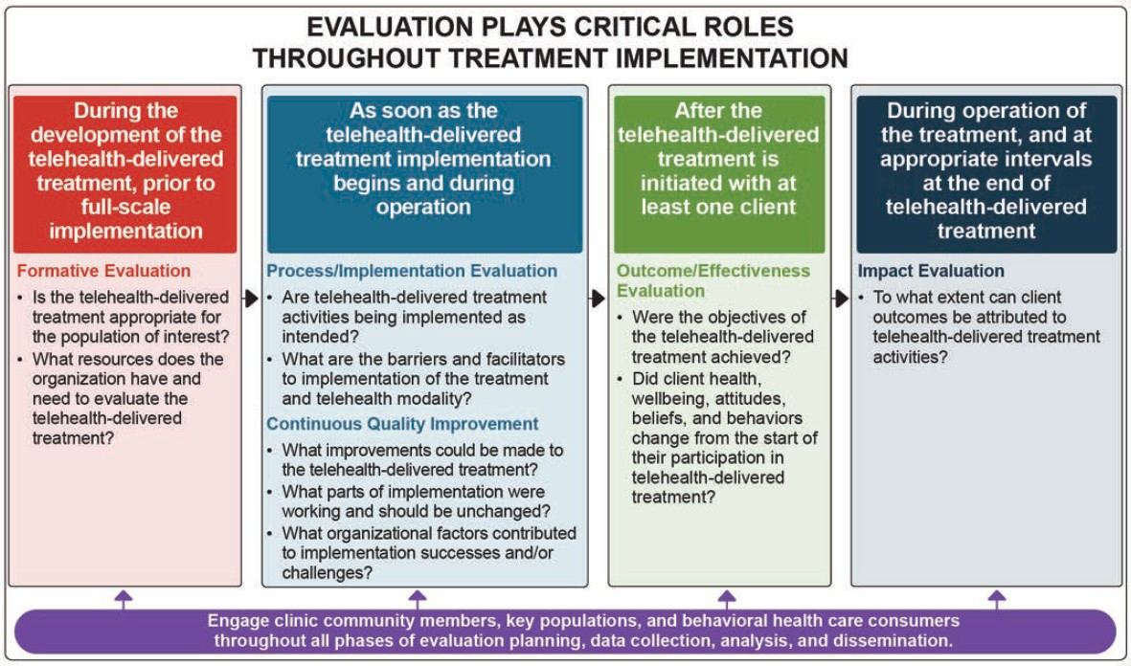

Outcome Evaluations
The table below provides a list of potential outcomes, illustrative outcome indicators, and qualitative and quantitative data sources that program managers, clinicians, and others may use to evaluate practices mentioned earlier in this document.
Client health outcomes may be tracked at baseline and throughout the program duration through standardized screening, or through interviews with staff and clients. Telehealth-related patient outcomes, such as engagement and retention in telehealth, or therapeutic alliance may be obtained through administrative data, surveys, or interviews. Provider outcomes may be captured through surveys or interviews. Population health outcomes may be tracked through administrative data and interviews. Finally, cost-related outcomes can be captured through administrative data.

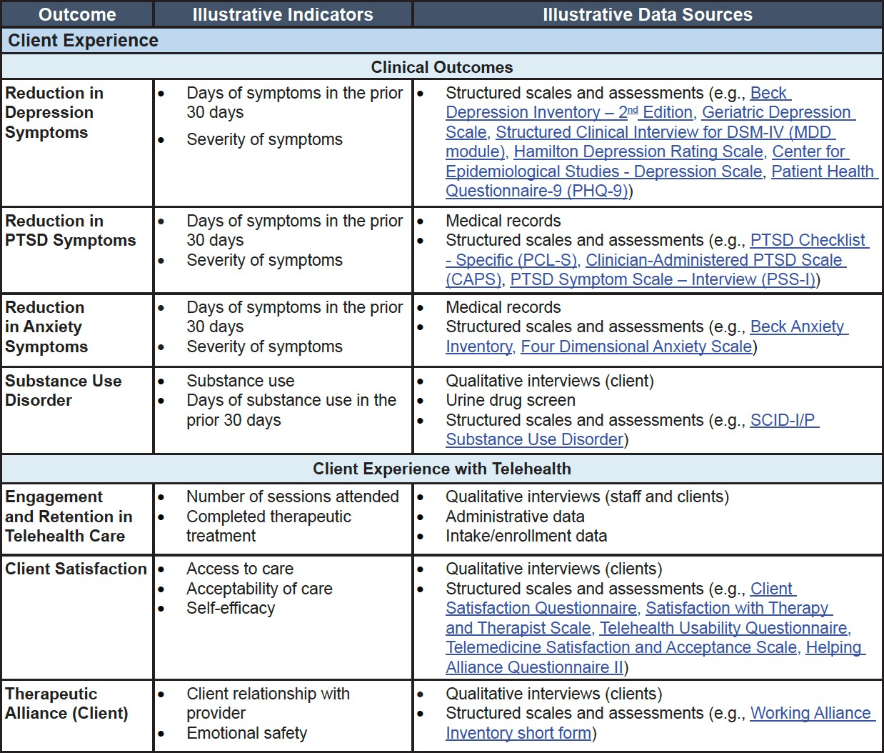

Legal and Ethical Considerations
The provision of mental health services via telehealth is not without its challenges and considerations. In this section, we will further explore the legal and ethical considerations related to the provision of mental health services via telehealth, as well as the best practices for delivering these services effectively.

Legal considerations for telemental health

The provision of mental health services via telehealth is governed by federal and state laws, as well as professional guidelines and standards. These laws and guidelines aim to ensure the privacy, security, and quality of care for patients receiving mental health services via telehealth.

5A. Federal Laws and Regulations

One of the key federal laws governing the provision of telehealth services is the Health Insurance Portability and Accountability Act (HIPAA). HIPAA sets standards for the privacy and security of patient information and applies to all healthcare providers, including those providing mental health services via telehealth. HIPAA requires that telehealth providers implement safeguards to protect patient information and ensure that it is only used for authorized purposes. In addition to HIPAA, there are several other federal laws and regulations that apply to the provision of telehealth services, including:
➡ The Telemedicine Act of 1996: This act established a definition of
telemedicine and established guidelines for the reimbursement of telehealth services by Medicare.
➡ The 21st Century Cures Act: This act, enacted in 2016, expanded the use of telehealth in Medicare and established new guidelines for the provision of telehealth services, including the use of telehealth for mental health services.
➡ The Federal Communications Commission (FCC): The FCC has established rules for the use of telecommunications in healthcare, including the use of telehealth for mental health services.

5B. State Telehealth Laws and Regulations
In addition to federal laws and regulations, each state has its own laws and regulations governing the provision of telehealth services, including mental health services. These laws can vary significantly from state to state and may include requirements for licensure, prescribing medications, and reimbursement for telehealth services. It is important for telehealth providers to be aware of and comply with the relevant state laws and regulations in the states in which they practice.

This section is for informational purposes only, and is not intended as a comprehensive statement of the law on this topic, nor to be relied upon as authoritative. Always consult with counsel or appropriate program administrators.

State Telehealth Laws and Policies

Introduction

The Center for Connected Health Policy’s (CCHP) release of the “State Telehealth Laws and Reimbursement Policies” report highlights the changes that have taken place in state telehealth policy. The report offers policymakers, health advocates, and other interested health care professionals a summary guide of telehealth- related policies, laws, and regulations for all 50 states and the District of Columbia.

While this guide focuses primarily on Medicaid fee-for-service policies, information on managed care is noted in the report as well. The report also notes particular areas where we were unable to find information. Recently passed legislation and regulation have also been included in this version of the document with their effective date noted in the report (if applicable). This information also is available electronically in the form of an interactive map and search tool accessible on our website cchpca.org. Consistent with previous editions, the information will be updated biannually, as laws, regulations and administrative policies are constantly changing.

Telehealth Policy Trends

States continue to refine and expand their telehealth reimbursement policies though they are not treated across the board in the same manner as in-person delivered services. Limitations in regards to reimbursable modality, services and location of the patient continue to be seen. Although each state’s laws, regulations, and

Medicaid program policies differ significantly, certain trends are evident. Live video Medicaid reimbursement, for example, continues to far exceed reimbursement for store-and-forward and remote patient monitoring (RPM).
Reimbursement for RPM and store-and- forward continue to be limited. There has been some increased interest in reimbursing for eConsult as California Medicaid joined Connecticut Medicaid in reimbursing for at least one eConsult code. Other noteworthy trends include the addition of the home and schools as an eligible originating site in some states, and the inclusion of teledentistry and substance use disorder services as a specialty qualifying for Medicaid reimbursement and/or required to be reimbursed by private insurers.

The release of the Center for Connected Health Policy’s (CCHP) report of state telehealth laws and Medicaid reimbursement policies is the eighteenth updated version of the report. Like its previous iterations, the report is updated on a biannual basis, in spring and fall. An interactive map version of the report is available on CCHP’s website, cchpca.org. Due to constant changes in laws, regulations, and policies, CCHP will continue to update the information in both PDF and map formats twice a year to keep it as accurate and timely as possible.

It should be noted that even if a state has enacted telehealth policies in statute and/ or regulation, these policies may not have been incorporated into its Medicaid program. Throughout the report, CCHP has notated changes in law that have not yet been incorporated into the Medicaid program, as well as laws and regulations that have been approved, but not yet taken effect.

Key Findings

No two states are alike in how telehealth is defined and regulated. While there are some similarities in language, perhaps indicating states may have utilized existing verbiage from other states, noticeable differences exist. These differences are to be expected, given that each state defines its Medicaid policy parameters, but it also creates a confusing environment for telehealth participants to navigate, particularly when a health system or practitioner provides health care services in multiple states. In most cases, states have moved away from duplicating Medicare’s restrictive telehealth policy, with some reimbursing a wide range of practitioners and services, with little to no restrictions.

As noted previously, even if a state has enacted telehealth policies in statute and/or regulation, these policies may not have been incorporated into its Medicaid program. In the findings below, there are a few cases in which a law has passed

requiring Medicaid reimbursement of a specific telehealth modality or removal of restrictions, but Medicaid policies have yet to reflect this change. CCHP has based its findings on current Medicaid policy according to those listed in their program regulations, manuals or other official documentation. Requirements in newly passed legislation will be incorporated into the findings section of future editions of CCHP’s report once they are implemented in the Medicaid program, and CCHP has located official documentation confirming this.

While this Executive Summary provides an overview of findings, it must be stressed that there are nuances in many of the telehealth policies. To fully understand a specific policy and all its intricacies, the full language of it must be read.

Varying State Definitions

States alternate between using the term “telemedicine” or “telehealth”. In some states both terms are explicitly de ned in law and/or policy and regulations. ” Telehealth” is sometimes used to reflect a broader definition, while “telemedicine” is used mainly to define the delivery of clinical services. Additional variations of the term, primarily utilizing the “tele” pre x are also becoming more prevalent. For example, the term “telepractice” is being used frequently as it relates to physical and occupational therapy, behavioral therapy, and speech language pathology. “Telesychiatry” is also a term commonly used as an alternative when referring specifically to psychiatry services.

Some states put specific restrictions within the definitions, which often limit the term to “live” or “interactive”, excluding store-and-forward and RPM from the definition and subsequently from reimbursement. The most common restriction states place on the term telemedicine/telehealth is the exclusion of email, phone, and/or fax from the definition. Forty- nine states and the District of Columbia have a definition in law, regulation, or their Medicaid program for telehealth, telemedicine, or both. Only Alabama lacks a definition for either term.

5C. BBS and California State Telehealth Regulations

CA BBS Continuing Education Requirements

Effective July 1, 2023, all applicants for licensure and current licensees who are up for renewal after January 1, 2023, will be required to complete three hours of training or coursework in telehealth mental health services. Registered associates

will also be required to complete a minimum of three hours of continuing education in law and ethics annually during their renewal period, regardless of whether they have passed the California Law & Ethics exam. However, as of

California Applicable Laws

The California Telehealth Resource Center has a webpage that lists current California
laws related to the provision of telemental health services: https://www.caltrc.org/
Here are some key laws and regulations:
california-telehealth-laws-policies.
- California Health and Safety Code Section 5636.2 - This law authorizes the provision of telehealth services, including mental health services, as long as the services are within the scope of practice of the provider and meet the same standards of care as in-person services.
- California Business and Professions Code Section 2290.5 - This law requires the Medical Board of California to adopt regulations related to the use of telehealth in the practice of medicine. The regulations can be found in Title 16, Division 13, Chapter 8 of the California Code of Regulations.
- California Insurance Code Section 10133.196 - This law requires health plans and insurers to cover telehealth services, including mental health services, in the same way as in-person services, with certain exceptions.
- California Welfare and Institutions Code Section 14132.95 - This law requires the Department of Health Care Services to establish a telehealth pilot program to provide mental health services to Medi-Cal beneficiaries.

It's important to note that these laws may be subject to change, so it's always a good idea to check for updates.

There are several ethical considerations that California telemental health and electronic therapy licensed providers should take into account when practicing
remotely.
- Informed consent: It is important to obtain informed consent from clients before providing telemental health services. This includes explaining the potential risks and benefits of remote therapy, as well as the technical requirements and limitations of the platform being used.

- Confidentiality: Telemental health providers must take steps to ensure the confidentiality of client communications, including using secure, encrypted platforms and following relevant laws and regulations (such as HIPAA in the US).

- Professional boundaries: It is important to maintain appropriate professional boundaries when providing telemental health services. This includes not engaging in dual relationships with clients (such as being their therapist and also a personal friend) and avoiding the use of personal communication tools (such as texting or social media) for therapy.

- Competence: Telemental health providers must ensure that they are competent to provide therapy remotely and seek additional training if necessary. This includes being familiar with the technical aspects of remote therapy and being aware of any unique ethical considerations that may arise in a virtual setting.

- Inclusivity: Telemental health providers should strive to make their services accessible to all clients, including those with disabilities. This may involve providing accommodations such as closed captioning or using assistive technology.

The following is a summary of the Board of Behavioral Sciences regulations on the standards of practice for telehealth:

The Board of Behavioral Sciences (BBS) developed regulations on the standards of practice for telehealth that first became effective July 1, 2016. All therapists licensed or registered with the BBS, who are interested in or are engaged in the practice of telehealth, need to be aware of these regulations. Non compliance could possibly result in unprofessional conduct (Regulatory and Legal Considerations for Telehealth, Tran A., The Therapist)

Definitions

Under law, “telehealth” is the mode of delivering health care via information and communication technologies, including, but not limited to, telephone and/or internet. Licensees may deliver health care, under their scope of practice, via telehealth, under certain conditions. Licensees are responsible for understanding all

applicable laws, to deliver health care via telehealth. Failure to comply with any provisions regarding telehealth may be subject to disciplinary action by the Board.

The two most common modes of telehealth for psychotherapy are via:
➡ Live videoconferencing either through a personal computer with a webcam or a mobile communications device with two-way camera capability, and
➡ Telephone.

According to CAMFT’s Tran A, “The BBS recognizes the practice of psychotherapy via telehealth as falling within its jurisdiction and subject to the same statutes and regulations that apply to in-person psychotherapy. Therefore, all California and/or federal laws regarding the confidentiality and privacy of health care information and a client’s right of access to his or her medical information apply to telehealth services.” (Regulatory and Legal Considerations for Telehealth, Tran A., The Therapist)

Regulations

- Individuals providing psychotherapy or counseling, either in person, via telephone, or via internet, must be licensed in California. LMFT, LCSW and LPCC must have a current license issued by the BBS in order to provide psychotherapy services to clients who are physically located in California.
- MFT Trainees, while under appropriate supervision and working in lawful, exempt settings, may provide psychotherapy services via telehealth (Business and Professions Code Section 2290.5)
- All laws regarding the confidentiality of health care information and a patient's right to their medical information shall apply to telehealth interactions.

§ 1815.5. Standards of Practice for Telehealth

“(a) All persons engaging in the practice of marriage and family therapy, educational psychology, clinical social work, or professional clinical counseling via telehealth, as defined in Section 2290.5 of the Code, with a client who is physically located in this State must have a valid and current license or registration issued by the Board.

- All psychotherapy services offered by board licensees and registrants via telehealth fall within the jurisdiction of the board just as traditional face-to-face services do. Therefore, all psychotherapy services offered via telehealth are subject to the board's statutes and regulations.

- Upon initiation of telehealth services, a licensee or registrant shall do the following:
  - Obtain informed consent from the client consistent with Section 2290.5 of the Code.
  - Inform the client of the potential risks and limitations of receiving treatment via telehealth.
  - Provide the client with his or her license or registration number and the type of license or registration.
  - Document reasonable efforts made to ascertain the contact information of relevant resources, including emergency services, in the patient's geographic area.

- Each time a licensee or registrant provides services via telehealth, he or she shall do the following:
  - Verbally obtain from the client and document the client's full name and address of present location, at the beginning of each telehealth session.
  - Assess whether the client is appropriate for telehealth, including, but not limited to, consideration of the client's psychosocial situation.
  - Utilize industry best practices for telehealth to ensure both client confidentiality and the security of the communication medium.

- A licensee or registrant of this state may provide telehealth services to clients located in another jurisdiction only if the California licensee or registrant meets the requirements to lawfully provide services in that jurisdiction, and delivery of services via telehealth is allowed by that jurisdiction.

- Failure to comply with these provisions shall be considered unprofessional conduct.

Note: Authority cited: Sections 4980.60 and 4990.20, Business and Professions Code. Reference: Sections 2290.5, 4980, 4989.50, 4996, 4999.30 and 4999.82, Business and Professions Code.”

Summary of Above Stated Code

Prior to the delivery of health care via telehealth, the provider initiating the use of telehealth shall:

- Obtain Consent: This is required by the Telehealth statute Business and Professions Code Section 2290.5 where the therapist must
  - Inform the client/patient about the use of telehealth
  - Obtain, and document, verbal or written consent from the client/patient for this use.

- Discuss Risks/Limitations: The therapist must inform the client either verbally and/or in writing of the potential risks and limitations of receiving psychotherapy via telehealth which may include but are not limited to technical failures; interruption by unauthorized persons; unauthorized access to transmitted and/or stored confidential information; and decreased availability of the therapist in the event of a crisis.

- The CAMFT Code of Ethics “Section 1.4.2 ELECTRONIC THERAPY: When patients are not physically present (e.g., therapy by telephone or Internet) during the provision of therapy, marriage and family therapists take extra precautions to meet their responsibilities to patients. Prior to utilizing electronic therapy, marriage and family therapists consider the appropriateness and suitability of this therapeutic modality to the patient’s needs. When therapy occurs by electronic means, marriage and family therapists inform patients of the potential risks, consequences, and benefits, including but not limited to, issues of confidentiality, clinical limitations, transmission difficulties, and ability to respond to emergencies. Marriage and family therapists ensure that such therapy complies with the informed consent requirements of the California Telemedicine Act.

- Licensee License/Registration: The therapist must either verbally or in writing, provide the client with their license or registration number and the type of license or registration. This is usually located on the informed consent form.

- Provide Contact Information of Relevant Resources: CAMFT Code of Ethics (2019) “1.5.3 EMERGENCIES/CONTACT BETWEEN SESSIONS:
Marriage and family therapists inform patients of the extent of their availability for emergencies and for other contacts between sessions. When a

marriage and family therapist is not located in the same geographic area as the patient, he/she shall provide the patient with appropriate resources in the patient’s locale for contact in case of emergency.” According to Tran A, “The therapist may achieve this by sending or emailing the relevant resources to the client or by providing the information verbally and documenting in the client’s record (e.g., the therapist informed the client of the University Hospital, located on Washington Street, which provides emergency services and inpatient psychiatric services, including specialized services for children). The emergency services near the client’s location may include telephone numbers and addresses for nearby emergency rooms, the psychiatric emergency team telephone number; and telephone numbers to local crisis hotlines/centers.” (Regulatory and Legal Considerations for Telehealth, Tran A., The Therapist).

During every telehealth session the therapist must:

- Verbally obtain from the client the client’s name and document such name and the address of the client’s present location for identify confirmation and emergency purposes.

- Assess whether the client is appropriate for telehealth. This includes but is not limited to, consideration of the client’s psychosocial situation. This is intended to evaluate the client’s possible changing mental health from session to session thereby determining continued appropriateness for telehealth. The therapist should document accordingly.

- Utilize industry best practices for telehealth including ensuring both client confidentiality and the security of the telehealth platform. Documentation of the therapist’s due diligence in this process is necessary.

5D. Telehealth Outside of California
California licensees or registrants who wish to engage in telehealth with a client located in another jurisdiction need to check with that jurisdiction to determine its laws related to telehealth, and if licensure in that jurisdiction is required. Several states currently consider a client located in their state to be under their jurisdiction. Therefore, a practitioner needs to comply with that jurisdiction’s laws in order to avoid any potential violations of those laws.

Currently, there are six states (Arizona, Colorado, Florida, New Jersey, Utah, and Wyoming), including D.C., that allow for out-of-state licensed MFTs to

temporarily practice marriage and family therapy (and via telehealth) to clients located in those states. Because states vary in their regulations, it is recommended for a therapist to contact the state’s MFT licensing board for an inquiry into the requirements for lawful practice of marriage and family therapy, or if the jurisdiction has relevant telehealth statutes, the practice of marriage and family therapy via telehealth in that state.

Resources

The California Telehealth Resource Center (CTRC) is nationally recognized as one of fourteen federally designated Telehealth Resource Centers around the country.
CTRC has a vision to achieve the fully optimized use of telehealth and other technology enabled health care in order to: 1) improve access to health care for all California citizens; 2) improve clinical efficiency and access to health information and education; and 3) reduce the cost of providing needed health care. Visit the CTRC website at http://www.caltrc.org.

The Center for Connected Health Policy (CCHP) is a program of the Public Health Institute which was established in 2008 to integrate telehealth virtual technologies into the health care system through advancing sound policy based on objective research and informed practices. Visit the CCHP website at http://cchpca.org.

The California Telehealth Network (CTN), an independent 501(c)(3) non-profit, focuses on increasing access to healthcare, including telehealth, telemedicine and health information exchange, through the innovative use of technology. CTN is funded through the Federal Communications Commission’s Rural Health Care Pilot Program. CTN is California’s authorized FCC broadband consortium for healthcare. Visit the CTN website at http://www.caltelehealth.org.

California Telehealth Resource Center Legislation & Regulation

The CA Telehealth Resource Center provides telehealth technical assistance to the state of California.

5E. Ethical Considerations

The provision of mental health services via telehealth raises a number of ethical considerations, including issues related to informed consent, confidentiality, and the quality of care.

There are several ethical considerations that California telemental health and electronic therapy licensed providers should take into account when practicing
remotely.
  - Informed consent: It is important to obtain informed consent from clients before providing telemental health services. This includes explaining the potential risks and benefits of remote therapy, as well as the technical requirements and limitations of the platform being used.
  - Confidentiality: Telemental health providers must take steps to ensure the confidentiality of client communications, including using secure, encrypted platforms and following relevant laws and regulations (such as HIPAA in the US).
  - Professional boundaries: It is important to maintain appropriate professional boundaries when providing telemental health services. This includes not engaging in dual relationships with clients (such as being their therapist and also a personal friend) and avoiding the use of personal communication tools (such as texting or social media) for therapy.
  - Competence: Telemental health providers must ensure that they are competent to provide therapy remotely and seek additional training if necessary. This includes being familiar with the technical aspects of remote therapy and being aware of any unique ethical considerations that may arise in a virtual setting.
  - Inclusivity: Telemental health providers should strive to make their services accessible to all clients, including those with disabilities. This may involve providing accommodations such as closed captioning or using assistive technology.

References supporting the ethical considerations of telemental health and
electronic therapy:
- The American Psychological Association's "Guidelines for the Practice of Telepsychology" (https://www.apa.org/practice/guidelines/telepsychology/)
- The California Board of Behavioral Sciences' "Guidelines for the Practice of Telemental Health" (https://www.bbs.ca.gov/pdf/ guidelines_telemental_health.pdf)
- The California Association of Marriage and Family Therapists' "Ethical Guidelines for the Practice of Telehealth" (https://www.camft.org/Ethics/ Telehealth.aspx)

- The International Society for Mental Health Online's "Guidelines for the Practice of TeleMental Health" (https://ismho.org/guidelines/)

Law and Ethics in the Provision of Electronic Therapy Medical Journal Summaries

Teletherapy, also known as telehealth or e-therapy, refers to the provision of mental health services remotely using electronic communication technologies such as videoconferencing, phone, and messaging. The use of teletherapy has increased significantly in recent years due to the COVID-19 pandemic and the need for social distancing. While teletherapy offers many benefits, including increased accessibility and convenience, it also raises legal and ethical concerns that need to be carefully considered.

One article published in the Journal of Medical Ethics in 2020 examined the ethical considerations of teletherapy in the context of the COVID-19 pandemic. The authors noted that teletherapy can be an effective and appropriate treatment option for many patients, but it may not be suitable for all patients and can present challenges for the therapist, such as difficulties in assessing the patient's physical and emotional state and in maintaining confidentiality. The authors also discussed the importance of informed consent and the need for clear communication about the limitations and potential risks of teletherapy.

Another article published in the Journal of Medical Internet Research in 2021 explored the legal and ethical issues related to teletherapy in the United States. The authors discussed the need for therapists to be aware of state-specific laws and regulations governing the practice of teletherapy, as well as the ethical principles of autonomy, beneficence, non-maleficence, and justice. They also highlighted the importance of maintaining confidentiality and the potential risks of data breaches and cyber attacks.

Articles discussing the legal and ethical considerations of teletherapy:

- "Teletherapy: Ethical and Legal Issues for Counselors" published in the Journal of Counseling & Development: This article discusses the ethical principles of confidentiality, informed consent, and competence, as well as the legal issues related to teletherapy in the United States. The authors also highlight the importance of considering the unique cultural and social

context of each client and the potential challenges of providing therapy remotely.
- "Teletherapy: Legal and Ethical Considerations for Mental Health Professionals" published in the Journal of Clinical Psychology in 2020: This article discusses the legal and ethical issues related to teletherapy in the United States and Canada, including issues of confidentiality, informed consent, and competence. The authors also discuss the potential risks and benefits of teletherapy, as well as strategies for mitigating those risks.

- "Ethical and Legal Issues in Teletherapy: A Review" published in the Indian Journal of Psychological Medicine in 2020: This review article discusses the ethical and legal issues related to teletherapy in the Indian context, including issues of informed consent, confidentiality, and competence. The authors also highlight the importance of considering the cultural and social context of each patient and the potential challenges of providing therapy remotely.

- "Ethical and Legal Considerations for Teletherapy During the COVID-19 Pandemic" published in the Journal of Medical Ethics in 2020: This article discusses the ethical and legal issues related to the use of teletherapy during the COVID-19 pandemic, including issues of informed consent, confidentiality, and competence. The authors also discuss the potential risks and benefits of teletherapy, as well as strategies for mitigating those risks.

- "Teletherapy in the Age of COVID-19: Legal and Ethical Considerations" published in the Journal of Law, Medicine & Ethics in 2020: This article discusses the legal and ethical considerations of teletherapy in the United States in the context of the COVID-19 pandemic. The authors discuss issues of informed consent, confidentiality, and competence, as well as the potential risks and benefits of teletherapy. They also highlight the importance of considering the unique cultural and social context of each patient when providing therapy remotely.

- "Teletherapy Ethics: Legal and Professional Considerations" published in the Professional Psychology: Research and Practice in 2020: This article discusses the legal and ethical considerations of teletherapy in the United States, including issues of informed consent, confidentiality, and competence. The authors also discuss the potential risks and benefits of teletherapy and provide strategies for mitigating those risks. They also highlight the importance of considering the unique cultural and social context of each patient when providing therapy remotely.

- "Ethical Issues in Telepsychotherapy" published in the Journal of Clinical Psychology in 2020: This article discusses the ethical considerations of teletherapy in the United States, including issues of informed consent, confidentiality, and competence. The authors also discuss the potential risks and benefits of teletherapy and provide strategies for mitigating those risks. They also highlight the importance of considering the unique cultural and social context of each patient when providing therapy remotely.

- "Teletherapy and Informed Consent: Ethical and Legal Considerations" published in the Journal of Medical Ethics in 2020: This article discusses the ethical and legal considerations of informed consent in teletherapy in the United Kingdom. The authors discuss the importance of obtaining informed consent from patients before beginning teletherapy and the potential risks and benefits of teletherapy. They also provide strategies for addressing informed consent in teletherapy, including the use of written consent forms and clear communication about the limitations and potential risks of teletherapy.

- "Ethical Issues in Telepsychology: A Review" published in the Journal of Clinical Psychology in 2020: This review article discusses the ethical considerations of teletherapy in the United States, including issues of informed consent, confidentiality, and competence. The authors also discuss the potential risks and benefits of teletherapy and provide strategies for mitigating those risks. They also highlight the importance of considering the unique cultural and social context of each patient when providing therapy remotely.

- "Teletherapy and Informed Consent: Ethical and Legal Considerations" published in the Journal of Medical Ethics in 2020: This article discusses the ethical and legal considerations of informed consent in teletherapy in the United Kingdom. The authors discuss the importance of obtaining informed consent from patients before beginning teletherapy and the potential risks and benefits of teletherapy. They also provide strategies for addressing informed consent in teletherapy, including the use of written consent forms and clear communication about the limitations and potential risks of teletherapy.

- "Teletherapy Ethics: A Review of the Literature" published in the Journal of Technology in Human Services in 2018: This review article discusses the ethical considerations of teletherapy in the United States and Canada, including issues of informed consent, confidentiality, and competence. The authors also discuss the potential risks and benefits of teletherapy and provide strategies for mitigating those risks.

It is important for mental health professionals to be aware of the legal and ethical considerations related to teletherapy and to carefully consider these issues when providing therapy remotely. This includes obtaining informed consent, maintaining confidentiality, and being aware of state laws and regulations governing the practice of teletherapy.

Professional guidelines and standards
In addition to federal and state laws and regulations, the provision of telehealth services is also governed by professional guidelines and standards set by professional organizations and licensing boards. For example, the American Psychological Association (APA) has developed guidelines for the use of telehealth in psychology practice, including the provision of mental health services. These guidelines provide guidance on issues such as informed consent, confidentiality, and the use of telehealth technology.

Bibliography

- "Telehealth and Telemedicine: An Overview." (n.d.). World Health Organization. https://www.who.int/teams/global-coordination-mechanism-on- the-prevention-and-control-of-noncommunicable-diseases/telehealth-and- telemedicine-an-overview
- "Telemedicine Act of 1996." (n.d.). U.S. Department of Health and Human Services. https://www.hhs.gov/about/laws-regulations/laws/telemedicine- act-1996/index.html
- "21st Century Cures Act." (n.d.). U.S. Department of Health and Human Services. https://www.hhs.gov/about/laws-regulations/laws/21st-century-cures- act/index.html
- "Guidelines for the Practice of Telepsychology." (n.d.). American Psychological Association. https://www.apa.org/practice/guidelines/ telepsychology
- "Confidentiality and Telepsychology." (n.d.). American Psychological Association. https://www.apa.org/practice/guidelines/confidentiality

- "Ethical Guidelines for Telehealth Services." (n.d.). American Medical Association. https://www.ama-assn.org/delivering-care/telemedicine/ethical- guidelines-telehealth-services
- "Telehealth and Telemedicine: A Review of the Legal and Regulatory Landscape." (2019). Health Affairs. https://www.healthaffairs.org/do/10.1377/ hblog20190905.054455/full/
- "Telehealth for Mental Health: A Review." (2018). Australian & New Zealand Journal of Psychiatry. https://www.ncbi.nlm.nih.gov/pmc/articles/ PMC6362415/
- "Challenges and Opportunities in Telehealth for Mental Health Care." (2019). Current Opinion in Psychiatry. https://www.ncbi.nlm.nih.gov/pmc/articles/ PMC6708983/
- "Evaluating the Effectiveness of Telehealth for Mental Health Care: A Systematic Review." (2018). Journal of Medical Internet Research. https:// www.ncbi.nlm.nih.gov/pmc/articles/PMC6040998/

- Substance Abuse and Mental Health Services Administration. (2020). CCBHCs using telehealth or telemedicine. https://www.samhsa.gov/section-223/ care- coordination/telehealth-telemedicine
- Health Resources and Services Administration. (2021). What is telehealth? https://telehealth.hhs. gov/patients/understanding-telehealth/#what-does-telehealth- mean
- National Institute of Mental Health. (2020). Mental illness. https:// www.nimh.nih.gov/health/statistics/ mental- illness.shtml#:~:text=Two%20broad%20 categories%20can%20be,the%20NIMH%20 Health%20Topics%20Pages
- Substance Abuse and Mental Health Services Administration. (2020). Mental health and substance use disorders. https://www.samhsa.gov/find-help/ disorders 5 Bashshur, R. L., Shannon, G. W., Bashshur, N., & Yellowlees, P. M. (2016). The empirical evidence for telemedicine interventions in mental disorders.
Telemedicine and e-Health, 22(2), 87-113. https:// dx.doi.org/ 10.1089%2Ftmj.2015.0206
- Lustig, T. (2012). The role of telehealth in an evolving health care environment: Workshop summary. National Academies Press. https://www. ncbi.nlm.nih.gov/ books/NBK207145/
- Mace, S., Boccanelli, A., & Dormond, M. (2018). The use of telehealth within behavioral health settings: Utilization, opportunities, and challenges. University of Michigan School of Public Health, Behavioral Health Workforce Research Center.

http://www.behavioralhealthworkforce.org/ wp-content/uploads/2018/05/ Telehealth-Full- Paper_5.17.18-clean.pdf
- Substance Abuse and Mental Health Services Administration. (2015). Using technology-based therapeutic tools in behavioral health services. Treatment Improvement Protocol (TIP) Series 60. https://store.samhsa.gov/product/TIP-60- Using- Technology-Based-Therapeutic-Tools-in-Behavioral- Health-Services/ SMA15-4924
- American Medical Association. (2019). Telehealth implementation playbook. Digital Health Implementation Playbook Series. https://www. ama-assn.org/ system/files/2020-04/ama-telehealth-implementation-playbook.pdf
- Center for Connected Health Policy. (2020). Live video (synchronous). Public Health Institute. https:// www.cchpca.org/about/about-telehealth/live-video- synchronous
- Warren, J. C., & Smalley, K. B. (2020). Using telehealth to meet mental health needs during the COVID-19 crisis. To the Point. https://doi. org/10.26099/
qb81-6c84
- Centers for Disease Control and Prevention. (2020, June 10). Using telehealth services. https://www.cdc. gov/coronavirus/2019-ncov/hcp/telehealth.html
- Center for Connected Health Policy. (2013). Telehealth & access to care. https://www.youtube.com/ watch?v=uT9fD7J3n6I
- Rural Health Information Hub. (2020). Telehealth application domains. https:// www.ruralhealthinfo. org/toolkits/telehealth/1/application-domains
- Center for Connected Health Policy. (2018). Remote patient monitoring research catalogue. https:// www.telehealthpolicy.us/sites/default/files/2018-09/ Remote%20Patient%20Monitoring%20Research%20 Catalogue%20%28Aug%202018%29.pdf
- Center for Connected Health Policy. (2020). Remote patient monitoring (RPM). Public Health Institute. https://www.cchpca.org/about/about-telehealth/ remote- patient-monitoring-rpm
- Centers for Disease Control and Prevention. (2020). Telehealth interventions to improve chronic disease. https://www.cdc.gov/dhdsp/pubs/telehealth.htm
- National Institute on Alcohol Abuse and Alcoholism. (2020). E-health technology and what it means for the alcohol field. Alcohol Alert. https:// pubs.niaaa. nih.gov/publications/aa88/AA88.pdf
- Center for Connected Health Policy. (2020). Store-and-forward (asynchronous). Public Health Institute. https://www.cchpca.org/about/about-telehealth/store-and- forward-asynchronous
- Substance Abuse and Mental Health Services Administration. (2016). Rural behavioral health: Telehealth challenges and opportunities. https://store. samhsa.gov/sites/default/files/d7/priv/sma16-4989.pdf

- Morehouse School of Medicine. (2020). Health information technology division. https://www.msm. edu/Research/research_centersandinstitutes/NCPC/ divisions/health-information-technology/history.php

- Hyler, S. E., Gangure, D. P., & Batchelder, S. T. (2005). Can telepsychiatry replace in-person psychiatric assessments? A review and meta-analysis of comparison studies. CNS Spectrums, 10(5), 403- 415. https://doi.org/10.1017/ S109285290002277X
- Ogilvie, C. B., Jotwani, R., Joshi, J., Gulati, A., & Mehta, N. (2020). Review of opioid risk assessment tools with the growing need for telemedicine. Future Medicine. https://doi.org/10.2217/pmt-2020-0064
- Hester, R. K., & Miller, J. H. (2006). Computer-based tools for diagnosis and treatment of alcohol problems. Alcohol Research & Health, 29(1), 36-40. https:// pubmed.ncbi.nlm.nih.gov/16767852/
- Drug Enforcement Administration. (2009). Implementation of the Ryan Haight online pharmacy consumer protection act of 2008. Final rule. Federal Register, 74 FR 15595, 15595-15625. https:// www.federalregister.gov/documents/2009/04/06/ E9-7698/implementation-of-the-ryan-haight-online-pharmacy-consumer- protection-act-of-2008
- Gregory, P., Alexander, J., & Satinsky, J. (2011). Clinical telerehabilitation: Applications for physiatrists. Physical Medicine and Rehabilitation, 3(7), 647-656. https://doi.org/10.1016/j. pmrj.2011.02.024
- Shore, J. H. (2020). Managing virtual hybrid psychiatrist-patient relationships in a digital world. JAMA Psychiatry, 77(5), 541-542. https://doi. org/10.1001/ jamapsychiatry.2020.0139
- Basit, S. A., Mathews, N., & Kunik, M. E. (2020). Telemedicine interventions for medication adherence in mental illness: A systematic review. General Hospital Psychiatry, 62, 28-36. https://doi. org/10.1016/j.genhosppsych.2019.11.004
- Hilty, D. M., Ferrer, D. C., Parish, M. B., Johnston, B., Callahan, E. J., & Yellowlees, P. M. (2013). The effectiveness of telemental health: A 2013 review. Telemedicine Journal and e-Health, 19(6), 444-454. https://doi.org/10.1089/ tmj.2013.0075
- Substance Abuse and Mental Health Services Administration. (2021, January 4). Medication-assisted treatment (MAT). SAMHSA. https://www. samhsa.gov/ medication-assisted-treatment
- Dissemination of Evidence-Informed Interventions. (2020). Integrating buprenorphine treatment for opioid use disorder in HIV primary care. https:// targethiv.org/sites/default/files/media/ documents/2020-12/deii-bup-cati.pdf

- Moran, G., & Snyder, C. (2019). Medication-assisted treatment for opioid use disorder playbook. Agency for Healthcare Research and Quality. https:// integrationacademy.ahrq.gov/products/playbooks/ opioid-use-disorder
- Fullerton, C. A., Kim, M., Thomas, C. P., Lyman, D. R., Montejano, L. B., Dougherty, R. H., Daniels, A. S., Ghose, S. S., & Delphin-Rittmon, M. E. (2014). Medication-assisted treatment with methadone: Assessing the evidence.
Psychiatric Services, 65(2), 146-157. https://doi.org/10.1176/appi.ps.201300235 13 National Academies of Sciences, Engineering, and Medicine. (2018).
Medication-assisted treatment for opioid use disorder. https:// www.ncbi.nlm.nih.gov/ books/NBK534504/
- U.S. Food and Drug Administration. (2019). Information about medication- assisted treatment (MAT). https://www.fda.gov/drugs/information-drug-class/ information-about-medication-assisted-treatment-mat
- Substance Abuse and Mental Health Services Administration, & National Institute on Alcohol Abuse and Alcoholism. (2015). Medication for the treatment of alcohol use disorder: A brief guide ((SMA) 15-4907). https://store.samhsa.gov/ sites/ default/files/d7/priv/sma15-4907.pdf
- Substance Abuse and Mental Health Services Administration. (2020). MAT medications, counseling, and related conditions. https://www. samhsa.gov/ medication-assisted-treatment/ medications-counseling-related-conditions
- Rural Health Information Hub. (2020). Medication-assisted treatment models. https://www. ruralhealthinfo.org/toolkits/substance-abuse/2/ treatment/medication- assisted-treatment
- Substance Abuse and Mental Health Services Administration. (2020). Statutes, regulations, and guidelines. https://www.samhsa.gov/medication-assisted- treatment/statutes-regulations-guidelines

