The State of Mental Health in America

Acknowledgments
Mental Health America (MHA) was founded in 1909 and is the nation’s leading community-based nonprofit dedicated to helping all people achieve wellness by living mentally healthier lives. Our work is driven by our commitment to promote mental health as a critical part of overall wellness, including prevention services for all, early identification and intervention for those at risk, integrated services and supports for those who need them, with recovery as the goal.
MHA dedicates this report to mental health advocates who fight tirelessly to help create parity and reduce disparities and inequities for people with mental health concerns. To our affiliates, thank you for your incredible state level advocacy and dedication to promoting recovery and protecting consumers’ rights!
This publication was made possible by the generous support of Alkermes, Otsuka America Pharmaceutical Companies, and Takeda Lundbeck Alliance.

Special Thanks To:
The Substance Abuse and Mental Health Services Administration (SAMHSA), The Centers for Disease Control and Prevention (CDC), and the Department of Education (DoE) who every year invest time and money to collect the national survey data without which this report would not be possible.

This report was researched, written, and prepared by Maddy Reinert, Theresa Nguyen and Danielle Fritze.

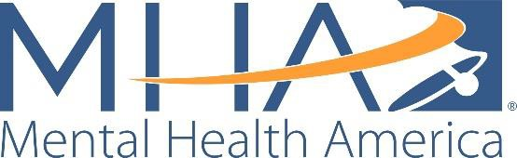
500 Montgomery Street, Suite 820
Alexandria, VA 22314-1520 www.mhanational.org
Copyright © 2020 by Mental Health America, Inc.

Table of Contents

05 Ranking Overview and Guidelines 09 State Rankings
14 Trend Infographics
18 Adult Prevalence of Mental Illness
21 Youth Prevalence of Mental Illness
24 Adult Access to Care
28 Youth Access to Care
- Mental Health Workforce Availability
- COVID-19 and Mental Health: 2020 Data
49 Glossary

MHA is committed to promoting mental health as a critical part of overall wellness. We advocate for prevention services for all, early identification and intervention for those at risk, integrated health, behavioral health and other services for those who need them, with recovery as the goal. We believe that gathering and providing up- to-date data and information about disparities faced by individuals with mental health problems is a tool for change.
Our report is a collection of data across all 50 states and the District of Columbia that seeks to answer the following questions:
- How many adults and youth have mental health issues?
- How many adults and youth have substance use issues?
- How many adults and youth have access to insurance?
- How many adults and youth have access to adequate insurance?
- How many adults and youth have access to mental health care?
- Which states have higher barriers to accessing mental health care?

Our Goal:

- To provide a snapshot of mental health status among youth and adults for policy and program planning, analysis, and evaluation;
- To track changes in prevalence of mental health issues and access to mental health care;
- To understand how changes in national data reflect the impact of legislation and policies; and
- To increase dialogue with and improve outcomes for individuals and families with mental health needs.

Why Gather this Information?

- Using national survey data allows us to measure a community’s mental health needs, access to care, and outcomes regardless of the differences between the states and their varied mental health policies.
- Rankings explore which states are more effective at addressing issues related to mental health and substance use.
- Analysis may reveal similarities and differences among states to begin assessing how federal and state mental health policies result in more or less access to care.

Ranking Overview and Guidelines
This chart book presents a collection of data that provides a baseline for answering some questions about how many people in America need and have access to mental health services. This report is a companion to the online interactive data on the MHA website (https://www.mhanational.org/issues/state-mental-health-america). The data and tables include state and national data and sharable infographics.

MHA Guidelines
Given the variability of data, MHA developed guidelines to identify mental health measures that are most appropriate for inclusion in our ranking. Indicators were chosen that met the following guidelines:
- Data that are publicly available and as current as possible to provide up-to-date results.
- Data that are available for all 50 states and the District of Columbia.
- Data for both adults and youth.
- Data that captured information regardless of varying utilization of the private and public mental health system.
- Data that could be collected over time to allow for analysis of future changes and trends.

Our 2021 Measures
- Adults with Any Mental Illness (AMI)
- Adults with Substance Use Disorder in the Past Year
- Adults with Serious Thoughts of Suicide
- Youth with At Least One Major Depressive Episode (MDE) in the Past Year
- Youth with Substance Use Disorder in the Past Year
- Youth with Severe MDE
- Adults with AMI who Did Not Receive Treatment
- Adults with AMI Reporting Unmet Need
- Adults with AMI who are Uninsured
- Adults with Cognitive Disability who Could Not See a Doctor Due to Costs
- Youth with MDE who Did Not Receive Mental Health Services
- Youth with Severe MDE who Received Some Consistent Treatment
- Children with Private Insurance that Did Not Cover Mental or Emotional Problems
- Students Identified with Emotional Disturbance for an Individualized Education Program
- Mental Health Workforce Availability

A Complete Picture
While the above 15 measures are not a complete picture of the mental health system, they do provide a strong foundation for understanding the prevalence of mental health concerns, as well as issues of access to insurance and treatment, particularly as that access varies among the states. MHA will continue to explore new measures that allow us to capture more accurately and comprehensively the needs of those with mental illness and their access to care.

Ranking
To better understand the rankings, it is important to compare similar states.

Factors to consider include geography and size. For example, California and New York are similar. Both are large states with densely populated cities. They are less comparable to less populous states like South Dakota North Dakota, Alabama, or Wyoming. Keep in mind that size of states and populations matter, both New York City and Los Angeles alone have more residents than North Dakota, South Dakota, Alabama, and Wyoming combined.

The rankings are based on the percentages, or rates, for each state collected from the most recently available data. For most indicators, the data represent data collected up to 2018. States with positive outcomes are ranked higher (closer to 1) than states with poorer outcomes. The overall, adult, youth, prevalence, and access rankings were analyzed by calculating a standardized score (Z score) for each measure and ranking the sum of the standardized scores. For most measures, lower percentages equated to more positive outcomes (e.g. lower rates of substance use or those who are uninsured). There are two measures where high percentages equate to better outcomes. These include Youth with Severe MDE (Major Depressive Episode) who Received Some Consistent Treatment, and Students Identified with Emotional Disturbance for an Individualized Education Program. Here, the calculated standardized score was multiplied by -1 to obtain a Reverse Z Score that was used in the sum. All measures were considered equally important, and no weights were given to any measure in the rankings.
Along with calculated rankings, each measure is ranked individually with an accompanying chart and table. The table provides the percentage and estimated population for each ranking. The estimated population number is weighted and calculated by the agency conducting the applicable federal survey. The ranking is based on the Z scores. Data are presented with 2 decimal places when available.
The measure Adults with Disability who Could Not See a Doctor Due to Costs was previously calculated using the Behavioral Risk Factor Surveillance System (BRFSS) question: “Are you limited in any way in any activities because of physical, mental or emotional problems?” (QLACTLM2). The QLACTLM2 question was removed from the BRFSS questionnaire after 2016, and therefore could not be calculated using 2018 BRFSS data. For this report, the indicator was amended to Adults with Cognitive Disability who Could Not See a Doctor Due to Costs, using the BRFSS question: “Because of a physical, mental, or emotional condition, do you have serious difficulty concentrating, remembering, or making decisions?” (DECIDE). This indicator likely serves as a better measure for individuals who experience disability tied to mental, cognitive or emotional problems, as it is less likely to include people who experience limitations due to a physical disability and is therefore a more sensitive measure for the population we are attempting to count.
For the measure Students Identified with Emotional Disturbance for an Individualized Education Program, due to data suppression because of quality, the 2016-2018 figures for Wisconsin were not available. This report notes the 2015 figure for Wisconsin.

Survey Limitations
Each survey has its own strengths and limitations. For example, strengths of both SAMHSA’s National Survey of Drug Use and Health (NSDUH) and the CDC’s Behavioral Risk Factor Surveillance System (BRFSS) are that they include national survey data with large sample sizes and utilized statistical modeling to provide weighted estimates of each state population. This means that the data is more representative of the general population. An example limitation of particular importance to the mental health community is that the NSDUH does not collect information from persons who are homeless and who do not stay at shelters, are active duty military personnel, or are institutionalized (i.e., in jails or hospitals). This limitation means that those individuals who have a mental illness who are also homeless or incarcerated are not represented in the data presented by the NSDUH. If the data did include individuals who were homeless and/or incarcerated, we would possibly see prevalence of behavioral health issues increase and access to treatment rates worsen. It is MHA’s goal to continue to search for the best possible data in future reports. Additional information on the methodology and limitations of the surveys can be found online as outlined in the glossary.
In addition, these data were gathered through 2018. This means that they are the most current data reported by the states and available to the public. They are most useful in providing some comparative baselines in the states for the needs and systems that were in place prior to the COVID-19 pandemic and the increased awareness of ongoing racial injustices in the nation in 2020. MHA regularly reports on its real-time data gathered from more than 6 million completed mental health screenings (through August 2020), featured in the Spotlight of this report. Based on these screening results from a help-seeking population, and both U.S. Census Bureau 2020 Pulse Survey data, which included brief depression and anxiety screening questions, and survey data reported by the Centers for Disease Control and Prevention (CDC), it appears that (1) the data in this report likely under-reports the current prevalence of mental illnesses in the population, both among children and adults, (2) higher-ranked states may have been better prepared to deal with the mental health effects of the pandemic at its start, and (3) because of its nationwide effect, nothing in the pandemic by itself would suggest that the relative rankings of the states would have changed solely because of the pandemic.

Major Findings
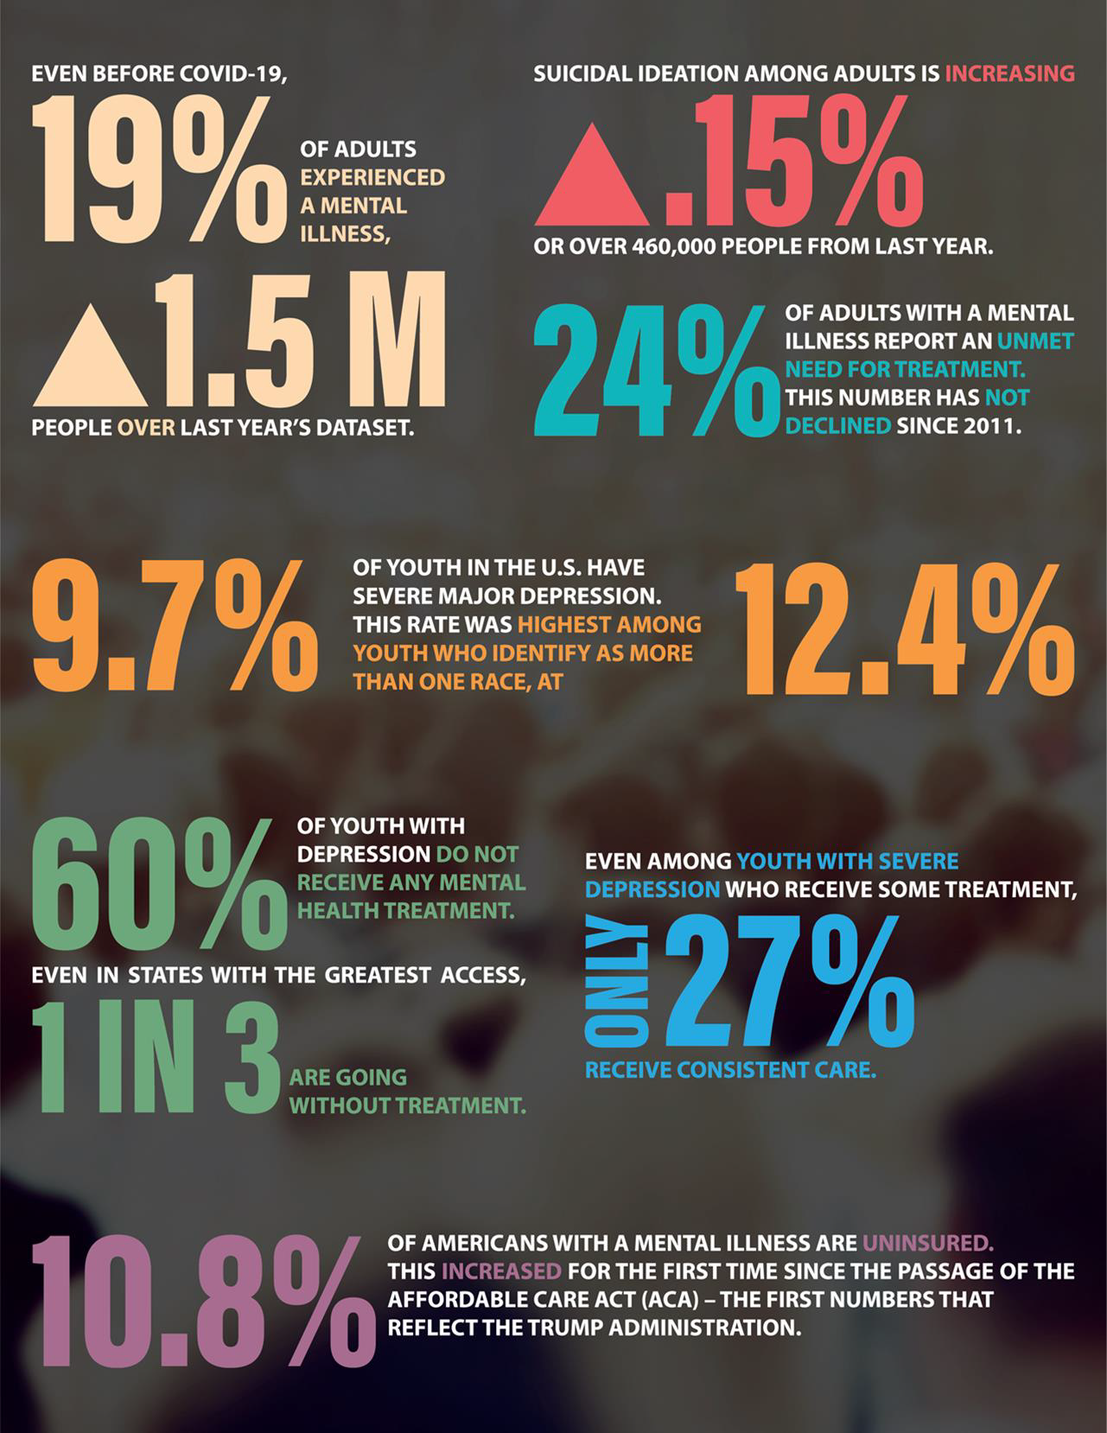

Overall Ranking
State |  | Rank
Vermont |  | 1
Pennsylvania |  | 2
Massachusetts |  | 3
Maryland |  | 4
New Jersey |  | 5
New York |  | 6
Minnesota |  | 7
Hawaii |  | 8
District of Columbia |  | 9
Delaware |  | 10
Ohio |  | 11
Rhode Island |  | 12
Connecticut |  | 13
Maine |  | 14
Michigan |  | 15
South Dakota |  | 16
Kentucky |  | 17
New Hampshire |  | 18
Wisconsin |  | 19
Nebraska |  | 20
Louisiana |  | 21
Illinois |  | 22
Iowa |  | 23
North Dakota |  | 24
California |  | 25
Virginia |  | 26
Texas |  | 27
Tennessee |  | 28
Kansas |  | 29
Montana |  | 30
Washington |  | 31
Mississippi |  | 32
Indiana |  | 33
New Mexico |  | 34
Florida |  | 35
Alabama |  | 36
Georgia |  | 37
Missouri |  | 38
West Virginia |  | 39
Arizona |  | 40
North Carolina |  | 41
Arkansas |  | 42
South Carolina |  | 43
Wyoming |  | 44
Oklahoma |  | 45
Utah |  | 46
Colorado |  | 47
Oregon |  | 48
Alaska |  | 49
Idaho |  | 50
Nevada |  | 51

An overall ranking 1-13 indicates lower prevalence of mental illness and higher rates of access to care. An overall ranking 39-51 indicates higher prevalence of mental illness and lower rates of access to care. The combined scores of all 15 measures make up the overall ranking. The overall ranking includes both adult and youth measures as well as prevalence and access to care measures.

The 15 measures that make up the overall ranking include:
- Adults with Any Mental Illness (AMI)
- Adults with Substance Use Disorder in the Past Year
- Adults with Serious Thoughts of Suicide
- Youth with At Least One Major Depressive Episode (MDE) in the Past Year
- Youth with Substance Use Disorder in the Past Year
- Youth with Severe MDE

- Adults with AMI who Did Not Receive Treatment
- Adults with AMI Reporting Unmet Need
- Adults with AMI who are Uninsured
- Adults with Cognitive Disability who Could Not See a Doctor Due to Costs
- Youth with MDE who Did Not Receive Mental Health Services
- Youth with Severe MDE who Received Some Consistent Treatment
- Children with Private Insurance that Did Not Cover Mental or Emotional Problems
- Students Identified with Emotional Disturbance for an Individualized Education Program
- Mental Health Workforce Availability

The chart is a visual representation of the sum of the scores for each state. It provides an opportunity to see the difference between ranked states. For example, Vermont (ranked 1) has a score that is higher than Rhode Island (ranked 12). South Dakota (ranked 16) has a score that is closest to the average.

15.00 10.00 5.00 0.00 -5.00 -10.00

Adult Rankings
Rank | State
1 | Hawaii
2 | New York
3 | New Jersey
4 | Minnesota
5 | Pennsylvania
6 | Michigan
7 | Maryland
8 | New Mexico
9 | Massachusetts
10 | Vermont
11 | Illinois
12 | Connecticut
13 | Delaware
14 | Ohio
15 | Texas
16 | Kentucky
17 | Arizona
18 | Tennessee
19 | Iowa
20 | South Dakota
21 | California
22 | Nebraska
23 | North Dakota
24 | Wisconsin
25 | Florida
26 | Rhode Island
27 | West Virginia
28 | New Hampshire
29 | Virginia
30 | Arkansas
31 | Maine
32 | South Carolina
33 | Louisiana
34 | Montana
35 | North Carolina
36 | District of Columbia
37 | Washington
38 | Kansas
39 | Indiana
40 | Alabama
41 | Oklahoma
42 | Nevada
43 | Georgia
44 | Missouri
45 | Mississippi
46 | Wyoming
47 | Idaho
48 | Colorado
49 | Oregon
50 | Alaska
51 | Utah

States that are ranked 1-13 have lower prevalence of mental illness and higher rates of access to care for adults. States that are ranked 39-51 indicate that adults have higher prevalence of mental illness and lower rates of access to care.

The 7 measures that make up the Adult Ranking include:
- Adults with Any Mental Illness (AMI)
- Adults with Substance Use Disorder in the Past Year
- Adults with Serious Thoughts of Suicide
- Adults with AMI who Did Not Receive Treatment
- Adults with AMI Reporting Unmet Need
- Adults with AMI who are Uninsured
- Adults with Cognitive Disability who Could Not See a Doctor Due to Costs

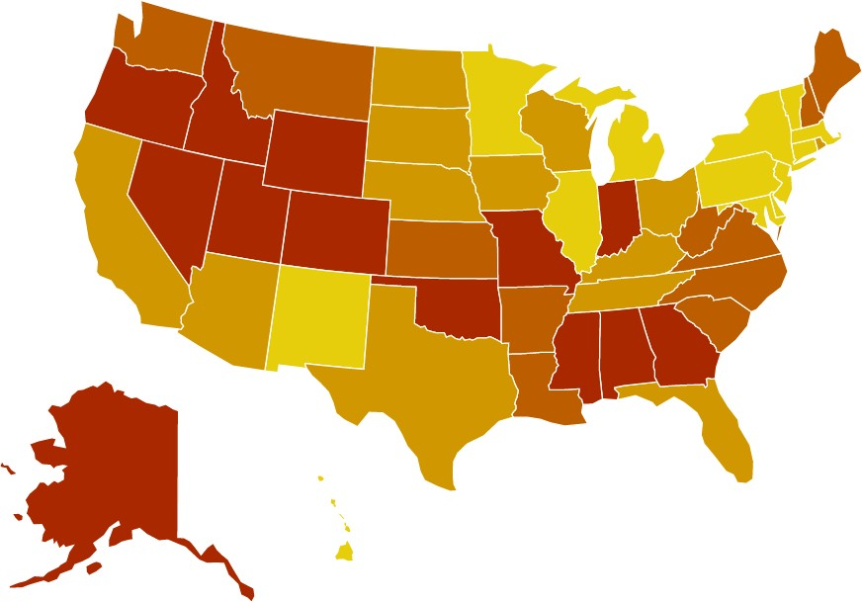

Youth Rankings
Rank | State
1 | Vermont
2 | Pennsylvania
3 | District of Columbia
4 | Maryland
5 | Massachusetts
6 | New Jersey
7 | Rhode Island
8 | Delaware
9 | Maine
10 | Minnesota
11 | Ohio
12 | New York
13 | South Dakota
14 | New Hampshire
15 | Wisconsin
16 | Louisiana
17 | Connecticut
18 | Mississippi
19 | Kentucky
20 | Virginia
21 | Nebraska
22 | Iowa
23 | Hawaii
24 | Alabama
25 | North Dakota
26 | Kansas
27 | Michigan
28 | Indiana
29 | Georgia
30 | Texas
31 | Missouri
32 | Utah
33 | California
34 | Tennessee
35 | Washington
36 | Illinois
37 | Montana
38 | Florida
39 | West Virginia
40 | Alaska
41 | Oregon
42 | Colorado
43 | Wyoming
44 | South Carolina
45 | North Carolina
46 | Oklahoma
47 | Arkansas
48 | Idaho
49 | Arizona
50 | New Mexico
51 | Nevada

States with rankings 1-13 have lower prevalence of mental illness and higher rates of
access to care for youth. States with rankings 39-51 indicate that youth have higher prevalence of mental illness and lower rates of access to care.

The 7 measures that make up the Youth Ranking include:
- Youth with At Least One Major Depressive Episode (MDE) in the Past Year
- Youth with Substance Use Disorder in the Past Year
- Youth with Severe MDE
- Youth with MDE who Did Not Receive Mental Health Services
- Youth with Severe MDE who Received Some Consistent Treatment
- Children with Private Insurance that Did Not Cover Mental or Emotional Problems
- Students Identified with Emotional Disturbance for an Individualized Education Program
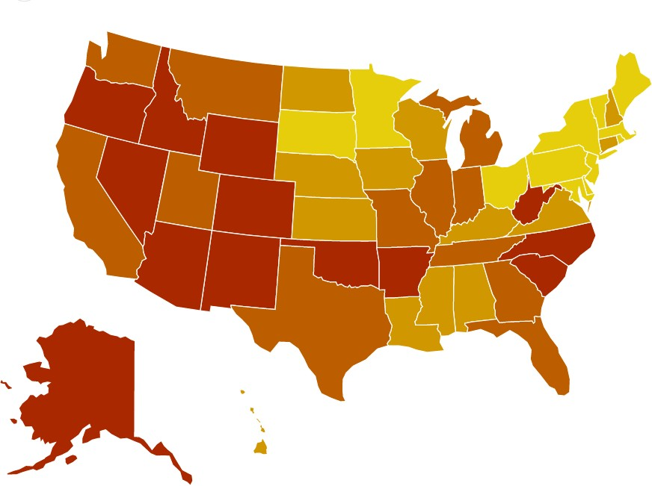

Prevalence of Mental Illness
Rank | State
1 | New Jersey
2 | Texas
3 | New York
4 | Pennsylvania
5 | Georgia
6 | Maryland
7 | Mississippi
8 | Florida
9 | Tennessee
10 | Hawaii
11 | Alabama
12 | Virginia
13 | Nebraska
14 | California
15 | South Dakota
16 | Minnesota
17 | South Carolina
18 | Louisiana
19 | Illinois
20 | Connecticut
21 | Michigan
22 | Kansas
23 | Kentucky
24 | North Carolina
25 | Delaware
26 | North Dakota
27 | Ohio
28 | Rhode Island
29 | Missouri
30 | Massachusetts
31 | Arkansas
32 | Arizona
33 | New Hampshire
34 | District of Columbia
35 | Wyoming
36 | Iowa
37 | Indiana
38 | New Mexico
39 | Wisconsin
40 | Oklahoma
41 | West Virginia
42 | Montana
43 | Nevada
44 | Alaska
45 | Maine
46 | Washington
47 | Utah
48 | Colorado
49 | Idaho
50 | Vermont
51 | Oregon

The scores for the six prevalence measures make up the Prevalence Ranking. The 6 measures that make up the Prevalence Ranking include:
  - Adults with Any Mental Illness (AMI)
  - Adult with Substance Use Disorder in the Past Year
  - Adults with Serious Thoughts of Suicide
  - Youth with At Least One Major Depressive Episode (MDE) in the Past Year
  - Youth with Substance Use Disorder in the Past Year
  - Youth with Severe MDE
A ranking 1-13 for Prevalence indicates a lower prevalence of mental health and substance use issues compared to states that ranked 39-51.

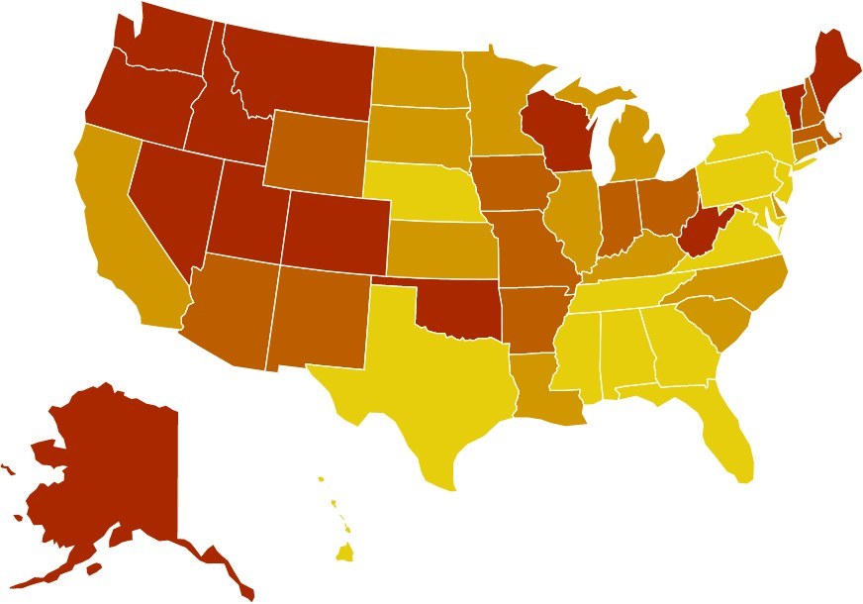

Access to Care Rankings
Rank | State
1 | Vermont
2 | Massachusetts
3 | Maine
4 | District of Columbia
5 | Delaware
6 | Minnesota
7 | Wisconsin
8 | Rhode Island
9 | Ohio
10 | New Hampshire
11 | Maryland
12 | Pennsylvania
13 | Connecticut
14 | Hawaii
15 | Iowa
16 | Washington
17 | Michigan
18 | Kentucky
19 | Montana
20 | New York
21 | Oregon
22 | South Dakota
23 | New Jersey
24 | North Dakota
25 | New Mexico
26 | Indiana
27 | Louisiana
28 | Illinois
29 | Nebraska
30 | West Virginia
31 | Colorado
32 | Utah
33 | Oklahoma
34 | California
35 | Idaho
36 | Kansas
37 | Alaska
38 | Wyoming
39 | Virginia
40 | Arizona
41 | Missouri
42 | Arkansas
43 | Tennessee
44 | North Carolina
45 | South Carolina
46 | Nevada
47 | Alabama
48 | Florida
49 | Mississippi
50 | Texas
51 | Georgia

The Access Ranking indicates how much access to mental health care exists within a state. The access measures include access to insurance, access to treatment, quality and cost of insurance, access to special education, and mental health workforce availability. A high Access Ranking (1-13) indicates that a state provides relatively more access to insurance and mental health treatment.

The 9 measures that make up the Access Ranking include:

- Adults with AMI who Did Not Receive Treatment
- Adults with AMI Reporting Unmet Need
- Adults with AMI who are Uninsured
- Adults with Cognitive Disability who Could Not See a Doctor Due to Costs
- Youth with MDE who Did Not Receive Mental Health Services
- Youth with Severe MDE who Received Some Consistent Treatment
- Children with Private Insurance that Did Not Cover Mental or Emotional Problems
- Students Identified with Emotional Disturbance for an Individualized Education Program
- Mental Health Workforce Availability

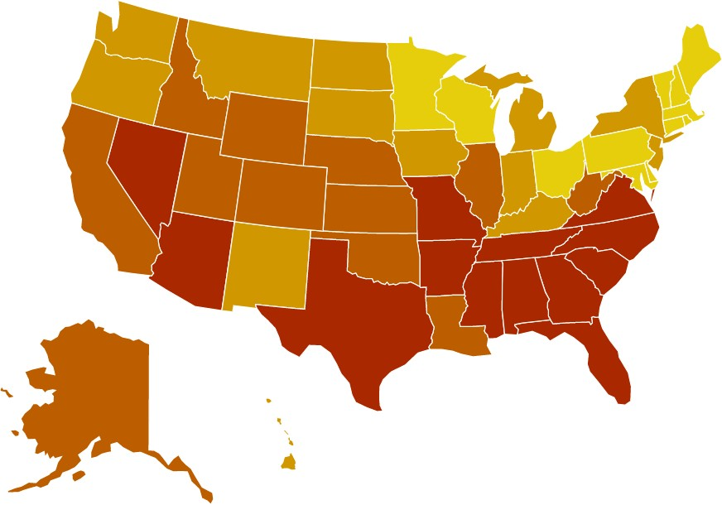

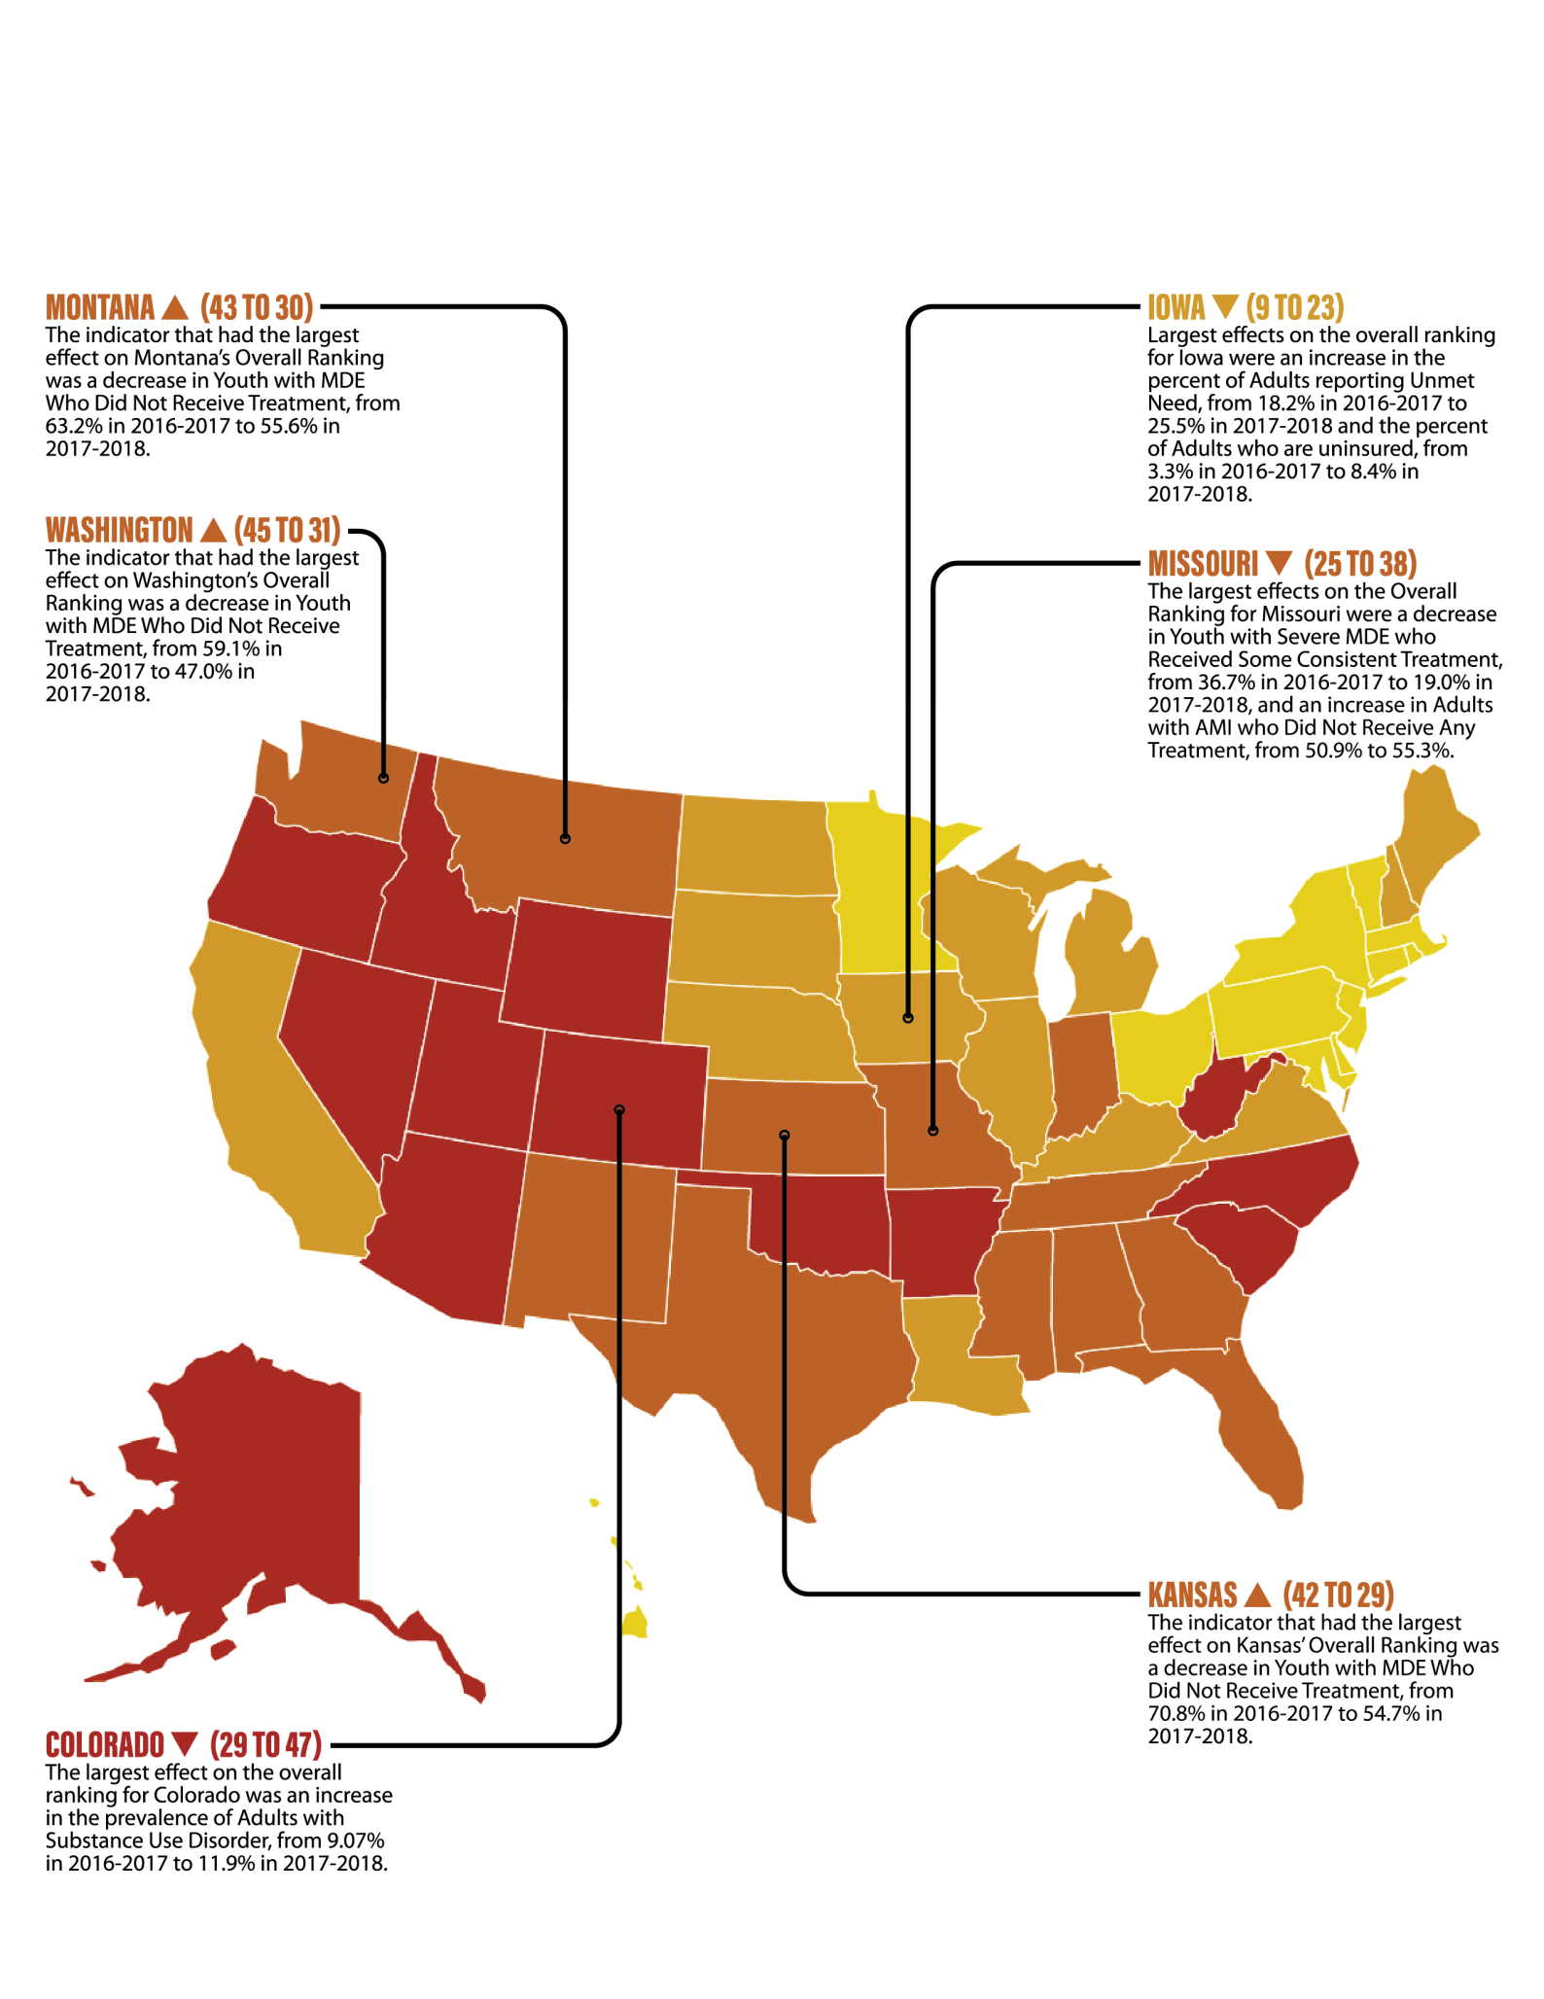Largest Changes in Overall Ranking: 2020-2021

Changes in Overall Ranking: State of Mental Health in America 2020-2021
State | Overall  Ranking (2020)* | Overall  Ranking (2021)*
Alabama | 40 | 36
Alaska | 46 | 49
Arizona | 28 | 40
Arkansas | 33 | 42
California | 22 | 25
Colorado | 29 | 47
Connecticut | 10 | 13
Delaware | 11 | 10
District of Columbia | 16 | 9
Florida | 32 | 35
Georgia | 36 | 37
Hawaii | 12 | 8
Idaho | 49 | 50
Illinois | 20 | 22
Indiana | 26 | 33
Iowa | 9 | 23
Kansas | 42 | 29
Kentucky | 21 | 17
Louisiana | 30 | 21
Maine | 19 | 14
Maryland | 5 | 4
Massachusetts | 7 | 3
Michigan | 17 | 15
Minnesota | 6 | 7
Mississippi | 34 | 32
Missouri | 25 | 38

State | Overall  Ranking (2020)* | Overall  Ranking (2021)*
Montana | 43 | 30
Nebraska | 23 | 20
Nevada | 51 | 51
New Hampshire | 14 | 18
New Jersey | 8 | 5
New Mexico | 31 | 34
New York | 2 | 6
North Carolina | 35 | 41
North Dakota | 15 | 24
Ohio | 18 | 11
Oklahoma | 41 | 45
Oregon | 50 | 48
Pennsylvania | 1 | 2
Rhode Island | 4 | 12
South Carolina | 44 | 43
South Dakota | 24 | 16
Tennessee | 39 | 28
Texas | 38 | 27
Utah | 48 | 46
Vermont | 3 | 1
Virginia | 27 | 26
Washington | 45 | 31
West Virginia | 37 | 39
Wisconsin | 13 | 19
Wyoming | 47 | 44

*2020 Overall Ranking is taken from the State of Mental Health in America 2020 Report, based on data from 2016-2017. 2021 Overall Ranking is taken from this report, based on data from 2017-2018.

Largest Changes in Adult Rankings: State of Mental Health in America 2020-2021

  - Mississippi (29 to 45): The largest effect on the adult ranking for Mississippi was an increase in the prevalence of Adults with Suicidal Ideation, from 4.01% in 2016-2017 to 4.82% in 2017-2018.
  - Alabama (25 to 40): The largest effect on the adult ranking for Alabama was an increase in the rate of Adults with AMI Reporting Unmet Need, from 14.3% in 2016-2017 to 18.7% in 2017-2018.

- Texas (30 to 15): The indicator that had the largest effect on Texas’ rise in Adult Rankings was a decrease in Adults with Cognitive Disability Who Could Not See a Doctor Due to Cost, from 41.03% in 2016-2017 to 34.57% in 2017- 2018.
- Kentucky (32 to 16): For the Adult Ranking, Kentucky had the largest improvement in Adults with AMI Who Did Not Receive Any Mental Health Treatment, from 55.0% in 2016-2017 to 50.9% in 2017-2018.

Largest Changes in Youth Rankings: State of Mental Health in America 2020-2021

  - North Dakota (3 to 25): The largest effects on the Youth ranking for North Dakota were an increase in Youth with Private Insurance that Did Not Cover Mental or Emotional Problems, from 8.5% in 2016-2017 to 13.5% in 2017- 2018, and an increase in the prevalence of Youth with Severe MDE, from 6.0% to 8.5%.
  - Arizona (30 to 49): The largest effects on the Youth ranking for Arizona were an increase in the prevalence of Youth with Severe MDE, from 8.9% in 2016-2017 to 12.5% in 2017-2018, and an increase in Youth with a Past Year MDE, from 13.06% to 15.93%.

- Nebraska (35 to 21): The largest improvement for Nebraska in terms of Youth Ranking was in the indicator Youth with MDE Who Did Not Receive Treatment, from 71.3% in 2016-2017 to 55.4% in 2017-2018.
- Maine (22 to 9): The largest effects on the Youth ranking for Maine were an increase in Youth with Severe MDE Who Received Some Consistent Treatment, from 41.3% in 2016-2017 to 50.0% in 2017-2018, and a decrease in Youth with MDE Who Did Not Receive Treatment, from 45.3% to 38.6%.

Largest Changes in Need/Prevalence Ranking: 2020-2021

  - Oklahoma (25 to 40): The largest effect on the Need/Prevalence Ranking for Oklahoma was an increase in Youth with Severe MDE, from 8.4% in 2016-2017 to 12.7% in 2017-2018.
  - North Carolina (10 to 24): The largest effects on the Need/Prevalence Ranking for North Carolina were an increase in Youth with Past Year MDE, from 12.03% in 2016- 2017 to 15.05% in 2017-2018, and an increase in Youth with Severe MDE, from 9.8% to 12.6%.

- South Dakota (29 to 15): South Dakota’s largest improvements in Need/Prevalence Ranking were decreases in the indicators Adults with Substance Use Disorder, which decreased from 9.56% in 2016-2017 to 9.17% in 2017-2018, and Adults with Serious Thoughts of Suicide, from 4.40% to 4.21%.
- Tennessee (22 to 9): The largest effect on the Need/Prevalence Ranking for Tennessee was an improvement in the rate of Youth with Severe MDE, from 10.4% in 2016-2017 to 9.2% in 2017-2018.
- Massachusetts (42 to 30): In Massachusetts, the largest improvements in Need/Prevalence Ranking were decreases in the rate of Youth with Severe MDE, which decreased from 10.5% in 2016-2017 to 8.5% in 2017-2018, and Adults with Substance Use Disorder, from 10.13% to 9.34%

Largest Changes in Access to Care Ranking: 2020-2021

  - Missouri (26 to 41): The largest effects on the Access to Care Ranking for Missouri were a decrease in Youth with Severe MDE who Received Some Consistent Treatment, from 36.7% in 2016-2017 to 19.0% in 2017-2018, and an increase in Adults with AMI who Did Not Receive Any Treatment, from 50.9% to 55.3%.
  - Colorado (17 to 31): The largest effect on the Access to Care Ranking for Colorado was an increase in Adults with AMI who Report Unmet Need for Treatment, from 22.2% in 2016-2017 to 28.2% in 2017-2018.

- Louisiana (30 to 15): (41 to 27): Louisiana’s largest improvements in Access to Care Ranking were a decrease in Youth with Private Insurance That Did Not Cover Mental or Emotional Problems, from 16.5% to 7.6%; a decrease in Adults with Cognitive Disability Who Could Not See a Doctor Due to Cost, from 38.23% to 28.08%; and a decrease in Adults with AMI Who are Uninsured, from 14.7% to 9.7%.
- Kentucky (31 to 18): The largest effect on the Access to Care Ranking for Kentucky was an improvement in Youth with MDE Who Did Not Receive Treatment, from 62.0% in 2016-2017 to 49.3% in 2017-2018.

Adult Prevalence of Mental Illness

Adults with Any Mental Illness (AMI)
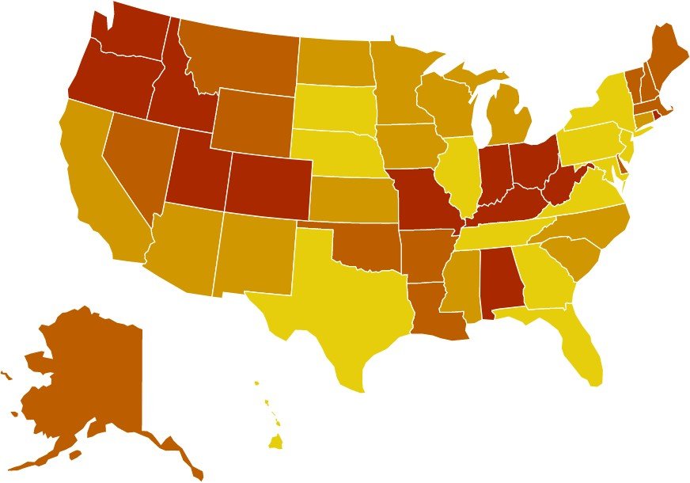
19.00 percent of adults are experiencing
a mental illness.

Equivalent to over 47 million
Americans.

4.55 percent are experiencing a severe
mental illness.
The state prevalence of adult
mental illness ranges from:
16.14% (NJ)
Ranked 1-13
25.25 % (UT) Ranked 39-51

Rank | State | % | #
1 | New Jersey | 16.14 | 1,112,000
2 | Texas | 16.21 | 3,347,000
3 | Maryland | 16.96 | 781,000
4 | Virginia | 17.38 | 1,115,000
5 | Florida | 17.39 | 2,889,000
6 | South Dakota | 17.49 | 112,000
7 | Hawaii | 17.58 | 187,000
8 | Illinois | 18.06 | 1,754,000
9 | Nebraska | 18.08 | 257,000
10 | Georgia | 18.09 | 1,405,000
11 | Pennsylvania | 18.23 | 1,814,000
12 | New York | 18.25 | 2,802,000
13 | Tennessee | 18.26 | 937,000
14 | South Carolina | 18.31 | 706,000
15 | California | 18.54 | 5,566,000
16 | North Carolina | 18.77 | 1,469,000
17 | Connecticut | 19.03 | 531,000
18 | Michigan | 19.07 | 1,469,000
19 | New Mexico | 19.10 | 300,000
20 | North Dakota | 19.13 | 108,000
21 | Arizona | 19.24 | 1,030,000
22 | Wisconsin | 19.26 | 859,000
23 | Minnesota | 19.32 | 819,000
24 | Mississippi | 19.49 | 431,000
25 | Kansas | 19.59 | 420,000
26 | Iowa | 19.89 | 473,000

Rank | State | % | #
27 | Montana | 20.00 | 163,000
28 | Delaware | 20.03 | 149,000
29 | Arkansas | 20.27 | 457,000
30 | Wyoming | 20.34 | 88,000
31 | Oklahoma | 20.43 | 592,000
32 | Alaska | 20.50 | 108,000
33 | New Hampshire | 20.56 | 221,000
34 | Louisiana | 20.63 | 715,000
35 | Vermont | 20.65 | 104,000
36 | Nevada | 20.67 | 474,000
37 | Maine | 20.82 | 223,000
38 | Massachusetts | 21.22 | 1,155,000
39 | Rhode Island | 21.32 | 178,000
40 | Alabama | 21.39 | 794,000
41 | Ohio | 21.40 | 1,906,000
42 | Missouri | 21.44 | 993,000
43 | Colorado | 21.50 | 924,000
44 | Kentucky | 22.14 | 746,000
45 | District of Columbia | 22.21 | 125,000
46 | Washington | 22.23 | 1,269,000
47 | Oregon | 22.45 | 731,000
48 | Indiana | 22.51 | 1,129,000
49 | West Virginia | 23.80 | 337,000
50 | Idaho | 24.46 | 311,000
51 | Utah | 25.25 | 550,000
 | National | 19.00 | 47,132,000

According to SAMHSA, “Any Mental Illness (AMI) is defined as having a diagnosable mental, behavioral, or emotional disorder, other than a developmental or substance use disorder, assessed by the Mental Health Surveillance Study (MHSS) Structured Clinical Interview for the Diagnostic and Statistical Manual of Mental Disorders—Fourth Edition—Research Version—Axis I Disorders (MHSS-SCID), which is based on the 4th edition of the Diagnostic and Statistical Manual of Mental Disorders (DSM-IV).”

Adults with Substance Use Disorder in the Past Year

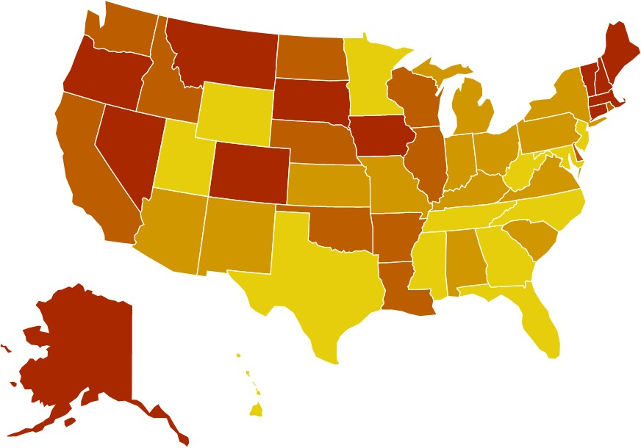
7.67 percent of adults in America reported having a substance use disorder in the past year.
2.87 percent of adults in America reported having an illicit drug use disorder in the past year.

5.74 percent of adults in America reported having an alcohol use disorder in the past year.

The state prevalence of adults with substance use disorder ranges from:
States in the southeast had the lowest rates of substance use disorder among adults (less than 8 percent), with the exception of Louisiana.
The largest increases in prevalence of adults with substance use disorder were in Colorado
(2.83%) and the District of Columbia (1.46%).

6.34% (TX)
Ranked 1-13
13.01% (D.C.)
Ranked 39-51
The largest decreases were in Maryland (1.00%) and Wyoming (0.80%)

Rank | State | % | #
1 | Texas | 6.34 | 1,308,000
2 | Utah | 6.42 | 140,000
3 | Florida | 6.68 | 1,109,000
4 | West Virginia | 6.76 | 96,000
5 | Georgia | 6.77 | 526,000
6 | Mississippi | 6.77 | 150,000
7 | Maryland | 6.89 | 317,000
8 | North Carolina | 6.95 | 544,000
9 | Tennessee | 6.95 | 357,000
10 | New Jersey | 7.01 | 483,000
11 | Hawaii | 7.13 | 76,000
12 | Minnesota | 7.24 | 307,000
13 | Wyoming | 7.25 | 31,000
14 | Kansas | 7.27 | 156,000
15 | Pennsylvania | 7.30 | 727,000
16 | Virginia | 7.32 | 470,000
17 | Arizona | 7.36 | 394,000
18 | Indiana | 7.39 | 371,000
19 | Kentucky | 7.46 | 251,000
20 | Alabama | 7.46 | 277,000
21 | Michigan | 7.47 | 576,000
22 | New Mexico | 7.53 | 118,000
23 | New York | 7.57 | 1,162,000
24 | Missouri | 7.57 | 351,000
25 | South Carolina | 7.60 | 293,000
26 | Ohio | 7.64 | 680,000

Rank | State | % | #
27 | Idaho | 7.76 | 99,000
28 | Nebraska | 8.01 | 114,000
29 | Arkansas | 8.02 | 181,000
30 | California | 8.12 | 2,437,000
31 | Illinois | 8.16 | 793,000
32 | Washington | 8.53 | 487,000
33 | Oklahoma | 8.54 | 248,000
34 | Wisconsin | 8.68 | 387,000
35 | Louisiana | 8.69 | 301,000
36 | Delaware | 8.76 | 65,000
37 | North Dakota | 8.79 | 50,000
38 | Rhode Island | 8.80 | 74,000
39 | Connecticut | 8.82 | 246,000
40 | Nevada | 9.00 | 206,000
41 | New Hampshire | 9.09 | 98,000
42 | Iowa | 9.13 | 217,000
43 | South Dakota | 9.17 | 59,000
44 | Maine | 9.27 | 99,000
45 | Massachusetts | 9.34 | 508,000
46 | Montana | 9.41 | 76,000
47 | Alaska | 9.76 | 51,000
48 | Oregon | 9.94 | 323,000
49 | Vermont | 10.51 | 53,000
50 | Colorado | 11.90 | 511,000
51 | District of Columbia | 13.01 | 73,000
 | National | 7.67 | 19,026,000

Adults with Serious Thoughts of Suicide

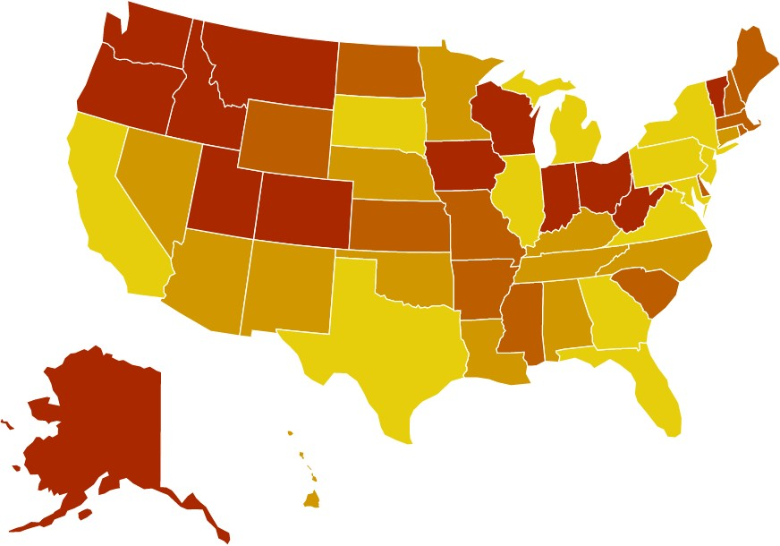
The percentage of adults reporting serious thoughts of suicide is 4.34 percent. The estimated number of adults with serious suicidal thoughts is over
10.7 million—an increase of over 460,000 people from last
year’s data set.

The state prevalence of adults with serious thoughts of suicide ranges from:

The rate of adults experiencing suicidal ideation increased by 0.15% from 2016-2017 to 2017-
2018.

States with the highest increases in suicidal ideation were Delaware (0.90%), Maine (0.82%) and Mississippi (0.81%). Utah has had the

3.47% (NJ)
Ranked 1-13
6.47% (UT)
Ranked 39-51
highest rate of suicidal ideation among adults
every year since 2012-2013.

Rank | State | % | #
1 | New Jersey | 3.47 | 239,000
2 | New York | 3.63 | 558,000
3 | Texas | 3.66 | 756,000
4 | Florida | 3.67 | 610,000
5 | Illinois | 3.87 | 376,000
6 | Georgia | 4.03 | 314,000
7 | Maryland | 4.07 | 188,000
8 | California | 4.10 | 1,232,000
9 | Michigan | 4.13 | 319,000
10 | Virginia | 4.16 | 267,000
11 | District of Columbia | 4.17 | 23,000
12 | Pennsylvania | 4.17 | 416,000
13 | South Dakota | 4.21 | 27,000
14 | New Mexico | 4.25 | 67,000
15 | Nebraska | 4.29 | 61,000
16 | Arizona | 4.43 | 237,000
17 | Alabama | 4.45 | 165,000
18 | Tennessee | 4.48 | 230,000
19 | Connecticut | 4.48 | 125,000
20 | Oklahoma | 4.53 | 132,000
21 | North Carolina | 4.57 | 358,000
22 | Louisiana | 4.57 | 159,000
23 | Minnesota | 4.59 | 195,000
24 | Hawaii | 4.59 | 49,000
25 | Kentucky | 4.65 | 157,000
26 | Nevada | 4.65 | 107,000

Rank | State | % | #
27 | Rhode Island | 4.66 | 39,000
28 | Arkansas | 4.71 | 106,000
29 | Missouri | 4.72 | 219,000
30 | Maine | 4.81 | 52,000
31 | Mississippi | 4.82 | 107,000
32 | Kansas | 4.82 | 103,000
33 | South Carolina | 4.90 | 189,000
34 | New Hampshire | 4.91 | 53,000
35 | Massachusetts | 4.92 | 268,000
36 | Wyoming | 5.04 | 22,000
37 | Delaware | 5.06 | 38,000
38 | North Dakota | 5.11 | 29,000
39 | Wisconsin | 5.17 | 231,000
40 | Ohio | 5.18 | 461,000
41 | Montana | 5.21 | 42,000
42 | Vermont | 5.22 | 26,000
43 | Indiana | 5.23 | 262,000
44 | West Virginia | 5.26 | 75,000
45 | Washington | 5.30 | 303,000
46 | Oregon | 5.36 | 175,000
47 | Iowa | 5.40 | 129,000
48 | Idaho | 5.45 | 69,000
49 | Colorado | 5.51 | 237,000
50 | Alaska | 5.85 | 31,000
51 | Utah | 6.47 | 141,000
 | National | 4.34 | 10,770,000

Youth Prevalence of Mental Illness

Youth with At Least One Major Depressive Episode (MDE) in the Past Year
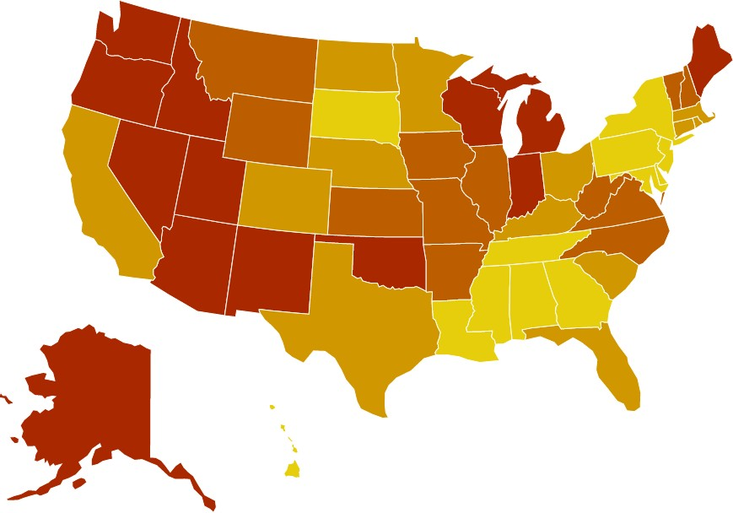
13.84 percent of youth (age 12-17) report suffering from at least one major depressive episode (MDE) in
the past year.

Childhood depression is more likely to persist into adulthood if gone untreated, but only half of children with pediatric major depression are diagnosed before
adulthood.1

The number of youths experiencing MDE increased by 206,000 from last year’s dataset.
The state prevalence of youth with MDE ranges from:

10.53% (DC)
Ranked 1-13
17.57% (OR)
Ranked 39-51

Rank | State | % | #
1 | District of Columbia | 10.53 | 3,000
2 | New York | 11.40 | 157,000
3 | Pennsylvania | 11.88 | 109,000
4 | New Jersey | 11.95 | 82,000
5 | Mississippi | 12.15 | 29,000
6 | Tennessee | 12.27 | 63,000
7 | Georgia | 12.52 | 108,000
8 | South Dakota | 12.53 | 9,000
9 | Louisiana | 12.84 | 46,000
10 | Hawaii | 12.93 | 12,000
11 | Maryland | 13.02 | 59,000
12 | Delaware | 13.05 | 9,000
13 | Alabama | 13.13 | 49,000
14 | Florida | 13.17 | 189,000
15 | Texas | 13.20 | 325,000
16 | Rhode Island | 13.40 | 10,000
17 | South Carolina | 13.56 | 51,000
18 | Kentucky | 13.61 | 46,000
19 | California | 13.71 | 415,000
20 | Ohio | 13.73 | 123,000
21 | North Dakota | 13.75 | 7,000
22 | Massachusetts | 13.86 | 67,000
23 | Colorado | 13.99 | 60,000
24 | Minnesota | 14.04 | 61,000
25 | Nebraska | 14.20 | 22,000
26 | Connecticut | 14.24 | 39,000

Rank | State | % | #
27 | Virginia | 14.28 | 90,000
28 | Montana | 14.40 | 11,000
29 | Vermont | 14.65 | 6,000
30 | West Virginia | 14.66 | 18,000
31 | Arkansas | 14.74 | 35,000
32 | Missouri | 14.78 | 69,000
33 | Illinois | 14.86 | 148,000
34 | Wyoming | 14.91 | 7,000
35 | Kansas | 14.95 | 35,000
36 | North Carolina | 15.05 | 119,000
37 | New Hampshire | 15.08 | 14,000
38 | Iowa | 15.09 | 37,000
39 | Nevada | 15.11 | 35,000
40 | Alaska | 15.21 | 9,000
41 | Wisconsin | 15.31 | 68,000
42 | Michigan | 15.36 | 117,000
43 | Maine | 15.45 | 14,000
44 | Washington | 15.66 | 85,000
45 | Indiana | 15.71 | 84,000
46 | Arizona | 15.93 | 89,000
47 | Oklahoma | 16.48 | 52,000
48 | Utah | 16.64 | 51,000
49 | Idaho | 16.70 | 26,000
50 | New Mexico | 17.43 | 29,000
51 | Oregon | 17.57 | 52,000
 | National | 13.84 | 3,449,000

1 Mullen, S. (2018). Major depressive disorder in children and adolescents. The Mental Health Clinician, 8(6):275-283. Doi: 10.9740/mhc.2018.11.275

Youth with Substance Use Disorder in the Past Year

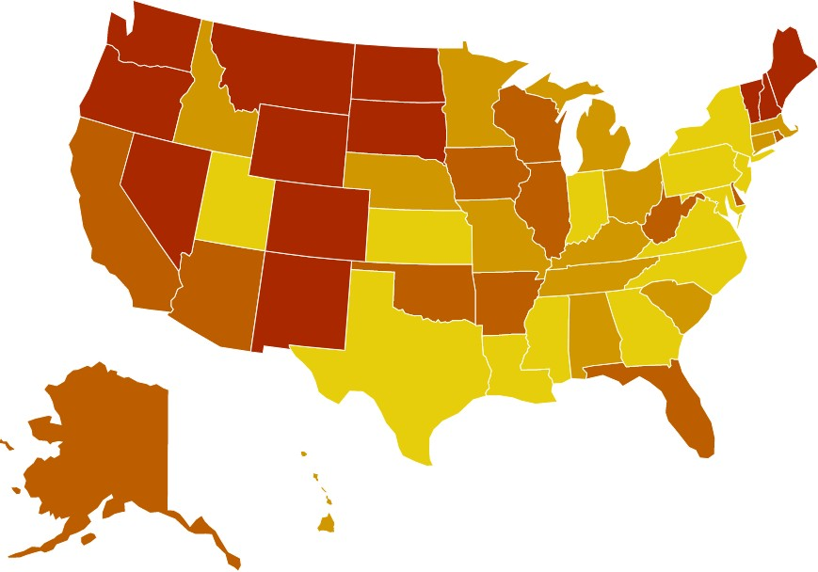3.83 percent of youth in the

The state prevalence of youth with substance use disorder ranges from:
U.S. reported a substance use disorder in the past
year.

1.69 percent had an alcohol use disorder in the past year, while 2.85 percent had an illicit drug use disorder.

3.16% (UT)
Ranked 1-13

5.61% (VT)
Ranked 39-51
The rate of youth with substance use disorder decreased 0.3 percent from last year’s dataset. The largest decreases were in Alaska (2.17%), New Mexico (1.21%) and Montana (1.12%).
The largest increases were in the District of Columbia (0.28%) and
Pennsylvania (0.23%).

Rank | State | % | #
1 | Utah | 3.16 | 10,000
2 | Georgia | 3.20 | 28,000
3 | Texas | 3.24 | 80,000
4 | Maryland | 3.26 | 15,000
5 | Mississippi | 3.30 | 8,000
6 | Indiana | 3.37 | 18,000
7 | New York | 3.41 | 47,000
8 | New Jersey | 3.42 | 23,000
9 | Pennsylvania | 3.42 | 31,000
10 | Virginia | 3.56 | 22,000
11 | North Carolina | 3.57 | 28,000
12 | Louisiana | 3.58 | 13,000
13 | Kansas | 3.63 | 9,000
14 | Alabama | 3.63 | 14,000
15 | Michigan | 3.64 | 28,000
16 | Missouri | 3.69 | 17,000
17 | Nebraska | 3.69 | 6,000
18 | Kentucky | 3.77 | 13,000
19 | Minnesota | 3.86 | 17,000
20 | Connecticut | 3.86 | 11,000
21 | Tennessee | 3.91 | 20,000
22 | Massachusetts | 3.92 | 19,000
23 | South Carolina | 3.95 | 15,000
24 | Idaho | 3.97 | 6,000
25 | Ohio | 3.97 | 36,000
26 | Hawaii | 4.04 | 4,000

Rank | State | % |  | #
27 | California |  | 4.04 | 122,000
28 | Illinois |  | 4.04 | 40,000
29 | Rhode Island |  | 4.05 | 3,000
30 | Wisconsin |  | 4.07 | 18,000
31 | Arizona |  | 4.08 | 23,000
32 | West Virginia |  | 4.08 | 5,000
33 | Arkansas |  | 4.11 | 10,000
34 | Delaware |  | 4.15 | 3,000
35 | Oklahoma |  | 4.19 | 13,000
36 | Iowa |  | 4.21 | 10,000
37 | Florida |  | 4.34 | 62,000
38 | Alaska |  | 4.37 | 3,000
39 | North Dakota |  | 4.38 | 2,000
40 | New Hampshire |  | 4.41 | 4,000
41 | Maine |  | 4.59 | 4,000
42 | Wyoming |  | 4.63 | 2,000
43 | Oregon |  | 4.65 | 14,000
44 | South Dakota |  | 4.78 | 3,000
45 | New Mexico |  | 4.80 | 8,000
46 | Washington |  | 5.01 | 27,000
47 | Nevada |  | 5.09 | 12,000
48 | Colorado |  | 5.12 | 22,000
49 | Montana |  | 5.18 | 4,000
50 | District of Columbia |  | 5.42 | 2,000
51 | Vermont |  | 5.61 | 2,000
 | National |  | 3.83 | 954,000

Youth with Severe Major Depressive Episode

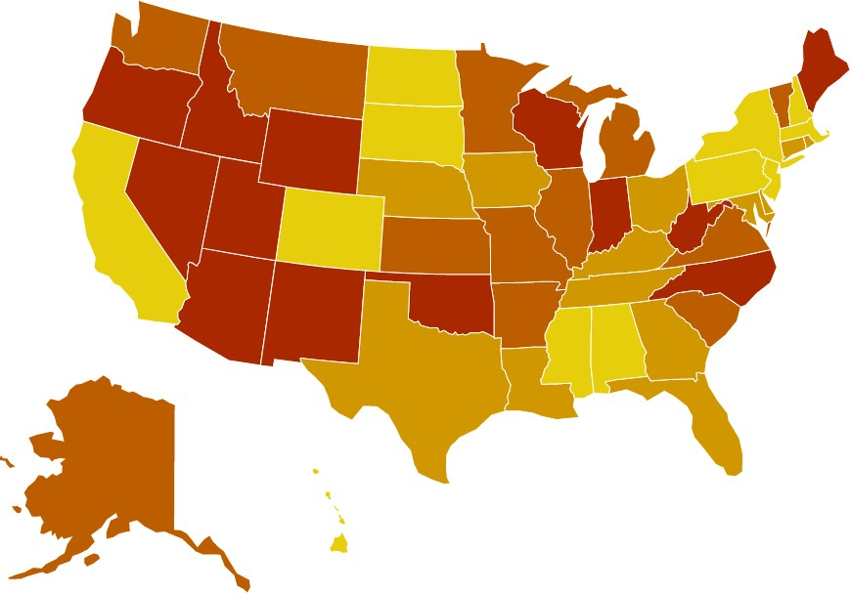
9.7 percent of youth (over 2.3 million youth) cope with severe major
depression.

The number of youths experiencing Severe MDE increased by 126,000 from last
year’s dataset.

Rates of severe major depressive episode were highest among youth who identified as more than one race, at 12.4 percent (about 98,000 youth).

The state prevalence of youth with severe MDE ranges from:

6.3% (MS)
Ranked 1-13
13.5% (ME)
Ranked 39-51

Rank | State | % | #
1 | Mississippi | 6.3 | 15,000
2 | Alabama | 6.4 | 23,000
3 | District of Columbia | 6.8 | 2,000
4 | Pennsylvania | 7.1 | 64,000
5 | New York | 7.8 | 105,000
6 | South Dakota | 8.0 | 5,000
7 | New Jersey | 8.1 | 54,000
8 | Hawaii | 8.5 | 8,000
9 | North Dakota | 8.5 | 4,000
10 | Massachusetts | 8.5 | 40,000
11 | California | 8.7 | 256,000
12 | Colorado | 8.7 | 36,000
13 | New Hampshire | 8.7 | 8,000
14 | Connecticut | 9.0 | 24,000
15 | Nebraska | 9.0 | 14,000
16 | Ohio | 9.1 | 79,000
17 | Texas | 9.2 | 219,000
18 | Louisiana | 9.2 | 33,000
19 | Tennessee | 9.2 | 46,000
20 | Florida | 9.3 | 128000
21 | Georgia | 9.3 | 78000
22 | Delaware | 9.3 | 6000
23 | Rhode Island | 9.5 | 7,000
24 | Kentucky | 9.6 | 31,000
25 | Iowa | 9.8 | 23,000
26 | Maryland | 9.8 | 42,000

Rank | State | % | #
27 | Minnesota | 9.8 | 41,000
28 | South Carolina | 9.8 | 36,000
29 | Kansas | 9.9 | 23,000
30 | Virginia | 10.2 | 62,000
31 | Washington | 10.3 | 53,000
32 | Montana | 10.4 | 8,000
33 | Missouri | 10.4 | 47,000
34 | Alaska | 10.7 | 6,000
35 | Vermont | 10.7 | 4,000
36 | Arkansas | 10.7 | 25,000
37 | Illinois | 11.0 | 104,000
38 | Michigan | 11.3 | 84,000
39 | Nevada | 11.8 | 26,000
40 | Utah | 11.9 | 36,000
41 | Wyoming | 12.0 | 5,000
42 | West Virginia | 12.5 | 15,000
43 | Arizona | 12.5 | 66,000
44 | North Carolina | 12.6 | 98,000
45 | Idaho | 12.7 | 19,000
46 | Indiana | 12.7 | 66,000
47 | Oklahoma | 12.7 | 39,000
48 | Oregon | 13.1 | 37,000
49 | New Mexico | 13.1 | 21,000
50 | Wisconsin | 13.4 | 58,000
51 | Maine | 13.5 | 12,000
 | National | 9.7 | 2,343,000

According to SAMHSA, youth who experience a Major Depressive Episode (MDE) in the last year with severe role impairment (Youth with Severe MDE) reported the maximum level of interference over four role domains including: chores at home, school or work, family
relationships, and social life.

Adult Access to Care

Adults with AMI who Did Not Receive Treatment

57 percent of adults with a mental illness receive no
treatment.

Over 26 million individuals experiencing a mental illness are going untreated.

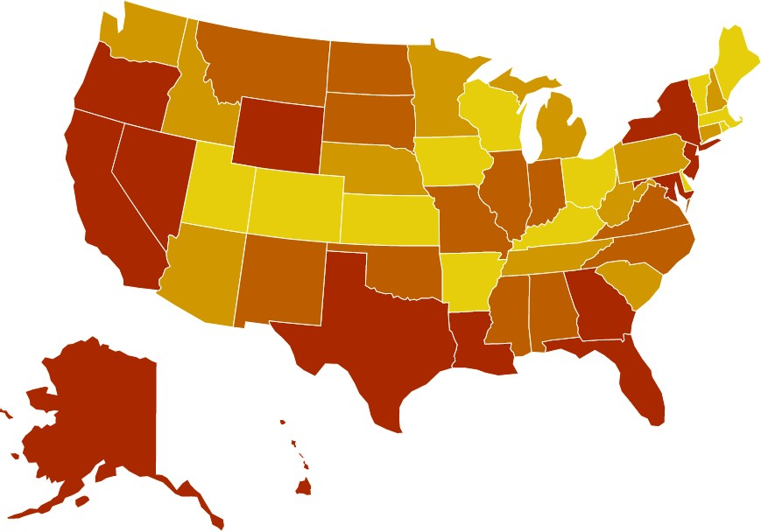
Although adults who did not have insurance coverage were less likely to receive treatment than those who did, 86 percent of people who did not receive mental health treatment were covered by health insurance, indicating that ensuring coverage is not the same as ensuring access to care.
The state prevalence of untreated adults with mental illness ranges

42.8% (VT)
Ranked 1-13
from: 65.8% (HI)
Ranked 39-51

Rank | State | % | #
1 | Vermont | 42.8 | 45,000
2 | Arkansas | 47.5 | 221,000
3 | Rhode Island | 49.0 | 89,000
4 | Wisconsin | 49.2 | 412,000
5 | Massachusetts | 49.5 | 597,000
6 | Delaware | 49.7 | 75,000
7 | Iowa | 49.8 | 231,000
8 | Maine | 49.9 | 114,000
9 | Ohio | 50.7 | 978,000
10 | Kentucky | 50.9 | 392,000
11 | Colorado | 50.9 | 475,000
12 | Kansas | 51.1 | 213,000
13 | Utah | 51.2 | 294,000
14 | South Carolina | 51.4 | 349,000
15 | Tennessee | 51.7 | 463,000
16 | New Hampshire | 51.9 | 116,000
17 | West Virginia | 52.2 | 193,000
18 | District of Columbia | 52.2 | 68,000
19 | Minnesota | 52.6 | 416,000
20 | Arizona | 52.7 | 535,000
21 | Pennsylvania | 53.0 | 953,000
22 | Nebraska | 53.0 | 128,000
23 | Washington | 53.5 | 704,000
24 | Idaho | 53.5 | 177,000
25 | Michigan | 53.8 | 779,000
26 | Connecticut | 53.9 | 287,000

Rank | State | % | #
27 | Montana | 54.2 | 89,000
28 | Virginia | 54.5 | 589,000
29 | North Dakota | 54.5 | 56,000
30 | South Dakota | 54.8 | 57,000
31 | Missouri | 55.3 | 576,000
32 | Illinois | 55.8 | 946,000
33 | Indiana | 55.9 | 653,000
34 | North Carolina | 56.5 | 833,000
35 | New Mexico | 56.6 | 167,000
36 | Alabama | 56.7 | 463,000
37 | Mississippi | 57.7 | 247,000
38 | Oklahoma | 58.9 | 340,000
39 | Maryland | 59.1 | 459,000
40 | Oregon | 59.3 | 442,000
41 | Texas | 59.6 | 1,960,000
42 | New Jersey | 60.0 | 644,000
43 | New York | 60.3 | 1,655,000
44 | Nevada | 60.3 | 282,000
45 | Louisiana | 62.0 | 459,000
46 | Florida | 63.0 | 1,816,000
47 | Wyoming | 64.8 | 60,000
48 | Georgia | 64.9 | 888,000
49 | California | 65.0 | 3,620,000
50 | Alaska | 65.5 | 70,000
51 | Hawaii | 65.8 | 124,000
 | National | 57.0 | 26,797,000

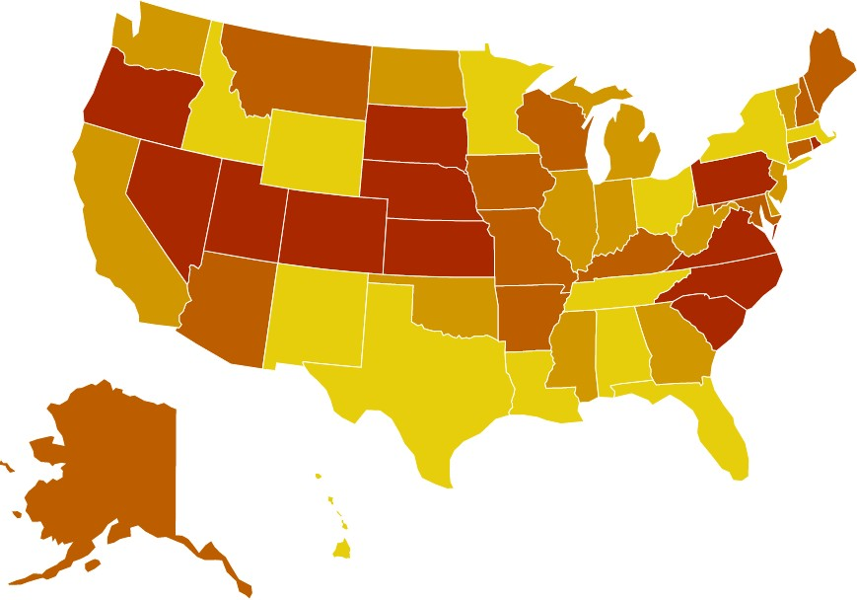
Adults with AMI Reporting Unmet Need
Almost a quarter (23.6 percent) of all adults with a mental illness reported that they were not able to receive the treatment they needed. This number has not declined since 2011.
Individuals seeking treatment but still not receiving needed services face the same barriers that contribute to the number of individuals not receiving treatment:
- No insurance or limited coverage of services.
- Shortfall in psychiatrists, and an overall undersized mental health workforce.
- Lack of available treatment types (inpatient treatment, individual therapy, intensive community services).
- Disconnect between primary care systems and behavioral health systems.

The state prevalence of adults with AMI reporting unmet treatment needs ranges

- Insufficient finances to cover costs – including
copays, uncovered treatment types, or when providers do not take insurance.
12.0% (HI)
Ranked 1-13
31.6% (KS)
Ranked 39-51

Rank | State | % | #
1 | Hawaii | 12.0 | 23,000
2 | Alabama | 18.7 | 153,000
3 | Texas | 19.9 | 655,000
4 | Wyoming | 19.9 | 18,000
5 | Minnesota | 20.7 | 163,000
6 | New Mexico | 20.8 | 61,000
7 | Tennessee | 20.9 | 188,000
8 | Louisiana | 21.0 | 155,000
9 | New York | 21.4 | 585,000
10 | Massachusetts | 21.6 | 263,000
11 | Florida | 21.9 | 633,000
12 | Ohio | 22.1 | 427,000
13 | Idaho | 22.1 | 73,000
14 | Vermont | 22.5 | 24,000
15 | California | 22.8 | 1,272,000
16 | Illinois | 22.9 | 388,000
17 | West Virginia | 22.9 | 84,000
18 | Delaware | 23.0 | 35,000
19 | Georgia | 23.1 | 317,000
20 | North Dakota | 23.3 | 24,000
21 | Oklahoma | 23.5 | 136,000
22 | Washington | 23.7 | 310,000
23 | Mississippi | 23.8 | 102,000
24 | Indiana | 23.9 | 281,000
25 | Michigan | 24.4 | 353,000
26 | New Jersey | 24.4 | 262,000

Rank | State | % | #
27 | Alaska | 24.4 | 26,000
28 | Kentucky | 24.5 | 189,000
29 | Montana | 24.6 | 41,000
30 | Maine | 24.8 | 57,000
31 | New Hampshire | 24.8 | 55,000
32 | Wisconsin | 24.9 | 209,000
33 | Maryland | 25.2 | 196,000
34 | Connecticut | 25.4 | 135,000
35 | Iowa | 25.5 | 117,000
36 | Arizona | 25.8 | 259,000
37 | Arkansas | 26.0 | 122,000
38 | Missouri | 26.1 | 272,000
39 | Nevada | 26.1 | 122,000
40 | Nebraska | 26.2 | 63,000
41 | South Dakota | 26.4 | 28,000
42 | North Carolina | 26.5 | 391,000
43 | South Carolina | 26.6 | 181,000
44 | Pennsylvania | 26.8 | 480,000
45 | Rhode Island | 27.9 | 50,000
46 | Colorado | 28.2 | 263,000
47 | Virginia | 28.6 | 309,000
48 | District of Columbia | 29.4 | 38,000
49 | Utah | 30.1 | 172,000
50 | Oregon | 30.2 | 225,000
51 | Kansas | 31.6 | 132,000
 | National | 23.6 | 11,119,000

Adults with AMI who are Uninsured
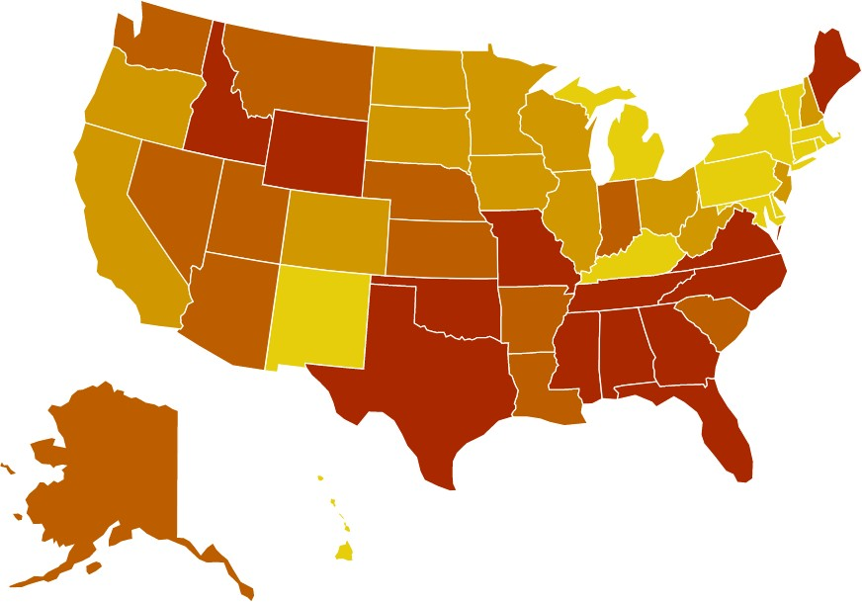
The state prevalence of uninsured adults with mental illness ranges from:

2.5% (DC)
Ranked 1-13
23.0% (WY)
Ranked 39-51

Rank | State | Rate | #
1 | District of Columbia | 2.5 | 3,000
2 | Vermont | 3.9 | 4,000
3 | Massachusetts | 4.2 | 51,000
4 | Connecticut | 4.6 | 25,000
5 | Kentucky | 4.8 | 37,000
6 | New York | 5.1 | 139,000
7 | Rhode Island | 5.8 | 11,000
8 | Pennsylvania | 6.0 | 108,000
9 | Michigan | 6.4 | 93,000
10 | New Mexico | 6.4 | 19,000
11 | Hawaii | 6.4 | 12,000
12 | Delaware | 6.8 | 10,000
13 | Maryland | 7.0 | 55,000
14 | Ohio | 7.1 | 138,000
15 | Minnesota | 7.3 | 58,000
16 | Wisconsin | 7.4 | 62,000
17 | New Hampshire | 7.5 | 17,000
18 | California | 7.8 | 434,000
19 | South Dakota | 8.2 | 9,000
20 | West Virginia | 8.3 | 31,000
21 | Iowa | 8.4 | 39,000
22 | New Jersey | 8.8 | 94,000
23 | North Dakota | 8.8 | 9,000
24 | Illinois | 8.9 | 151,000
25 | Colorado | 9.0 | 84,000
26 | Oregon | 9.0 | 67,000
27 | Arizona | 9.6 | 97,000
28 | Louisiana | 9.7 | 72,000
29 | Nebraska | 10.3 | 25,000
30 | Montana | 10.3 | 17,000
31 | Nevada | 10.5 | 51,000
32 | Washington | 10.6 | 140,000
33 | Arkansas | 10.9 | 51,000
34 | Indiana | 11.4 | 134,000
35 | Alaska | 11.6 | 12,000
36 | Utah | 11.7 | 67,000
37 | Kansas | 12.4 | 52,000
38 | South Carolina | 12.5 | 85,000
39 | Maine | 12.7 | 29,000
40 | Virginia | 13.5 | 147,000
41 | Idaho | 13.7 | 46,000
42 | North Carolina | 13.8 | 204,000
43 | Oklahoma | 15.9 | 92,000
44 | Missouri | 16.2 | 169,000
45 | Florida | 17.4 | 503,000
46 | Georgia | 18.5 | 255,000
47 | Alabama | 18.8 | 154,000
48 | Tennessee | 19.0 | 171,000
49 | Texas | 20.1 | 664,000
50 | Mississippi | 22.2 | 95,000
51 | Wyoming | 23.0 | 21,000
 | National | 10.8 | 5,114,000

10.8 percent (over 5.1 million) of adults with a mental illness are uninsured.
The rankings for this indicator used data from the 2017-2018 NSDUH. In December 2017, the Congress passed the Tax Cuts and Jobs Act, which eliminated the individual mandate penalty from the ACA.
There was a 0.5 percent increase from last year’s dataset, the first time this indicator has increased since the passage of the Affordable Care Act (ACA).
The increase in this indicator is consistent with data from the U.S. Census Bureau, which found that in 2018, the rate of uninsured Americans rose for the first time since the ACA took effect.1
Only twenty states saw a reduction in Adults with AMI who are
uninsured in this year’s dataset. The largest reductions were seen in Louisiana (5.0 percent), South Dakota (3.3 percent), Kentucky (2.4 percent) and Kansas (2.2 percent).
The largest increases were seen in Iowa (5.1 percent), Mississippi (3.9 percent), Arkansas (3.7) and Missouri (3.2 percent).

Berchick, E.R., Barnett, J.C. & Upton, R.D. (November 2019). Health Insurance Coverage in the United States: 2018. U.S. Census Bureau Current Population Reports, P60-267(RV). Available at https://www.census.gov/library/publications/2019/demo/p60-267.html

Adults with Cognitive Disability who Could Not See a Doctor Due to Costs
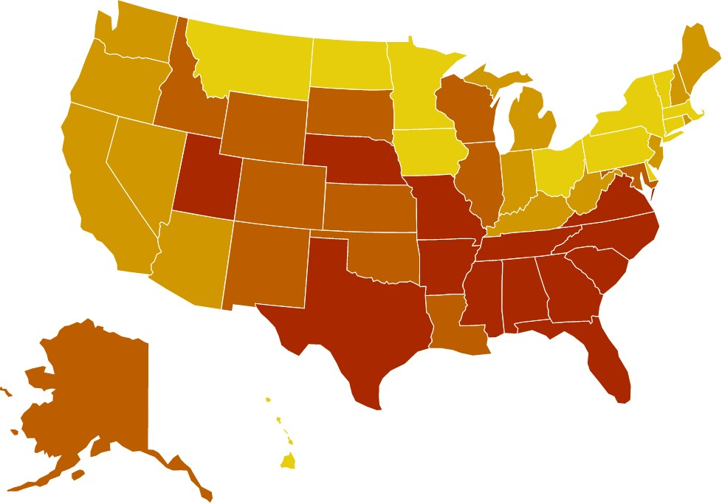
28.69 percent of adults with a cognitive disability were not able to see a doctor due to costs.
Cognitive disability is defined as having serious difficulty concentrating, remembering, or making decisions because of a physical, mental, or emotional disability.
According to the Centers for Disease Control (CDC),
11.5 percent of people in the United States had a cognitive disability in 2018, even when adjusted for age. The percentage of people with cognitive disability ranged from 7.9 percent in some states to
17.9 percent.

A 2017 study found that compared to working-age adults without disabilities, those with disabilities are more likely to live below the federal poverty level
The prevalence of adults with cognitive disability who could not see a MD due to cost ranges from:

and to use public insurance. Their average health costs were also 3-7 times higher than those without disabilities.2
17.10% (DC)
Ranked 1-13
41.92% (GA)
Ranked 39-51

Rank | State | % | #
1 | District of Columbia | 17.10 | 8,373
2 | Iowa | 17.54 | 37,774
3 | Hawaii | 17.63 | 16,639
4 | Massachusetts | 18.56 | 109,857
5 | Vermont | 19.02 | 9,542
6 | New York | 20.97 | 314,383
7 | Delaware | 20.98 | 18,284
8 | Ohio | 21.02 | 236,528
9 | Connecticut | 21.61 | 53,913
10 | Pennsylvania | 22.48 | 277,857
11 | Montana | 22.85 | 20,088
12 | North Dakota | 23.74 | 12,428
13 | Minnesota | 24.20 | 91,135
14 | Maine | 24.37 | 33,492
15 | Washington | 24.84 | 141,746
16 | Michigan | 25.18 | 252,279
17 | New Jersey | 25.19 | 177,138
18 | Nevada | 25.27 | 76,372
19 | Rhode Island | 25.71 | 26,383
20 | Kentucky | 25.85 | 137,755
21 | West Virginia | 25.99 | 65,433
22 | Oregon | 26.03 | 108,294
23 | New Hampshire | 26.91 | 28,858
24 | California | 27.05 | 796,447
25 | Indiana | 27.10 | 157,334
26 | Arizona | 27.17 | 153,262

Rank | State | % | #
27 | Wyoming | 27.44 | 12,362
28 | Colorado | 27.45 | 88,135
29 | Maryland | 27.45 | 111,740
30 | Louisiana | 28.08 | 160,506
31 | Oklahoma | 28.18 | 115,914
32 | Wisconsin | 28.20 | 119,187
33 | New Mexico | 28.23 | 54,533
34 | South Dakota | 28.36 | 17,869
35 | Illinois | 29.66 | 249,140
36 | Kansas | 30.27 | 70,938
37 | Alaska | 30.90 | 17,348
38 | Idaho | 31.04 | 43,794
39 | Nebraska | 31.66 | 39,724
40 | Tennessee | 31.86 | 245,411
41 | Utah | 31.92 | 75,977
42 | Missouri | 32.87 | 190,827
43 | South Carolina | 33.75 | 179,775
44 | Arkansas | 34.16 | 111,986
45 | Virginia | 34.24 | 223,528
46 | Texas | 34.57 | 690,102
47 | Mississippi | 35.20 | 130,909
48 | North Carolina | 35.23 | 343,530
49 | Florida | 35.36 | 754,413
50 | Alabama | 36.70 | 212,868
51 | Georgia | 41.92 | 410,646
 | National | 28.69 | 8,153,779

Centers for Disease Control and Prevention, National Center on Birth Defects and Developmental Disabilities, Division of Human Development and Disability. Disability and Health Data System (DHDS) Data [online]. (2018). Available at https://dhds.cdc.gov
2 Kennedy, J., Geneva Wood, E. & Frieden, L. (2017). Disparities in insurance coverage, health services use, and access following implementation of the Affordable Care Act: A comparison of disabled and nondisabled working-age adults. Inquiry, 54. Available at https://www.ncbi.nlm.nih.gov/pmc/articles/PMC5798675/

Youth Access to Care

Youth with MDE who Did Not Receive Mental Health Services

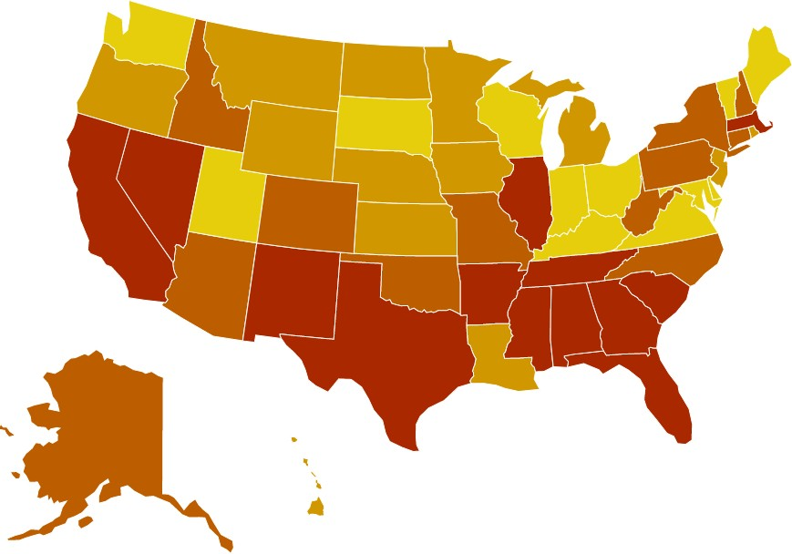59.6 percent of youth with major depression do not receive any mental health treatment.
Youth experiencing MDE continue to go untreated. Even among the states with greatest access for youth, over 1 in 3 youth are still not receiving the mental health
services they need.

The state prevalence of untreated youth with depression ranges from:

38.6% (ME)
Ranked 1-13
71.0% (NV)
Ranked 39-51

Rank | State | % | #
1 | Maine | 38.6 | 6,000
2 | District of Columbia | 38.8 | 1,000
3 | Vermont | 40.7 | 2,000
4 | Maryland | 41.3 | 23,000
5 | Utah | 45.2 | 22,000
6 | Washington | 47.0 | 38,000
7 | Wisconsin | 47.2 | 33,000
8 | Delaware | 47.9 | 4,000
9 | Kentucky | 49.3 | 19,000
10 | South Dakota | 49.7 | 3,000
11 | Ohio | 52.2 | 59,000
12 | Virginia | 53.0 | 51,000
13 | Indiana | 53.0 | 48,000
14 | Iowa | 53.0 | 20,000
15 | North Dakota | 53.4 | 3,000
16 | Rhode Island | 53.4 | 5,000
17 | Oregon | 53.9 | 30,000
18 | Kansas | 54.7 | 19,000
19 | Louisiana | 54.9 | 24,000
20 | Minnesota | 55.4 | 32,000
21 | Nebraska | 55.4 | 12,000
22 | Montana | 55.6 | 5,000
23 | Michigan | 55.7 | 66,000
24 | New Jersey | 55.7 | 40,000
25 | Hawaii | 56.2 | 5,000
26 | Wyoming | 56.6 | 4,000

Rank | State | % | #
27 | New Hampshire | 56.9 | 9,000
28 | Pennsylvania | 57.5 | 56,000
29 | Alaska | 57.8 | 5,000
30 | Missouri | 58.8 | 40,000
31 | New York | 59.1 | 85,000
32 | Connecticut | 59.1 | 24,000
33 | West Virginia | 59.3 | 11,000
34 | Arizona | 59.6 | 52,000
35 | North Carolina | 60.2 | 77,000
36 | Colorado | 60.9 | 29,000
37 | Oklahoma | 61.1 | 35,000
38 | Idaho | 61.2 | 15,000
39 | Massachusetts | 61.2 | 41,000
40 | Tennessee | 61.5 | 35,000
41 | Illinois | 62.1 | 90,000
42 | New Mexico | 62.9 | 20,000
43 | Arkansas | 63.9 | 23,000
44 | Florida | 64.7 | 116,000
45 | California | 66.0 | 259,000
46 | Mississippi | 66.3 | 18,000
47 | Texas | 67.1 | 209,000
48 | South Carolina | 68.0 | 36,000
49 | Alabama | 69.7 | 31,000
50 | Georgia | 70.4 | 73,000
51 | Nevada | 71.0 | 23,000
 | National | 59.6 | 1,988,000

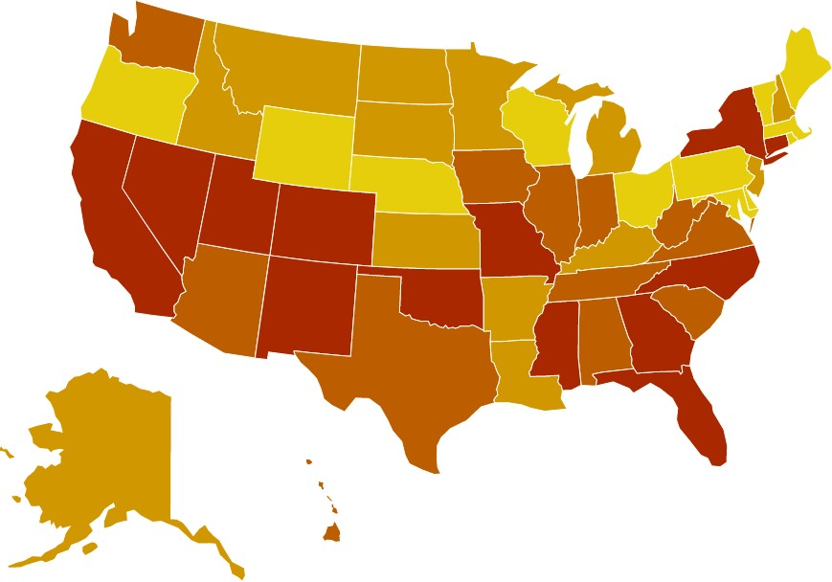Youth with Severe MDE who Received Some Consistent Treatment

High percentages are associated with positive outcomes and low percentages are associated with poorer outcomes.

Nationally, only 27.3 percent of youth with severe depression receive some consistent treatment (7-25+ visits in a year).
Consistent treatment is determined if a youth visits a specialty outpatient mental health service, including a day treatment facility, mental health clinic, private therapist or in-home therapist, more than 7 times in the previous year. It does not consider the quality of the care
– for example, whether the mental health service was specialized toward youth, what the outcomes of treatment were, or whether the child was offered a continuum of supports.
Even with simply measuring the number of visits, less than 1 in 3 youth with severe depression meet this determination of consistent care.

The state prevalence of youth with severe depression who received some outpatient treatment ranges from:

50.0% (ME)
Ranked 1-13
11.2% (NV)
Ranked 39-51

Rank | State | % | #
1 | Maine | 50.0 | 5,000
2 | Maryland | 49.2 | 21,000
3 | Vermont | 45.4 | 2,000
4 | Delaware | 41.5 | 2,000
5 | Rhode Island | 41.2 | 3,000
6 | Wisconsin | 40.4 | 23,000
7 | Oregon | 37.9 | 14,000
8 | Massachusetts | 37.7 | 15,000
9 | District of Columbia | 37.3 | 1,000
10 | Pennsylvania | 37.1 | 23,000
11 | Wyoming | 36.3 | 2,000
12 | Ohio | 36.0 | 28,000
13 | Nebraska | 35.9 | 5,000
14 | Idaho | 35.8 | 6,000
15 | New Hampshire | 34.9 | 3,000
16 | Kentucky | 34.2 | 10,000
17 | Minnesota | 33.7 | 13,000
18 | North Dakota | 33.0 | 1,000
19 | New Jersey | 32.5 | 16,000
20 | Louisiana | 32.0 | 9,000
21 | Kansas | 31.1 | 7,000
22 | Arkansas | 30.0 | 7,000
23 | Alaska | 29.9 | 2,000
24 | Michigan | 29.8 | 24,000
25 | Montana | 29.3 | 2,000
26 | South Dakota | 29.2 | 1,000

Rank | State | % | #
27 | Iowa | 28.8 | 7,000
28 | South Carolina | 28.3 | 9,000
29 | Hawaii | 28.3 | 2,000
30 | West Virginia | 27.8 | 4,000
31 | Tennessee | 27.3 | 12,000
32 | Washington | 26.7 | 13,000
33 | Indiana | 26.1 | 16,000
34 | Virginia | 26.1 | 16,000
35 | Alabama | 25.9 | 6,000
36 | Texas | 25.0 | 54,000
37 | Illinois | 25.0 | 26,000
38 | Arizona | 24.7 | 15,000
39 | California | 24.6 | 59,000
40 | Utah | 24.5 | 8,000
41 | Oklahoma | 23.5 | 8,000
42 | New Mexico | 22.6 | 5,000
43 | New York | 21.9 | 22,000
44 | North Carolina | 21.9 | 21,000
45 | Connecticut | 21.6 | 5,000
46 | Colorado | 21.5 | 8,000
47 | Florida | 19.7 | 24,000
48 | Georgia | 19.2 | 15,000
49 | Missouri | 19.0 | 9,000
50 | Mississippi | 14.9 | 2,000
51 | Nevada | 11.2 | 3,000
 | National | 27.3 | 614,000

Children with Private Insurance that
Rank | State | % | #
1 | Vermont | 0.6 | 0
2 | Massachusetts | 1.2 | 4,000
3 | New Hampshire | 2.5 | 1,000
4 | Connecticut | 3.3 | 5,000
5 | Maine | 3.4 | 2,000
6 | New Jersey | 4.0 | 14,000
7 | District of Columbia | 4.6 | 1,000
8 | Washington | 5.2 | 16,000
9 | Rhode Island | 5.3 | 2,000
10 | Montana | 5.4 | 2,000
11 | South Dakota | 5.4 | 2,000
12 | Michigan | 5.5 | 23,000
13 | Wisconsin | 5.5 | 16,000
14 | Ohio | 5.9 | 26,000
15 | Missouri | 5.9 | 14,000
16 | Alabama | 5.9 | 7,000
17 | Pennsylvania | 6.1 | 29,000
18 | Georgia | 6.5 | 23,000
19 | Virginia | 6.6 | 21,000
20 | Oregon | 6.7 | 10,000
21 | Delaware | 6.9 | 3,000
22 | Indiana | 7.1 | 22,000
23 | Illinois | 7.2 | 34,000
24 | Maryland | 7.2 | 18,000
25 | West Virginia | 7.2 | 4,000
26 | California | 7.5 | 100,000
27 | Minnesota | 7.5 | 20,000
28 | Mississippi | 7.5 | 6,000
29 | Iowa | 7.5 | 10,000
30 | Louisiana | 7.6 | 10,000
31 | Utah | 7.8 | 16,000
32 | New Mexico | 7.8 | 4,000
33 | Oklahoma | 7.9 | 11,000
34 | Kansas | 7.9 | 9,000
35 | New York | 8.3 | 49,000
36 | Colorado | 8.3 | 17,000
37 | Hawaii | 9.2 | 3,000
38 | Florida | 9.4 | 52,000
39 | North Carolina | 10.0 | 33,000
40 | Alaska | 10.3 | 2,000
41 | Kentucky | 11.0 | 17,000
42 | Texas | 11.5 | 108,000
43 | Wyoming | 12.0 | 3,000
44 | Arizona | 12.1 | 32,000
45 | Nevada | 12.6 | 13,000
46 | Nebraska | 12.6 | 10,000
47 | Idaho | 12.7 | 10,000
48 | North Dakota | 13.5 | 5,000
49 | Tennessee | 13.5 | 27,000
50 | Arkansas | 14.4 | 13,000
51 | South Carolina | 14.8 | 23,000
 | National | 7.8 | 901,000

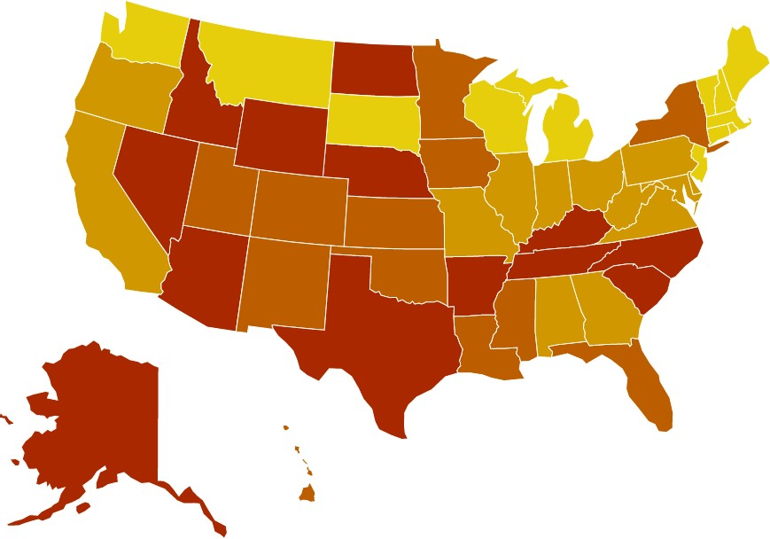
Did Not Cover Mental or Emotional Problems

The state prevalence of children lacking mental health coverage ranges from:

0.6% (VT)
Ranked 1-13
14.8% (SC)
Ranked 39-51

The Mental Health Parity and Addiction Equity Act (MHPAEA) was enacted in 2008 and promised the equal coverage of mental health and substance use services. The rate of children with private insurance that does not cover mental or emotional problems decreased 0.3 percent from last year’s dataset. However, there are still 901,000 youth without coverage for their behavioral health.
In 2019, a Milliman research report1 found large disparities between behavioral health and medical/surgical services, including that patients saw out-of-network behavioral health providers at much higher rates than physical health providers. It also found that these disparities were worse for children. In 2017, a behavioral health visit for a child was over 10 times more likely to be out-of- network than a primary care office visit. This was over two times the disparity shown for adults.
To improve the worsening mental health of children and adolescents in the U.S., insurance companies must not only achieve parity in coverage of services, but also in network adequacy, so people are able to access those services when they need them.

1 Melek, S., Davenport, S. & Gray, T.J. (November 19, 2019). Addiction and mental health vs. physical health: Widening disparities in network use and provider reimbursement. Milliman Research Report. Available at

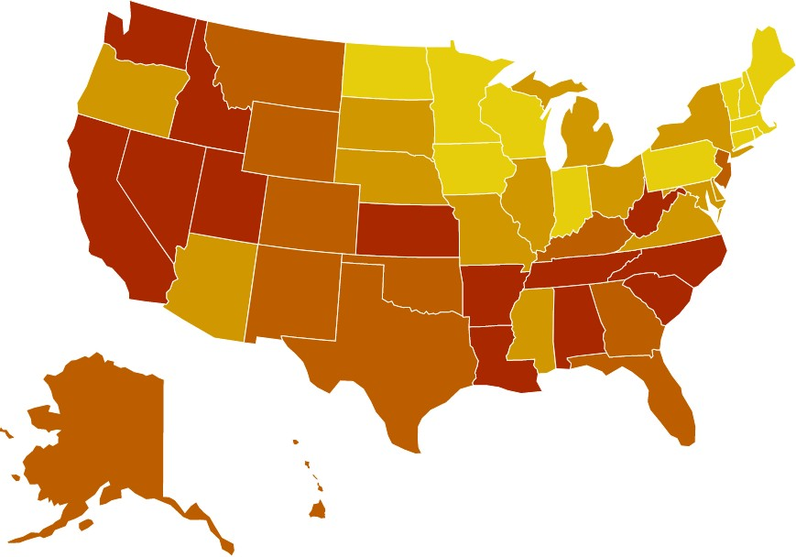
Students Identified with Emotional Disturbance for an Individualized Education Program
Rank* | State | Rate | #
1 | Vermont | 30.41 | 2,233
2 | Minnesota | 20.69 | 16,510
3 | Massachusetts | 19.51 | 16,935
4 | Wisconsin | 16.18 | *
5 | Pennsylvania | 15.76 | 25,166
6 | Maine | 14.35 | 2,328
7 | Indiana | 13.41 | 12,838
8 | Iowa | 13.31 | 5,896
9 | New Hampshire | 12.77 | 2,095
10 | Rhode Island | 12.38 | 1,615
11 | District of Columbia | 12.32 | 827
12 | Connecticut | 11.94 | 5,691
13 | North Dakota | 11.85 | 1,183
14 | Illinois | 10.19 | 18,237
15 | Nebraska | 10.06 | 2,846
16 | Ohio | 9.97 | 15,377
17 | South Dakota | 9.89 | 1,213
18 | Oregon | 9.81 | 5,286
19 | Delaware | 9.25 | 1,152
20 | New York | 9.15 | 22,553
21 | Missouri | 8.66 | 7,072
22 | Michigan | 8.45 | 11,458
23 | Virginia | 8.38 | 9,782
24 | Maryland | 7.64 | 6,107
25 | Mississippi | 7.62 | 3,326
26 | Arizona | 7.61 | 7,742
27 | Kentucky | 7.45 | 4,524
28 | Oklahoma | 6.89 | 4,142
29 | Colorado | 6.88 | 5,596
30 | Wyoming | 6.72 | 579
31 | Texas | 6.60 | 31,519
32 | Montana | 6.50 | 881
33 | Georgia | 6.45 | 10,286
34 | Alaska | 6.26 | 745
35 | New Mexico | 6.16 | 1,853
36 | New Jersey | 5.98 | 7,485
37 | Hawaii | 5.74 | 947
38 | Florida | 5.68 | 14,604
39 | Kansas | 5.53 | 2,436
40 | Washington | 5.25 | 5,324
41 | Idaho | 4.95 | 1,372
42 | West Virginia | 4.80 | 1,133
43 | Nevada | 4.43 | 1,959
44 | California | 4.42 | 25,118
45 | Tennessee | 3.76 | 3,381
46 | North Carolina | 3.72 | 5,275
47 | Utah | 3.17 | 1,918
48 | South Carolina | 3.04 | 2,112
49 | Louisiana | 2.70 | 1,715
50 | Arkansas | 2.42 | 1,070
51 | Alabama | 2.09 | 1,406
 | National | 7.57 | 344,473

High percentages are associated with positive outcomes
and low percentages are associated with poorer outcomes.
The state rate of students identified as having an Emotional Disturbance (ED) for an Individual Education Program (IEP) ranges from:

30.41% (VT)
Ranked 1-13
2.09% (AL)
Ranked 39-51

Only .757 percent* of students are identified as having an ED for IEP.
Early identification for IEPs is critical. IEPs provide the services, accommodations and support students with ED need to receive a quality education. For purposes of an IEP, the term “Emotional Disturbance” is used to define youth with a mental illness that is affecting their ability to succeed in school. In 2017-2018, nearly 10 percent of youth had severe MDE, reporting the maximum level of interference over four role domains including school, yet less than 1 percent were identified for an IEP under ED.

In addition to ensuring that students in need of accommodations and supports in school receive them through an IEP, improvements in the implementation of the special education mandate must be made to ensure appropriate identification of students, without creating further disparities. The federal eligibility criteria to identify students as having an emotional disturbance for an IEP have indicated extremely poor reliability among school psychologists,2 and therefore must be revised to adequately identify students in need of more supports.

The rate for this measure is shown as a rate per 1,000 students. The calculation was made this way for ease of reading. Unfortunately, doing so hides the fact that the percentages are significantly lower. If states were doing a better job of identifying whether youth had emotional difficulties that could be better supported through an IEP – the rates would be closer to .8 percent.
1 Scardamalia, K., Bentley-Edwards, K.L. & Grasty, K. (April 2019). Consistently inconsistent: An examination of the variability in the identification of emotional disturbance. Psychology in the Schools, 56(4): 569-581. Available at https://onlinelibrary.wiley.com/doi/pdf/10.1002/pits.22213
31

Mental Health Workforce Availability
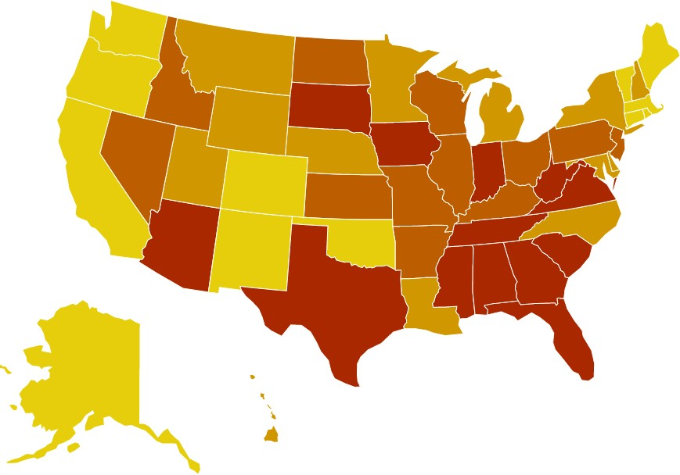

The state rate of mental health workforce ranges from:

160:1 (MA)
Ranked 1-13
990:1 (AL)
Ranked 39-51
Rank | State | #
1 | Massachusetts | 160:1
2 | Oregon | 190:1
3 | District of Columbia | 210:1
4 | Maine | 210:1
5 | Vermont | 220:1
6 | Alaska | 230:1
7 | Rhode Island | 240:1
8 | Connecticut | 250:1
9 | Oklahoma | 250:1
10 | New Mexico | 260:1
11 | Washington | 270:1
12 | California | 280:1
13 | Colorado | 280:1
14 | Utah | 300:1
15 | Wyoming | 300:1
16 | Montana | 330:1
17 | New Hampshire | 330:1
18 | Louisiana | 340:1
19 | New York | 350:1
20 | Michigan | 370:1
21 | Delaware | 380:1
22 | Nebraska | 380:1
23 | Maryland | 390:1
24 | Hawaii | 400:1
25 | Minnesota | 400:1
26 | North Carolina | 410:1
27 | Ohio | 410:1
28 | Arkansas | 440:1
29 | Illinois | 440:1
30 | Kentucky | 440:1
31 | New Jersey | 450:1
32 | Nevada | 470:1
33 | Idaho | 480:1
34 | Pennsylvania | 480:1
35 | Wisconsin | 490:1
36 | Kansas | 510:1
37 | Missouri | 510:1
38 | North Dakota | 530:1
39 | South Dakota | 550:1
40 | South Carolina | 570:1
41 | Virginia | 570:1
42 | Florida | 620:1
43 | Indiana | 620:1
44 | Mississippi | 630:1
45 | Iowa | 640:1
46 | Tennessee | 660:1
47 | Georgia | 730:1
48 | Arizona | 750:1
49 | West Virginia | 770:1
50 | Texas | 880:1
51 | Alabama | 990:1

The term “mental health provider” includes psychiatrists, psychologists, licensed clinical social workers, counselors, marriage and family therapists, and advanced practice nurses specializing in mental health care, but not yet certified peer specialists (because peer specialists are primarily covered only by Medicaid, and qualifications for them vary by state).

The rate of mental health providers has improved in nearly every state since last year’s report. However, the need for mental health care will greatly outpace these additions to the workforce, especially as rates of depression, anxiety and other mental health concerns increase in response to the coronavirus pandemic and increased awareness of ongoing racial injustice in 2020.

However, the COVID-19 pandemic has also shown that these workforce shortages can be mitigated through different models of care delivery. The Center for Medicare and Medicaid Services (CMS) encouraged states to reduce barriers to tele-mental health under Medicaid, and Medicare allowed audio-only tele-mental health visits during the pandemic. If these changes to care delivery be made permanent and coverage for peer support specialists and other paraprofessionals is expanded, these could help mitigate some of the effects of provider shortages in the future.

COVID-19 and Mental Health: 2020 Data

Executive Summary
From January to September 2020, 1,560,288 people took a screen and accessed immediate resources and supports through the MHA Online Screening Program.
From those screens, we have found:
- The number of people looking for help with anxiety and depression has skyrocketed. From January to September 2020, 315,220 people took the anxiety screen, a 93 percent increase over the 2019 total number of anxiety screens. 534,784 people took the depression screen, a 62 percent increase over the 2019 total number of depression screens.
- The number of people screening with moderate to severe symptoms of depression and anxiety has continued to increase throughout 2020 and remains higher than rates prior to COVID-19. In September 2020, the rate of moderate to severe anxiety peaked, with over 8 in 10 people who took an anxiety screen scoring with moderate to severe symptoms. Over 8 in 10 people who took a depression screen have scored with symptoms of moderate to severe depression consistently since the beginning of the pandemic in March 2020.
- More people are reporting frequent thoughts of suicide and self-harm than have ever been recorded in the MHA Screening program since its launch in 2014. Since the COVID-19 pandemic began to spread rapidly in March 2020, over 178,000 people have reported frequent suicidal ideation. 37 percent of people reported having thoughts of suicide more than half or nearly every day in September 2020.
- Young people are struggling most with their mental health. The proportion of youth ages 11-17 who accessed screening was 9 percent higher than the average in 2019. Not only are the number of youth searching for help with their mental health increasing, but throughout the COVID-19 pandemic youth ages 11-17 have been more likely than any other age group to score for moderate to severe symptoms of anxiety and depression.
- Rates of suicidal ideation are highest among youth, especially LGBTQ+ youth. In September 2020, over half of 11-17-year-olds reported having thoughts of suicide or self-harm more than half or nearly every day of the previous two weeks. From January to September 2020, 77,470 youth reported experiencing frequent suicidal ideation, including 27,980 LGBTQ+ youth.
- People screening at risk for mental health conditions are struggling most with loneliness or isolation. From April to September 2020, among people who screened with moderate to severe symptoms of anxiety or depression, 70 percent reported that one of the top three things contributing to their mental health concerns was loneliness or isolation.
- People who identify as Asian or Pacific Islander are searching for mental health resources more in 2020 than ever before. The proportion of screeners identifying as Asian or Pacific Islander increased 7 percent, from 9 percent of screeners in 2019 to 16 percent in 2020.
- While rates of anxiety, depression, and suicidal ideation are increasing for people of all races and ethnicities, there are notable differences in those changes over time. Black or African American screeners have had the highest average percent change over time for anxiety and depression, while

Native American or American Indian screeners have had the highest average percent change over time for suicidal ideation.

A Growing Crisis
The State of Mental Health in America report is designed to create a complete picture of mental health throughout the United States that can be used to track the successes and failures of federal and state policy initiatives aimed at affecting mental health outcomes over time. In 2015 when this initiative was created, we did not anticipate that there would be a population-level health crisis that would change the landscape of mental health in every community throughout the United States, with effects of for years to come.
As COVID-19 spread throughout the United States, it not only resulted in greater morbidity and mortality in terms of physical health but also had disastrous effects on the mental health of the nation. As opposed to previous disasters in the United States that affected certain specific regions or populations where aid and trauma response could be concentrated, the COVID-19 pandemic has affected the entire population of the country. While the risk of contracting the disease itself is a population-wide traumatizing event, our physical and social environments have changed as well, leading to greater rates of isolation and loneliness, financial hardship, housing and food insecurity, and interpersonal violence. Further, the COVID-19 pandemic has highlighted and exacerbated existing inequities and injustices faced primarily by black, indigenous, and people of color (BIPOC) in the United States. Any of these factors by themselves can negatively affect the mental health of individuals, but in combination they have created a nationwide mental health crisis.
The data presented throughout the State of Mental Health in America 2021 report was collected in 2017-2018 and are the most current data reported by states and available to the public. While they are useful in providing comparative baselines in the states for needs and prevalence rates prior to COVID-19, they do not reflect the state of the nation since the onset of the pandemic.
In 2014, Mental Health America created the Online Screening Program (www.mhascreening.org), a collection of ten free, anonymous, confidential and clinically-validated screens that are among the most commonly used mental health screening tools in clinical settings.¹ Through September 2020, over 6 million people have taken a screen, including over 1.5 million people from January-September 2020. This makes it the largest dataset ever collected from a help-seeking population experiencing mental health conditions. The screening results also comprise one of the largest datasets collecting national mental health information in real-time, allowing us to recognize and react to changes in the mental health of the nation as they occur, including the mounting mental health crisis throughout the COVID-19 pandemic.
Strengths and Limitations
The MHA Screening dataset collects information from a help-seeking population, meaning people searching for mental health resources and supports online. As a result, users are more likely to screen positive or moderate to severe for mental health conditions than the general population. The MHA Screening Program also exists entirely online, and therefore does not reflect the mental health needs of people who do not have access to Internet

1 These screens include the Patient Health Questionnaire-9 item (PHQ-9) for depression and the Generalized Anxiety Disorder-7 item (GAD-7) for anxiety, the long forms of the same tools used by the CDC to measure depression and anxiety in the U.S. Household Pulse
Survey.

services, likely undercounting communities at higher risk of mental health challenges, such as people experiencing homelessness, poverty, and institutionalization, and communities that do not have broadband access.
393-416. Doi: 10.1111/j.1475-6773.2004.00234.x
MHA Screening however, by existing in an online space, can capture information about individual’s mental health needs earlier than other datasets. From January-September 2020, 66 percent of people who screen positive or moderate to severe for a mental health condition have never received a mental health diagnosis before, and 61 percent have never received any form of mental health treatment or support. When people first begin experiencing symptoms of a mental health condition, they often look for answers, resources and supports online, long before speaking to a provider. The average time between onset of mental health symptoms and diagnosis and treatment of a mental health condition is 11 years.² The data from MHA Screening capture the mental health needs of people who either may not have access to care or have not engaged in care in healthcare settings, which allows for it to be used for earlier intervention and detection of mental health concerns before they become crises.
The following analysis is of the data collected from over 1.5 million screeners who sought help from MHA Screening from January-September 2020.

Basic Demographics
1,560,288 people took a screen through MHA Screening from January-September 2020. Of those the majority took a depression screen (34 percent), followed by the anxiety screen (20 percent) and the bipolar screen (17 percent).
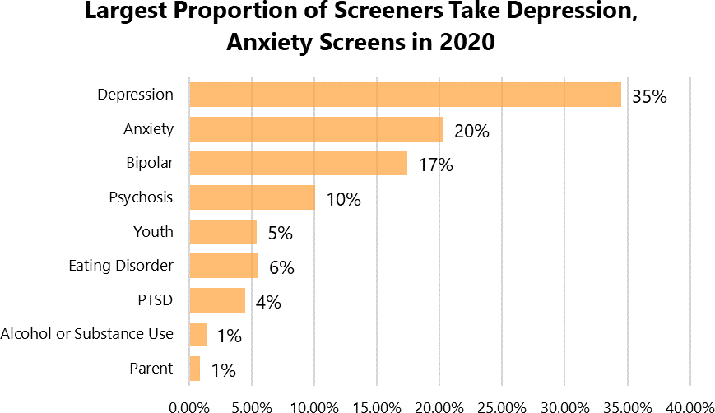
73 percent of screeners identified as female, 25 percent identified as male and 2 percent identified as another gender. In April 2020, we added a separate option to identify as transgender. 3 percent of screeners (N=38,090) from April to September 2020 identified as transgender.

2 Wang, P.S. et al. (April 2004). Delays in initial treatment contact after first onset of a mental disorder. Health Services Research, 39(2):

People who accessed screening in 2020 were younger than the 2019 average. 38 percent of screeners from January-September 2020 were youth ages 11-17, a 9 percent increase over 2019 (29 percent). While the MHA Screening population has always been young with over 60 percent of screeners under the age of 25, this indicates that youth under the age of 18 were even more likely to be searching for mental health resources and supports in 2020. The percentage of 18-24-year-olds remained the same from 2019 to 2020 (32 percent).

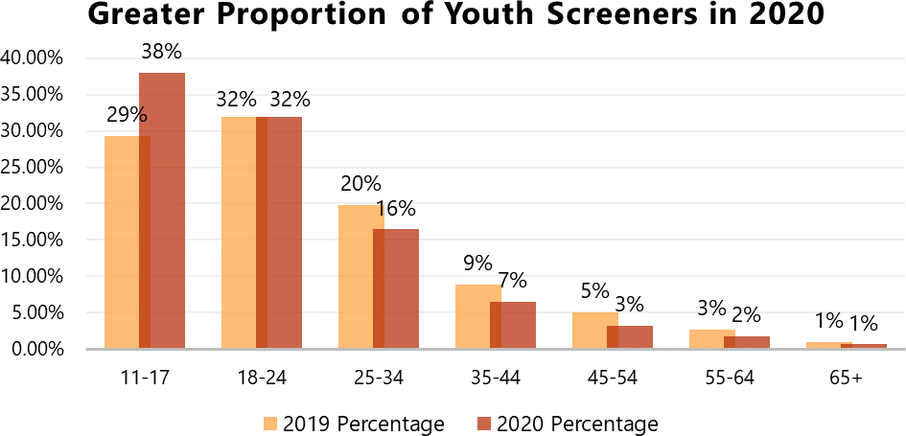

There have also been changes in the race/ethnicity of screeners in 2020, as compared to 2019. The proportion of screeners identifying as Asian or Pacific Islander increased 7 percent, from 9 percent of screeners in 2019 to 16 percent in 2020. Anti-Asian discrimination increased significantly in the U.S. during the COVID-19 pandemic, and the increase in Asian or Pacific Islander screeners is consistent with research predicting negative health effects among Asian Americans as a result of COVID-19.³ The percentage of screeners identifying their race as “Other” increased as well, from 3 percent to 5 percent. The proportion of White screeners decreased, from 60 percent to 53 percent.

Race/Ethnicity | 2019 Count | 2019  Percentage | 2020 Count | 2020  Percentage
Asian or Pacific Islander | 35,021 | 9.13% | 170,295 | 15.50%
Black or African American (non- Hispanic) | 33,696 | 8.79% | 91,170 | 8.30%
Hispanic or Latino | 47,414 | 12.36% | 134,790 | 12.27%
More than one of the above | 20,883 | 5.45% | 55,277 | 5.03%
Native American or American Indian | 5,020 | 1.31% | 12,888 | 1.17%
Other | 12,893 | 3.36% | 51,611 | 4.70%
White (non-Hispanic) | 228,596 | 59.60% | 582,308 | 53.02%
Grand Total | 383,523 | 100.00% | 1,098,339 | 100.00%

3 Chen, J.A., Zhang, E. & Liu, C.H. (June 2020). Potential impact of COVID-19-related racial discrimination on the health of Asian
Americans. American Journal of Public Health, pp. e1-e4. Doi: https://doi.org/10.2105/AJPH.2020.305858

Screeners from January-September 2020 reported slightly higher household incomes than those in 2019 as well. Half (50 percent) of screeners reported a household income less than $40,000 in 2020, compared to 52 percent in 2019. Over 24 percent reported a household income greater than $80,000, compared to 22 percent in 2019.
Across all screens, 74 percent (N=1,158,429) scored moderate to severe for the mental health condition for which they screened. This was consistent with the 2019 average. However, there were notable differences in rates of positive or moderate to severe screens among anxiety and depression screens over time.

Mounting Anxiety, Depression and Suicidal Ideation
MHA uses the Generalized Anxiety Disorder 7-item (GAD-7) tool to screen for anxiety. From January to September 2020, 315,220 people took the anxiety screen, a 93 percent increase over the 2019 total number of anxiety screens (N=162,958). In September 2020, an average of 2,262 anxiety screens were taken per day.
Despite the dramatic increase in the number of people taking anxiety screens in 2020, the rate of people screening with moderate to severe symptoms of anxiety remained higher than rates prior to the COVID-19 pandemic. In September 2020, 80 percent (N=54,315) of people who took an anxiety screen scored for moderate to severe anxiety, with 48 percent (N=32,870) scoring for symptoms of severe anxiety.

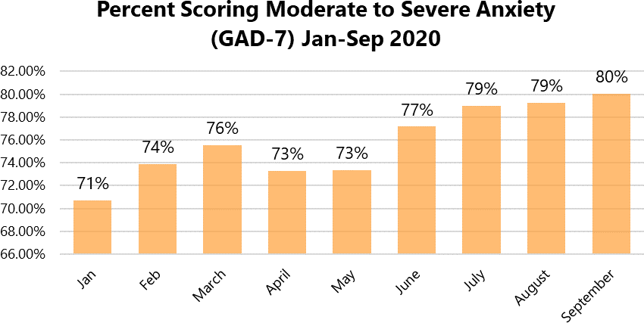

MHA uses the Patient Health Questionnaire 9-item (PHQ-9) tool to screen for depression. From January to September 2020, 534,784 people took the depression screen, a 62 percent increase over the 2019 total number of depression screens (N=331,089). In September 2020, an average of 4,321 depression screens were taken per day.

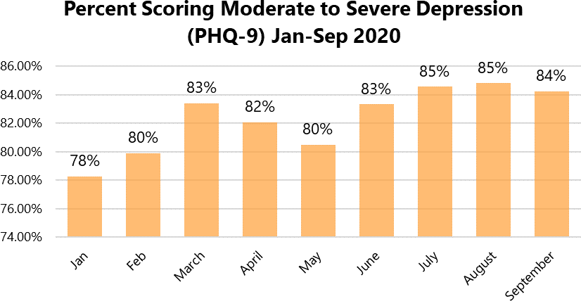
Like the anxiety screen, the rate of people screening with moderate to severe symptoms of depression has remained higher than rates prior to the COVID-19 pandemic. In September 2020, 84 percent (N=109,232) of people who took a depression screen scored for moderate to severe depression, with 31 percent (N=40,139) scoring for symptoms of severe depression.
Anxiety and Depression Highest for Youth
Throughout the COVID-19 pandemic, youth ages 11-17 were more likely than any other age group to score for moderate to severe symptoms of anxiety and depression.

Age | Number Scoring Moderate to Severe Anxiety: January- September 2020 | Percent Scoring Moderate to Severe Anxiety: January- September 2020 | Number Scoring Moderate to Severe Depression: January- September 2020 | Percent Scoring Moderate to Severe Depression: January- September 2020
11-17 | 68,584 | 82.88% | 140,988 | 90.20%
18-24 | 62,657 | 79.72% | 122,253 | 86.39%
25-34 | 32,284 | 75.86% | 58,991 | 79.17%
35-44 | 12,841 | 72.45% | 21,808 | 74.18%
45-54 | 6,381 | 68.72% | 10,740 | 70.72%
55-64 | 3,257 | 61.70% | 5,953 | 65.53%
65+ | 1,149 | 56.57% | 2,183 | 60.19%

From March to September 2020, over 80 percent of 11-17-year-olds who took an anxiety screen scored for moderate to severe anxiety. In September 2020, 84 percent of 11-17-year-olds scored for moderate to severe anxiety, totaling 18,551 youth.

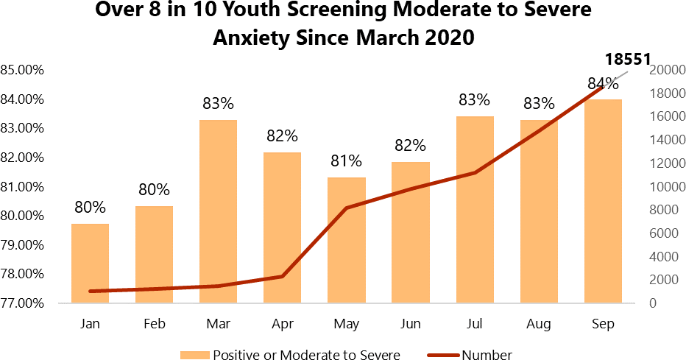

From March to September 2020, at least 90 percent of 11-17-year-olds who took a depression screen scored for moderate to severe depression. In September 2020, 90 percent of 11-17-year-olds scored for moderate to severe depression, totaling 38,215 youth.

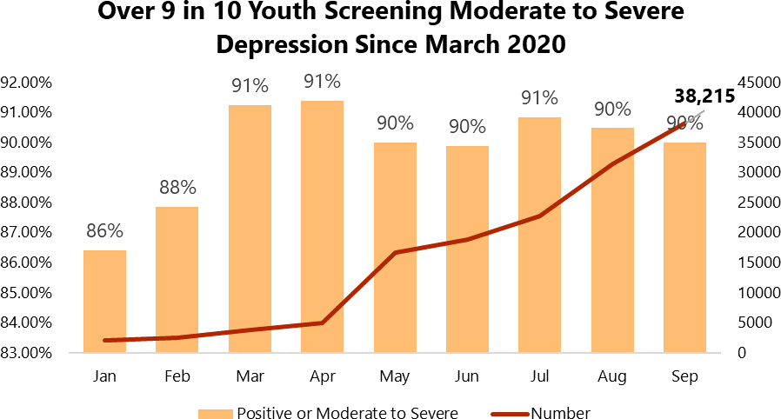

Suicidal Ideation
Question 9 of the PHQ-9 screen asks, “Over the last two weeks, how often have you been bothered thoughts that you would be better off dead, or of hurting yourself?” In 2020, the number and rate of people reporting frequent suicidal ideation has reached the highest level ever recorded in the MHA screening population.

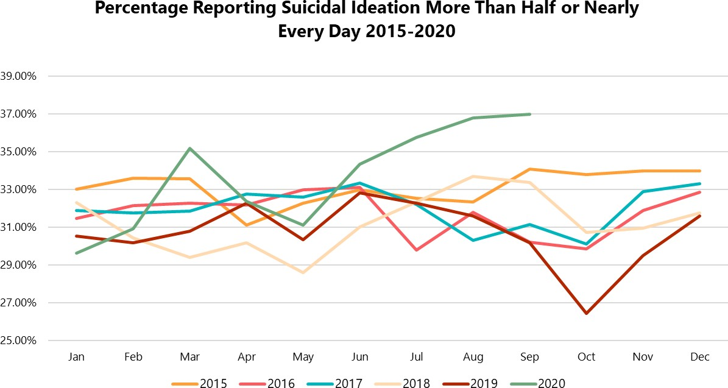

In September 2020, 37 percent (N=47,968) of people who screened for depression indicated that they experienced suicidal ideation more than half or nearly every day of the previous two weeks. 22 percent (N=28,356) indicated that they experienced thoughts of suicide or self-harm nearly every day. Since the COVID-19 pandemic began to spread rapidly in March 2020, over 178,000 people have reported frequent suicidal ideation on the PHQ-9.

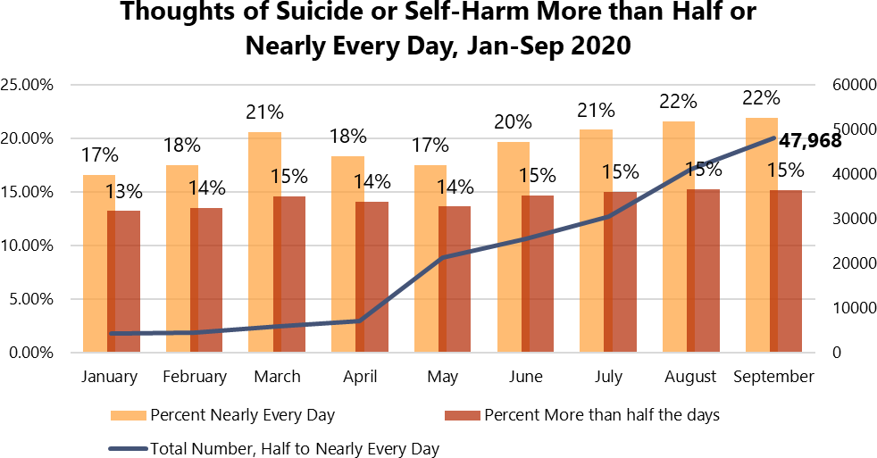

As with rates of anxiety and depression, youth ages 11-17 report the highest rates of suicidal ideation of any age group. In September 2020, 51% (N=21,586) of 11-17-year-olds reported having thoughts of suicide or self- harm more than half or nearly every day of the previous two weeks. From January to September 2020, 77,470 youth reported experiencing frequent suicidal ideation, including 75,107 since the beginning of the pandemic in March.

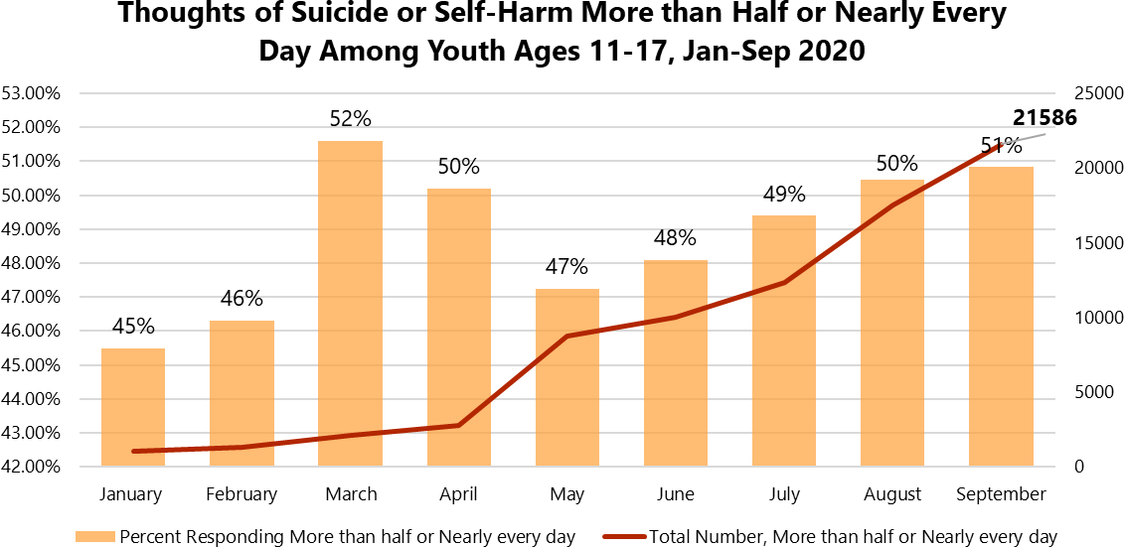

Suicidal ideation is also higher among people who identify as LGBTQ+, especially LGBTQ+ youth. In September 2020, 55 percent (N=11,865) of LGBTQ+ individuals reported frequent suicidal ideation, and 62 percent (N=7,988) of youth ages 11-17 who identified as LGBTQ+ reported suicidal ideation more than half the days or nearly every day. From January to September 2020, 27,980 LGBTQ+ youth reported experiencing frequent suicidal ideation.

All LGBTQ+  Respondents | 2019  Average | Jan 2020 | Feb 2020 | Mar 2020 | Apr 2020 | May 2020 | June 2020 | Jul 2020 | Aug 2020 | Sep 2020
Percent Reporting Frequent Suicidal Ideation | 49% (N=15,586) | 48%  (781) | 51%  (901) | 52%  (1,218) | 52%  (1,745) | 48%  (4,822) | 48%  (5,622) | 52%  (7,058) | 53%  (9,657) | 55%  (11,865)

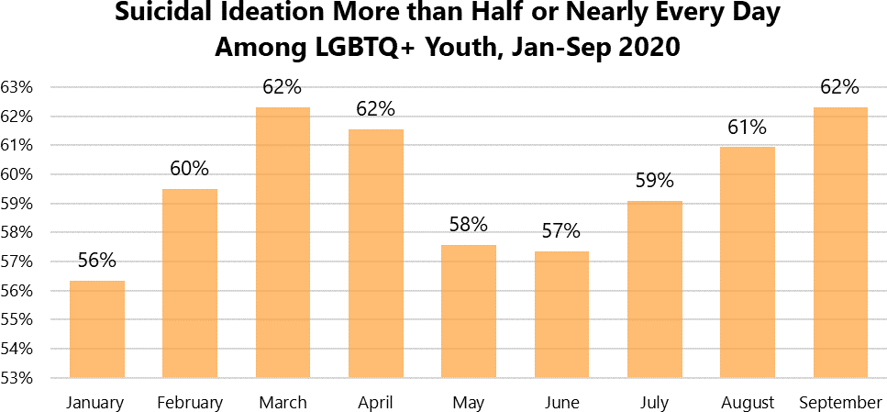

Main Concerns of People Screening Positive for Mental Health Conditions
In April 2020, MHA added the question, “Think about your mental health test. What are the main things contributing to your mental health problems right now? Choose up to three.”
From April to September 2020, among people who screened with moderate to severe symptoms of anxiety or depression, 70 percent reported that one of the top three things contributing to their mental health concerns was loneliness or isolation. This was followed by 46 percent reporting past trauma and 43 percent reporting relationship problems. 27 percent of people who scored with moderate to severe symptoms of anxiety or depression reported coronavirus as one of the top three things affecting their mental health, and 27 percent reported current events, including news and politics.

Think about your mental health test. What are the main things contributing to your mental health problems right now?  Choose up to 3. | Count, Individuals with Moderate to Severe Anxiety or Depression, Apr-Sep 2020 | Percentage, Individuals with Moderate to Severe Anxiety or Depression, Apr-Sep 2020
Coronavirus | 133259 | 26.97%
Current events (news, politics, etc.) | 132338 | 26.79%
Financial Problems | 118235 | 23.93%
Loneliness or isolation | 348190 | 70.47%
Grief or loss of someone or something | 130101 | 26.33%
Past trauma | 228184 | 46.18%
Relationship problems | 210251 | 42.56%
Racism | 31345 | 7.65%*
Grand Total | 494066
*Racism was not added as an option until June 16, 2020. Percentage is reported from the total responses from June 16-September 2020 (N=409,678)
However, the main concerns among individuals who screened with moderate to severe symptoms of depression and anxiety have changed over time. The percentage of people reporting loneliness or isolation as one of the three things contributing to their mental health problems increased 2 percent from May to June 2020 and has remained at 71 percent through September (N=92,142). 32 percent of people selected coronavirus as one of their top three concerns in May 2020, but as increased media attention, awareness and protests began in response to racial injustice and police brutality in June, there was a 7 percent increase in people reporting current events as one of their three main concerns, mirrored by a 7 percent decrease in those reporting coronavirus. In September, 26 percent (N=34,109) reported current events, and 25 percent (N=31,979) reported coronavirus as one of their top three concerns.

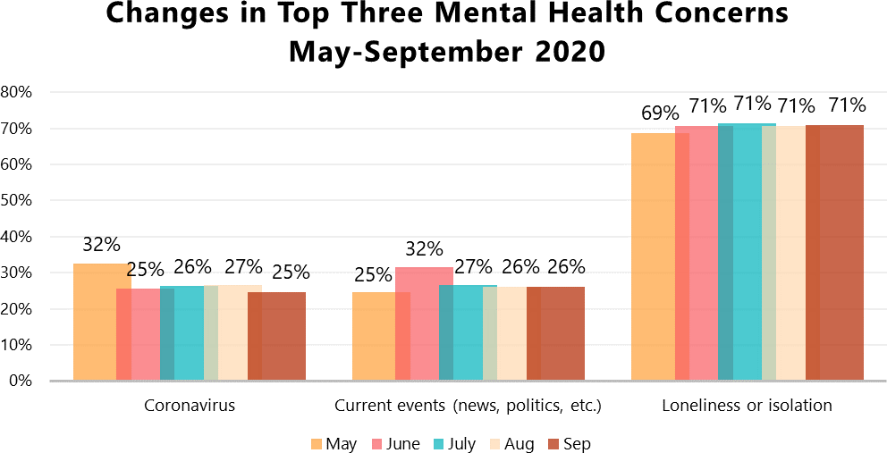

Think about your mental health test. What are the main things contributing to your mental health problems  right now? Choose up to 3. | Percentage, Individuals with Moderate to Severe Anxiety or  Depression, May | Percentage, Individuals with Moderate to Severe Anxiety or Depression,  June | Percentage, Individuals with Moderate to Severe Anxiety  or Depression, July | Percentage, Individuals with Moderate to Severe Anxiety or  Depression, August | Percentage, Individuals with Moderate to Severe Anxiety  or Depression, September
Coronavirus | 32.45% | 25.50% | 26.24% | 26.64% | 24.53%
Current events (news, politics, etc.) | 24.53% | 31.56% | 26.58% | 26.02% | 26.17%
Financial Problems | 23.19% | 23.64% | 24.27% | 24.79% | 23.46%
Loneliness or isolation | 68.81% | 70.70% | 71.35% | 70.77% | 70.69%
Grief or loss of someone or something | 26.63% | 25.88% | 26.22% | 26.64% | 26.27%
Past trauma | 46.70% | 45.55% | 46.65% | 46.56% | 45.58%
Relationship problems | 43.17% | 42.74% | 42.77% | 42.61% | 42.05%

Disproportionate Impact of Mental Health Concerns Among BIPOC Communities
The COVID-19 pandemic and the secondary impacts of the pandemic such as effects on food, housing and economic security have had a disproportionate impact on black, indigenous, and other communities of color. These in turn can create larger impacts on the mental health of individuals within these communities. To better understand existing unmet needs, inequities in care, and the disproportionate impact of COVID-19 on the mental health of traditionally underserved populations, MHA conducted an analysis of the 579,793 screens for anxiety and depression where race/ethnicity was reported from January 1st to September 22, 2020. For more detailed data tables accompanying each chart, click here.
Anxiety
For nearly all racial/ethnic groups, rates of moderate to severe anxiety increased during the last few days of February 2020 and into the beginning of March, as people became more aware of the pandemic and its spread into the United States. All racial/ethnic groups also experienced an increase in the rate of moderate to severe anxiety from the first weeks of May into the first weeks of June.
The September average for moderate to severe anxiety was higher than the monthly average for May-August for nearly every racial/ethnic group (excluding screeners who identified as more than one race and screeners who identified as another race, whose July averages were higher, and White screeners, whose August average was higher). Native American or American Indian screeners had the highest rate of anxiety in August and September, with 87% scoring with moderate to severe anxiety. However, Black or African American screeners had the highest average percent change over time for anxiety, at 0.74 percent, followed by screeners who identified with more than one race at 0.51 percent. From February to September, the average rate of moderate to severe anxiety among Black or African American screeners increased from 70 percent to 78 percent.
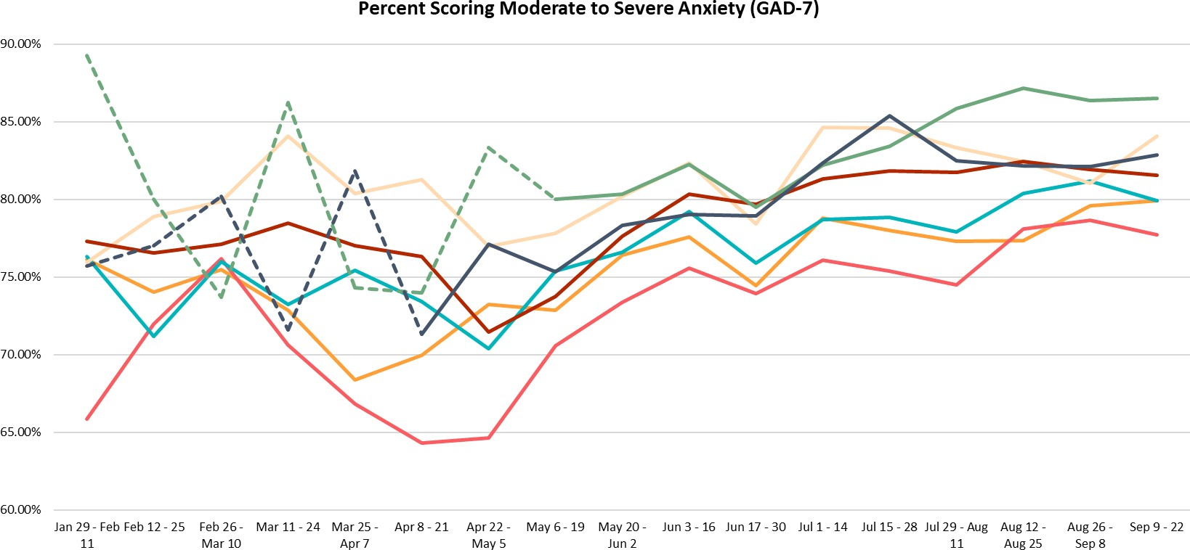

*Dotted line to represent where N < 100 people.

Depression
The September average for moderate to severe depression among Black or African American and Native American or American Indian screeners was higher than the monthly average for August 2020 (September averages were lower than August for every other race/ethnicity). Native American or American Indian screeners and screeners who identify with more than one race have the highest overall rates of depression, with 90 percent of screeners scoring with moderate to severe symptoms of depression in August and September.
However, Black or African American screeners had the highest average percent change over time for depression at 0.62 percent, followed by Native American or American Indian screeners at 0.56 percent and Hispanic or Latino screeners at 0.38 percent. From February to September, the percentage of Black or African American screeners scoring with symptoms of moderate to severe depression increased from 77 percent to 84 percent.
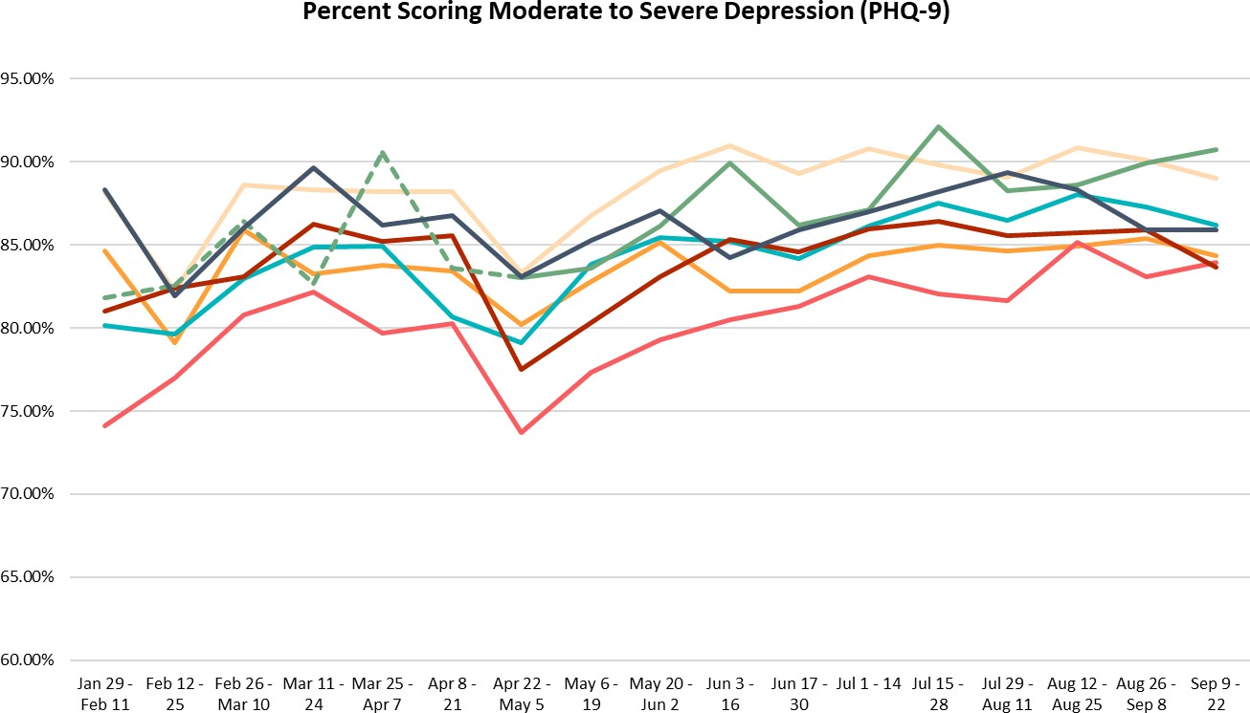

*Dotted line to represent where N < 100 people.

Suicidal Ideation
The September average for suicidal ideation was higher than the May-August averages, as well as the 2019 average for nearly every racial/ethnic group (excluding Asian or Pacific Islander and White screeners, whose August averages were higher). Since the end of May 2020, nearly every racial/ethnic group has been experiencing consistently higher rates of suicidal ideation than the 2019 average (excluding Native American or American Indian screeners and screeners who identified as another race/ethnicity, who experienced consistently higher rates of suicidal ideation than the 2019 average beginning in July).
Native American or American Indian screeners had the highest average percent change over time for suicidal ideation at 1.03 percent, followed by Asian or Pacific Islander screeners at 0.57 percent and Black or African American screeners at 0.55 percent. From February to September, rates of frequent suicidal ideation among Native American or American Indian screeners increased from 29 percent to 47 percent, although sample sizes of Native American or American Indian screeners were low until April. From February to September, the percentage of Asian or Pacific Islander screeners reporting suicidal ideation more than half or nearly every day increased from 36 percent to 43 percent, and among Black or African American screeners increased from 29 percent to 38 percent.
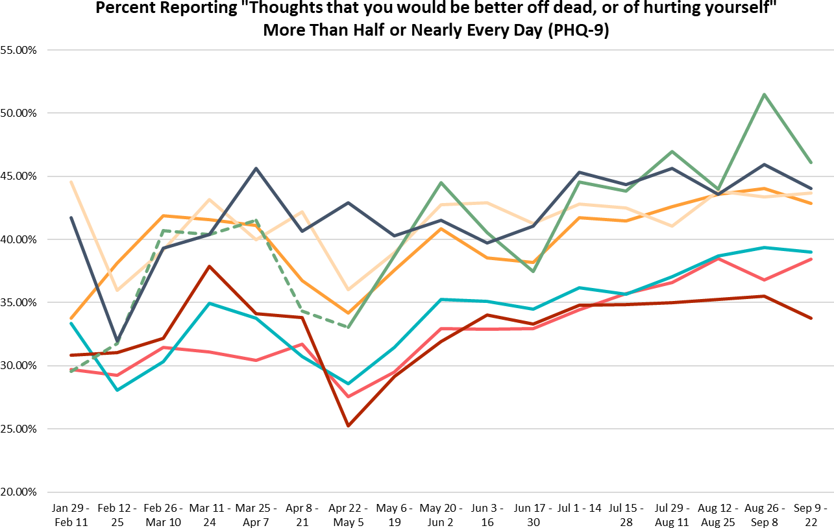

*Dotted line to represent where N < 100 people.

MHA will continue to report on real time analyses of data collected from MHA Screening on our website.
For more detailed information on the above analyses, and for more resources related to COVID-19, visit:
- Mental Health and COVID-19 Information and Resources: A compilation of resources and information to aid individuals and communities during the COVID-19 pandemic, including crisis resources, information for people with existing mental health conditions and resources for specific populations such as parents, caregivers, LGBTQ+ individuals, and older adults, among others.
- Mental Health Information and Resources for Frontline Workers: A compilation of resources on mental health during COVID-19 specifically created for frontline workers.
- MHA Center for Research and Innovation: to learn more about the MHA Screening Program and access other research and reports published using screening data, including rapid analyses of COVID-19 data.
- MHA News: to access MHA Press Releases, including monthly analyses of screening data during COVID- 19.
- Screening 2 Supports: an interactive online space providing resources and supports for individuals to better their mental health in four domains: information and psychoeducation (“Learn”); information about treatment options and referrals to care (“Treatment”); do-it-yourself tools (“DIY”); and online engagement with peers (“Connect”).
- MHA Screening Tools: a collection of ten clinically validated screening tools for individuals to check on their mental health. Click here to take a screen.

Glossary

Indicator | Description of Measure | Source
Adults with Any Mental Illness (AMI) | Any Mental Illness (AMI) is defined as having a diagnosable mental, behavioral, or emotional disorder, other than a developmental or substance use disorder, assessed by the Mental Health Surveillance Study (MHSS) Structured Clinical Interview for the Diagnostic and Statistical Manual of Mental Disorders—Fourth Edition—Research Version—Axis I Disorders (MHSS-SCID), which is based on the 4th edition of the Diagnostic and Statistical Manual of Mental Disorders (DSM-IV). For details, see Section B of the "2017-2018 NSDUH: Guide to State Tables and Summary of Small Area Estimation Methodology" at https://www.samhsa.gov/data/.  Data survey years: 2017-2018. | SAMHSA, Center for Behavioral Health Statistics and Quality, National Survey on Drug Use and Health, https://www.samhsa.go v/data/sites/default/file s/cbhsq- reports/NSDUHMethods SummDefs2018/NSDUH MethodsSummDefs201 8.htm#appa
Adults with AMI  Reporting Unmet Need | AMIYR_U, is an indicator for Any Mental Illness (AMI) based on the 2012 revised predicted probability of SMI (SMIPP_U). If SMIPP_U is greater than or equal to a specified cutoff point (0.0192519810) then AMIYR_U=1, and if SMIPP_U is less than the cutoff point then AMIYR_U=0. This indicator based on the 2012 model is not comparable with the indicator based on the 2008 model. AMI is defined as having Serious, Moderate, or Mild Mental Illness. Specific details about this variable can be found in the Recoded Mental Health Appendix.  AMHTXND2 is defined as feeling a perceived need for mental health treatment/counseling that was not received. This is often referred to as "unmet need." Mental Health Treatment/Counseling is defined as having received inpatient treatment/counseling or outpatient treatment/counseling or having used prescription medication for problems with emotions, nerves, or mental health. Respondents were not to include treatment for drug or alcohol use. Respondents with unknown treatment/counseling information were excluded.  Data survey years: 2017-2018. | SAMHSA, Center for Behavioral Health Statistics and Quality, National Survey on Drug Use and Health. https://www.datafiles.s amhsa.gov/info/nsduh- rdas-codebooks- nid17216
Adults with AMI Who are Uninsured | For IRINSUR4, a respondent is classified as having any health insurance (IRINSUR4=1) if they satisfied ANY of the following conditions. (1) Covered by private insurance (IRPRVHLT=1) (2) Covered by Medicare (IRMEDICR=1)  (3) Covered by Medicaid/CHIPCOV (IRMCDCHP=1) (4) Covered by Champus, ChampVA, VA, or Military (IRCHMPUS=1) (5) Covered by other health insurance (IROTHHLT=1) A respondent is classified as NOT having any health insurance (IRINSUR4=2) if they meet EVERY one of the following conditions. (1) Not covered by private insurance (IRPRVHLT=2) (2) Not covered by Medicare (IRMEDICR=2) (3) Not covered by Medicaid/CHIPCOV (IRMCDCHP=2) (4) Not covered by Champus, ChampVA, VA, or Military (IRCHMPUS=2) (5) Not covered by other health insurance (IROTHHLT=2)  Data survey years: 2017-2018. | SAMHSA, Center for Behavioral Health Statistics and Quality, National Survey on Drug Use and Health. https://www.datafiles.s amhsa.gov/info/nsduh- rdas-codebooks- nid17216

Indicator | Description of Measure | Source
Adult with Substance Abuse Disorder in the Past Year. | Substance Use Disorder is defined as meeting criteria for illicit drug or alcohol dependence or abuse. Dependence or abuse is based on definitions found in the 4th edition of the Diagnostic and Statistical Manual of Mental Disorders (DSM-IV). Illicit Drug Use includes the misuse of prescription psychotherapeutics or the use of marijuana, cocaine (including crack), heroin, hallucinogens, inhalants, or methamphetamine. Misuse of prescription psychotherapeutics is defined as use in any way not directed by a doctor, including use without a prescription of one's own; use in greater amounts, more often, or longer than told; or use in any other way not directed by a doctor. Prescription psychotherapeutics do not include over-the-counter drugs.  Data survey years: 2017-2018. | SAMHSA, Center for Behavioral Health Statistics and Quality, National Survey on Drug Use and Health, https://www.samhsa.gov  /data/report/2018- nsduh-detailed-tables
Adults with Cognitive Disability Who Could Not See a Doctor Due to Costs | Disability questions were added to the Behavioral Risk Factor Surveillance System (BRFSS) core questionnaire in 2004. The question: “Are you limited in any way in any activities because of physical, mental or emotional problems?” (QLACTLM2), which was previously used to calculate this indicator, was removed in 2016. Disability was determined using the following BRFSS question: “Because of a physical, mental, or emotional condition, do you have serious difficulty concentrating, remembering, or making decisions?” (DECIDE). Respondents were defined as having a cognitive disability if they answered “Yes” to this question. Respondents were also asked: “Was there a time in the past 12 months when you needed to see a doctor but could not because of cost?” (MEDCOST). The measure was calculated based on individuals who answered Yes to MEDCOST among those who answered Yes to DECIDE.  Data survey year 2018. | Centers for Disease Control and Prevention (CDC). Behavioral Risk Factor Surveillance System Survey Data.  Atlanta, Georgia: U.S. Department of Health and Human Services, Centers for Disease Control and Prevention, 2018.  https://www.cdc.gov/brf ss/annual_data/annual_2 018.html  Downloaded and calculated on 5/27/20.
Adults with Serious Thoughts of Suicide | Adults aged 18 or older were asked, "At any time in the past 12 months, did you seriously think about trying to kill yourself?" If they answered "Yes," they were categorized as having serious thoughts of suicide in the past year.  Data survey year: 2017-2018. | SAMHSA, Center for Behavioral Health Statistics and Quality, National Survey on Drug Use and Health, https://www.samhsa.gov  /data/report/2018- nsduh-detailed-tables
Children with private insurance that did not cover mental or emotional problems | Children with private insurance that did not cover mental or emotional problems is defined as any child age 12-17 responding NO to HLTINMNT. HLTINMNT is defined as: “Does [SAMPLE MEMBER POSS] private health insurance include coverage for treatment for mental or emotional problems?  Data survey years: 2017-2018. | SAMHSA, Center for Behavioral Health Statistics and Quality, National Survey on Drug Use and Health, https://www.datafiles.sa mhsa.gov/info/nsduh- rdas-codebooks-  nid17216

Adults with AMI who did not receive mental health treatment | AMHTXRC-3 is a recoded variable with levels 1=Yes (Received any mental health treatment in past year) and 2=No (Did not receive any mental health treatment in past year). Recoded from variable AMHSVTYP, classifies what type of mental health treatment/counseling was received in the past year. Respondents who reported receiving treatment for mental health were classified in one of seven mutually exclusive categories. A respondent was assigned to level one if they reported receiving inpatient treatment only (AMHINP2=1 and AMHOUTP3=2 and AMHRX2=2), to level two if they reported receiving outpatient treatment only (AMHINP2=2 and AMHOUTP3=1 and AMHRX2=2), to level three if they reported receiving prescription medication treatment only (AMHINP2=2 and AMHOUTP3=2 and AMHRX2=1), to level four if they reported receiving both inpatient and outpatient treatment only (AMHINP2=1 and AMHOUTP3=1 and AMHRX2=2), to level five if they reported receiving inpatient and prescription medication treatment only (AMHINP2=1 and AMHOUTP3=2 and AMHRX2=1), to level six if they reported receiving outpatient and prescription medication treatment only (AMHINP2=2 and AMHOUTP3=1 and AMHRX2=1), or to level seven if they reported receiving inpatient, outpatient, and prescription medication treatment (AMHINP2=1 and AMHOUTP3=1 and AMHRX2=1). Respondents who did not receive mental health treatment in the past year were assigned to level eight (AMHINP2=2 and AMHOUTP3=2 and AMHRX2=2).  Adults with AMI who did not receive mental health treatment was calculated, where AMHTXRC-3= 2 (No treatment) and AMIYR_U indicates AMI.  Data survey years: 2017-2018. | SAMHSA, Center for Behavioral Health Statistics and Quality, National Survey on Drug Use and Health, https://www.datafiles.sa mhsa.gov/info/nsduh- rdas-codebooks- nid17216

Indicator | Description of Measure | Source
Mental Health Workforce Availability | Mental health workforce availability is the ratio of the county population to the number of mental health providers including psychiatrists, psychologists, licensed clinical social workers, counselors, marriage and family therapists and advanced practice nurses specializing in mental health care. In 2015, marriage and family therapists and mental health providers that treat alcohol and other drug abuse were added to this measure.  Survey data year: 2019. | County Health Rankings & Roadmaps. http://www.cou ntyhealthrankings.org/  This data comes from the National Provider Identification data file, which has some limitations. Providers who transmit electronic health records are required to obtain an identification number, but very small providers may not obtain a number. While providers have the option of deactivating their identification number, some mental health professionals included in this list may no longer be practicing or accepting new clients.
Students Identified with Emotional Disturbance for Individualized Education Program Individualized Education Program | Percent of Children Identified as having an Emotional Disturbance among enrolled students Grade 1-12 and Ungraded. This measure was calculated from data provided by IDEA Part B Child Count and Educational Environments, Common Core of Data. Under IDEA regulation, Emotional Disturbance is identified as a condition exhibiting one or more of the following characteristics over a long period of time and to a marked degree that adversely affects a child's educational performance: (A) An inability to learn that cannot be explained by intellectual, sensory, or health factors. (B) An inability to build or maintain satisfactory interpersonal relationships with peers and teachers. (C) Inappropriate types of behavior or feelings under normal circumstances. (D) A general pervasive mood of unhappiness or depression. (E) A tendency to develop physical symptoms or fears associated with personal or school problems. Emotional disturbance includes schizophrenia. The term does not apply to children who are socially maladjusted, unless it is determined that they have an emotional disturbance.  Data years 2017-2018. | IDEA Data Center, 2017 – 2018 IDEA Section 618, State Level Data Files, Child Count and Educational Environments. https://www2.ed.gov/pro grams/osepidea/618- data/state-level-data- files/index.html#bccee  US Department of Education, National Center for Education Statistics, Common Core of Data. https://nces.ed.gov/ccd/st nfis.asp  Downloaded and calculated on 5/27/2020.

Indicator | Description of Measure | Source
Youth with At Least One Past Year Major Depressive Episode (MDE) | Among youth age 12-17, Major Depressive Episode (MDE) is defined as in the 5th edition of the Diagnostic and Statistical Manual of Mental Disorders (DSM-5), which specifies a period of at least 2 weeks when an individual experienced a depressed mood or loss of interest or pleasure in daily activities and had a majority of specified depression symptoms. For details, see Section B of the "2017-2018 NSDUH: Guide to State Tables and Summary of Small Area Estimation Methodology" at https://www.samhsa.gov/data/.  Data survey year 2017-2018. | SAMHSA, Center for Behavioral Health Statistics and Quality, National Survey on Drug Use and Health, 2017-2018.  https://www.samhsa.gov/ data/report/2018-nsduh- detailed-tables
Youth with Substance Abuse Disorder in the Past Year. | Among youth 12-17, substance Use Disorder is defined as meeting criteria for illicit drug or alcohol dependence or abuse. Dependence or abuse is based on definitions found in the 4th edition of the Diagnostic and Statistical Manual of Mental Disorders (DSM-IV). Illicit Drug Use includes the misuse of prescription psychotherapeutics or the use of marijuana, cocaine (including crack), heroin, hallucinogens, inhalants, or methamphetamine. Misuse of prescription psychotherapeutics is defined as use in any way not directed by a doctor, including use without a prescription of one's own; use in greater amounts, more often, or longer than told; or use in any other way not directed by a doctor. Prescription psychotherapeutics do not include over-the-counter drugs.  Data survey years: 2017-2018 | SAMHSA, Center for Behavioral Health Statistics and Quality, National Survey on Drug Use and Health, https://www.samhsa.gov/ data/report/2018-nsduh- detailed-tables
Youth with MDE who Did Not Receive Mental Health Services | Youth with Past Year MDE who Did Not Receive Treatment is defined as those who apply to having Past Year MDE as defined above (“Youth with At Least One Past Year Major Depressive Episode,” YMDEYR) and respond NO to ANYSMH2.  ANYSMH2 indicates whether a youth reported receiving specialty mental health services in the past year from any of 6 specific inpatient/residential or outpatient specialty sources for problems with behavior or emotions that were not caused by alcohol or drugs. This variable was created based on the following 7 source of treatment variables: stayed overnight in a hospital (YHOSP), stayed in a residential treatment facility (YRESID), spent time in a day treatment facility (YDAYTRT), received treatment from a mental health clinic (YCLIN), from a private therapist (YTHER), and from an in-home therapist (YHOME). Youths who reported a positive response (source variable=1) to one or more of the 6 questions were included in the yes category regardless of how many of the 6 questions they answered. Youths who did not report a positive response but answered all 6 of the questions were included in the no category. Youths who did not report a positive response and did not answer all the  questions, and adults were included in the unknown/18+ category.  Data survey year 2017-2018. | SAMHSA, Center for Behavioral Health Statistics and Quality, National Survey on Drug Use and Health https://www.datafiles.sa mhsa.gov/info/nsduh- rdas-codebooks-nid17216

Indicator | Description of Measure | Source
Youth with Severe MDE | Youth with severe MDE is defined as having had MDE in the past year were then asked questions from the SDS to measure the level of functional impairment in major life activities reported to be caused by the MDE in the past 12 months (Leon, Olfson, Portera, Farber, & Sheehan, 1997). The SDS measures mental health-related impairment in four major life activities or role domains. The following variable, YSDSOVRL, is assigned the maximum level of interference over the four role domains of SDS: chores at home (YSDSHOME), school or work (YSDSWRK), family relationships (YSDSREL), and social life (YSDSSOC). Each module consists of four questions that are assessed on a 0 to 10 visual analog scale with categories of "none" (0), "mild" (1-3), "moderate" (4-6), "severe" (7-9), and "very severe" (10). The four SDS role domain variables were recoded so that no interference = 1, mild = 2, moderate = 3, severe = 4, and very severe = 5. A maximum level of interference over all four domains was then defined as YSDSOVRL. A maximum impairment score (YSDSOVRL) is defined as the single highest severity level of role impairment across all four SDS role domains. Ratings greater than or equal to 7 on the scale YSDSOVRL=4, 5 were considered severe impairment.  “Youth with Severe MDE” is defined as the following variable MDEIMPY. MDEIMPY is derived from the maximum severity level of MDE role impairment (YSDSOVRL) and is restricted to adolescents with past year MDE (YMDEYR). Youth met criteria for MDEIMPY if they answered YES to YSDSOVRL and YES to YMDEYR.  Data survey years 2017-2018. | SAMHSA, Center for Behavioral Health Statistics and Quality, National Survey on Drug Use and Health https://www.datafiles.sa mhsa.gov/info/nsduh- rdas-codebooks-nid17216
Youth with Severe MDE who Received Some Consistent Treatment | The following variable calculated as how many youths who answered YES to MDEIMPY from “Youth with severe MDE” defined above and SPOUTVST. The variable SPOUTVST, indicates how many times a specialty outpatient mental health service was visited in the past year. The number of visits is calculated by adding the number of visits to a day treatment facility (YUDYTXNM), mental health clinic (YUMHCRNM), private therapist (YUTPSTNM), and an in-home therapist (YUIHTPNM). A value of 6 (No Visits) was assigned whenever a respondent said they had used none of the services (YUDYTXYR, YUMHCRYR, YUTPSTYR, YUIHTPYR all equal 2). A value of missing was assigned when the response to whether received treatment or number of visits was unknown for any of the 4 locations (any of YUDYTXYR, YUMHCRYR, YUTPSTYR, YUIHTPYR=85, 94, 97, 98 OR any of YUDYTXNM, YUMHCRNM, YUTPSTNM, YUIHTPNM=985, 994, 997,  998), unless sum of the visits for services with non-missing information was greater than or equal to 25, in which case a value of 5 (25 or more visits) was assigned. A missing value was also assigned for respondents aged 18 or older. The variable SPOUTVST was recoded for visit distribution as 0-6 Visits, and 7-25+ Visits. Some consistent treatment was considered 7-25+ visits in a year. Data survey years 2017-2018. | Substance Abuse and Mental Health Services Administration. Center for Behavioral Health Statistics and Quality. https://www.datafiles.sa mhsa.gov/info/nsduh- rdas-codebooks-nid17216

