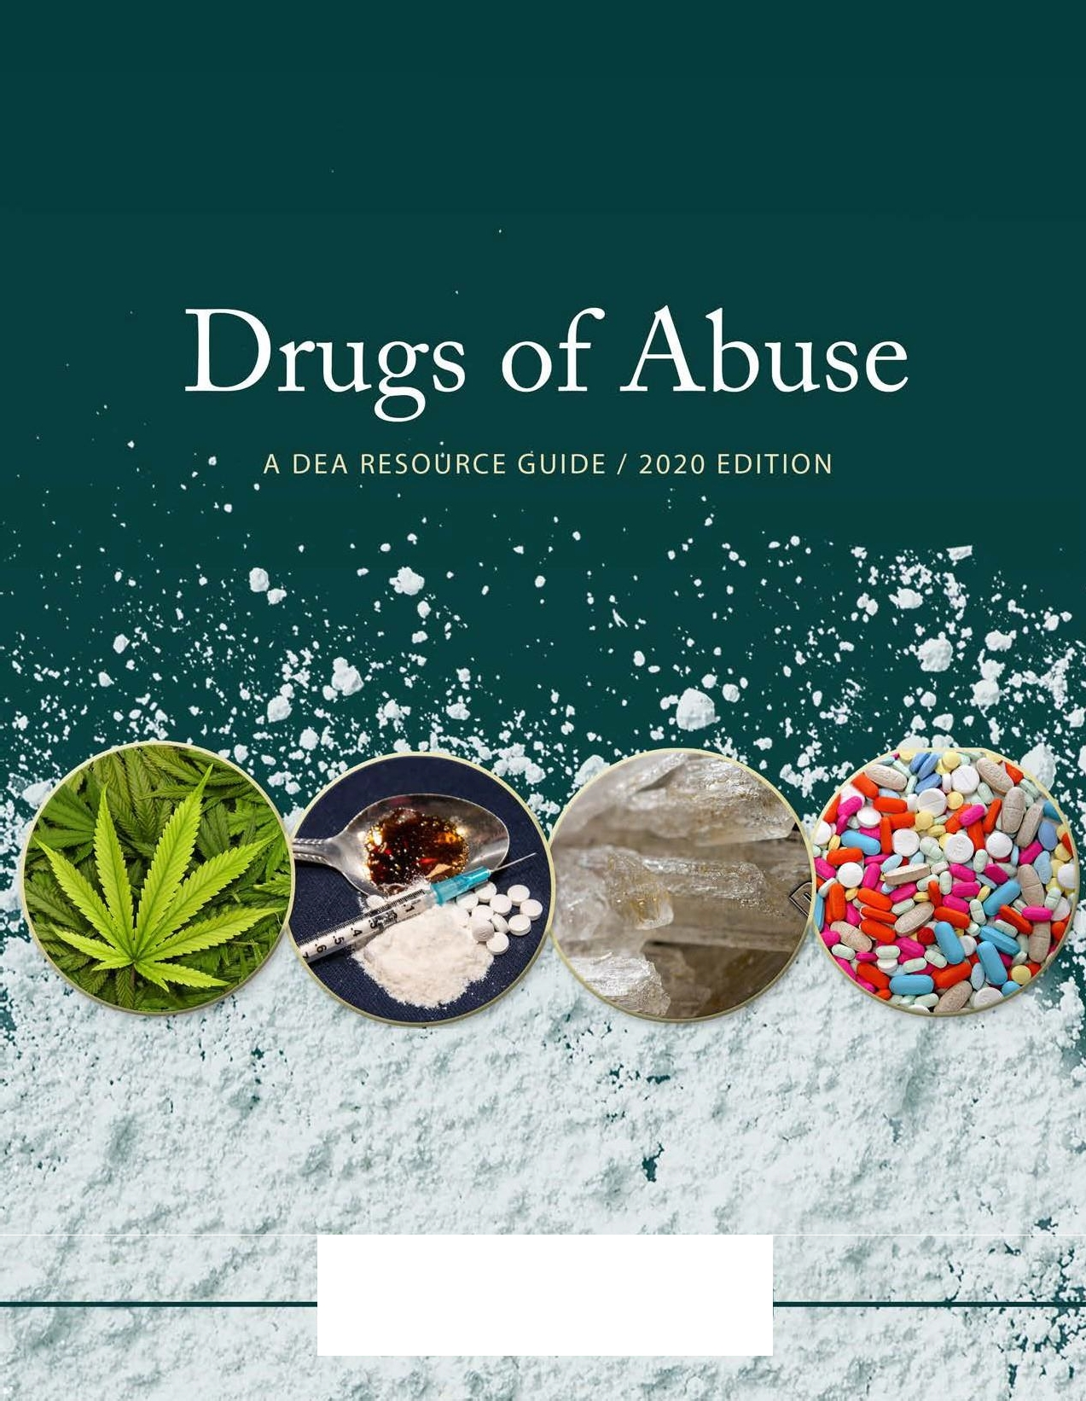

"''"" - USDEPARTMENT OF JUSTICE
ENFORCEMENT ADMINISTRATION
)}
D G
-,:-,_ .,._t'
( •.,,,,,,.,,1¥"'1"'

Drugs of Abuse

A DEA RESOURCE GUIDE

2020 Edition

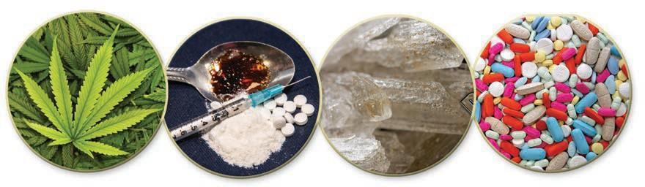

PRODUCED AND PUBLISHED BY
Drug Enforcement Administration, U.S. Department of Justice

Contents

Welcome 5
- Controlled Substances Act 6
Drug Scheduling 18
Schedule I 18
Schedule II 26
Schedule III 28
Schedule IV 32
Schedule V 35
Federal Trafficking Penalties 36
Federal Trafficking Penalties—Marijuana 37
- U.S. Chemical Control 38
- Introduction to Drug Classes 44
Narcotics 48
Fentanyl 50
Heroin 52
Hydromorphone 54
Methadone 56
Morphine 57
Opium 58
Oxycodone 59
Stimulants 60
Amphetamines 62
Cocaine 63
Khat 65
Methamphetamine 66
Depressants 68
Barbiturates 70
Benzodiazepines 71
GHB 72
Rohypnol ® 74
Hallucinogens 76
Ecstasy/MDMA 78
Ketamine 80
LSD 82
Peyote & Mescaline 83
Psilocybin 84
Steroids 86
Marijuana/Cannabis 88
Marijuana Concentrates 91
Vaping 92
Inhalants 94
Designer Drugs 96
Bath Salts 96
K2/Spice 98
Synthetic Opioids 100
Drugs of Concern 102
DXM 102
Kratom 104
Salvia Divinorum 105
- Resources 106

Welcome

TO THE LATEST EDITION OF DRUGS OF ABUSE

Education plays a critical role in preventing substance abuse. Drugs of Abuse, A DEA Resource Guide, is designed to be a reliable resource on the most commonly abused and misused drugs in the United States. This comprehensive guide provides important information about the harms and consequences of drug use by describing a drug’s effects on the body and mind, overdose potential, origin, legal status, and other key facts.
Drugs of Abuse also offers a list of additional drug education and prevention resources, including the DEA websites:

www.DEA.gov; www.JustThinkTwice.com, aimed at teenagers; www.GetSmartAboutDrugs.com, designed for parents, educators, and caregivers; www.CampusDrugPrevention.gov, for higher education, and www.OperationPrevention.com for opioid curricula.

Drugs of Abuse | A DEA Resource Guide: 2020 EDITION 5

Controlled Substances Act

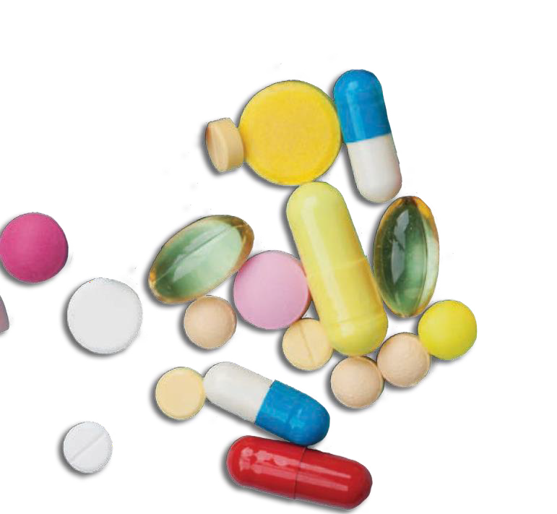Controlled Substances Act

CONTROLLING DRUGS OR OTHER SUBSTANCES THROUGH FORMAL SCHEDULING

The Controlled Substances Act (CSA) places all substances which were in some manner regulated under existing federal law into one of five schedules. This placement is based upon the substance’s accepted medical use, potential for abuse, and safety or dependence liability. The Act also provides a mechanism for substances to be controlled (added to or transferred between schedules) or decontrolled (removed from control). The procedure for these actions is found in Section 201 of the Act (21U.S.C.
§811).
Proceedings to add, delete, or change the schedule of a drug or other substance may be initiated by the Drug Enforcement Administration (DEA), the Department of Health and Human Services (HHS), or by petition from any interested party, including:

      - The manufacturer of a drug
      - A medical society or association
      - A pharmacy association
      - A public interest group concerned with drug abuse
      - A state or local government agency
      - An individual citizen

When a petition is received by the DEA, the agency begins its own investigation of the drug. The DEA also may begin an investigation of a drug at any time based upon information received from law enforcement laboratories, state and local law enforcement and regulatory agencies, or other sources of information.
Once the DEA has collected the necessary data, the DEA Administrator, by authority of the Attorney

Drugs of Abuse 2020 EDITION: A DEA Resource Guide 7

General, requests from HHS a scientific and medical evaluation and recommendation as to whether the drug or other substance should be controlled or removed from control. This request is sent to the Assistant Secretary for Health of HHS.
The Assistant Secretary, by authority of the Secretary, compiles the information and transmits back to the DEA: a medical and scientific evaluation regarding the drug or other substance, a recommendation as to whether the drug should be controlled, and in what schedule it should be placed.
The medical and scientific evaluations are binding on the DEA with respect to scientific and medical matters and form a part of the scheduling decision.
Once the DEA has received the scientific and medical evaluation from HHS, the Administrator will evaluate all available data and make a final decision whether to propose that a drug or other substance should be removed or controlled and into which schedule it should be placed.
If a drug does not have a potential for abuse, it cannot be controlled. Although the term “potential for abuse” is not defined in the CSA, there is much discussion of the term in the legislative history of the Act. The following items are indicators that a drug or other substance has a potential for abuse:
- There is evidence that individuals are taking the drug or other substance in amounts sufficient to create a hazard to their health or to the safety of other individuals or to the community.
- There is significant diversion of the drug or other substance from legitimate drug channels.
- Individuals are taking the drug or other substance on their own initiative rather than on
the basis of medical advice from a practitioner.
- The drug is a new drug so related in its action to a drug or other substance already listed as having a potential for abuse to make it likely that the drug will have the same potential for abuse as such drugs, thus making it reasonable to assume that there may be significant diversions from legitimate channels, significant use contrary to or without medical advice, or that it has a substantial capability of creating hazards to
the health of the user or to the safety of the community. Of course, evidence of actual abuse of a substance is indicative that a drug has a potential for abuse.
In determining into which schedule a drug or other substance should be placed, or whether a substance should be decontrolled or rescheduled, certain factors are required to be considered.
These factors are listed in Section 201 (c), [21
U.S.C. § 811 (c)] of the CSA as follows:

- The drug’s actual or relative potential for abuse.

- Scientific evidence of the drug’s pharmacological effect, if known. The state of knowledge with respect to the effects of a specific drug is, of course, a major consideration. For example, it is vital to know whether or not a drug has a hallucinogenic effect if it is to be controlled due to that effect.
The best available knowledge of the pharmacological properties of a drug should be considered.

- The state of current scientific knowledge regarding the substance. Criteria (2) and (3) are closely related. However, (2) is primarily

8 Drugs of Abuse | A DEA Resource Guide: 2020 EDITION

concerned with pharmacological effects and (3) deals with all scientific knowledge with respect to the substance.

- Its history and current pattern of abuse. To determine whether or not a drug should be controlled, it is important to know the pattern of abuse of that substance.

- The scope, duration, and significance of abuse. In evaluating existing abuse, the DEA Administrator must know not only the pattern of abuse, but also whether the abuse is widespread.

- What, if any, risk there is to the public health. If a drug creates dangers to the public health, in addition to or because of its abuse potential, then these dangers must also be considered by the Administrator.

- The drug’s psychic or physiological dependence liability. There must be an assessment of the extent to which a drug is physically addictive or psychologically habit forming.

- Whether the substance is an immediate precursor of a substance already controlled. The CSA allows inclusion of immediate precursors on this basis alone into the appropriate schedule and thus safeguards against possibilities of clandestine manufacture. After considering the above listed factors, the Administrator must make specific findings concerning the drug or other substance. This will determine into which schedule the drug or other substance will be placed. These schedules are
established by the CSA. They are as follows:

Schedule I
- The drugorother substancehasa highpotential for abuse.
- The drug or other substance has no currently accepted medical usein treatmentin the United States.
- There is a lack of accepted safety for use of the drug or othersubstance undermedicalsupervision.
- Examples of Schedule I substances include heroin, gamma hydroxybutyric acid (GHB), lysergic acid diethylamide (LSD), marijuana, and methaqualone.

Schedule II
- The drugorother substancehasa highpotential for abuse.
- The drug or other substance has a currently accepted medicaluseintreatment inthe United States or
a currently accepted medical use with severe restrictions.
- Abuse of the drug orothersubstance maylead to severe psychological orphysical dependence.
- Examples of Schedule II substances include morphine, phencyclidine (PCP), cocaine, methadone, hydrocodone, fentanyl, and methamphetamine.

Schedule III
- The drug orother substance hasless potential forabusethanthedrugsorothersubstancesin Schedules I and II.
- The drug or other substance has a currently accepted medical useintreatment in the United States.
- Abuse of the drug or other substance may lead to moderate or low physical dependence or high psychological dependence.
- Anabolic steroids, codeine products with aspirin or acetaminophen, and some barbiturates are examples of Schedule IIIsubstances.

Drugs of Abuse | A DEA Resource Guide: 2020 EDITION 9

Schedule IV
  - The drug orother substance hasa low potential for abuse relative to the drugs or other substances in Schedule III.
  - The drug or other substance has a currently accepted medical useintreatmentinthe United States.
  - Abuse of the drug or other substance may lead to limited physical dependence or psychological
dependence relative to the drugs or other substances in Schedule III.
  - Examples of drugs included in Schedule IV are alprazolam,clonazepam,anddiazepam.

Schedule V
  - The drug or other substance has a low potential for abuse relative to the drugs or other substances in Schedule IV.
  - The drug or other substance has a currently accepted medical useintreatmentinthe United States.
  - Abuseofthedrugorothersubstancesmaylead to limited physical dependence or psychological
dependence relative to the drugs or other substances in Schedule IV.
  - Cough medicines with codeine are examples of Schedule V drugs.

When the DEA Administrator has determined that a drug or other substance should be controlled, decontrolled, or rescheduled, a proposal to take action is published in the Federal Register. The proposal invites all interested persons to file comments with the DEA and may also request a hearing with the DEA. If no hearing is requested, the DEA will evaluate all comments received and publish a final order in the Federal Register, controlling the drug as proposed or with modifications based upon the written comments
filed. This order will set the effective dates for imposing the various requirements of the CSA.
If a hearing is requested, the DEA will enter into discussions with the party or parties requesting
a hearing in an attempt to narrow the issue for litigation. If necessary, a hearing will then be held before an Administrative Law Judge. The judge will take evidence on factual issues and hear arguments on legal questions regarding the control of the drug. Depending on the scope and complexity of the issues, the hearing may be brief or quite extensive. The Administrative Law Judge, at the close of the hearing, prepares findings of fact and conclusions of law and a recommended decision that is submitted to the DEA Administrator. The DEA Administrator will
review these documents, as well as the underlying material, and prepare his/her own findings of fact and conclusions of law (which may or may not be the same as those drafted by the Administrative Law Judge). The DEA Administrator then publishes a final order in the Federal Register either scheduling the drug or other substance or declining to do so.
Once the final order is published in the Federal Register, interested parties have 30 days to appeal to a U.S. Court of Appeals to challenge the order. Findings of fact by the Administrator are deemed conclusive if supported by “substantial evidence.” The order imposing controls is not stayed during the appeal, however, unless so ordered by the Court.

Emergency or Temporary Scheduling The CSA was amended by the Comprehensive Crime Control Act of 1984. This Act included a provision which allows the DEA Administrator to place a substance, on a temporary basis, into

10 Drugs of Abuse | A DEA Resource Guide: 2020 EDITION

Schedule I, when necessary, to avoid an imminent hazard to public safety.
This emergency scheduling authority permits the scheduling of a substance which is not currently controlled, is being abused, and is a risk to public health while the formal rulemaking procedures described in the CSA are being conducted. This emergency scheduling applies only to substances with no accepted medical use.
A temporary scheduling order may be issued for two years with a possible extension of up to one year if formal scheduling procedures have been initiated. The notice of intent and order are published in the Federal Register, as are the proposals and orders for formal scheduling. [21
U.S.C. § 811 (h)]

Controlled Substance analogues Controlled substance analogues are substances that are not formally controlled substances,
but may be found in illicit trafficking. They are structurally or pharmacologically similar to Schedule I or II controlled substances and have no legitimate medical use. A substance that meets the definition of a controlled substance analogue and is intended for human consumption may be treated under the CSA as if it were a controlled substance in Schedule I. [21 U.S.C. § 802(32), 21
U.S.C. § 813]

International treaty obligations
United States treaty obligations may require that a drug or other substance be controlled under the CSA, or rescheduled if existing controls are less stringent than those required by a treaty. The procedures for these scheduling actions are found in Section 201 (d)of the Act. [21 U.S.C. § 811 (d)]
The United States is a party to the Single
Convention on Narcotic Drugs of 1961, which was designed to establish effective control over
international and domestic traffic in narcotics, coca leaf, cocaine, and cannabis. A second treaty, the Convention on Psychotropic Substances of 1971, which entered into force in 1976 and was ratified by Congress in 1980, is designed to establish comparable control over stimulants, depressants, and hallucinogens.

REGULATION
The CSA creates a closed system of distribution for controlled substances. The cornerstone of this system is the registration of all those authorized by DEA to handle controlled substances. All individuals and firms that are registered are required to maintain complete and accurate inventories, and records of all transactions involving controlled substances, as well as security for the storage of controlled substances.

Registration
Any person who handles or intends to handle controlled substances must obtain a registration issued by DEA. A unique number is assigned to each legitimate handler of controlled drugs such as importer, exporter, manufacturer, distributor, hospital, pharmacy, practitioner, and researcher.
This number must be made available to the supplier by the customer prior to the purchase of a controlled substance, and its validity can be verified online through the Diversion Control Division website at www.DEAdiversion.usdoj. gov. Thus, the opportunity for unauthorized transactions is greatly diminished.

Drugs of Abuse | A DEA Resource Guide: 2020 EDITION 11

Recordkeeping and Reporting
The CSA requires that complete and accurate records be kept of all quantities of controlled substances manufactured, imported, exported, received, delivered, distributed, dispensed,
or otherwise disposed. Each substance must be physically inventoried every two years.
Some limited exceptions to the recordkeeping requirements apply to certain categories of registrants.
From these records it is possible to trace the flow of any drug from the time it is first imported or manufactured, through the distribution level, to the pharmacy or hospital that dispensed it, and then to the actual patient who received the drug. The mere existence of this requirement is sufficient to discourage many forms of diversion. It actually serves large drug corporations as an internal check to uncover diversion, such as pilferage by employees.
There is one distinction between scheduled items for record keeping requirements. Records for Schedule I and II drugs must be kept separate from all other records maintained by the registrant. Records for Schedule III, IV, and V substances must be kept in a “readily retrievable” form, or maintained separately from all other records.

Distribution
Maintaining records is required for distribution of a controlled substance from one manufacturer to
another, from manufacturer to distributor, and from distributor to dispenser. In the case of Schedule
I and II drugs, the supplier must first receive a special order from the customer. This order form (DEA Form 222) is issued by DEA only to persons who are properly registered to handle Schedule I and II controlled substances.
The form is preprinted with the name and address of the customer. The drugs must be shipped to this name and address. The use of this form is a special reinforcement of the registration requirement; it ensures that only authorized individuals may obtain Schedule I and II drugs.

Controlled Substance Ordering System (CSOS)
– Electronic Order Forms
Any registrant permitted to order Schedule II controlled substances may do so electronically via the DEA Controlled Substance Ordering System (CSOS). The use of electronic orders is optional; registrants may continue to issue orders on a paper DEA Form 222. CSOS allows for secure electronic transmission of controlled substance orders without the supporting paper DEA Form
222. The adoption of the CSOS standards is the only allowance for the electronic transmission of Schedule II controlled substance orders between controlled substance manufacturers, distributors, pharmacies, and other DEA authorized entities. CSOS uses Public Key Infrastructure (PKI) technology, which requires CSOS users to obtain a CSOS digital certificate for electronic ordering. The electronic orders must be signed using a digital signature issued by a Certification Authority (CA) operated by DEA.
Digital certificates can be obtained only by registrants and individuals granted power of attorney by registrants to sign orders. A registrant must appoint a CSOS coordinator who will serve as that registrant’s recognized agent regarding issues pertaining to issuance of, revocation
of, and changes to, digital certificates issued under that registrant’s DEA registration. A CSOS digital certificate will be valid until the DEA registration under which it is issued expires or

12 Drugs of Abuse | A DEA Resource Guide: 2020 EDITION

until the CSOS CA is notified that the certificate should be revoked. Certificates will be revoked if the certificate holder is no longer authorized to sign Schedule II orders for the registrant, if the information on which the certificate is based changes, or if the digital certificate used to sign
electronic orders has been compromised, stolen, or lost.
One benefit of using the CSOS system is that participants who are registered in other schedules in addition to Schedule II can then use this same system to also order those other controlled substances.
Another benefit of the DEA Form 222 is the special monitoring it permits. The form is issued in triplicate: the customer keeps one copy; two copies go to the supplier, who, after filling the
order, keeps a copy and forwards the third copy to the nearest DEA office.
For drugs in Schedules III, IV, and V, no order form is necessary, but both the supplier and the purchaser must still maintain records of all
transactions involving these controlled substances and those records must contain specific information required by DEA regulation.
The supplier in each case, however, is under an obligation to verify the authenticity of the customer. The supplier is held fully accountable for any drugs that are shipped to a purchaser who does not have a valid registration. Manufacturers
must submit periodic reports of the Schedule I and II controlled substances they produce in bulk and dosage forms.
They also report the manufactured quantity and form of each narcotic substance listed
in Schedule III. Distributors of controlled substances must report the quantity and form of all their transactions of controlled drugs listed in
Schedules I and II, narcotics listed in Schedule III, and GHB. Both manufacturers and distributors are required to provide reports of their annual inventories of these controlled substances. This
data is entered into a system called the Automated Reports and Consolidated Orders System (ARCOS). It enables the DEA to monitor the distribution of controlled substances throughout the country, and to identify retail level registrants that receive unusual quantities of controlled substances.

Dispensing to Patients
The dispensing of a controlled substance is the delivery by a practitioner of the controlled substance to the ultimate user, who may be a patient or research subject. Special control mechanisms operate here as well. Schedule I
drugs are those that have no currently accepted medical use in the United States; therefore, they may be used in the United States only in research situations.
They generally are supplied by only a limited number of firms to properly registered and qualified researchers. Controlled substances may be dispensed by a practitioner by direct administration, by prescription, or by dispensing.
Records must be maintained by the practitioner of all dispensing of controlled substances and of certain administrations.
The CSA does not require the practitioner to maintain copies of prescriptions unless such substances are prescribed in the course of maintenance or detoxification treatment of an individual. Certain states require the use of multiple-copy prescriptions for Schedule II and other specified controlled substances.
The determination to place drugs on prescription

Drugs of Abuse | A DEA Resource Guide: 2020 EDITION 13

is within the jurisdiction of the FDA. Unlike other prescription drugs, however, controlled
substances are subject to additional restrictions.
Schedule II prescription orders must be written and signed by the practitioner; they may not
be telephoned into the pharmacy except in an emergency. In addition, a prescription for a Schedule II drug may not be refilled. For Schedule III and IV drugs, the prescription order may
be either written or oral (that is, by telephone to the pharmacy). In addition, the patient may (if authorized by the practitioner) have the
prescription refilled up to five times and at any time within six months from the date the prescription was issued.
Schedule V includes some prescription drugs and many narcotic preparations, including antitussives and antidiarrheals. Even here, however, the law imposes restrictions beyond those normally required for the over-the-counter sales; for example, the patient must be at least 18 years of age, must offer some form of identification, and have his or her name entered into a special log maintained by the pharmacist as part of a special record.

Electronic Prescriptions
On March 31, 2010, DEA published in the Federal Register the Electronic Prescriptions for Controlled Substances interim final rule which became effective June 1, 2010. The rule provides
practitioners with the option of writing prescriptions for controlled substances electronically and also permits pharmacies to receive, dispense, and archive these electronic prescriptions.
Persons who wish to dispense controlled substances using electronic prescriptions must select software that meets the requirements of
this rule. As of June 1, 2010, only those electronic applications that comply with all of DEA’s requirements as set forth in 21 C.F.R. §1311 may be used to electronically create, transmit, receive/ archive controlled substances prescriptions, and dispense controlled substances based on those prescriptions.

Ryan Haight Online Pharmacy Consumer Protection Act of 2008
On October 15, 2008, the President signed into law the Ryan Haight Online Pharmacy Consumer Protection Act of 2008, often referred to as the Ryan Haight Act. This law amends the CSA by adding a series of new regulatory requirements and criminal provisions designed to combat the proliferation of so-called “rogue Internet sites” that unlawfully dispense controlled substances by means of the Internet. The Ryan Haight
Act applies to all controlled substances in all schedules. An online pharmacy is a person, entity, or Internet site, whether in the United States or abroad, that knowingly or intentionally delivers, distributes, or dispenses, or offers or attempts
to deliver, distribute, or dispense, a controlled substance by means of the Internet.
This law became effective April 13, 2009. As of that date, it is illegal under federal law to deliver, distribute, or dispense a controlled substance
by means of the Internet unless the online pharmacy holds a modification of DEA registration authorizing it to operate as an online pharmacy.

Quotas
DEA limits the quantity of Schedule I and II controlled substances and specific List I
chemicals (pseudoephedrine, ephedrine, and phenylpropanolamine) that may be produced in

14 Drugs of Abuse | A DEA Resource Guide: 2020 EDITION

the United States in any given calendar year for legitimate medical, scientific and research needs, inventory, and lawful exports. By utilizing available data on sales and inventories of these controlled substances, and taking into account estimates
of drug usage provided by the FDA, the DEA establishes annual aggregate production quotas for Schedule I and II controlled substances and the List I chemicals pseudoephedrine, ephedrine, and phenylpropanolamine.
The aggregate production quotas and the assessment of annual needs are allocated among the various manufacturers who are registered
to manufacture the specific substance or listed chemical. DEA also allocates the amount of bulk material that may be procured by those DEA registered manufacturers that prepare the substances into dosage units.

Security
DEA registrants are required by regulation to maintain certain security for the storage and distribution of controlled substances.
Manufacturers and distributors of Schedule I and II substances must store controlled substances in specially constructed vaults or highly rated safes, and maintain electronic security for all storage areas. Lesser physical security requirements apply to retail level registrants such as hospitals and pharmacies. All registrants are required
to make every effort to ensure that controlled substances in their possession are not diverted into the illicit market. This requires operational as well as physical security. For example, registrants are responsible for ensuring that
controlled substances are distributed only to other registrants that are authorized to receive them, or to legitimate patients.
Controlled Substance Theft or Significant Loss Should a theft or significant loss of any controlled substance occur, a registrant must implement the following procedures within one business day of the discovery of the theft or loss.

- Notify DEA and Local Police
The theft of controlled substances from a registrant is a criminal act and a source of diversion that requires notification to DEA.
A registrant must notify in writing the local DEA Diversion Field Office within one business day of discovery of a theft or significant loss of a controlled substance. Although not specifically required by federal law or regulations, the
registrant should also notify local law enforcement and state regulatory agencies.
Prompt notification to enforcement agencies will allow them to investigate the incident and prosecute those responsible for the diversion. If there is a question as to whether a theft has occurred or a loss is significant, a registrant should err on the side of caution and report it to DEA and local law enforcement authorities.
DEA must be notified directly. This requirement is not satisfied by reporting the theft or significant loss in any other manner. For example, a corporation which owns or operates multiple registered sites and wishes to channel all notifications through corporate management or any other internal department responsible for security, must still provide notice directly to DEA in writing within one business day upon discovery and keep a copy of that notice for its records. The notice must be signed by an authorized individual of the registrant.

Drugs of Abuse | A DEA Resource Guide: 2020 EDITION 15

- Complete DEA Form 106
A registrant must also complete a DEA Form 106 (Report of Theft or Loss of Controlled Substances) which can be found online at www. DEAdiversion.usdoj.gov under the Quick Links section. The DEA Form 106 is used to document the actual circumstances of the theft or significant loss and the quantities of controlled substances involved. A paper version of the form may also be obtained by writing to the Drug Enforcement Administration. If completing the paper version, the registrant should send the original DEA Form 106 to the local DEA Diversion Field Office and keep a copy for its records.

PENALTIES
The CSA provides penalties for unlawful manufacturing, distribution, and dispensing of controlled substances. The penalties are basically determined by the schedule of the drug or other substance, and sometimes are specified by drug name, as in the case of marijuana. As the statute has been amended since its initial passage
in 1970, the penalties have been altered by Congress. The following charts are an overview of the penalties for trafficking or unlawful distribution of controlled substances. This is not inclusive of the penalties provided under the CSA.

User Accountability/Personal Use Penalties
On November 19, 1988, Congress passed the Anti-Drug Abuse Act of 1988, P. L. 100-690. Two sections of this Act represent the U.S. Government’s attempt to reduce drug abuse by dealing not just with the person who sells the illegal drug, but also with the person who buys it.
The first new section is titled “User Accountability,” and is codified at 21 U.S.C. § 862 and various sections of Title 42, U.S.C. The second involves “personal use amounts” of illegal drugs, and is codified at 21 U.S.C. § 844a.

User Accountability
The purpose of User Accountability is to not only make the public aware of the federal government’s position on drug abuse, but to describe new programs intended to decrease drug abuse by holding drug users personally responsible for their illegal activities, and
imposing civil penalties on those who violate drug laws.
It is important to remember that these penalties are in addition to the criminal penalties drug users are already given, and do not replace those criminal penalties.
The new User Accountability programs call for more instruction in schools, kindergarten through senior high, to educate children on the dangers of drug abuse. These programs will include participation by students, parents, teachers, local businesses and the local, state, and federal government.
User Accountability also targets businesses interested in doing business with the federal government. This program requires those businesses to maintain a drug-free workplace, principally through educating employees on the dangers of drug abuse, and by informing employees of the penalties they face if they engage in illegal drug activity on company property. There is also a provision in the law

16 Drugs of Abuse | A DEA Resource Guide: 2020 EDITION

that makes public housing projects drug-free by evicting those residents who allow their units to be used for illegal drug activity, and denies federal benefits, such as housing assistance and student loans, to individuals convicted of illegal drug activity. Depending on the offense, an individual may be prohibited from ever receiving any benefit provided by the federal government.

Personal Use Amounts
This section of the 1988 Act allows the government to punish drug offenders with minor infractions without giving the offender a criminal record if the offender is in possession of only a small amount of drugs.
This law is designed to impact the “user” of illicit drugs, while simultaneously saving the government the costs of a full-blown criminal investigation. Under this section, the government has the option of imposing only a civil fine on individuals possessing only a small quantity of an illegal drug. Possession of this small quantity, identified as a “personal use amount,” carries a civil fine of up to $10,000.
In determining the amount of the fine in a particular case, the drug offender’s income and assets will be considered. This is accomplished through an administrative proceeding rather than a criminal trial, thus reducing the exposure of the offender to the entire criminal justice system, and reducing the costs to the offender and the government.
The value of this section is that it allows the government to punish a minor drug offender, gives the drug offender the opportunity to fully
redeem himself or herself, and have all public record of the proceeding destroyed. If this was the drug offender’s first offense, and the offender has paid all fines, can pass a drug test, and has not been convicted of a crime after three years, the offender can request that all proceedings be dismissed.
If the proceeding is dismissed, the drug offender can lawfully say he or she had never been prosecuted, either criminally or civilly, for a drug offense.
The law has imposed two limitations on this section’s use. It may not be used if (1) the drug offender has been previously convicted of a federal or state drug offense; or (2) the offender has already been fined twice under this section.

Drugs of Abuse | A DEA Resource Guide: 2020 EDITION 17

Drug Scheduling

This document is a general reference and not a comprehensive list. This list describes the basic or parent chemical and does not describe the salts, isomers and salts of isomers, esters, ethers, and derivatives which may also be controlled substances. While some positional isomers have been identified here, they are shown as examples, and the chart does not include every potential positional isomer.
Cannabimimetic agents as defined under the Food and Drug Administration Safety and Innovation Act were placed into Schedule I even though they are not included in this particular list. Please visit https:// go.usa.gov/59 for the most recent updates to the list.

SCHEDULE I

SUBSTANCE | DEA NUMBER | NARCOTIC | OTHER NAMES
(1-(4-Fluorobenzyl)-1H-indol-3-yl)(2,2,3,3-te- tramethylcyclopropyl)methanone | 7014 | N | FUB-144
1-(1-Phenylcyclohexyl)pyrrolidine | 7458 | N | PCPy, PHP, rolicyclidine
1-(2-Phenylethyl)-4-phenyl-4-acetoxypiperidine | 9663 | Y | PEPAP, synthetic heroin
1-(5-Fluoropentyl)-N-(2-phenylpro- pan-2-yl)-1H-indazole-3-carboxamide | 7083 | N | 5F-CUMYL-PINACA; SGT-25
1-[1-(2-Thienyl)cyclohexyl]piperidine | 7470 | N | TCP, tenocyclidine
1-[1-(2-Thienyl)cyclohexyl]pyrrolidine | 7473 | N | TCPy
1-Methyl-4-phenyl-4-propionoxypiperidine | 9661 | Y | MPPP, synthetic heroin
2-(2,5-Dimethoxy-4-(n)-propylphenyl) ethana- mine (2C-P) | 7524 | N | 2C-P
2-(2,5-Dimethoxy-4-ethylphenyl) ethanamine (2C-E ) | 7509 | N | 2C-E (Positional Isomer: 2,5-Dimethoxy-3,4-di- methylphenethylamine (2C-G))
2-(2,5-Dimethoxy-4-methylphenyl) ethanamine (2C-D) | 7508 | N | 2C-D
2-(2,5-Dimethoxy-4-nitro-phenyl) ethanamine (2C-N) | 7521 | N | 2C-N
2-(2,5-Dimethoxyphenyl) ethanamine (2C-H) | 7517 | N | 2C-H
2-(4-bromo-2,5-dimethoxyphenyl)-N-(2-methoxy- benzyl) ethanamine (25B-NBOMe) | 7536 | N | 25B-NBOMe, 2C-B-NBOMe, 25B, Cimbi-36
2-(4-Chloro-2,5-dimethoxyphenyl) ethanamine (2C-C) | 7519 | N | 2C-C
2-(4-chloro-2,5-dimethoxyphenyl)-N-(2-methoxy- benzyl) ethanamine (25C-NBOMe) | 7537 | N | 25C-NBOMe, 2C-C-NBOMe, 25C, Cimbi-82
2-(4-Ethylthio-2,5-dimethoxyphenyl) ethanamine (2C-T-2 ) | 7385 | N | 2C-T-2
2-(4-iodo-2,5-dimethoxyphenyl) ethanamine (2C-I) | 7518 | N | 2C-I
2-(4-iodo-2,5-dimethoxyphenyl)-N-(2-methoxy- benzyl) ethanamine (25I-NBOMe) | 7538 | N | 25I-NBOMe, 2C-I-NBOMe, 25I, Cimbi-5
2-(4-Isopropylthio)-2,5-dimethoxyphenyl) ethan- amine (2C-T-4 ) | 7532 | N | 2C-T-4 (Positional Isomer: 2,5-Dimethoxy-4-eth- ylthioamphetamine (Aleph-2))
2,5-Dimethoxy-4-(n)-propylthiophenethylamine (2C-T-7) | 7348 | N | 2C-T-7 (Positional Isomer: 2,5-Dimethoxy-4-eth- ylthioamphetamine (Aleph-2))

18 Drugs of Abuse | A DEA Resource Guide: 2020 EDITION

SUBSTANCE | DEA NUMBER NARCOTIC |  | OTHER NAMES
2,5-Dimethoxy-4-ethylamphetamine | 7399 | N | DOET
2,5-Dimethoxyamphetamine | 7396 | N | DMA, 2,5-DMA
2-methoxy-N-(1-phenethylpiperidin-4-yl)-N-phe- nylacetamide | 9825 | Y | Methoxyacetyl fentanyl
3,4,5-Trimethoxyamphetamine | 7390 | N | TMA (Positional Isomers: 2,4,5-Trimethoxy-am- phetamine (TMA-5), 2,4,6-Trimethoxy-amphet- amine (TMA-6), Escaline)
3,4-Methylenedioxyamphetamine | 7400 | N | MDA, Love Drug
3,4-Methylenedioxymethamphetamine | 7405 | N | MDMA, Ecstasy, XTC
3,4-Methylenedioxy-N-ethylamphetamine | 7404 | N | N-ethyl MDA, MDE, MDEA
3-Fluoro-N-methylcathinone (3-FMC) | 1233 | N | 1-(3-fluorophenyl)-2-(methylamino)propan-1-one) (Positional isomer: 2-FMC)
3-Methylfentanyl | 9813 | Y | China White, fentanyl
3-Methylthiofentanyl | 9833 | Y | China White, fentanyl
4´-methyl-alpha-pyrrolidinohexiophenone (MPHP) | 7446 | N | MPHP
4-Bromo-2,5-dimethoxyamphetamine | 7391 | N | DOB, 4-bromo-DMA
4-Bromo-2,5-dimethoxyphenethylamine | 7392 | N | 2C-B, Nexus, has been sold as Ecstasy, i.e. MDMA
4-chloro-alpha-pyrrolidinovalerophenone (4-chloro-a-PVP) | 7443 | N | 4-chloro-a-PVP
4-CN-CUMYL-BUTINACA (1-(4-cyanobu-  tyl)-N-(2-phenylpropan-2-yl)-1 H-indazole-3-car- boxamide) | 7089 | N | 4-cyano-CUMYL-BUTINACA; 4-CN-CUMYL BINACA; CUMYL-4CN-BINACA; SGT-78
4-Fluoroisobutyryl fentanyl (N-(4-fluoro-  phenyl)-N-(1-phenethylpiperidin-4-yl)isobutyra- mide) | 9824 | Y | Para-fluoroisobutyryl fentanyl
4-Fluoro-N-methylcathinone (4-FMC) | 1238 | N | flephedrone; 1-(4-fluorophenyl)-2-(methylamino) propan-1-one) (Positional isomer: 2-FMC)
4-Methoxyamphetamine | 7411 | N | PMA
4-Methyl-2,5-dimethoxyamphetamine | 7395 | N | DOM, STP (Positional Isomer: 2,5-Dime- thoxy-3,4-dimethylphenethylamine (2C-G))
4-methyl-alpha-ethylaminopentiophenone (4- MEAP) | 7245 | N | 4-MEAP
4-Methyl-alphapyrrolidinopropiophenone (4-MePPP) | 7498 | N | MePPP, 4-methyl-α-pyrrolidinopropiophenone, 1-(4-methylphenyl)-2-(pyrrolidin-1-yl)-propan-1- one)
4-Methylaminorex (cis isomer) | 1590 | N | U4Euh, McN-422
4-Methyl-N-ethylcathinone (4-MEC) | 1249 | N | 2-(ethylamino)-1-(4-methylphenyl)propan-1-one) (Positional Isomers:3-methylethcathinone (3- MEC), 4-ethylmethcathinone (4-EMC), 4-methyl- buphedrone (4-MeMABP;4-MeBP), 3,4-dimeth- ylmethcathinone(3,4-DMMC),N-ethylbuphedrone (NEB),N-ethyl-N-methylcathinone(EMC))
5F-AB-PINACA (N-(1-amino-3-methyl-1-oxobu- tan-2-yl)-1-(5-fluoropentyl)-1 H-indazole-3-car- boxamide) | 7025 | N

Drugs of Abuse | A DEA Resource Guide: 2020 EDITION 19

SUBSTANCE | DEA NUMBER NARCOTIC |  | OTHER NAMES
5F–ADB; 5F–MDMB–PINACA (Methyl  2-(1-(5-fluoropentyl)-1H-indazole-3-carboxam- ido)-3,3-dimethylbutanoate) | 7034 | N | 5F-ADB, 5F-MDMB-PINACA
5F–AMB (Methyl 2-(1-(5-fluoropentyl)-1H-inda- zole-3-carboxamido)-3-methylbutanoate) | 7033 | N | 5F-AMB
5F–APINACA, 5F–AKB48 (N-(adaman-  tan-1-yl)-1-(5-fluoropentyl)-1H-indazole-3-car- boxamide) | 7049 | N | 5F-APINACA, 5F-AKB48
5F-CUMYL-P7AICA (1-(5-fluoropen-  tyl)-N-(2-phenylpropan-2-yl)-1 H-pyrrolo[2,3-b] pyridine-3-carboxamide) | 7085 | N
5-Fluoro-UR-144 and XLR11 [1-(5-Fluoro-pen- tyl)1H-indol-3-yl](2,2,3,3-tetramethylcyclopropyl) methanone | 7011 | N | 5-Fluoro-UR-144, XLR-11 and XLR11
5F-PB-22 (Quinolin-8-yl 1-(5-fluoropentyl)-1H-in- dole-3-carboxylate) | 7225 | N | 5-Fluoro-PB-22; 5F-PB-22
5-Methoxy-3,4-methylenedioxyamphetamine | 7401 | N | MMDA
5-Methoxy-N,N-diisopropyltryptamine | 7439 | N | 5-MeO-DIPT (Positional Isomer: 5-Me- thoxy-N,N-dipropyltryptamine (5-MeO-DPT))
5-Methoxy-N-N-dimethyltryptamine | 7431 | N | 5-MeO-DMT (Positional Isomer: 4-Me-  thoxy-N,N-dimethyltryptamine (4-MeO-DMT))
AB-CHMINACA (N-(1-amino-3-methyl-1- oxobutan-2-yl)-1-(cyclohexylmethyl)-  1H-indazole-3-carboxamide | 7031 | N | AB-CHMINACA
AB-FUBINACA (N-(1-amino-3-methyl-1-oxobu- tan-2-yl)-1-(4-fluorobenzyl)-1H-indazole-3-car- boxamide) | 7012 | N | AB-FUBINACA
AB-PINACA (N-(1-amino-3-methyl-  1-oxobutan-2-yl)-1-pentyl-1H-indazole- 3-carboxamide) | 7023 | N | AB-PINACA
Acetorphine | 9319 | Y
Acetyl Fentanyl (N-(1-phenethylpiperi- din-4-yl)-N-phenylacetamide) | 9821 | Y
Acetyl-alpha-methylfentanyl | 9815 | Y
Acetyldihydrocodeine | 9051 | Y | Acetylcodone
Acetylmethadol | 9601 | Y | Methadyl acetate
Acryl fentanyl (N-(1-phenethylpiperi- din-4-yl)-N-phenylacrylamide) | 9811 | Y | Acryloylfentanyl
ADB–FUBINACA (N-(1-amino-3,3-dimethyl-1- oxobutan-2-yl)-1-(4-fluorobenzyl)-1H-indazole-3- carboxamide) | 7010 | N | ADB-FUBINACA
ADB-PINACA (N-(1-amino-3,3-dimethyl-1- oxobutan-2-yl)-1-pentyl-1H-indazole-3-carbox- amide) | 7035 | N | ADB-PINACA
AH-7921 (3,4-dichloro-N-[(1-dimethylamino) cyclohexylmethyl]benzamide)) | 9551 | Y | AH-7921
Allylprodine | 9602 | Y
Alphacetylmethadol except levo-alphacetylmeth- adol | 9603 | Y

20 Drugs of Abuse | A DEA Resource Guide: 2020 EDITION

SUBSTANCE | DEA NUMBER NARCOTIC |  | OTHER NAMES
Alpha-ethyltryptamine | 7249 | N | ET, Trip
Alphameprodine | 9604 | Y
Alphamethadol | 9605 | Y
Alpha-methylfentanyl | 9814 | Y | China White, fentanyl
Alpha-methylthiofentanyl | 9832 | Y | China White, fentanyl
Alpha-methyltryptamine | 7432 | N | AMT (Positional Isomer: N-Methyltryptamine)
alpha-pyrrolidinobutiophenone (α-PBP) | 7546 | N | 1-phenyl-2-(pyrrolidin-1-yl)butan-1-one)
alpha-pyrrolidinoheptaphenone (PV8) | 7548 | N | PV8
alpha-pyrrolidinohexanophenone (a-PHP) | 7544 | N | a-PHP
alpha-pyrrolidinopentiophenone (α-PVP) | 7545 | N | α-pyrrolidinovalerophenone, 1-phenyl-2- (pyr- rolidin-1-yl)pentan-1-one)(Positional isomers:  4-methyl-α-pyrrolidinobutiophenone (4-MePBP), 1-phenyl-2-(piperidin-1-yl)butan-1-one)
AM2201 (1-(5-Fluoropentyl)-3-(1-naphthoyl) indole) | 7201 | N | AM2201
AM-694 (1-(5-Fluoropentyl)-3-(2-iodobenzoyl) indole) | 7694 | N | AM-694
Aminorex | 1585 | N | has been sold as methamphetamine
APINACA and AKB48 N-(1-Adamantyl)-1-pen- tyl-1H-indazole-3-carboxamide | 7048 | N | APINACA and AKB48
Benzethidine | 9606 | Y
Benzylmorphine | 9052 | Y
Betacetylmethadol | 9607 | Y
Beta-hydroxy-3-methylfentanyl | 9831 | Y | China White, fentanyl
Beta-hydroxyfentanyl | 9830 | Y | China White, fentanyl
Beta-hydroxythiofentanyl | 9836 | Y | N-[1-[2-hydroxy-2-(thiophen-2-yl)ethyl]piperi-  din-4-yl]-N-phenylpropionamide, N-[1-[2-hydroxy- 2-(2-thienyl)ethyl]-4-piperidinyl]-N-phenylpropan- amide
Betameprodine | 9608 | Y
Betamethadol | 9609 | Y
Betaprodine | 9611 | Y
Bufotenine | 7433 | N | Mappine, N,N-dimethylserotonin
Butylone | 7541 | N | bk-MBDB; 1-(1,3-benzodioxol-5-yl)-2-(methyl- amino)butan-1-one) (Positional Isomers: ethylone (bk-MDEA; MDEC), dimethylone (bk- MDDMA; MDDMC))
Butyryl Fentanyl | 9822 | Y | N-(1-phenethylpiperidin-4-yl)-N-phenylbutyra- mide, N-(1-phenethylpiperidin-4-yl)-N-phenylbu- tanamide
Cathinone | 1235 | N | Constituent of “Khat” plant
Clonitazene | 9612 | Y
Codeine methylbromide | 9070 | Y
Codeine-N-oxide | 9053 | Y

Drugs of Abuse | A DEA Resource Guide: 2020 EDITION 21

SUBSTANCE | DEA NUMBER NARCOTIC |  | OTHER NAMES
CP-47,497 (5-(1,1-Dimethylhepty-  l)-2-[(1R,3S)-3-hydroxycyclohexyl-phenol) | 7297 | N | CP-47,497
CP-47,497 C8 Homologue (5-(1,1-Dimethyloc- tyl)-2-[(1R,3S)3-hydroxycyclohexyl-phenol) | 7298 | N | CP-47,497 C8 Homologue
Cyclopentyl fentanyl | 9847 | Y | N-(1-phenethylpiperidin-4-yl)-N-phenylcyclopen- tanecarboxamide
Cyclopropyl Fentanyl | 9845 | Y | N-(1-phenethylpiperidin-4-yl)-N-phenylcyclopro- panecarboxamide
Cyprenorphine | 9054 | Y
Desomorphine | 9055 | Y
Dextromoramide | 9613 | Y | Palfium, Jetrium, Narcolo
Diampromide | 9615 | Y
Diethylthiambutene | 9616 | Y
Diethyltryptamine | 7434 | N | DET, N,N-Diethyltryptamine (Positional Isomer: N-Methyl-N-isopropyltryptamine (MiPT))
Difenoxin | 9168 | Y | Lyspafen
Dihydromorphine | 9145 | Y
Dimenoxadol | 9617 | Y
Dimepheptanol | 9618 | Y
Dimethylthiambutene | 9619 | Y
Dimethyltryptamine | 7435 | N | DMT
Dioxaphetyl butyrate | 9621 | Y
Dipipanone | 9622 | Y | Dipipan, phenylpiperone HCl, Diconal, Wellconal
Drotebanol | 9335 | Y | Metebanyl, oxymethebanol
Ethyl 2-(1-(5-fluoropentyl)-1H-indazole-3-carbox- amido)-3,3-dimethylbutanoate | 7036 | N | 5F-EDMB-PINACA
Ethylmethylthiambutene | 9623 | Y
Etonitazene | 9624 | Y
Etorphine (except HCl) | 9056 | Y
Etoxeridine | 9625 | Y
Fenethylline | 1503 | N | Captagon,amfetyline,ethyltheophylline amphet- amine
Fentanyl related-substances as defined in 21 CFR 1308.11(h) | 9850 | Y
Furanyl fentanyl (N-(1-phenethylpiperi- din-4-yl)-N-phenylfuran-2-carboxamide) | 9834 | Y
Furethidine | 9626 | Y
Gamma Hydroxybutyric Acid | 2010 | N | GHB, gamma hydroxybutyrate, sodium oxybate
Heroin | 9200 | Y | Diacetylmorphine, diamorphine
Hydromorphinol | 9301 | Y
Hydroxypethidine | 9627 | Y
Ibogaine | 7260 | N | Constituent of “Tabernanthe iboga” plant

22 Drugs of Abuse | A DEA Resource Guide: 2020 EDITION

SUBSTANCE | DEA NUMBER NARCOTIC |  | OTHER NAMES
Isobutyryl fentanyl | 9827 | Y | N-(1-phenethylpiperidin-4-yl)-N-phenylisobutyr- amide
JWH-018 (also known as AM678) (1-Pentyl-3-(1- naphthoyl)indole) | 7118 | N | JWH-018 and AM-678
JWH-019 (1-Hexyl-3-(1-naphthoyl)indole) | 7019 | N | JWH-019
JWH-073 (1-Butyl-3-(1-naphthoyl)indole) | 7173 | N | JWH-073
JWH-081 (1-Pentyl-3-(1-(4-methoxynaphthoyl) indole) | 7081 | N | JWH-081
JWH-122 (1-Pentyl-3-(4-methyl-1-naphthoyl) indole) | 7122 | N | JWH-122
JWH-200 (1-[2-(4-Morpholinyl)ethyl]-3-(1-naph- thoyl)indole) | 7200 | N | JWH-200
JWH-203 (1-Pentyl-3-(2-chlorophenylacetyl) indole) | 7203 | N | JWH-203
JWH-250 (1-Pentyl-3-(2-methoxyphenylacetyl) indole) | 6250 | N | JWH-250
JWH-398 (1-Pentyl-3-(4-chloro-1-naphthoyl) indole) | 7398 | N | JWH-398
Ketobemidone | 9628 | Y | Cliradon
Levomoramide | 9629 | Y
Levophenacylmorphan | 9631 | Y
Lysergic acid diethylamide | 7315 | N | LSD, lysergide
MAB-CHMINACA (N-(1-amino-3,3dimeth-  yl-1-oxobutan-2-yl)-1-(cyclohexylmethyl)-1H-in- dazole-3-carboxamide) | 7032 | N | MAB-CHMINACA and ADB-CHMINACA
Marihuana | 7360 | N | Cannabis, marijuana
Marihuana Extract | 7350 | N
MDMB–CHMICA, MMB–CHMINACA (Methyl  2-(1-(cyclohexylmethyl)-1H-indole-3-carboxam- ido)-3,3-dimethylbutanoate) | 7042 | N | MDMB-CHMICA, MMB-CHMINACA
MDMB–FUBINACA (Methyl 2-(1-(4-fluoroben- zyl)-1H-indazole-3-carboxamido)-3,3-dimethyl- butanoate) | 7020 | N | MDMB-FUBINACA
MDPV (3,4-Methylenedioxypyrovalerone) | 7535 | N | MDPV
Mecloqualone | 2572 | N | Nubarene
Mephedrone (4-Methyl-N-methylcathinone) | 1248 | N | (Positional Isomers: 3-Methyl-methcathinone, Buphedrone, Ethcathinone, N,N-Dimethyl-cathi- none)
Mescaline | 7381 | N | Constituent of “Peyote” cacti
Methaqualone | 2565 | N | Quaalude, Parest, Somnafac, Opitimil, Mandrax
Methcathinone | 1237 | N | N-Methylcathinone, “cat”
Methyl 2-(1-(4-fluorobenzyl)-1Hindazole-3-car- boxamido)-3- methylbutanoate | 7021 | N | FUB–AMB, MMB– FUBINACA, AMB–FUBINACA
Methyl 2-(1-(5-fluoropentyl)-1H-indole-3-carbox- amido)-3,3-dimethylbutanoate | 7041 | N | 5F-MDMB-PICA
Methyldesorphine | 9302 | Y

Drugs of Abuse | A DEA Resource Guide: 2020 EDITION 23

SUBSTANCE | DEA NUMBER NARCOTIC |  | OTHER NAMES
Methyldihydromorphine | 9304 | Y
Methylone (3,4-Methylenedioxy-N-methylcathi- none) | 7540 | N | (Positional Isomer: 2,3-methylenedioxymeth- cathinone (2,3-MDMC, 1-(benzo[d][1,3]diox- ol-4-yl)-2-(methylamino)propan-1-one))
MMB-CHMICA, AMB-CHMICA (methyl  2-(1-(cyclohexylmethyl)-1 H-indole-3-carboxam- ido)-3-methylbutanoate) | 7044 | N
Morpheridine | 9632 | Y
Morphine methylbromide | 9305 | Y
Morphine methylsulfonate | 9306 | Y
Morphine-N-oxide | 9307 | Y
MT-45 (1-cyclohexyl-4-(1,2-diphenylethyl) piperazine)) | 9560 | Y | MT-45
Myrophine | 9308 | Y
N-(1-phenethylpiperidin-4-yl)-N-phenyltetrahy- drofuran-2-carboxamide | 9843 | Y | Tetrahydrofuranyl fentanyl
N-(2-fluorophenyl)-N-(1-phenethylpiperidin-4-yl) propionamide | 9816 | Y | Ortho-fluorofentanyl or 2-fluorofentanyl
N-(Adamantan-1-yl)-1-(4-fluorobenzyl)-1H-inda- zole-3-carboxamide | 7047 | N | FUB-AKB48; FUB-APINACA; AKB48 N-(4-FLU- OROBENZYL)
N,N-Dimethylamphetamine | 1480 | N
Naphyrone | 1258 | N | naphthylpyrovalerone; 1-(naphthalen-2-yl)-2- (pyrrolidin-1-yl)pentan-1-one) (Positional Isomer: α-naphyrone)
N-Benzylpiperazine | 7493 | N | BZP, 1-benzylpiperazine
N-Ethyl-1-phenylcyclohexylamine | 7455 | N | PCE
N-Ethyl-3-piperidyl benzilate | 7482 | N | JB 323
N-Ethylamphetamine | 1475 | N | NEA
N-ethylhexedrone | 7246 | N
N-Ethylpentylone (1-(1,3-benzodiox- ol-5-yl)-2-(ethylamino)-pentan-1-one) | 7543 | N | Ephylone
N-Hydroxy-3,4-methylenedioxyamphetamine | 7402 | N | N-hydroxy MDA
Nicocodeine | 9309 | Y
Nicomorphine | 9312 | Y | Vilan
NM2201; CBL2201 (Naphthalen-1-yl 1-(5-fluoro- pentyl)-1 H-indole-3-carboxylate) | 7221 | N
N-Methyl-3-piperidyl benzilate | 7484 | N | JB 336
Noracymethadol | 9633 | Y
Norlevorphanol | 9634 | Y
Normethadone | 9635 | Y | Phenyldimazone
Normorphine | 9313 | Y
Norpipanone | 9636 | Y
Ocfentanil | 9838 | Y | N-(2-fluorophenyl)-2-methoxy-N-(1-pheneth- ylpiperidin-4-yl)acetamide

24 Drugs of Abuse | A DEA Resource Guide: 2020 EDITION

SUBSTANCE | DEA NUMBER NARCOTIC |  | OTHER NAMES
Para-chloroisobutyryl fentanyl | 9826 | Y | N-(4-chlorophenyl)-N-(1-phenethylpiperidin-4-yl) isobutyramide
Para-fluorobutyryl fentanyl | 9823 | Y | N-(4-fluorophenyl)-N-(1-phenethylpiperidin-4-yl) butyramide
Para-Fluorofentanyl | 9812 | Y | China White, fentanyl
Parahexyl | 7374 | N | Synhexyl,
Para-methoxybutyryl fentanyl | 9837 | Y | N-(4-methoxyphenyl)-N-(1-phenethylpiperidin-4- yl)butyramide
PB-22 (Quinolin-8-yl 1-pentyl-1H-indole-3-car- boxylate) | 7222 | N | QUPIC; PB-22
Pentedrone (α-methylaminovalerophenone) | 1246 | N | 2-(methylamino)-1-phenylpentan-1-one)(Posi- tional Isomers:3-methylethcathinone (3-MEC), 4- ethylmethcathinone (4-EMC), 4-methylbu- phedrone (4-MeMABP;4-MeBP), 3,4-dimethyl- methcathinone (3,4-DMMC),N-ethylbuphedrone (NEB),N-ethyl-N-methylcathinone(EMC))
Pentylone | 7542 | N | bk-MBDP; 1-(1,3-benzodioxol-5-yl)-2-(methyl- amino)pentan-1-one) (Positional Isomers: dibutylone (bk-DMBDB) and propylone (3’,4’-methylenedioxy-N-propylaminocathinone, 1-(benzo[d][1,3]dioxol-5-yl)-2-(propylamino) propan-1-one))
Peyote | 7415 | N | Cactus which contains mescaline
Phenadoxone | 9637 | Y
Phenampromide | 9638 | Y
Phenomorphan | 9647 | Y
Phenoperidine | 9641 | Y | Operidine, Lealgin
Pholcodine | 9314 | Y | Copholco, Adaphol, Codisol, Lantuss, Pholcolin
Piritramide | 9642 | Y | Piridolan
Proheptazine | 9643 | Y
Properidine | 9644 | Y
Propiram | 9649 | Y | Algeril
Psilocybin | 7437 | N | Constituent of “Magic mushrooms”
Psilocyn | 7438 | N | Psilocin, constituent of “Magic mushrooms”
Racemoramide | 9645 | Y
SR-18 (Also known as RCS-8) (1-Cyclohexy- lethyl-3-(2-methoxyphenylacetyl) indole) | 7008 | N | SR-18 and RCS-8
SR-19 (Also known as RCS-4) (1-Pen- tyl-3-[(4-methoxy)-benzoyl] indole | 7104 | N | SR-19 and RCS-4
Tetrahydrocannabinols | 7370 | N | THC, Delta-8 THC, Delta-9 THC, dronabinol and others
Thebacon | 9315 | Y | Acetylhydrocodone, Acedicon, Thebacetyl
Thiofentanyl | 9835 | Y | Chine white, fentanyl

Drugs of Abuse | A DEA Resource Guide: 2020 EDITION 25

SUBSTANCE | DEA NUMBER NARCOTIC |  | OTHER NAMES
THJ-2201 [1-(5-fluoropentyl)-1H-indazol-3- yl](naphthalen-1-yl)methanone | 7024 | N | THJ-2201
Tilidine | 9750 | Y | Tilidate, Valoron, Kitadol, Lak, Tilsa
Trimeperidine | 9646 | Y | Promedolum
U-47700 (3,4-dichloro-N-[2-(dimethylamino) cyclohexyl]-N-methylbenzamide) | 9547 | Y | U-47700
UR-144 (1-Pentyl-1H-indol-3-yl)(2,2,3,3-te- tramethylcyclopropyl)metanone | 7144 | N | UR-144
Valeryl fentanyl | 9840 | Y | N-(1-phenethylpiperidin-4-yl)-N-phenylpentan- amide
 | SCHEDULE II
SUBSTANCE | DEA NUMBER | NARCOTIC | OTHER NAMES
1-Phenylcyclohexylamine | 7460 | N | PCP precursor
1-Piperidinocyclohexanecarbonitrile | 8603 | N | PCC, PCP precursor
4-Anilino-N-phenethyl-4-piperidine (ANPP) | 8333 | N | ANPP, Despropionyl fentanyl
Alfentanil | 9737 | Y | Alfenta
Alphaprodine | 9010 | Y | Nisentil
Amobarbital | 2125 | N | Amytal, Tuinal
Amphetamine | 1100 | N | Dexedrine, Adderall, Obetrol
Anileridine | 9020 | Y | Leritine
Bezitramide | 9800 | Y | Burgodin
Carfentanil | 9743 | Y | Wildnil
Coca Leaves | 9040 | Y
Cocaine | 9041 | Y | Methyl benzoylecgonine, Crack
Codeine | 9050 | Y | Morphine methyl ester, methyl morphine
Dextropropoxyphene, bulk (non-dosage forms) | 9273 | Y | Propoxyphene
Dihydrocodeine | 9120 | Y | Didrate, Parzone
Dihydroetorphine | 9334 | Y | DHE
Diphenoxylate | 9170 | Y
Dronabinol in an oral solution in a drug product approved for marketing by the U.S. Food and Drug Administration | 7365 | N | Syndros
Ecgonine | 9180 | Y | Cocaine precursor, in Coca leaves
Ethylmorphine | 9190 | Y | Dionin
Etorphine HCl | 9059 | Y | M 99
Fentanyl | 9801 | Y | Duragesic, Oralet, Actiq, Sublimaze, Innovar

26 Drugs of Abuse | A DEA Resource Guide: 2020 EDITION

SUBSTANCE | DEA NUMBER NARCOTIC |  | OTHER NAMES
Glutethimide | 2550 | N | Doriden, Dorimide
Hydrocodone | 9193 | Y | dihydrocodeinone
Hydromorphone | 9150 | Y | Dilaudid, dihydromorphinone
Isomethadone | 9226 | Y | Isoamidone
Levo-alphacetylmethadol | 9648 | Y | LAAM, long acting methadone, levomethadyl acetate
Levomethorphan | 9210 | Y
Levorphanol | 9220 | Y | Levo-Dromoran
Lisdexamfetamine | 1205 | N | Vyvanse
Meperidine | 9230 | Y | Demerol, Mepergan, pethidine
Meperidine intermediate-A | 9232 | Y | Meperidine precursor
Meperidine intermediate-B | 9233 | Y | Meperidine precursor, normeperidine
Meperidine intermediate-C | 9234 | Y | Meperidine precursor
Metazocine | 9240 | Y
Methadone | 9250 | Y | Dolophine, Methadose, Amidone
Methadone intermediate | 9254 | Y | Methadone precursor
Methamphetamine | 1105 | N | Desoxyn, D-desoxyephedrine, ICE, Crank, Speed
Methylphenidate | 1724 | N | Concerta, Ritalin, Methylin
Metopon | 9260 | Y
Moramide-intermediate | 9802 | Y
Morphine | 9300 | Y | MS Contin, Roxanol, Oramorph, RMS, MSIR
Nabilone | 7379 | N | Cesamet
Noroxymorphone | 9668 | Y
Opium extracts | 9610 | Y
Opium fluid extract | 9620 | Y
Opium poppy | 9650 | Y | Papaver somniferum
Opium tincture | 9630 | Y | Laudanum
Opium, granulated | 9640 | Y | Granulated opium
Opium, powdered | 9639 | Y | Powdered opium
Opium, raw | 9600 | Y | Raw opium, gum opium
Oripavine | 9330 | Y
Oxycodone | 9143 | Y | OxyContin, Percocet, Endocet, Roxicodone, Roxicet,
Oxymorphone | 9652 | Y | Numorphan
Pentobarbital | 2270 | N | Nembutal
Phenazocine | 9715 | Y | Narphen, Prinadol
Phencyclidine | 7471 | N | PCP, Sernylan
Phenmetrazine | 1631 | N | Preludin

Drugs of Abuse | A DEA Resource Guide: 2020 EDITION 27

SUBSTANCE | DEA NUMBER NARCOTIC |  | OTHER NAMES
Phenylacetone | 8501 | N | P2P, phenyl-2-propanone, benzyl methyl ketone
Piminodine | 9730 | Y
Poppy Straw | 9650 | Y | Opium poppy capsules, poppy heads
Poppy Straw Concentrate | 9670 | Y | Concentrate of Poppy Straw, CPS
Racemethorphan | 9732 | Y
Racemorphan | 9733 | Y | Dromoran
Remifentanil | 9739 | Y | Ultiva
Secobarbital | 2315 | N | Seconal, Tuinal
Sufentanil | 9740 | Y | Sufenta
Tapentadol | 9780 | Y
Thebaine | 9333 | Y | Precursor of many narcotics
Thiafentanil | 9729 | Y | Thianil
 | SCHEDULE III
SUBSTANCE | DEA NUMBER | NARCOTIC | OTHER NAMES
[3,2-c]-furazan-5α-androstan-17β-ol | 4000 | N
[3,2-c]pyrazole-androst-4-en-17β-ol | 4000 | N
13Beta-ethyl-17beta-hydroxygon-4-en-3-one | 4000 | N
17Alpha-methyl-3alpha,17beta-dihydroxy-5al- pha-androstane | 4000 | N
17Alpha-methyl-3beta,17beta-dihydroxy-5al- pha-androstane | 4000 | N
17Alpha-methyl-3beta,17beta-dihydroxyan- drost-4-ene | 4000 | N
17Alpha-methyl-4-hydroxynandrolone (17alpha- methyl-4-hydroxy-17beta-hydroxyestr-4-en-3- one) | 4000 | N
17Alpha-methyl-delta1-dihydrotestosterone (17beta-hydroxy-17alpha-methyl-5alpha-an- drost-1-en-3-one) | 4000 | N | 17-Alpha-methyl-1-testosterone
17α-Methyl-5α-androstan-17β-ol | 4000 | N
17α-methyl-androst-2-ene-3,17β-diol | 4000 | N
17α-methyl-androsta-1,4-diene-3,17β-diol | 4000 | N
17α-Methyl-androstan-3-hydroxyimine-17β-ol | 4000 | N
17β-Hydroxy-androstano[2,3-d]isoxazole | 4000 | N
17β-Hydroxy-androstano[3,2-c]isoxazole | 4000 | N
18a-Homo-3-hydroxy-estra-2,5(10)-dien-17-one | 4000 | N
19-Nor-4,9(10)-androstadienedione | 4000 | N

28 Drugs of Abuse | A DEA Resource Guide: 2020 EDITION

SUBSTANCE | DEA NUMBER NARCOTIC |  | OTHER NAMES
19-Nor-4-androstenediol (3beta,17beta-dihy- droxyestr-4-ene; 3alpha,17beta-dihydroxye- str-4-ene) | 4000 | N
19-Nor-4-androstenedione (estr-4-en-3,17-di- one) | 4000 | N
19-Nor-5-androstenediol (3beta,17beta-dihy- droxyestr-5-ene; 3alpha,17beta-dihydroxye- str-5-ene) | 4000 | N
19-Nor-5-androstenedione (estr-5-en-3,17-di- one) | 4000 | N
1-Androstenediol (3beta,17beta-dihydroxy-5al- pha-androst-1-ene; 3alpha,17beta-dihy-  droxy-5alpha-androst-1-ene) | 4000 | N
1-Androstenedione (5alpha-androst-1-en-3,17- dione) | 4000 | N
2α,17α-dimethyl-17β-hydroxy-5β-androstan-3- one | 4000 | N
2α,3α-epithio-17α-methyl-5α-androstan-17β-ol | 4000 | N
3Alpha,17beta-dihydroxy-5alpha-androstane | 4000 | N
3Beta,17beta-dihydroxy-5alpha-androstane | 4000 | N
3β-hydroxy-estra-4,9,11-trien-17-one | 4000 | N
4-Androstenediol (3beta,17beta-dihydroxy-an- drost-4-ene) | 4000 | N | 4-AD
4-Androstenedione (androst-4-en-3,17-dione) | 4000 | N
4-chloro-17α-methyl-17β-hydroxy-androst-4-en- 3-one | 4000 | N
4-chloro-17α-methyl-17β-hydroxy-androst-4- ene-3,11-dione | 4000 | N
4-chloro-17α-methyl-androst-4-ene-3β,17β-diol | 4000 | N
4-chloro-17α-methyl-androsta-1,4-diene-3,17β- diol | 4000 | N
4-Dihydrotestosterone (17beta-hydroxyandros- tan-3-one) | 4000 | N | Anabolex, Andractim, Pesomax, Stanolone
4-Hydroxy-19-nortestosterone (4,17beta-dihy- droxyestr-4-en-3-one) | 4000 | N
4-Hydroxy-androst-4-ene-3,17-dione | 4000 | N | Listed as 4-Hydroxy-androst-4-ene-3,17-di- one[3,2-c]pyrazole-5α-androstan-17β-ol
4-Hydroxytestosterone (4,17beta-dihydroxyan- drost-4-en-3-one) | 4000 | N
5-Androstenediol (3beta,17beta-dihydroxy-an- drost-5-ene) | 4000 | N
5-Androstenedione (androst-5-en-3,17-dione) | 4000 | N
5α-Androstan-3,6,17-trione | 4000 | N
6-bromo-androsta-1,4-diene-3,17-dione | 4000 | N
6-bromo-androstan-3,17-dione | 4000 | N
6α-Methyl-androst-4-ene-3,17-dione | 4000 | N
Amobarbital & noncontrolled active ingred. | 2126 | N

Drugs of Abuse | A DEA Resource Guide: 2020 EDITION 29

SUBSTANCE | DEA NUMBER NARCOTIC |  | OTHER NAMES
Amobarbital suppository dosage form | 2126 | N
Anabolic steroids | 4000 | N | “Body Building” drugs
Androstanedione (5alpha-androstan-3,17-dione) | 4000 | N
Aprobarbital | 2100 | N | Alurate
Barbituric acid derivative | 2100 | N | Barbiturates not specifically listed
Benzphetamine | 1228 | N | Didrex, Inapetyl
Bolasterone (7alpha,17alpha-dimethyl-17be- ta-hydroxyandrost-4-en-3-one) | 4000 | N
Boldenone (17beta-hydroxyandrost-1,4-di- ene-3-one) | 4000 | N | Equipoise, Parenabol, Vebonol, dehydrotestos- terone
Boldione | 4000 | N
Buprenorphine | 9064 | Y | Buprenex, Temgesic, Subutex, Suboxone
Butabarbital (secbutabarbital) | 2100 | N | Butisol, Butibel
Butalbital | 2100 | N | Fiorinal, Butalbital with aspirin
Butobarbital (butethal) | 2100 | N | Soneryl (UK)
Calusterone (7beta,17alpha-dimethyl-17beta-hy- droxyandrost-4-en-3-one) | 4000 | N | Methosarb
Chlorhexadol | 2510 | N | Mechloral, Mecoral, Medodorm, Chloralodol
Chlorphentermine | 1645 | N | Pre-Sate, Lucofen, Apsedon, Desopimon
Clortermine | 1647 | N | Voranil
Clostebol (4-chloro-17beta-hydroxyandrost-4- en-3-one) | 4000 | N | Alfa-Trofodermin, Clostene, 4-chlorotestosterone
Codeine & isoquinoline alkaloid 90 mg/du | 9803 | Y | Codeine with papaverine or noscapine
Codeine combination product 90 mg/du | 9804 | Y | Empirin,Fiorinal,Tylenol,ASA or APAP w/codeine
Dehydrochloromethyltestosterone (4-chloro-  17beta-hydroxy-17alpha-methylandrost-1,4-di- en-3-one) | 4000 | N | Oral-Turinabol
Delta1-dihydrotestosterone (17beta-hydroxy-5al- pha-androst-1-en-3-one) | 4000 | N | 1-Testosterone
Desoxymethyltestosterone | 4000 | N
Dihydrocodeine combination product 90 mg/du | 9807 | Y | Synalgos-DC, Compal
Dronabinol (synthetic) in sesame oil in soft gela- tin capsule as approved by FDA | 7369 | N | Marinol, synthetic THC in sesame oil/soft gelatin as approved by FDA
Drostanolone (17beta-hydroxy-2alpha-meth- yl-5alpha-androstan-3-one) | 4000 | N | Drolban, Masterid, Permastril
Embutramide | 2020 | N | Tributane
Estra-4,9,11-triene-3,17-dione | 4000 | N
Ethylestrenol (17alpha-ethyl-17beta-hydroxye- str-4-ene) | 4000 | N | Maxibolin, Orabolin, Durabolin-O, Duraboral
Ethylmorphine combination product 15 mg/du | 9808 | Y
Fluoxymesterone (9-fluoro-17alpha-meth-  yl-11beta,17beta-dihydroxyandrost-4-en-3-one) | 4000 | N | Anadroid-F, Halotestin, Ora-Testryl
Formebolone (2-formyl-17alpha-methyl-11al- pha,17beta-dihydroxyandrost-1,4-dien-3-one) | 4000 | N | Esiclene, Hubernol

30 Drugs of Abuse | A DEA Resource Guide: 2020 EDITION

SUBSTANCE | DEA NUMBER NARCOTIC |  | OTHER NAMES
Furazabol (17alpha-methyl-17beta-hydroxyan- drostano[2,3-c]-furazan) | 4000 | N | Frazalon, Miotolon, Qu Zhi Shu
Gamma Hydroxybutyric Acid preparations | 2012 | N | Xyrem
Ketamine | 7285 | N | Ketaset, Ketalar, Special K, K
Lysergic acid | 7300 | N | LSD precursor
Lysergic acid amide | 7310 | N | LSD precursor
Mestanolone (17alpha-methyl-17beta-hy- droxy-5alpha-androstan-3-one) | 4000 | N | Assimil, Ermalone, Methybol, Tantarone
Mesterolone (1alpha-methyl-17beta-hydroxy-5al- pha-androstan-3-one) | 4000 | N | Androviron, Proviron, Testiwop
Methandienone (17alpha-methyl-17beta-hy- droxyandrost-1,4-dien-3-one) | 4000 | N | Dianabol, Metabolina, Nerobol, Perbolin
Methandriol (17alpha-methyl-3beta,17beta-dihy- droxyandrost-5-ene) | 4000 | N | Sinesex, Stenediol, Troformone
Methasterone (2alpha,17alpha-dimethyl-5al- pha-androstan-17beta-ol-3-one) | 4000 | N | Methasterone; 2α,17α-dimethyl-17β-hydroxy- 5α-androstan-3-one
Methenolone (1-methyl-17beta-hydroxy-5alpha- androst-1-en-3-one) | 4000 | N | Primobolan, Primobolan Depot, Primobolan S
Methyldienolone (17alpha-methyl-17beta-hy- droxyestra-4,9(10)-dien-3-one) | 4000 | N
Methyltestosterone (17alpha-methyl-17beta-hy- droxyandrost-4-en-3-one) | 4000 | N | Android, Oreton, Testred, Virilon
Methyltrienolone (17alpha-methyl-17beta-hy- droxyestra-4,9,11-trien-3-one) | 4000 | N | Metribolone
Methyprylon | 2575 | N | Noludar
Mibolerone (7alpha,17alpha-dimethyl-17beta-hy- droxyestr-4-en-3-one) | 4000 | N | Cheque, Matenon
Morphine combination product/50 mg/(100 ml or 100 gm) | 9810 | Y
Nalorphine | 9400 | Y | Nalline
Nandrolone (17beta-hydroxyestr-4-en-3-one) | 4000 | N | Deca-Durabolin, Durabolin, Durabolin-50
Norbolethone (13beta,17alpha-diethyl-17be- ta-hydroxygon-4-en-3-one) | 4000 | N | Genabol
Norclostebol (4-chloro-17beta-hydroxyestr-4- en-3-one | 4000 | N | Anabol-4-19, Lentabol
Norethandrolone (17alpha-ethyl-17beta-hy- droxyestr-4-en-3-one) | 4000 | N | Nilevar, Pronabol, Solevar
Normethandrolone (17alpha-methyl-17beta-hy- droxyestr-4-en-3-one) | 4000 | N | Lutenin, Matronal, Orgasteron
Opium combination product 25 mg/du | 9809 | Y | Paregoric, other combination products
Oxandrolone (17alpha-methyl-17beta-hydroxy- 2-oxa-5alpha-androstan-3-one) | 4000 | N | Anavar, Lonavar, Oxandrin, Provitar, Vasorome
Oxymesterone (17alpha-methyl-4,17beta-dihy- droxyandrost-4-en-3-one) | 4000 | N | Anamidol, Balnimax, Oranabol, Oranabol 10
Oxymetholone (17alpha-methyl-2-hydroxymeth- ylene-17beta-hydroxy-5alpha-androstan-3-one) | 4000 | N | Anadrol-50, Adroyd, Anapolon, Anasteron, Pardroyd
Pentobarbital & noncontrolled active ingred. | 2271 | N | FP-3
Pentobarbital suppository dosage form | 2271 | N | WANS

Drugs of Abuse | A DEA Resource Guide: 2020 EDITION 31

SUBSTANCE | DEA NUMBER NARCOTIC |  | OTHER NAMES
Perampanel | 2261 | N | Fycompa, [2-(2-oxo-l-phenyl-  5-pyridin-2-yl-l ,2-dihydropyridin-3-yl) benzonitrile  ]
Phendimetrazine | 1615 | N | Plegine, Prelu-2, Bontril, Melfiat, Statobex
Prostanozol (17beta-hydroxy-5alpha-androsta- no[3,2-c]pyrazole) | 4000 | N | Prostanozol; [3,2-c]pyrazole-5α-an- drostan-17β-ol
Secobarbital & noncontrolled active ingred | 2316 | N
Secobarbital suppository dosage form | 2316 | N
Stanozolol (17alpha-methyl-17beta-hydroxy-5al- pha-androst-2-eno[3,2-c]-pyrazole) | 4000 | N | Winstrol, Winstrol-V
Stenbolone (17beta-hydroxy-2-methyl--5alpha- androst-1-en-3-one) | 4000 | N
Stimulant compounds previously excepted | 1405 | N | Mediatric
Sulfondiethylmethane | 2600 | N
Sulfonethylmethane | 2605 | N
Sulfonmethane | 2610 | N
Talbutal | 2100 | N | Lotusate
Testolactone (13-hydroxy-3-oxo-13,17-secoan- drosta-1,4-dien-17-oic acid lactone) | 4000 | N | Teolit, Teslac
Testosterone (17beta-hydroxyandrost-4-en-3- one) | 4000 | N | Android-T, Androlan, Depotest, Delatestryl
Tetrahydrogestrinone (13beta,17alpha-dieth- yl-17beta-hydroxygon-4,9,11-trien-3-one) | 4000 | N | THG
Thiamylal | 2100 | N | Surital
Thiopental | 2100 | N | Pentothal
Tiletamine & Zolazepam Combination Product | 7295 | N | Telazol
Trenbolone (17beta-hydroxyestr-4,9,11-trien-3- one) | 4000 | N | Finaplix-S, Finajet, Parabolan
Vinbarbital | 2100 | N | Delvinal, vinbarbitone
 | SCHEDULE IV
SUBSTANCE | DEA NUMBER | NARCOTIC | OTHER NAMES
Alfaxalone | 2731 | N | Alfaxan, 5α-pregnan-3α-ol-11,20-dione
Alprazolam | 2882 | N | Xanax
Barbital | 2145 | N | Veronal, Plexonal, barbitone
Bromazepam | 2748 | N | Lexotan, Lexatin, Lexotanil
Butorphanol | 9720 | N | Stadol, Stadol NS, Torbugesic, Torbutrol
Camazepam | 2749 | N | Albego, Limpidon, Paxor
Carisoprodol | 8192 | N | Soma

32 Drugs of Abuse | A DEA Resource Guide: 2020 EDITION

SUBSTANCE | DEA NUMBER NARCOTIC |  | OTHER NAMES
Cathine | 1230 | N | Constituent of “Khat” plant, (+)-norpseudoephed- rine
Chloral betaine | 2460 | N | Beta Chlor
Chloral hydrate | 2465 | N | Noctec
Chlordiazepoxide | 2744 | N | Librium, Libritabs, Limbitrol, SK-Lygen
Clobazam | 2751 | N | Urbadan, Urbanyl
Clonazepam | 2737 | N | Klonopin, Clonopin
Clorazepate | 2768 | N | Tranxene
Clotiazepam | 2752 | N | Trecalmo, Rize, Clozan, Veratran
Cloxazolam | 2753 | N | Akton, Lubalix, Olcadil, Sepazon
Delorazepam | 2754 | N
Dexfenfluramine | 1670 | N | Redux
Dextropropoxyphene dosage forms | 9278 | Y | Darvon, propoxyphene, Darvocet, Propacet
Diazepam | 2765 | N | Valium, Diastat
Dichloralphenazone | 2467 | N | Midrin, dichloralantipyrine
Diethylpropion | 1610 | N | Tenuate, Tepanil
Difenoxin 1 mg/25 ug AtSO4/du | 9167 | Y | Motofen
Eluxadoline | 9725 | N | VIBERZI
Estazolam | 2756 | N | ProSom, Domnamid, Eurodin, Nuctalon
Ethchlorvynol | 2540 | N | Placidyl
Ethinamate | 2545 | N | Valmid, Valamin
Ethyl loflazepate | 2758 | N
Fencamfamin | 1760 | N | Reactivan
Fenfluramine | 1670 | N | Pondimin, Ponderal
Fenproporex | 1575 | N | Gacilin, Solvolip
Fludiazepam | 2759 | N
Flunitrazepam | 2763 | N | Rohypnol, Narcozep, Darkene, Roipnol
Flurazepam | 2767 | N | Dalmane
Fospropofol | 2138 | N | Lusedra
Halazepam | 2762 | N | Paxipam
Haloxazolam | 2771 | N
Ketazolam | 2772 | N | Anxon, Loftran, Solatran, Contamex
Loprazolam | 2773 | N
Lorazepam | 2885 | N | Ativan
Lorcaserin | 1625 | N | Belviq
Lormetazepam | 2774 | N | Noctamid
Mazindol | 1605 | N | Sanorex, Mazanor
Mebutamate | 2800 | N | Capla
Medazepam | 2836 | N | Nobrium

Drugs of Abuse | A DEA Resource Guide: 2020 EDITION 33

SUBSTANCE | DEA NUMBER NARCOTIC |  | OTHER NAMES
Mefenorex | 1580 | N | Anorexic, Amexate, Doracil, Pondinil
Meprobamate | 2820 | N | Miltown, Equanil, Micrainin, Equagesic, Mepro- span
Methohexital | 2264 | N | Brevital
Methylphenobarbital (mephobarbital) | 2250 | N | Mebaral, mephobarbital
Midazolam | 2884 | N | Versed
Modafinil | 1680 | N | Provigil
Nimetazepam | 2837 | N | Erimin
Nitrazepam | 2834 | N | Mogadon
Nordiazepam | 2838 | N | Nordazepam, Demadar, Madar
Oxazepam | 2835 | N | Serax, Serenid-D
Oxazolam | 2839 | N | Serenal, Convertal
Paraldehyde | 2585 | N | Paral
Pemoline | 1530 | N | Cylert
Pentazocine | 9709 | N | Talwin, Talwin NX, Talacen, Talwin Compound
Petrichloral | 2591 | N | Pentaerythritol chloral, Periclor
Phenobarbital | 2285 | N | Luminal, Bellergal-S
Phentermine | 1640 | N | Ionamin, Fastin, Adipex-P, Obe-Nix, Zantryl
Pinazepam | 2883 | N | Domar
Pipradrol | 1750 | N | Detaril, Stimolag Fortis
Prazepam | 2764 | N | Centrax
Quazepam | 2881 | N | Doral
Sibutramine | 1675 | N | Meridia
SPA | 1635 | N | 1-dimethylamino-1,2-diphenylethane, Lefetamine
Suvorexant | 2223 | N | MK-4305, [(7R)-4-(5-chloro-1,3-benzoxazol-2-  yl)-7-methyl-1,4-diazepan-1-yl][5-methyl-2-(2H- 1,2,3-triazol-2-yl)phenyl]methanone
Temazepam | 2925 | N | Restoril
Tetrazepam | 2886 | N | Myolastan, Musaril
Tramadol (2-[(dimethylamino)methyl]-1-(3-me- thoxyphenyl)cyclohexanol) | 9752 | Y | Tramadol
Triazolam | 2887 | N | Halcion
Zaleplon | 2781 | N | Sonata
Zolpidem | 2783 | N | Ambien, Ivadal, Stilnoct, Stilnox
Zopiclone | 2784 | N | Lunesta

34 Drugs of Abuse | A DEA Resource Guide: 2020 EDITION

SUBSTANCE | DEA NUMBER | NARCOTIC | OTHER NAMES
Approved Cannabidiol Drugs (as defined in 21 CFR 1308.15(f)) | 7367 | N | A drug product in finished dosage formulation that has been approved by the U.S. Food and Drug Administration that contains Cannabidiol derived from cannabis and no more than 0.1 percent (w/w) residual tetrahydrocannabinols.
Brivaracetam | 2710 | N | BRV, UCB-34714, Briviact, ((2S)-2-[(4R)-2-  oxo-4-  propylpyrrolidin-1-yl] butanamide)
Codeine preparations - 200 mg/(100 ml or 100 gm) |  | Y | Cosanyl,Robitussin A-C,Cheracol,Cerose,Pedi- acof
Difenoxin preparations - 0.5 mg/25 ug AtSO4/du |  | Y | Motofen
Dihydrocodeine preparations 100mg/(100 ml or 100 gm) |  | Y | Cophene-S, various others
Diphenoxylate preparations 2.5 mg/25 ug AtSO4 |  | Y | Lomotil, Logen
Ethylmorphine preparations 100 mg/(100 ml or 100 gm) |  | Y
Ezogabine | 2779 | N | Potiga
Lacosamide | 2746 | N | Vimpat
Opium preparations - 100 mg/(100 ml or 100 gm) |  | Y | Parepectolin, Kapectolin PG, Kaolin Pectin P.G.
Pregabalin | 2782 | N | Lyrica
Pyrovalerone | 1485 | N | Centroton, Thymergix

Drugs of Abuse | A DEA Resource Guide: 2020 EDITION 35

DRUG/SCHEDULE | QUANTITY | PENALTIES | QUANTITY | PENALTIES
Cocaine (Schedule II) | 500–4999 grams mixture | First Offense: Not less than 5 yrs, and not more than 40 yrs. If death or serious injury, not  less than 20 or more than life. Fine of not more than $5 million if an individual, $25 million if not an individual.  Second Offense: Not less than 10 yrs, and not more than life. If death or serious injury, life imprisonment.  Fine of not more than $8 million if an individual, $50 million if not an individual. | 5 kgs or more mixture | First Offense: Not less than 10 yrs, and not more than life. If death or serious injury, not less than 20 or more than life. Fine of not more than $10 mil- lion if an individual, $50 million if not an individual.  Second Offense: Not less than 20 yrs, and not more than life. If death or serious injury, life imprisonment.  Fine of not more than $20 million if an individual, $75 million if not an individual.  2 or More Prior Offenses:  Life imprisonment. Fine of not more than $20 million if an individual, $75 million if not an individual.
Cocaine Base (Schedule II) | 28–279 grams mixture |  | 280 grams or more mixture
Fentanyl (Schedule II) | 40–399 grams mixture |  | 400 grams or more mixture
Fentanyl Analogue (Schedule I) | 10–99 grams mixture |  | 100 grams or more mixture
Heroin (Schedule I) | 100–999 grams mixture |  | 1 kg or more mixture
LSD (Schedule I) | 1–9 grams mixture |  | 10 grams or more mixture
Methamphetamine  (Schedule II) | 5–49 grams pure or  50–499 grams mixture |  | 50 grams or more pure or  500 grams or more mixture
PCP (Schedule II) | 10–99 grams pure  or 100–999 grams mixture |  | 100 gm or more pure or 1 kg or more mixture
PENALTIES
Other Schedule I & II drugs (and any drug  product containing Gamma Hydroxybutyric Acid) | Any amount | First Offense: Not more than 20 yrs. If death or serious injury, not less than 20 yrs, or more than life. Fine $1 million if an individual, $5 million if not an individual.  Second Offense: Not more than 30 yrs. If death or serious bodily injury, life imprison- ment. Fine $2 million if an individual, $10 million if not an individual.
Flunitrazepam (Schedule IV) | 1 gram
Other Schedule III drugs | Any amount | First Offense: Not more than 10 years. If death or serious injury, not more that 15 yrs. Fine not more than $500,000 if an individual, $2.5 million if not an individu- al.  Second Offense: Not more than 20 yrs. If death or serious injury, not more than 30 yrs. Fine not more than $1 million if an individual, $5 million if not an individual.
All other Schedule IV drugs | Any amount | First Offense: Not more than 5 yrs. Fine not more than $250,000 if an individ- ual, $1 million if not an individual.  Second Offense: Not more than 10 yrs. Fine not more than $500,000 if an individ- ual, $2 million if other than an individual.
Flunitrazepam (Schedule IV) | Other than 1 gram or more
All Schedule V drugs | Any amount | First Offense: Not more than 1 yr. Fine not more than $100,000 if an individual,  $250,000 if not an individual.  Second Offense: Not more than 4 yrs. Fine not more than $200,000 if an individ- ual, $500,000 if not an individual.

36 Drugs of Abuse | A DEA Resource Guide: 2020 EDITION

DRUG | QUANTITY | 1st OFFENSE | 2nd OFFENSE *
Marijuana (Schedule I) | 1,000 kg or more marijuana mixture; or 1,000 or more marijuana plants | Not less than 10 yrs. or more than life. If death or serious bodily injury, not less than 20 yrs., or more than life. Fine not more than life. Fine not more than $10 million if an individual, $50 million if  other than an individual. | Not less than 20 yrs. or more than life. If death or serious bodily injury, life imprisonment. Fine not more than $20 moillion if an individual, $75 million if other than an individual.
Marijuana (Schedule I) | 100 kg to 999 kg marijuana mixture; or 100 to 999 marijuana plants | Not less than 5 yrs. or more than 40 yrs. If death or serious bodily injury, not less than 20 yrs., or more than life. Fine not more than life. Fine not more than  $5 million if an individual, $25 million if other than an individual. | Not less than 10 yrs. or more than life. If death or serious bodily injury, life imprisonment. Fine not more than $20 moillion if an individual, $75 million if other than an individual.
Marijuana (Schedule I) | More than 10 kgs hashish;  50 to 99 kg marijuana mixture  More than 1 kg of hashish oil; 50 to 99 marijuana plants | Not less than 20 yrs. If death or serious bodily injury, not less than 20 yrs., or more than life. Fine $1 million if an individual, $5 million if other than an  individual. | Not less than 30 yrs. If death or serious bodily injury, life imprisonment. Fine  $2 million if an individual, $10 million if other than an individual.
Marijuana (Schedule I) | Less than 50 kilograms marijuana (but does not include 50 or more marijuana plants regardless of weight) marijuana plants;  1 to 49 marijuana plants; | Not less than 5 yrs. Fine not more than  $250,000, $1 million if other than an individual | Not less than 10 yrs. Fine $500,000 if an individual, $2 million if other than individual
Hashish (Schedule I) | 10 kg or less
Hashish Oil (Schedule I) | 1 kg or less

*The minimum sentence for a violation after two or more prior convictions for a felony drug offense have become final is a mandatory term of life imprisonment without release and a fine up to $20 million if an individual and $75 million if other than an individual.

Drugs of Abuse | A DEA Resource Guide: 2020 EDITION 37

U.S. Chemical Control

U.S. Chemical Control

The Drug Enforcement Administration (DEA) employs a multifaceted approach to combat drug trafficking which includes enforcement, interdiction, and education. A lesser known approach which combines elements from all three of these facets is chemical control. Large quantities ofchemicalsare required tosynthesize,extract,and purify most illicit drugs.The DEAhas long recognized the needto monitor these chemicals aspartof itsoveralldrug control strategy.

During the 1980s there was a tremendous increase in the clandestine production of controlled substances, particularly methamphetamine in
the United States. There was also a proliferation of clandestine laboratories producing controlled substance analogues, very potent and dangerous variations of controlled narcotics, stimulants,
and hallucinogens. Furthermore, DEA learned that U.S. firms were exporting large quantities of chemicals, such as acetone, methylethylketone,
and potassium permanganate to cocaine producing countries. Significant amounts of these chemicals ultimately were diverted to clandestine cocaine laboratories. It became clear that mandatory controls were needed to control the distribution of these chemicals in order to have an impact on the clandestine laboratory problem.
DEA embarked upon a broad chemical control program in 1989 that began with the Chemical Diversion and Trafficking Act (CDTA) of 1988.
The CDTA regulated 12 precursor chemicals, eight essential chemicals, tableting machines, and encapsulating machines by imposing recordkeeping and import/export reporting requirements on transactions involving these products. It resulted in effectively reducing the supply of illicit methamphetamine. The number of clandestine laboratories seized in the first three years following the law’s implementation reversed

Drugs of Abuse | A DEA Resource Guide: 2020 EDITION 39

the trend of the previous three decades and resulted in a decline. Currently, DEA regulates 42 chemicals which are commonly used in illicit drug production.
Maintaining this success requires continuous effort to thwart traffickers’ never-ending search for new methods of diversion and new precursor materials.
The foundation of the government’s program to prevent chemical diversion is based on additional laws such as the Domestic Chemical Diversion Control Act of 1993 (DCDCA), the Comprehensive Methamphetamine Control Act of 1996 (MCA),
the Methamphetamine Anti-Proliferation Act of 2000 (MAPA), and the Combat Methamphetamine Epidemic Act of 2005 (CMEA). This is illustrated by changes in the patterns of diversion:

- When the quantity of U.S. chemicals shipped to cocaine manufacturing areas declined, chemical suppliers from other parts of the world emerged as new sources of supply. The U.S. government then undertook an aggressive international campaign to educate and elicit the support of other nations in establishing chemical controls. Today, thereis a broad level of international agreement regarding the actionsthatmust betaken to achieve chemical control. Many nations have passed laws to prevent the diversion ofchemicals.

- As a result of government controls, ephedrine and other chemicals used to manufacture
methamphetamine became more difficult to divert. Traffickers then began using over-the-counter capsules and tablets that contained these ingredients. As chemicals rendered into legitimate medicines purportedly for the commercial market, these products were exempted from the CDTA requirements. The
DCDCA closed this loophole and required DEA registration for all manufacturers, distributors, importers, and exporters of List I chemicals. It also established recordkeeping and reporting requirements for transactions in single-entity ephedrine products.

- When single-entity ephedrine products became regulated, drug traffickers turned to pseudoephedrine. This was addressed by the MCA which expanded regulatory control of lawfully marketed drug products containing ephedrine, pseudoephedrine, and phenylpropanolamine (PPA)1.

- MAPA focused on the continuing retail level diversion by constricting retail transactions of pseudoephedrine and PPA drug products. It reduced the threshold for such transactions from 24 grams to nine grams of pseudoephedrine or PPA base in a single transaction and limited package sizes to contain no more than three grams of pseudoephedrine or PPA base. The Act also increased penalties for chemical diversion andprovidedforrestitutiontothegovernmentfor cleanup costs.

- TheCMEA furtherrestricted retaillevel transactions byredefining nonprescription products that contain ephedrine, pseudoephedrine, and PPA as “scheduled listedchemicalproducts(SLCPs).”TheActrequires all regulated sellersof SLCPsto completea required training and self-certification process effective September 30, 2006. On this date, stores were required to keep all SLCPs behind the counter or in
a locked cabinet. Consumers wishing to purchase

(1)Due to concerns regarding harmful side effects that phenylpropanolamine (PPA) can have, on November 6, 2000, the Food and Drug Administration invoked a voluntary withdrawal of over-the counter PPA products intended for human consumption.

40 Drugs of Abuse | A DEA Resource Guide: 2020 EDITION

SLCPs are required to show identification and sign a logbook for each purchase. The Act also implements dailysaleslimitsof3.6gramsperpurchaserand purchase limits of nine grams of these products in a 30 day period to any person.

- All of these federal laws (CDTA, DCDCA, MCA, MAPA, and CMEA) imposed varying degrees of reporting requirements on the chemical and
pharmaceutical industries. Yet the involvement of private industry and the public should not be limited to the laws passed by Congress. The voluntary support by industry constitutes a powerful resource forprotectingthehealthandsafetyofthenation.DEA encourages each firm to be vigilant and to become a partner in combating the diversion of chemicals used in illegal drugproduction.
  - It is DEA’s goal to effectively regulate while maintaining a positive working relationship with the regulated community and to educate the regulated community on the variouslawsregarding precursor chemicalsandtheirimplementingregulations. DEA understands that it can best serve the publicinterest by working in voluntary cooperation with the chemical industry in developing programs designed to prevent the diversion of regulated chemicals into the illicit market.

Drugs of Abuse | A DEA Resource Guide: 2020 EDITION 41

Listed Chemicals regulated under the Controlled Substances Act
See 21, C.F.R. §§ 1309, 1310,
and 1314 for details March 2019

CONTROLLED SUBSTANCE PRODUCED

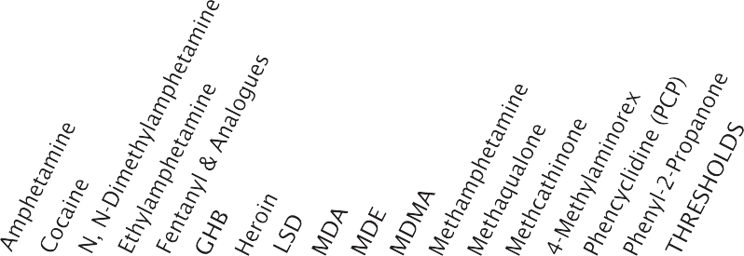
LIST I
1. N-Acetylanthranilic Acid 2 |  |  |  |  |  |  |  |  |  |  |  |  | ▲ |  |  |  |  | 40 | 40
2. Alpha-Phenylacetoacetonitrile 3 (PAAN) |  |  |  |  |  |  |  |  |  |  |  |  |  |  |  |  | ▲ | 0 | 0
3. Anthranilic Acid 2 |  |  |  |  |  |  |  |  |  |  |  |  | ▲ |  |  |  |  | 30 | 30
4. Benzaldehyde | ▲ |  |  |  |  |  |  |  |  |  |  |  |  |  |  |  | ▲ | 4 | 4
5. Benzyl Cyanide |  |  |  |  |  |  |  |  |  |  |  |  |  |  |  |  | ▲ | 1 | 1
6. Ephedrine 3 & 7 |  |  |  |  |  |  |  |  |  |  |  | ▲ |  | ▲ |  |  |  | 0 | 0
7. Ergocristine 1 |  |  |  |  |  |  |  | ▲
8. Ergonovine 1 |  |  |  |  |  |  |  | ▲ |  |  |  |  |  |  |  |  |  | 0.010 | 0.010
9. Ergotamine 1 |  |  |  |  |  |  |  | ▲ |  |  |  |  |  |  |  |  |  | 0.020 | 0.020
10. Ethylamine 1 |  |  |  | ▲ |  |  |  |  |  | ▲ |  |  |  |  |  |  |  | 1 | 1
11. Gamma-Butyrolactone (GBL) |  |  |  |  |  | ▲ |  |  |  |  |  |  |  |  |  |  |  | 0 | 0
12. Hydriodic Acid |  |  |  |  |  |  |  |  |  |  |  | ■ |  |  |  |  |  | 1.7 | 1.7
13. Hypophosphorous Acid 1 | ■ |  |  |  |  |  |  |  |  |  |  | ■ |  |  |  |  |  | 0 | 0
14. Iodine | ■ |  |  |  |  |  |  |  |  |  |  | ■ |  |  |  |  |  | 0 | 0
15. Isosafrole |  |  |  |  |  |  |  |  | ▲ | ▲ | ▲ |  |  |  |  |  |  | 4 | 4
16. Methylamine 1 |  |  |  |  |  |  |  |  |  |  | ▲ | ▲ |  |  |  |  |  | 1 | 1
17. 3, 4-Methylenedioxyphenyl-2-Propanone |  |  |  |  |  |  |  |  | ▲ | ▲ | ▲ |  |  |  |  |  |  | 4 | 4
18. N-Methylephedrine 3 |  |  | ▲ |  |  |  |  |  |  |  |  |  |  |  |  |  |  | 1 | 1
19. N-Methylpseudoephedrine 3 |  |  | ▲ |  |  |  |  |  |  |  |  |  |  |  |  |  |  | 1 | 1
20. N-phenethyl-4-Piperidone (NPP) |  |  |  |  | ▲ |  |  |  |  |  |  |  |  |  |  |  |  | 0 | 0
21. Nitroethane | ▲ |  |  |  |  |  |  |  | ▲ |  |  |  |  |  |  |  | ▲ | 2.5 | 2.5
22. Norpseudoephedrine 3 | ▲ |  |  |  |  |  |  |  |  |  |  |  |  |  | ▲ |  |  | 2.5 | 2.5
23. Phenylacetic Acid 2 |  |  |  |  |  |  |  |  |  |  |  |  |  |  |  |  | ▲ | 1 | 1
24. Phenylpropanolamine 3 & 7 | ▲ |  |  |  |  |  |  |  |  |  |  |  |  |  | ▲ |  |  | 2.5 | 2.5
25. Phosphorus (red) | ■ |  |  |  |  |  |  |  |  |  |  | ■ |  |  |  |  |  | 0 | 0
26. Phosphorus (white or yellow) | ■ |  |  |  |  |  |  |  |  |  |  | ■ |  |  |  |  |  | 0 | 0
27. Piperidine 1 |  |  |  |  |  |  |  |  |  |  |  |  |  |  |  | ▲ |  | 0.500 | 0.500
28. Piperonal (heliotropin) |  |  |  |  |  |  |  |  | ▲ | ▲ | ▲ |  |  |  |  |  |  | 4 | 4
29. Propionic Anhydride |  |  |  |  | ▲ |  |  |  |  |  |  |  |  |  |  |  |  | 0.001 | 0.001
30. Pseudoephedrine 3 & 7 |  |  |  |  |  |  |  |  |  |  |  | ▲ |  | ▲ |  |  |  | 1 | 1
31. Safrole |  |  |  |  |  |  |  |  | ▲ | ▲ | ▲ |  |  |  |  |  |  | 4 | 4
- Reagent ▲ Precursor |  |  |  |  |  |  |  |  |  |  |  |  |  |  |  |  |  | DOMESTIC | IMPORTS & EXPORTS
 |  |  |  |  |  |  |  |  |  |  |  |  |  |  |  |  |  | KILOGRAMS

42 Drugs of Abuse | A DEA Resource Guide: 2020 EDITION

LIST II

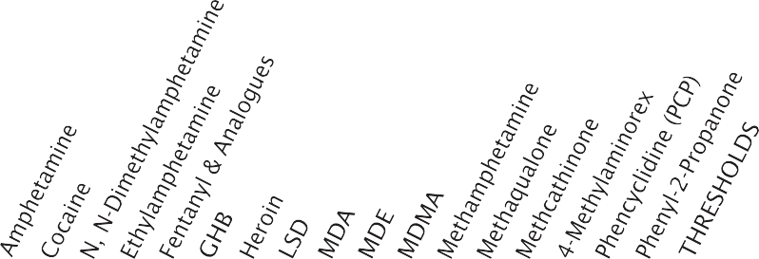CONTROLLED SUBSTANCE PRODUCED

Listed Chemicals regulated under the Controlled Substances Act
See 21, C.F.R. §§ 1309, 1310,
1313, and 1314 for details
March 2019

32. Acetic Anhydride |  |  |  |  |  |  | ▲ |  |  |  |  |  | ▲ |  |  |  | ▲ | 1,023 | 1,023
33. Acetone |  | ● |  |  |  |  | ● | ● | ● | ● | ● | ● |  |  |  |  |  | 150 | 1,500
34. Benzyl Chloride |  |  |  |  |  |  |  |  |  |  |  | ▲ |  |  |  |  |  | 1 | 4
35. Ethyl Ether | ● | ● |  |  | ● |  | ● | ● | ● | ● | ● | ● | ● | ● |  | ● | ● | 135.8 | 1,364
36. Hydrochloric Acid 5 & 6 | ■ | ■ | ■ | ■ | ■ |  | ■ | ■ | ■ | ■ | ■ | ■ | ■ | ■ |  | ■ |  | N/C | 222.3
36a. Hydrogen Chloride Gas 5 & 6 | ■ | ■ | ■ | ■ | ■ |  | ■ | ■ | ■ | ■ | ■ | ■ | ■ | ■ |  | ■ |  | 0 | 27
37. Methyl Ethyl Ketone (2-Butanone) |  | ● |  |  |  |  | ● |  | ● | ● |  | ● |  |  |  |  |  | 145 | 1.455
38. Methyl Isobutyl Ketone 4 |  | ● |  |  |  |  | ● |  | ● | ● |  | ● |  |  |  |  |  | N/C | 1.523
39. Potassium Permanganate |  | ■ |  |  |  |  |  |  |  |  |  |  |  |  |  |  |  | 55 | 500
40. Sodium Permanganate |  | ■ |  |  |  |  |  |  |  |  |  |  |  |  |  |  |  | 55 | 500
41. Sulfuric Acid 5 & 6 | ■ | ■ |  |  |  |  |  |  | ■ | ■ | ■ | ■ |  |  |  |  | ■ | N/C | 347
42. Toluene |  | ● |  |  | ● |  |  |  |  |  |  |  | ● |  |  | ● | ● | 159 | 1,591
 |  |  |  |  |  |  |  |  |  |  |  |  |  |  |  |  |  | DOMESTIC | IMPORTS & EXPORTS
 |  |  |  |  |  |  |  |  |  |  |  |  |  |  |  |  |  | KILOGRAMS

▲ = Precursor
■ = Reagent
● = Solvent
KEY
1 and its salts
2 and its salts and esters
3 and its salts, optical isomers, and salts of optical isomers
4 Exports only, to all Western Hemisphere except Canada
5 Exports to all South American countries & Panama — Domestic for HCI gas
6 Threshold for HCI acid and sulfuric acid is 50 gallons, the equivalent weight in kilograms is shown
7 For pseudoephedrine, phenylpropanolamine, and ephedrine drug products, see 21 USC § 802 (45)(A) and 21 C.F.R. Part 1314 N/C = Not Controlled

Drugs of Abuse | A DEA Resource Guide: 2020 EDITION 43

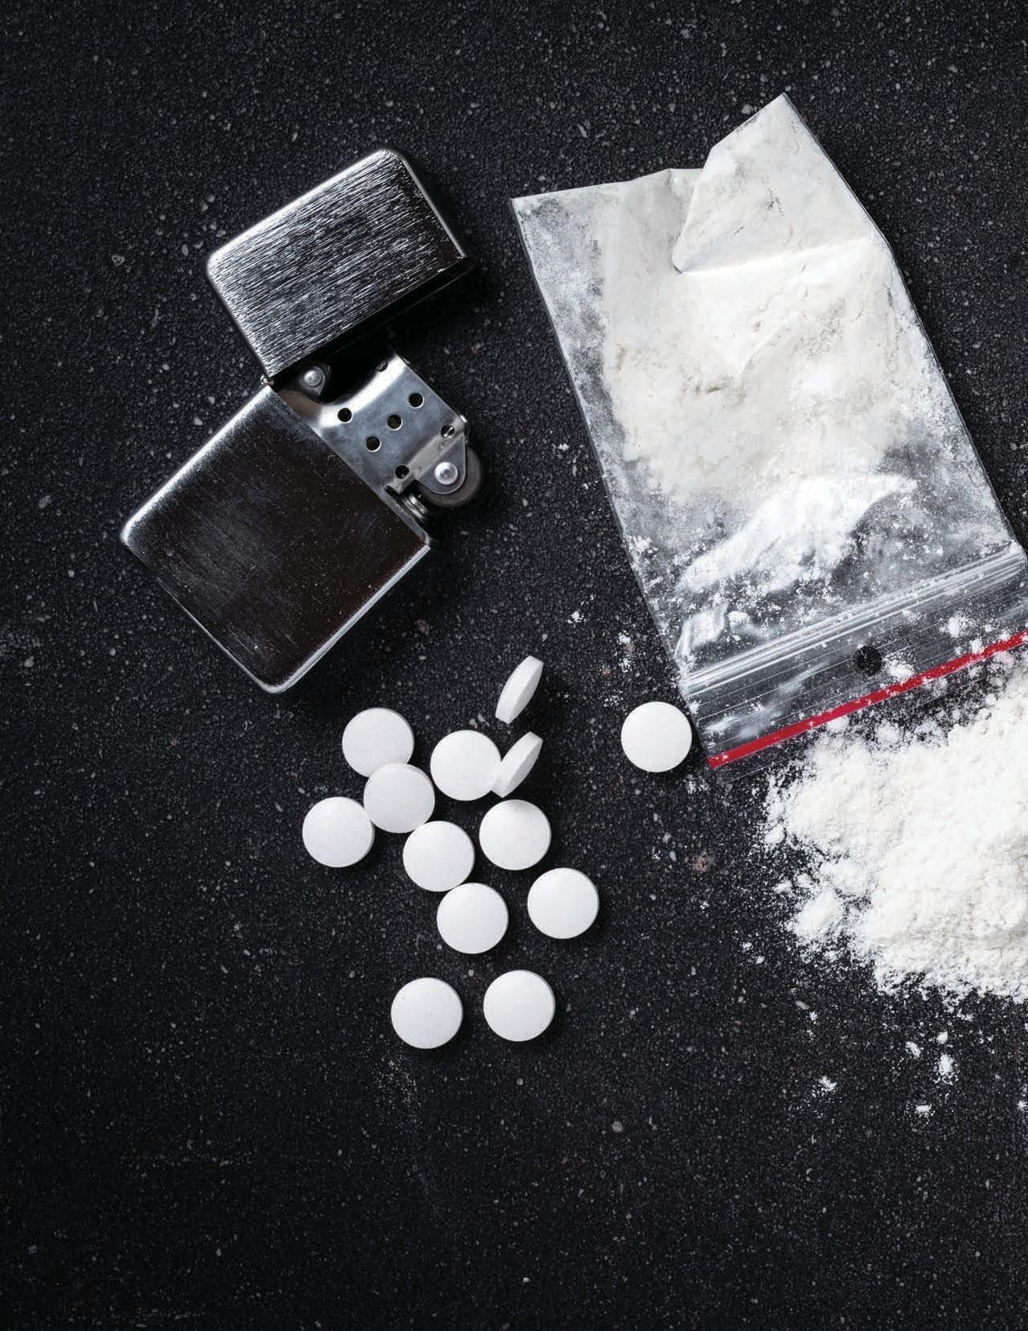Introduction to Drug Classes

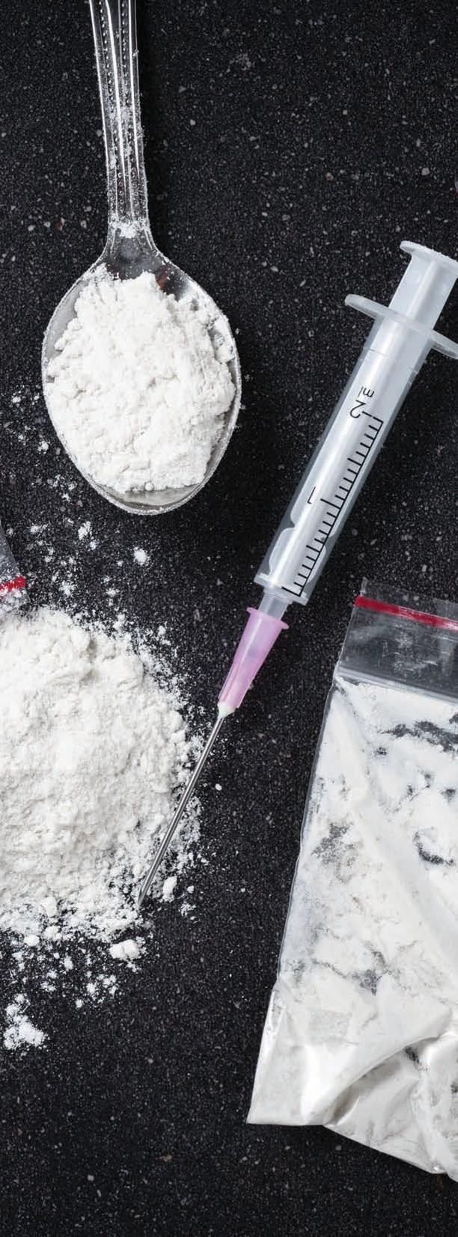Introduction to Drug Classes

The Controlled Substances Act (CSA) regulates five classes of drugs:

- Narcotics
- Depressants
- Stimulants
- Hallucinogens
- Anabolic Steroids

Each class has distinguishing properties, and drugs within each class often produce similar effects. However, all controlled substances, regardless of class, share a number of common features. This introduction will familiarize you with these shared features and define the terms frequently associated with these drugs.
All controlled substances have abuse potential or are immediate precursors to substances with abuse potential. With the exception of anabolic steroids, controlled substances are abused to alter mood, thought, and feeling through their actions on the central nervous system (brain and spinal cord). Some of these drugs alleviate pain, anxiety, or depression. Some induce sleep and others energize.
Though some controlled substances are therapeutically useful, the “feel good” effects of these drugs contribute to their abuse. The extent to which a substance is reliably capable of producing intensely pleasurable feelings (euphoria) increases the likelihood of that substance being abused.

DRUG ABUSE
When controlled substances are used in a manner or amount inconsistent with the
legitimate medical use, it is called drug abuse. The non-sanctioned use of substances controlled in Schedules I through V of the CSA is considered

Drugs of Abuse | A DEA Resource Guide: 2020 EDITION 45

drug abuse. While legal pharmaceuticals placed under control in the CSA are prescribed and used by patients for medical treatment, the use of these same pharmaceuticals outside the scope of sound medical practice is drug abuse.

DEPENDENCE
In addition to having abuse potential, most controlled substances are capable of producing dependence, either physical or psychological.

Physical Dependence
Physical dependence refers to the changes that have occurred in the body after repeated use of a drug that necessitates the continued
administration of the drug to prevent a withdrawal syndrome. This withdrawal syndrome can range from mildly unpleasant to life-threatening and is dependent on a number of factors, such as:

- The drug beingused
- The dose and route of administration
- Concurrent use of other drugs
- Frequency and duration of drug use
- Theage,sex,health,andgeneticmakeupofthe user

Psychological Dependence Psychological dependence refers to the perceived “need” or “craving” for a drug.
Individuals who are psychologically dependent on a particular substance often feel that they cannot function without continued use of that substance. While physical dependence disappears within days or weeks after drug use stops, psychological
dependence can last much longer and is one of the primary reasons for relapse (initiation of drug use after a period of abstinence).
Contrary to common belief, physical dependence is not addiction. While individuals with a substance use disorder are usually physically dependent on the drug they are abusing, physical dependence can exist without addiction. For example, patients who take narcotics for chronic pain management or benzodiazepines to treat anxiety are likely to be physically dependent on that medication.

ADDICTION
Addiction is defined as compulsive drug- seeking behavior where acquiring and using a drug becomes the most important activity in the user’s life. This definition implies a loss of
control regarding drug use, and the person with a substance use disorder will continue to use a drug despite serious medical and/or social
consequences. In 2018, an estimated 31.9 million Americans aged 12 or older were current (past month) illicit drug users, meaning they had used an illicit drug during the month prior to the survey interview. This estimate represents 11.7% of the population aged 12 or older. Illicit drugs include marijuana, cocaine (including crack), heroin, hallucinogens, inhalants, methamphetamine, or prescription psychotherapeutics (including pain relievers, tranquilizers, stimulants, and sedatives) that were misused.1
Drugs within a class are often compared with each other with terms like potency and efficacy. Potency refers to the amount of a drug that must be taken to produce a certain effect, while
efficacy refers to whether or not a drug is capable of producing a given effect regardless of dose.

(1)Results from the 2019 National Survey on Drug Use and Health: Detailed Tables; U.S. Department of Health and Human Services, Substance Abuse and Mental Health Services Administration

46 Drugs of Abuse | A DEA Resource Guide: 2020 EDITION

Both the strength and the ability of a substance to produce certain effects play a role in whether that drug is selected by the drug user.
It is important to keep in mind that the effects produced by any drug can vary significantly and is largely dependent on the dose and route of administration. Concurrent use of other drugs can enhance or block an effect, and substance users often take more than one drug to boost the desired effects or counter unwanted side effects.
The risks associated with drug abuse cannot be accurately predicted because each user has his/her own unique sensitivity to a drug. There are a number of theories that attempt to explain these differences, and it is clear that a genetic component may predispose an individual to certain toxicities or even addictive behavior.
Youth are especially vulnerable to drug abuse. According to the National Institute on Drug Abuse, young Americans engaged in unprecedented levels of illicit drug use in the last third of the twentieth century. Today, about 47% of young people have used an illicit drug by the time they leave high school and about 8.5% of eighth graders, 20% of tenth graders, and 24% of twelfth graders are current (within the past month) users.2
Substance use in youth can result in tragic consequences with untold harm to themselves, heir families, and others. The 2016 Surgeon General’s Report on Alcohol, Drugs, and Health
identified risk factors for youth which might lead them into substance abuse. These include being raised in a home where the parents or other relatives use drugs, living in neighborhoods and going to schools where drug use is common, and associating with peers who use substances. Nearly 70% of those who try an illicit drug before the age of 13 develop a substance use disorder in the next 7 years, compared with 27% of those who first try an illicit drug after the age of 17.3
In the sections that follow, each of the classes of drugs is reviewed and various drugs within each class are profiled.
Although marijuana is classified in the CSA as a hallucinogen, a separate section is dedicated to that topic. There are also a
number of substances that are abused but not regulated under the CSA. Alcohol and tobacco, for example, are specifically exempt from control by the CSA. In addition, a whole group of substances called inhalants are commonly available and widely abused by children. Control of these substances under the CSA would not only impede legitimate commerce, but also would likely have little effect on the abuse of these substances by youngsters. An energetic campaign aimed at educating both adults and youth about inhalants is more likely to prevent
their abuse. To that end, a section is dedicated to providing information on inhalants.

(2)Monitoring the Future Survey, 2019; National Institute on Drug Abuse, National Institutes of Health, U.S. Department of Health and Human Services

(3)Facing Addiction in America. The Surgeon General s Report on Alcohol, Drugs, and Health, October 2016. U.S. Department of Health and Human Services.

Drugs of Abuse | A DEA Resource Guide: 2020 EDITION 47

WHAT ARE NARCOTICS?
Also known as “opioids,” the term “narcotic” comes from the Greek word for “stupor” and originally referred to a variety of substances that dulled the senses and relieved pain. Though some people still refer to
all drugs as “narcotics,” today “narcotic” refers to opium, opium derivatives, and their semi-synthetic substitutes. A more current term for these drugs, with less uncertainty regarding its meaning, is “opioid.” Examples include the illicit drug heroin and pharmaceutical drugs like OxyContin®, Vicodin®, codeine, morphine, methadone, and fentanyl.

WHAT IS THEIR ORIGIN?
The poppy Papaver somniferum is the source for all natural opioids, whereas synthetic opioids are made entirely in a lab and include meperidine, fentanyl, and methadone. Semi-synthetic opioids are synthesized from naturally occurring opium products, such as morphine and codeine, and include heroin, oxycodone, hydrocodone, and hydromorphone. Teens can obtain narcotics from friends, family members, medicine cabinets, pharmacies, nursing homes, hospitals, hospices, doctors, and the Internet.

What are common street names?
Street names for various narcotics/opioids include:
- Smack, Horse, Mud, Brown Sugar, Junk, Black Tat, Big H, Paregoric, Dover’s Powder, MPTP (New Heroin), Hillbilly Heroin, Lean or Purple Drank, OC, Ox, Oxy, Oxycotton, Sippin Syrup

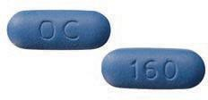

OxyContin 160 mg tablet

What do they looklike?
Narcotics/opioids come in various forms, including:
  - Tablets, capsules, skin patches, powder, chunks in varying colors(from whiteto shadesofbrown and black), liquid formfor oral use and injection, syrups, suppositories, and lollipops

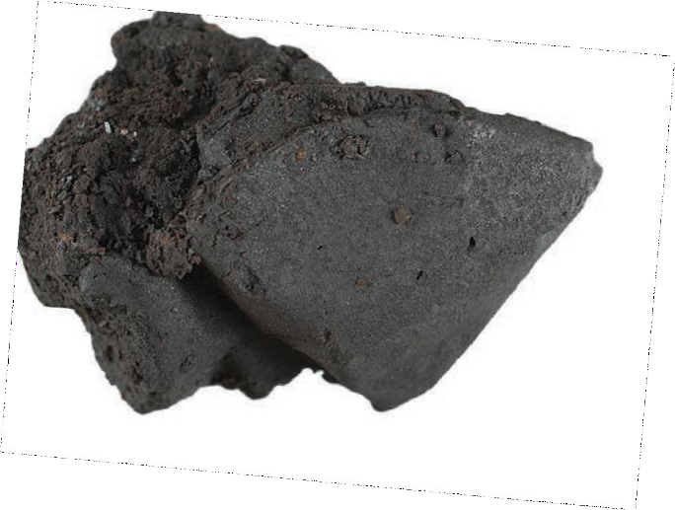How are they abused?
Heroin
  - Narcotics/opioids can be swallowed, smoked, sniffed, or injected.

What is their effect on the mind?
Besides their medical use, narcotics/opioids produce a general sense of well-being by reducing tension, anxiety, and aggression. These effects are helpful in a therapeutic setting but contribute to the drugs’ abuse. Narcotic/opioid use comes with a variety of unwanted effects, including drowsiness, inability to concentrate, and apathy.

Narcotics

48 Drugs of Abuse | A DEA Resource Guide: 2020 EDITION

Psychological dependence
Use can create psychological dependence. Long after the physical need for the drug has passed, the user may continue to think and talk about using drugs and feel overwhelmed coping with daily activities. Relapse is common if there are not changes to the physical environment or the behavioral motivators that prompted the abuse in the first place.

What is their effect on the body? Narcotics/opioids are prescribed by doctors to treat pain, suppress cough, cure diarrhea, and put people to sleep. Effects depend heavily on the dose, how it’s taken, and previous exposure to the drug. Negative effects include:
- Slowedphysicalactivity,constrictionofthepupils, flushing of the face and neck, constipation, nausea, vomiting, and slowed breathing

As the dose is increased, both the pain relief and the harmful effects become more pronounced. Some of these preparations are so potent that a single dose can be lethal to an inexperienced user. However, except in cases of extreme intoxication, there is no loss of motor coordination or slurred speech.

Physical dependence and withdrawal Physical dependence is a consequence of chronic opioid use, and withdrawal takes place when drug use is discontinued. The intensity and character of the physical symptoms experienced during withdrawal are directly related to the particular drug used, the total daily dose, the interval
between doses, the duration of use, and the health and personality of the user. These symptoms usually appear shortly before the time of the next scheduled dose.
Early withdrawal symptoms often include:
- Watery eyes, runny nose, yawning, and sweating

As the withdrawal worsens, symptoms can include:
- Restlessness, irritability, loss of appetite, nausea, tremors, drug craving, severe depression, vomiting, increased heart rate and blood pressure, and chills alternating with flushing and excessive sweating

However, without intervention, the withdrawal usually runs its course, and most physical symptoms disappear within days or weeks, depending on the particular drug.

What are their overdose effects? Overdoses of narcotics are not uncommon and can be fatal. Physical signs of narcotics/opioid overdose include:
- Constricted(pinpoint)pupils, coldclammyskin, confusion, convulsions, extreme drowsiness, and slowed breathing

Which drugs cause similar effects? With the exception of pain relief and cough suppression, most central nervous system
depressants (like barbiturates, benzodiazepines, and alcohol) have similar effects, including slowed breathing, tolerance, and dependence.

What is their legal status in the United States? Narcotics/opioids are controlled substances that vary from Schedule I to Schedule V, depending on their medical usefulness, abuse potential, safety, and drug dependence profile. Schedule I narcotics, like heroin, have no medical use in the U.S. and are illegal to distribute, purchase, or use outside of medical research.

Drugs of Abuse | A DEA Resource Guide: 2020 EDITION 49

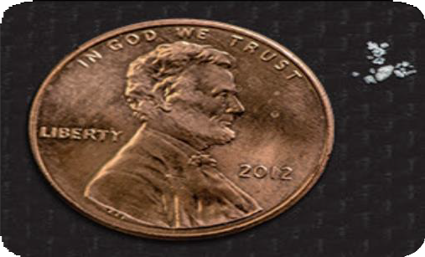WHAT IS ITS FENTANYL?
Fentanyl is a potent synthetic opioid drug approved by the Food and Drug Administration for use as an analgesic (pain relief) and anesthetic. It is approximately 100 times more potent than morphine and 50 times more potent than heroin as an analgesic.

WHAT IS ITS ORIGIN?
Fentanyl was first developed in 1959 and introduced in the 1960s as an intravenous anesthetic. It is legally manufactured and distributed in the United States. Licit fentanyl pharmaceutical products are diverted via theft, fraudulent prescriptions, and illicit distribution by patients, physicians, and pharmacists.
From 2011 through 2018, both fatal overdoses associated with abuse of clandestinely produced fentanyl and fentanyl analogues, and law enforcement encounters increased markedly.
According to the Centers for Disease Control and Prevention (CDC), fentanyl analouges were involved in roughly 2,600 drug overdose deaths each year in 2011 and 2012, but from 2012 through 2018, the number of drug overdose deaths involving fentanyl and other synthetic opioid increased dramatically each year. More recently, there has been a re-emergence of trafficking, distribution, and abuse of illicitly produced fentanyl and fentanyl analogues with an associated dramatic increase in overdose

fatalities, ranging from 2,666 in 2011 to 31,335 in
2018.

What are common street names?
Common street names include:
- Apache, China Girl, China Town, Dance Fever, Friend, Goodfellas, Great Bear, He-Man, Jackpot, King Ivory, Murder 8, and Tango & Cash.

What does it look like?
Fentanyl pharmaceutical products are currently available in the following dosage forms: oral transmucosal lozenges commonly referred to as fentanyl “lollipops” (Actiq®), effervescent buccal tablets (Fentora®), sublingual tablets (Abstral®), sublingual sprays (Subsys®), nasal sprays (Lazanda®), transdermal patches (Duragesic®), and injectable formulations.
Clandestinely produced fentanyl is encountered either as a powder or in counterfeit tablets and is

Fentanyl

50 Drugs of Abuse | A DEA Resource Guide: 2020 EDITION

sold alone or in combination with other drugs such as heroin or cocaine.

How is it abused?
Fentanyl can be injected, snorted/sniffed, smoked, taken orally by pill or tablet, and spiked onto blotter paper. Fentanyl patches are abused by removing its gel contents and then injecting or ingesting these contents. Patches have also been frozen, cut into pieces, and placed under the tongue or in the cheek cavity. Illicitly produced fentanyl is sold alone or in combination with heroin and other substances and has been identified in counterfeit pills, mimicking pharmaceutical drugs such as oxycodone. According to the National Forensic Laboratory Information System, reports on fentanyl (both pharmaceutical and clandestinely produced) increased from nearly 5,400 in 2014 to over 56,500 in 2017, asreported byfederal, state, andlocal forensic laboratories in the United States.

Whatistheeffectonthebody?
Fentanyl, similar to other commonly used opioid analgesics (e.g., morphine), produces effects such as relaxation, euphoria, pain relief, sedation, confusion, drowsiness, dizziness, nausea, vomiting, urinary retention, pupillary constriction,
and respiratory depression.

What are the overdose effects?
Overdose may result in stupor, changes in pupillary size, cold and clammy skin, cyanosis, coma, and respiratory failure leading to death. The presence of triad of symptoms such as coma, pinpoint pupils, and respiratory depression are strongly suggestive of opioid poisoning.

Which drugs cause similar effects? Drugs that cause similar effects include other opioids such as morphine, hydrocodone, oxycodone, hydromorphone, methadone, and heroin.

What is the legal status in the Federal Control Substances Act?
Fentanyl is a Schedule II narcotic under the United States Controlled Substances Act of 1970.

Drugs of Abuse | A DEA Resource Guide: 2020 EDITION 51

WHAT IS HEROIN?
Heroin is a highly addictive drug and it is a rapidly acting opioid.

WHAT IS ITS ORIGIN?
Heroin is processed from morphine, a naturally occurring substance extracted from the seed pod of certain varieties of poppy plants grown in:
  - Mexico, South America, Southeast Asia (Thailand, Laos, and Myanmar (Burma)), and Southwest Asia (Afghanistan and Pakistan)
Heroin comes in several forms, primarily white powder from Mexico and South America; and “black tar” and brown powder from Mexico.

What are common street names?
Common street names for heroin include:
  - BigH,Black Tar, Chiva, Hell Dust, Horse, Negra, Smack, and Thunder

What does it look like?
Heroin is typically sold as a white or brownish powder, or as the black sticky substance known on the streets as “black tar heroin.” Although purer heroin is becoming more common, most street heroin is “cut” with other drugs or with substances such as sugar, starch, powdered milk, or quinine.

How is it abused?
Heroin can be injected, smoked, or sniffed/ snorted. High purity heroin is usually snorted or smoked.

What is its effect on the mind?
Because it enters the brain so rapidly, heroin is particularly addictive, both psychologically and
physically. Heroin users report feeling a surge of euphoria or “rush” followed by a twilight state of sleep and wakefulness.

What is its effect on the body?
One of the most significant effects of heroin use is addiction. With regular heroin use, tolerance to the drug develops. Once this happens, the person must use more heroin to achieve the same intensity. As higher doses of the drug are used over time, physical dependence and addiction to the drug develop.
Effects of heroin use include:
- Drowsiness, respiratory depression, constricted pupils, nausea, a warm flushing of the skin, dry mouth, and heavy extremities

What are its overdose effects?
Because heroin users do not know the actual strength of the drug or its true contents, they are at a high risk of overdose or death.
The effects of a heroin overdose are:
- Slow and shallow breathing, blue lips and fingernails, clammy skin, convulsions, coma, and possible death

Which drugs cause similar effects?
Other opioids such as OxyContin®, Vicodin®, codeine, morphine, methadone, and fentanyl can cause similar effects as heroin.

What is its legal status in the United States? Heroin is a Schedule I substance under the Controlled Substances Act meaning that it has a high potential for abuse, no currently accepted medical use in treatment in the United States, and a lack of accepted safety for use under medical supervision.

Heroin

52 Drugs of Abuse | A DEA Resource Guide: 2020 EDITION

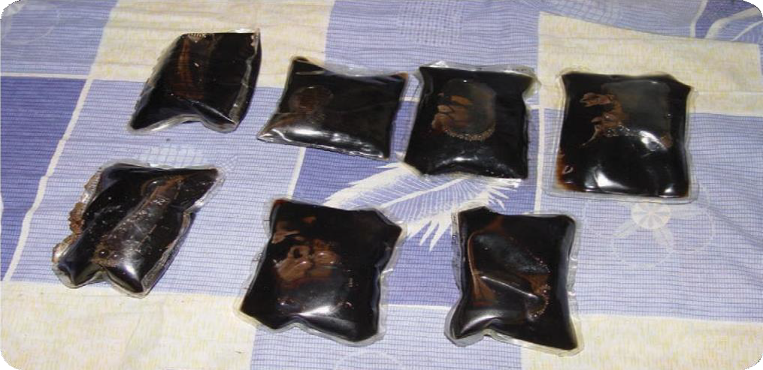

Heroin liquid packets

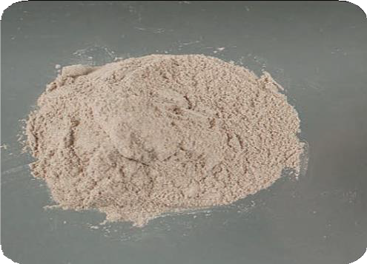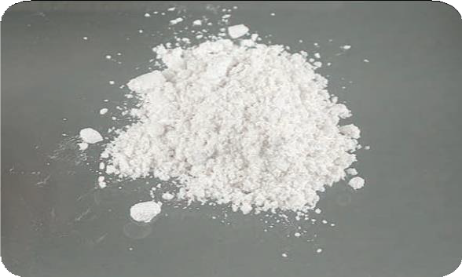

Brown powder heroin White powder heroin

Drugs of Abuse | A DEA Resource Guide: 2020 EDITION 53

WHAT IS HYDROMORPHONE?
Hydromorphone
Hydromorphone belongs to a class of drugs called “opioids,” which includes morphine. It has an analgesic potency of two to eight times greater than that of morphine and has a rapid onset of action.

WHAT IS ITS ORIGIN?
Hydromorphone is legally manufactured and distributed in the United States. However, users can obtain hydromorphone from forged prescriptions, “doctor-shopping,” theft from pharmacies, and from friends and acquaintances.

What are the street names?
Common street names include:
  - D, Dillies, Dust, Footballs, Juice, and Smack

What does it look like?
Hydromorphone comes in:
  - Tablets, capsules, oral solutions, and injectable formulations

How is it abused?
Users may abuse hydromorphone tablets by ingesting them. Injectable solutions, as well as tablets that have been crushed and dissolved in a solution may be injected as a substitute for heroin.

What is its effect on the mind?
When used as a drug of abuse, and not under a doctor’s supervision, hydromorphone is taken to produce feelings of euphoria, relaxation,

54 Drugs of Abuse| ADEAResource Guide: 2020 EDITION
sedation, and reduced anxiety. It may also cause mental clouding, changes in mood, nervousness, and restlessness. It works centrally (in the
brain) to reduce pain and suppress cough. Hydromorphone use is associated with both physiological and psychological dependence.

What is its effect on the body?
Hydromorphone may cause:
- Constipation, pupillary constriction, urinary retention, nausea, vomiting, respiratory depression, dizziness, impaired coordination, loss of appetite, rash, slow or rapidheartbeat,andchangesinbloodpressure

What are its overdose effects?
Acute overdose of hydromorphone can produce: Severe respiratory depression, drowsiness progressing to stupor or coma, lack of skeletal muscle tone, cold and clammy skin, constricted pupils, and reduction in blood pressure and heart rate
Severe overdose may result in death due to respiratory depression.

Which drugs cause similar effects?
Drugs that have similar effects include:
- Heroin, morphine, hydrocodone, fentanyl, and oxycodone

Whatis itslegal statusin the United States? Hydromorphone is a Schedule II drug under the Controlled Substances Act with an accepted medical use as a pain reliever. Hydromorphone has a high potential for abuse and use may lead to severe psychological or physical dependence.

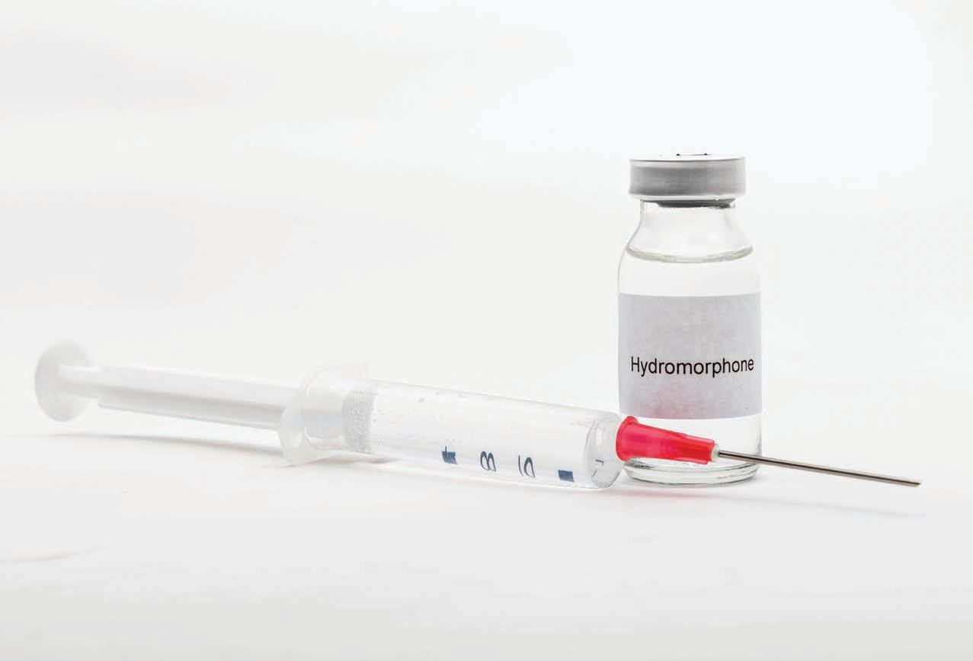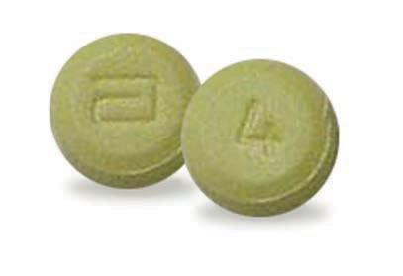Hydromorphone pills

Hydromorphone injectable solution

Drugs of Abuse | A DEA Resource Guide: 2020 EDITION 55

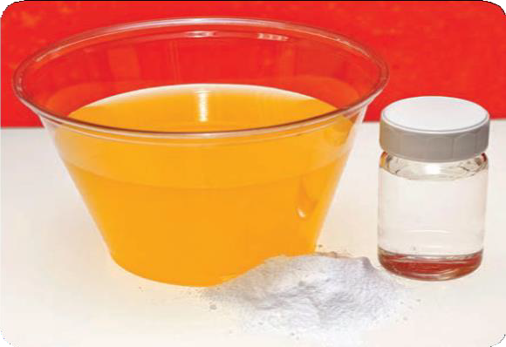WHAT IS METHADONE?
Methadone is a synthetic (man-made) narcotic.

WHAT IS ITS ORIGIN?
German scientists synthesized methadone during World War II because of a shortage of morphine. Methadone was introduced into the United States in 1947 as an analgesic (Dolophine®).

What are common street names?
Common street names include:
  - Amidone, Chocolate Chip Cookies, Fizzies with MDMA, and Wafer

What does it look like?
Methadone is available as a tablet, oral solution, or injectable liquid. Tablets are available in 5 mg and 10 mg formulations. As of January 1, 2008, manufacturers of methadone hydrochloride tablets 40 mg (dispersible) have voluntarily agreed to restrict distribution of this formulation to only those facilities authorized for detoxification and maintenance treatment of opioid addiction, and hospitals. Manufacturers will instruct their
wholesale distributors to discontinue supplying this formulation to any facility not meeting the above criteria.

How is it abused?
Methadone can be swallowed or injected.

What is its effect on the mind?
Abuse of methadone can lead to psychological dependence.

What is its effect on the body?
When an individual uses methadone, he/she may experience physical symptoms like sweating,

Methadone

itchy skin, or sleepiness. Individuals who abuse methadone risk becoming tolerant of and physically dependent on the drug.
When use is stopped, individuals may experience withdrawal symptoms including:
- Anxiety, muscle tremors, nausea, diarrhea, vomiting, and abdominal cramps

What are its overdose effects?
The effects of a methadone overdose are:
- Slow and shallow breathing, blue fingernails and lips, stomach spasms, clammy skin, convulsions, weak pulse, coma, and possibledeath

Which drugs cause similar effects? Although chemically unlike morphine or heroin, methadone produces many of the same effects.

What is its legal status in the United States? Methadone is a Schedule II drug under the Controlled Substances Act. While it may legally be used under a doctor’s supervision, its non-medical use is illegal.

Methadone

56 Drugs of Abuse | A DEA Resource Guide: 2020 EDITION

WHAT IS MORPHINE?
Morphine
Morphine is a non-synthetic narcotic with a high potential for abuse and is derived from opium. It is used for the treatment of pain.

WHAT IS ITS ORIGIN?
In the United States, a small percentage of the morphine obtained from opium is used directly for pharmaceutical products. The remaining morphine is processed into codeine and other derivatives.

What are common street names?
Common street names include:
  - Dreamer, Emsel, First Line, God’s Drug, Hows, M.S.,
Mister Blue, Morf, Morpho, and Unkie

What does it look like?
Morphine is marketed under generic and brand name products, including:
  - MS-Contin®, Oramorph SR®, MSIR®, Roxanol®, Kadian®, and RMS®

How is it abused?
Traditionally, morphine was almost exclusively used by injection, but the variety of pharmaceutical forms that it is marketed as today support its use by oral and other routes of administration.
Forms include:
  - Oral solutions, immediate-and extended-release tablets and capsules, and injectable preparations

Those dependent on morphine prefer injection because the drug enters the bloodstream more quickly.

What is its effect on the mind?
Morphine’s effects include euphoria and relief of pain. Chronic use of morphine results in tolerance, and physical and psychological dependence.

What is its effect on the body?
Morphine use results in relief from physical pain, decrease in hunger, and inhibition of the cough reflex.

What are its overdose effects?
Overdose effects include:
- Cold and clammy skin, lowered blood pressure, sleepiness, slowed breathing, slow pulse rate, coma, and possible death

Which drugs cause similar effects?
Drugs causing similar effects as morphine include:
- Opium, codeine, heroin, methadone, hydrocodone, fentanyl, and oxycodone

What is its legal status in the United States? Morphine is a Schedule II narcotic under the Controlled Substances Act.
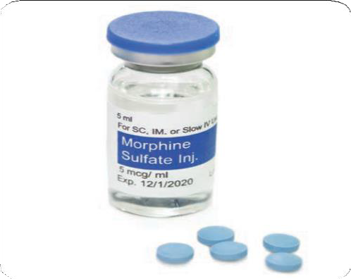
Morphine

Drugs of Abuse | A DEA Resource Guide: 2020 EDITION 57

WHAT IS OPIUM?
Opium is a highly addictive non-synthetic narcotic that is extracted from the poppy plant, Papaver somniferum. The opium poppy is the key source for many narcotics, including morphine, codeine, and heroin.

WHAT IS ITS ORIGIN?
The poppy plant, Papaver somniferum, is the source of opium. It was grown in the Mediterranean region as early as 5000 B.C., and has since been cultivated in a number of countries throughout the world. The milky fluid that seeps from its incisions in the unripe seedpod of this poppy has been scraped by hand and air-dried to produce what is known as opium.
A more modern method of harvesting for pharmaceutical use is by the industrial poppy straw process of extracting alkaloids from the mature dried plant (concentrate of poppy straw). All opium and poppy straw used for pharmaceutical products are imported into the United States from legitimate sources in regulated countries.

What are common street names?
Common street names include:
  - Ah-pen-yen, Aunti, Aunti Emma, Big O, Black Pill, Chandoo, Chandu, Chinese Molasses, Chinese Tobacco, Dopium, Dover’s Powder, Dream Gun, Dream Stick, Dreams, Easing Powder, Fi-do-nie, Gee, God’s Medicine, Gondola, Goric, Great Tobacco, Guma, Hop/hops, Joy Plant, Midnight Oil, Mira, O, O.P., Ope, Pen Yan, Pin Gon, Pox, Skee, Toxy, Toys, When-shee, Ze, and Zero

What does it look like?
Opium can be a liquid, solid, or powder, but most poppy straw concentrate is available commercially as a fine brownish powder.

How is it abused?
Opium can be smoked, intravenously injected, or taken in pill form. Opium is also abused in combination with other drugs. For example, “Black” is a combination
of marijuana, opium, and methamphetamine, and “Buddha” is potent marijuana spiked with opium.

What is its effect on the mind?
The intensity of opium’s euphoric effects on the brain depends on the dose and route of administration. It works quickly when smoked because the opiate chemicals pass into the lungs, where they are quickly absorbed and then sent to the brain. An opium “high” is very similar to a heroin “high”; users experience a euphoric rush, followed by relaxation and the relief of physical pain.

What is its effect on the body?
Opium inhibits muscle movement in the bowels leading to constipation. It also can dry out the mouth and mucous membranes in the nose. Opium use leads to physical and psychological dependence, and can lead to overdose.

What are its overdose effects?
Overdose effects include:
- Slow breathing, seizures, dizziness, weakness, loss of consciousness, coma, and possible death

Which drugs cause similar effects?
Drugs that cause similar effects include:
- Morphine, codeine, heroin, methadone, hydroquinone, fentanyl, and oxycodone

What is its legal status in the United States? Opium is a Schedule II drug under the Controlled Substances Act. Most opioids are Schedule II, III, IV, or V drugs. Some drugs that are derived from opium, such as heroin, are Schedule I drugs.

Opium

58 Drugs of Abuse | A DEA Resource Guide: 2020 EDITION

WHAT IS OXYCODONE?
Oxycodone is a semi-synthetic narcotic analgesic and historically has been a popular drug of abuse among the narcotic abusing population.

WHAT IS ITS ORIGIN?
Oxycodone is synthesized from thebaine, a constituent of the poppy plant.

What are common street names?
Common street names include:
- Hillbilly Heroin, Kicker, OC, Ox, Roxy, Perc, and Oxy

What does it look like?
Oxycodone is marketed alone as OxyContin® in 10, 20, 40 and 80 mg extended-release tablets and other immediate-release capsules like 5
mg OxyIR®. It is also marketed in combination products with aspirin such as Percodan® or acetaminophen such as Roxicet®.

How is it abused?
Oxycodone is abused orally or intravenously. The tablets are crushed and sniffed or dissolved in water and injected. Others heat a tablet that has been placed on a piece of foil then inhale the vapors.

What is its effect on the mind?
Euphoria and feelings of relaxation are the most common effects of oxycodone on the brain, which explains its high potential for abuse.

What is its effect on the body?
Physiological effects of oxycodone include:
  - Pain relief, sedation, respiratory depression, constipation, papillary constriction, and cough suppression. Extended or chronic use of oxycodone containing acetaminophen may cause severe liver damage

What are its overdose effects?
Overdose effects include:
  - Extreme drowsiness, muscle weakness, confusion, cold and clammy skin, pinpoint pupils, shallow breathing, slow heart rate, fainting, coma, and possible death

Which drugs cause similar effects? Drugs that cause similar effects to Oxycodone include:
  - Opium, codeine, heroin, methadone, hydrocodone, fentanyl, and morphine

What is its legal status in the United States? Oxycodone products are in Schedule II of the Controlled Substances Act.

Oxycodone
Oxycodone pills
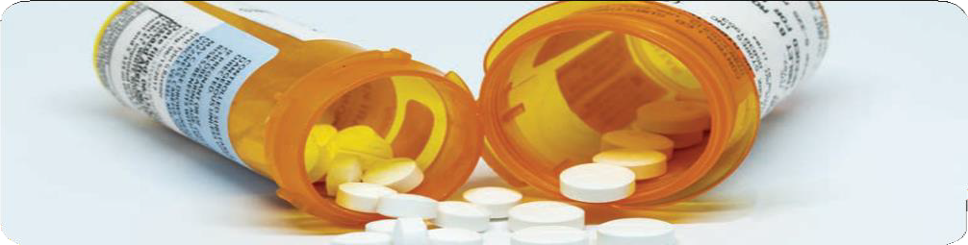

Drugs of Abuse | A DEA Resource Guide: 2020 EDITION 59

WHAT ARE STIMULANTS?
Stimulants speed up the body’s systems. This class of drugs includes:
    - Prescription drugs such as amphetamines [Adder- all® and Dexedrine®], methylphenidate [Concerta® and Ritalin®], diet aids [such as Didrex®, Bontril®, Preludin®, Fastin®, Adipex P®, Ionomin®, and Meridia®] and other illicitly used drugs such as methamphetamine, cocaine, methcathinone, and other synthetic cathinones that are commonly sold under the guise of “bath salts.”

WHAT IS THEIR ORIGIN?
Stimulants are diverted from legitimate channels and clandestinely manufactured exclusively for the illicit market.

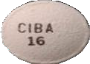
Ritalin SR 20mg tablet

What are common street names?
Common street names for stimulants include:
- Bennies, Black Beauties, Cat, Coke, Crank, Crystal, Flake, Ice, Pellets, R-Ball, Skippy, Snow, Speed, Uppers, and Vitamin R

What do they look like?
Stimulants come in the form of:
- Pills, powder, rocks, and injectable liquids

How are they abused?
Stimulants can be pills or capsules that are swallowed. Smoking, snorting, or injecting stimulants produces a sudden sensation known as a “rush” or a “flash.”
Abuse is often associated with a pattern of binge use — sporadically consuming large doses of stimulants over a short period of time. Heavy users may inject themselves every few hours, continuing until they have depleted their drug supply or reached a point of delirium, psychosis, and physical exhaustion. During heavy use, all other interests become secondary to recreating the initial euphoric rush.

What is their effect on the mind?
When used as drugs of abuse and not under a doctor’s supervision, stimulants are frequently taken to:
  - Produce a sense of exhilaration, enhance self- esteem, improve mental and physical performance, increase activity, reduce appetite, extend wakefulness for prolonged period, and “get high”

Chronic, high-dose use is frequently associated with agitation, hostility, panic, aggression, and suicidal or homicidal tendencies.

Stimulants

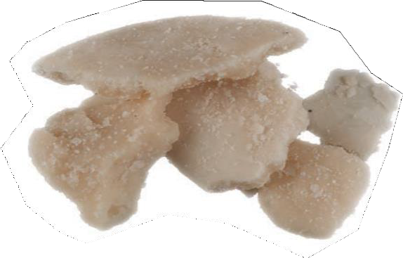60 Drugs of Abuse | A DEA Resource Guide: 2020 EDITION
Crack Cocaine

Paranoia, sometimes accompanied by both auditory and visual hallucinations, may also occur.
Tolerance, in which more and more drug is needed to produce the usual effects, can develop rapidly, and psychological dependence occurs.
In fact, the strongest psychological dependence observed occurs with the more potent stimulants, such as amphetamine, methylphenidate, methamphetamine, cocaine, and methcathinone.
Abrupt cessation is commonly followed by depression, anxiety, drug craving, and extreme fatigue, known as a “crash.”

What is their effect on the body? Stimulants are sometimes referred to as uppers and reverse the effects of fatigue on both mental and physical tasks.
Therapeutic levels of stimulants can produce exhilaration, extended wakefulness, and loss of appetite. These effects are greatly intensified when large doses of stimulants are taken.
Taking too large a dose at one time or taking large doses over an extended period of time may cause such physical side effects as:
- Dizziness, tremors, headache, flushed skin, chest pain with palpitations, excessive sweating, vomiting, and abdominal cramps.

What are their overdose effects?
In overdose, unless there is medical intervention, high fever, convulsions, and cardiovascular collapse may precede death. Because accidental death is partially due to the effects of stimulants on the body’s cardiovascular and temperature- regulating systems, physical exertion increases the hazards of stimulant use.
Which drugs cause similar effects? Some hallucinogenic substances, such as ecstasy, have a stimulant component to their activity.

What is their legal status in the United States?
A number of stimulants have no medical use in the United States but have a high potential for abuse. These stimulants are controlled in
Schedule I. Some prescription stimulants are not controlled, and some stimulants like tobacco and caffeine don’t require a prescription — though society’s recognition of their adverse effects has resulted in a proliferation of caffeine-free products and efforts to discourage cigarette smoking.
Stimulant chemicals in over-the-counter products, such as ephedrine and pseudoephedrine, can be found in allergy and cold medicine. As required by The Combat Methamphetamine Epidemic Act of 2005, a retail outlet must store these products out of reach of customers, either behind the counter or in a locked cabinet. Regulated sellers are required to maintain a written or electronic form of a logbook to record sales of these products.
In order to purchase these products, customers must now show a photo identification issued by a state or federal government. They are also required to write or enter into the logbook: their name, signature, address, date, and time of sale. In addition to the above, there are daily and monthly sales limits set for customers.

Drugs of Abuse | A DEA Resource Guide: 2020 EDITION 61

WHAT ARE AMPHETAMINES?
Amphetamines are stimulants that speed up the body’s system. Some are legally prescribed and used to treat attention-deficit hyperactivity disorder (ADHD).

WHAT IS THEIR ORIGIN?
Amphetamines were first marketed in the 1930s as Benzedrine in an over-the-counter inhaler to treat nasal congestion.
By 1937 amphetamines were available by prescription in tablet form and were used in the treatment of the sleeping disorder narcolepsy and ADHD.
Over the years, the use and abuse of clandestinely produced amphetamines have spread. Today, clandestine laboratory production of amphetamines has mushroomed, and the abuse of the drug has increased dramatically.

What are common street names?
Common street names include:
    - Bennies, Black Beauties, Crank, Ice, Speed, and Uppers

What do they look like?
Amphetamines can look like pills or powder. Common prescription amphetamines include amphetamine and dextroamphetamine (Adderall®), dextroamphetamine (Dexedrine®), lisdexamphetamine (Vyvanse™) and methamphetamine (Desoxyn®).

How are they abused?
Amphetamines are generally taken orally or injected.
However, the addition of “ice,” the slang name of crystallized methamphetamine hydrochloride, has promoted smoking as another mode of
administration. Just as “crack” is smokable cocaine, “ice” is smokable methamphetamine.

What is their effect on the mind?
The effects of amphetamines are similar to cocaine, but their onset is slower and their duration is longer. In contrast to cocaine, which is quickly removed from the brain and is almost completely metabolized, methamphetamine remains in the central nervous system longer, and a larger percentage of the drug remains unchanged in the body, producing prolonged stimulant effects.
Chronic abuse produces a psychosis that resembles schizophrenia and is characterized by paranoia, picking at the skin, preoccupation with one’s own thoughts, and auditory and visual hallucinations. Violent and erratic behavior is frequently seen among chronic users of amphetamines.

What is their effect on the body?
Physical effects of amphetamine use include:
- Increased blood pressure and pulse rates, insomnia, loss of appetite, and physical exhaustion

What are their overdose effects?
Overdose effects include:
- Agitation, increased body temperature, hallucinations, convulsions, and possible death

Which drugs cause similar effects?
Drugs that cause similar effects include:
- Dexmethylphendiate, phendimetrazine, cocaine, crack, and khat

What is their legal status in the United States? Many amphetamines are Schedule II stimulants, which means that they have a high potential for abuse and a currently acceptable medical use (in FDA-approved products). Pharmaceutical products are available only through a prescription that cannot be refilled.

Amphetamines

62 Drugs of Abuse | A DEA Resource Guide: 2020 EDITION

WHAT IS COCAINE?
Cocaine
Cocaine is an intense, euphoria-producing stimulant drug with strong addictive potential.

WHAT IS ITS ORIGIN?
Cocaine is derived from coca leaves grown in Bolivia, Peru, and Colombia. The cocaine manufacturing process takes place in remote jungle labs where the raw product undergoes
a series of chemical transformations. Colombia produces about 90 percent of the cocaine powder reaching the United States. Most of the cocaine entering the United States comes through Mexico.

What are common street names?
Common street names include:
- Blow, Coca, Coke, Crack, Flake, Snow, and Soda Cot

What does it look like?
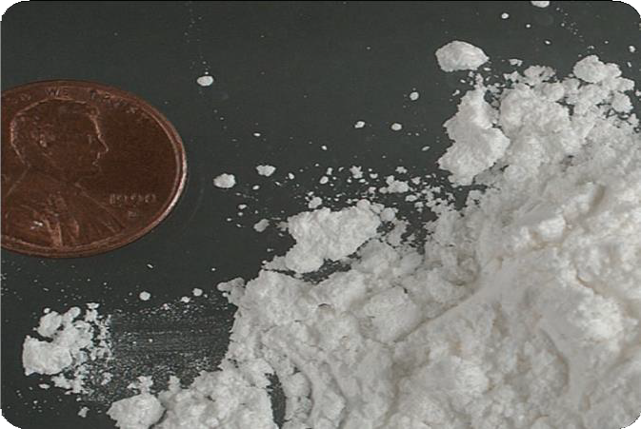Cocaine is usually distributed as a white, crystalline powder. Cocaine is often diluted (“cut”) with a variety of substances, the most common of

Cocaine powder
which are sugars and local anesthetics. It is “cut” to stretch the amount of the product and increase profits for dealers. In contrast, cocaine base (crack) looks like small, irregularly shaped chunks (or “rocks”) of a whitish solid.

How is it abused?
Powdered cocaine can be snorted or injected into the veins after dissolving in water. Cocaine base (crack) is smoked, either alone or on marijuana or tobacco. Cocaine is also used in combination with an opiate, like heroin, a practice known as “speedballing.” Although injecting into veins or muscles, snorting, and smoking are the common ways of using cocaine, all mucous membranes
readily absorb cocaine. Cocaine users often binge on the drug until they are exhausted or run out of cocaine.

What is its effect on the mind?
The intensity of cocaine’s euphoric effects depends on how quickly the drug reaches the brain, which depends on the dose and method of abuse. Following smoking or intravenous injection, cocaine reaches the brain in seconds, with a rapid buildup in levels. This results in a rapid-onset, intense euphoric effect known as a “rush.”
By contrast, the euphoria caused by snorting cocaine is less intense and does not happen as quickly due to the slower build-up of the drug in the brain. Other effects include increased
alertness and excitation, as well as restlessness, irritability, and anxiety.
Tolerance to cocaine’s effects develops rapidly, causing users to take higher and higher doses.
Taking high doses of cocaine or prolonged use, such as binging, usually causes paranoia. The

Drugs of Abuse | A DEA Resource Guide: 2020 EDITION 63

crash that follows euphoria is characterized by mental and physical exhaustion, sleep, and depression lasting several days. Following the
crash, users experience a craving to use cocaine again.

What is its effect on the body? Physiological effects of cocaine include increased blood pressure and heart rate, dilated pupils, insomnia, and loss of appetite. The widespread
abuse of highly pure street cocaine has led to many severe adverse health consequences such as:
- Irregular heartbeat, ischemic heart conditions, sudden cardiac arrest, convulsions, strokes, and death

In some users, the long-term use of inhaled cocaine has led to a unique respiratory syndrome, and chronic snorting of cocaine has led to the erosion of the upper nasal cavity.
Which drugs cause similar effects? Other stimulants, such as amphetamine and methamphetamine, cause effects similar to cocaine that vary mainly in degree.
What is its legal status in the United States? Cocaine is a Schedule II drug under the Controlled Substances Act, meaning it has a high potential for abuse and has an accepted medical use for treatment in the United States. Cocaine hydrochloride solution (4 percent and 10 percent) is used primarily as a topical local anesthetic
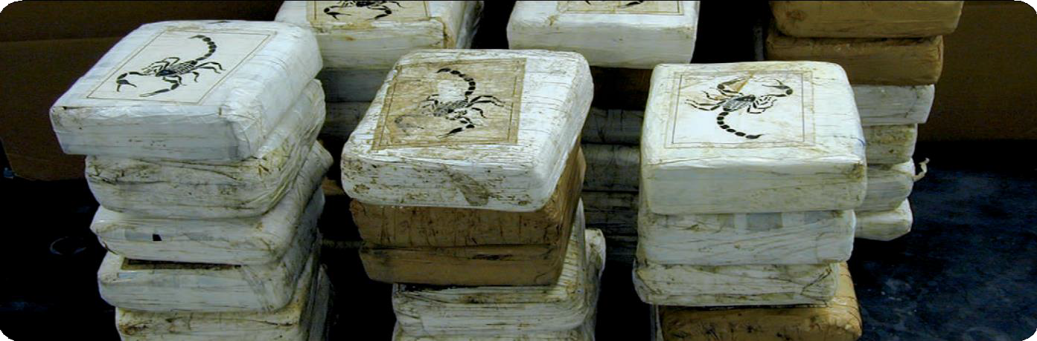for the upper respiratory tract. It also is used to reduce bleeding of the mucous membranes in the mouth, throat, and nasal cavities. However, more effective products have been developed for these purposes, and cocaine is now rarely used medically in the United States.

Cocaine bricks, seized by DEA

64 Drugs of Abuse | A DEA Resource Guide: 2020 EDITION

WHAT IS KHAT?
Khat is a flowering evergreen shrub that is abused for its stimulant-like effect. Khat has two active ingredients, cathine and cathinone.

WHAT IS ITS ORIGIN?
Khat
Khat is native to East Africa and the Arabian Peninsula, where the use of it is an established cultural tradition for many social situations.

What are common street names?
Common street names for khat include:
  - Abyssinian Tea, African Salad, Catha, Chat, Kat, and Oat

What are its overdose effects?
The dose needed to constitute an overdose is not known, however it has been historically associated with those who are long-term chewers of the leaves. Symptoms of toxicity include:
  - Delusions, loss of appetite, difficulty with breathing, and increases in both blood pressure and heart rate

Additionally, there are reports of liver damage (chemical hepatitis) and of cardiac complications, specifically myocardial infarctions. This mostly occurs among long-term chewers of khat or those who have chewed too large a dose.

What does it look like?
Khat is a flowering evergreen shrub. Khat that is sold and abused is usually just the leaves, twigs, and shoots of the khat shrub.

How is it abused?
Khat is typically chewed like tobacco, then retained in the cheek and chewed intermittently to release the active drug, which produces a stimulant-like effect. Dried khat leaves can be made into tea or a

Khat plant

chewable paste, and khat can also be smoked and even sprinkled on food.

What is its effect on the mind?
Khat can induce manic behavior with:
- Grandiose delusions, paranoia, nightmares, hallucinations, and hyperactivity
- Chronic khat abuse can result in violence and suicidal depression.

What is its effect on the body?
Khat causes an immediate increase in blood pressure and heart rate. Khat can also cause a brown staining of the teeth, insomnia, and gastric disorders. Chronic abuse of khat can cause physical exhaustion.

Which drugs cause similar effects?
Khat’s effects are similar to other stimulants, such as cocaine, amphetamine, and methamphetamine.

What is its legal status in the United States? The chemicals found in khat are controlled under the Controlled Substances Act. Cathine is a Schedule IV stimulant, and cathinone is a Schedule I stimulant under the Controlled Substances Act, meaning that it has a high potential for abuse, no currently accepted medical use in treatment in the United States, and a lack of accepted safety for use under medical supervision.

Drugs of Abuse | A DEA Resource Guide: 2020 EDITION 65

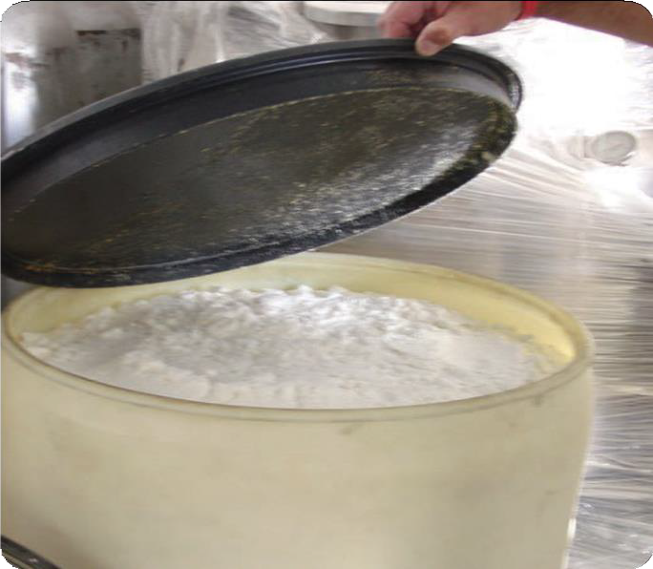WHAT IS METHAMPHETAMINE?
Methamphetamine (meth) is a stimulant. The FDA- approved brand-name medication is Desoxyn®.

WHAT IS ITS ORIGIN?
Mexican drug trafficking organizations have become the primary manufacturers and distributors of methamphetamine to cities throughout the United States, including in Hawaii. Domestic clandestine laboratory operators also produce
and distribute meth but usually on a smaller scale. The methods used depend on the availability of precursor chemicals.
Currently, this domestic clandestinely produced meth is mainly made with diverted products
that contain pseudoephedrine. Mexican methamphetamine is made with different precursor chemicals. The Combat Methamphetamine Epidemic Act of 2005 requires retailers of non-
prescription products containing pseudoephedrine, How is it abused?

Methamphetamine in finished form

ephedrine, or phenylpropanolamine to place these products behind the counter or in a locked cabinet.
Consumers must show identification and sign a logbook for each purchase.

What are common street names?
Common street names include:
  - Batu, Bikers Coffee, Black Beauties, Chalk, Chicken Feed, Crank, Crystal, Glass, Go-Fast, Hiropon, Ice, Meth, Methlies Quick, Poor Man’s Cocaine, Shabu, Shards, Speed, Stove Top, Tina, Trash, Tweak, Uppers, Ventana, Vidrio, Yaba, and Yellow Bam

What does it look like?
Regular meth is a pill or powder. Crystal meth resembles glass fragments or shiny blue-white “rocks” of various sizes.
Meth is swallowed, snorted, injected, or smoked. To intensify the effects, users may take higher doses of the drug, take it more frequently, or change their method of intake.

What is its effect on the mind?
Meth is a highly addictive drug with potent central nervous system (CNS) stimulant properties.
Those who smoke or inject it report a brief, intense sensation, or rush. Oral ingestion or snorting produces a long-lasting high instead of a rush, which reportedly can continue for as long as half a day. Both the rush and the high are believed to result from the release of very high levels of the neurotransmitter dopamine into areas of the brain
that regulate feelings of pleasure. Long-term meth use results in many damaging effects, including addiction.

Methamphetamine

66 Drugs of Abuse | A DEA Resource Guide: 2020 EDITION

Chronic meth users can exhibit violent behavior, anxiety, confusion, insomnia, and psychotic features including paranoia, aggression, visual and auditory hallucinations, mood disturbances, and delusions — such as the sensation of insects creeping on or under the skin.
Such paranoia can result in homicidal or suicidal thoughts. Researchers have reported that as much as 50 percent of the dopamine- producing cells in the brain can be damaged after prolonged exposure to relatively low levels of meth. Some studies suggested that the use of
methamphetamine may also result in serotonergic neurotoxicity.

What is its effect on the body?
Taking even small amounts of meth can result in:
- Increased wakefulness, increased physical activity, decreased appetite, rapid breathing and heart rate, irregular heartbeat, increased blood pressure, and hyperthermia (overheating)

High doses can elevate body temperature to dangerous, sometimes lethal, levels, and cause convulsions and even cardiovascular collapse and
death. Meth use may also cause extreme anorexia, memory loss, and severe dental problems.

What are its overdose effects?
High doses may result in death from stroke, heart attack, or multiple organ problems caused by overheating.

Which drugs cause similar effects? Cocaine and potent stimulant pharmaceuticals, such as amphetamines and methylphenidate, produce similar effects.

What is itslegalstatus in the United States? Methamphetamine is a Schedule II stimulant under the Controlled Substances Act, which means that it has a high potential for abuse and a currently accepted medical use (in FDA-approved products). It is available only through a prescription that cannot be refilled. Today there is only one legal meth product, Desoxyn®. It is currently marketed in 5, 10, and 15-milligram tablets (immediate release and extended release formulations) and has very limited use in the treatment of obesity and attention deficit hyperactivity disorder (ADHD).

Methamphetamine in finished form

Drugs of Abuse | A DEA Resource Guide: 2020 EDITION 67

WHAT ARE DEPRESSANTS?
Depressants will induce sleep, relieve anxiety and muscle spasms, and prevent seizures.
Barbiturates are older drugs and include butalbital (Fiorina®), phenobarbital, Pentothal®, Seconal®, and Nembutal®. A person can rapidly develop dependence on and tolerance to barbiturates, meaning a person needs more and more of them to feel and function normally. This makes them unsafe, increasing the likelihood of coma or death.
Benzodiazepines were developed to replace barbiturates, though they still share many of the undesirable side effects including tolerance
and dependence. Some examples are Valium®, Xanax®, Halcion®, Ativan®, Klonopin®, and Restoril®. Rohypnol® is a benzodiazepine that is not manufactured or legally marketed in the United States, but it is used illegally.
Lunesta®, Ambien®, and Sonata® are sedative-hypnotic medications approved for the short-term treatment of insomnia that share many of the properties of benzodiazepines. Other CNS
depressants include meprobamate, methaqualone (Quaalude®), and the illicit drug GHB.

WHAT IS THEIR ORIGIN?
Generally, legitimate pharmaceutical products are diverted to the illicit market. Teens can obtain depressants from the family medicine cabinet, friends, family members, the Internet, doctors, and hospitals.

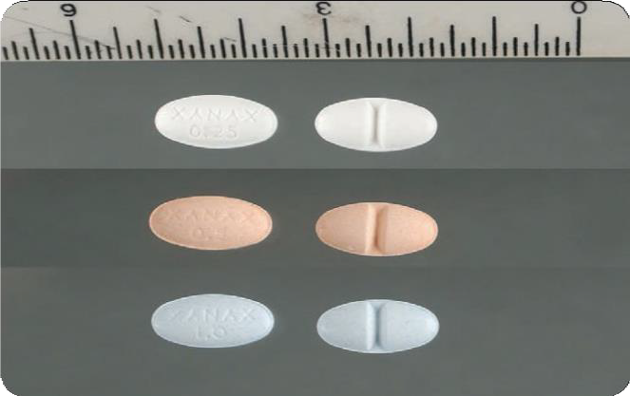Xanax 0.25,0.5 and 1mg scored tablets

What are common street names?
Common street names for depressants include:
- Barbs, Benzos, Downers, Georgia Home Boy, GHB, Grievous Bodily Harm, Liquid X, Nerve Pills, Phennies, R2, Reds, Roofies, Rophies, Tranks, and Yellows

What do they look like?
Depressants come in the form of pills, syrups, and injectable liquids.

How are they abused?
Individuals abuse depressants to experience euphoria. Depressants are also used with other drugs to add to the other drugs’ high or to deal with their side effects. Users take higher doses than people taking the drugs under a doctor’s supervision for therapeutic purposes. Depressants like GHB and Rohypnol are also misused to facilitate sexual assault.

Depressants

68 Drugs of Abuse | A DEA Resource Guide: 2020 EDITION

What is their effect on the mind? Depressants used therapeutically do what they are prescribed for:
- To induce sleep, relieve anxiety and muscle spasms, and prevent seizures

They also:
- Cause amnesia (leaving no memory of events that occur while under the influence), reduce reaction time, impair mental functioning and judgment, and cause confusion

Long-term use of depressants produces psychological dependence and tolerance.

What is their effect on the body? Some depressants can relax the muscles. Unwanted physical effects include:
- Slurred speech, loss of motor coordination, weakness, headache, lightheadedness, blurred vision, dizziness, nausea, vomiting, low blood pressure, and slowed breathing
Prolonged use of depressants can lead to physical dependence even at doses
recommended for medical treatment. Unlike barbiturates, large doses of benzodiazepines are rarely fatal unless combined with other drugs or alcohol. But unlike the withdrawal syndrome seen with most other drugs of abuse, withdrawal from depressants can be life threatening.

What is their legal status in the United States? Most depressants are controlled substances that range from Schedule I to Schedule IV under the Controlled Substances Act, depending on their risk for abuse and whether they currently have an accepted medical use. Many of the depressants have FDA-approved medical uses. Rohypnol® and Quaaludes® are not manufactured, legally marketed, and have no accepted medical use in the United States.

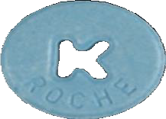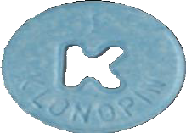

Klonopin 5mg tablet

Drugs of Abuse | A DEA Resource Guide: 2020 EDITION 69

WHAT ARE BARBITURATES?
Barbiturates are depressants that produce a wide spectrum of central nervous system depression from mild sedation to coma. They also have been used as sedatives, hypnotics, anesthetics, and anticonvulsants.
Barbiturates are classified as:
  - Ultrashort, Short, Intermediate, Long-acting

WHAT IS THEIR ORIGIN?
Barbiturates were first introduced for medical use in the 1900s, and today, few substances are in medical use.

What are common street names?
Common street names include:
  - Barbs, Block Busters, Christmas Trees, Goof Balls, Pinks, Red Devils, Reds & Blues, and Yellow Jackets

What do they look like?
Barbiturates come in a variety of multicolored pills and tablets. Users prefer the short-acting and intermediate barbiturates such as Amytal® and Seconal®.

How are they abused?
Barbiturates are abused by swallowing a pill or injecting a liquid form. Barbiturates are generally abused to reduce anxiety, decrease inhibitions, and treat unwanted effects of illicit drugs.
Barbiturates can be extremely dangerous because overdoses can occur easily and lead to death.

What is their effect on the mind?
Barbiturates cause:
- Mild euphoria, lack of restraint, relief of anxiety, and sleepiness

Higher doses cause:
- Impairment of memory, judgment, and coordination; irritability; and paranoid and suicidal ideation
- Tolerance develops quickly and larger doses are then needed to produce the same effect, increasing the danger of an overdose.

What is their effect on the body? Barbiturates slow down the central nervous system and cause sleepiness.

What are their overdose effects?
Effects of overdose include:
- Central nervous system depression, decreased respiration, increased heart rate, decreased blood pressure, decreased urine production, decreased body temperature, coma, and possible death

Which drugs cause similar effects?
Drugs with similar effects include:
- Alcohol, benzodiazepines like Valium® and Xanax®, tranquilizers, sleeping pills, Rohypnol®, and GHB

What is their legal status in the United States? Barbiturates are Schedule II, III, and IV depressants under the Controlled Substances Act.

Barbiturates

70 Drugs of Abuse | A DEA Resource Guide: 2020 EDITION

WHAT ARE BENZODIAZEPINES?
Benzodiazepines
Benzodiazepines are depressants that produce sedation and hypnosis, relieve anxiety and muscle spasms, and reduce seizures.

WHAT IS THEIR ORIGIN?
Benzodiazepines are only legally available through prescription. Many users maintain their drug supply by getting prescriptions from several doctors, forging prescriptions, or buying them illicitly.
Alprazolam and clonazepam are the two most frequently encountered benzodiazepines on the illicit market.

What are common street names? Common street names include Benzos and Downers.

What do they look like?
The most common benzodiazepines are the prescription drugs Valium®, Xanax®, Halcion®, Ativan®, and Klonopin®. Tolerance can develop, although at variable rates and to different degrees.
Shorter-acting benzodiazepines used to manage insomnia include estazolam (ProSom®), flurazepam (Dalmane®), temazepam (Restoril®), and triazolam (Halcion®). Midazolam (Versed®), a short-acting benzodiazepine, is utilized for sedation, anxiety, and amnesia in critical care settings and prior to anesthesia. It is available in the United States as an injectable preparation and as a syrup (primarily for pediatric patients).
Benzodiazepines with a longer duration of action are utilized to treat insomnia in patients with daytime anxiety. These benzodiazepines include alprazolam (Xanax®), chlordiazepoxide (Librium®), clorazepate (Tranxene®), diazepam (Valium®), halazepam (Paxipam®), lorzepam
(Ativan®), oxazepam (Serax®), prazepam (Centrax®), and quazepam (Doral®). Clonazepam (Klonopin®), diazepam, and clorazepate are also used as anticonvulsants.

How are they abused?
Abuse is frequently associated with adolescents and young adults who take the drug orally or crush it up and snort it to get high.
Abuse is particularly high among heroin and cocaine users. Additionally, opioid users often co- abuse benzodiazepines to enhance euphoria.

What is their effect on the mind? Benzodiazepines are associated with amnesia, hostility, irritability, and vivid or disturbing dreams.

What is their effect on the body? Benzodiazepines slow down the central nervous system and may cause sleepiness and relaxed mood.

What are their overdose effects?
Effects of overdose include:
- Extreme drowsiness, confusion, impaired coordination, decreased reflexes, respiratory depression, coma, and possible death. Overdose effects of concomitant use of benzodiazepines and opioids include: Profound sedation, respiratory depression, coma, and death.

Which drugs cause similar effects?
Drugs that cause similar effects include:
- Alcohol, barbiturates, sleeping pills, and GHB

What is their legal status in the United States? Benzodiazepines are controlled in Schedule IV of the Controlled Substances Act.

Drugs of Abuse | A DEA Resource Guide: 2020 EDITION 71

WHAT IS GHB?
Gamma-Hydroxybutyric acid (GHB) is another name for the generic drug sodium oxybate. Xyrem® (which is sodium oxybate) is the trade name of the Food and Drug Administration (FDA)-approved prescription medication. Xyrem® is approved as
a treatment to improve daytime sleepiness and muscle weakness with narcolepsy (a disorder marked by sudden, unexplained, spontaneous fatigue, napping, or falling asleep throughout the day).
Analogues that are often substituted for GHB include GBL (gamma butyrolactone) and 1,4 BD (also called just “BD”), which is 1,4-butanediol. These analogues are available legally as industrial solvents used to produce polyurethane, pesticides, elastic fibers, pharmaceuticals, coatings on metal or plastic, and other products. They are also sold illicitly as supplements for bodybuilding, fat loss, reversal of baldness, improved eyesight, and to combat aging, depression, drug addiction, and insomnia.
GBL and BD are sold as “fish tank cleaner,” “ink stain remover,” “ink cartridge cleaner,” and “nail enamel remover” for approximately $100 per bottle — much more expensive than comparable products. Attempts to identify the abuse of GHB analogues are hampered by the fact that routine
toxicological screens do not detect the presence of these analogues.

WHAT IS ITS ORIGIN?
GHB is produced illegally in both domestic and foreign clandestine laboratories. The major source of GHB on the street is through clandestine synthesis by local operators. At bars or “rave” parties, GHB is typically sold in liquid form
by the capful or “swig” for $5 to $25 per cap.

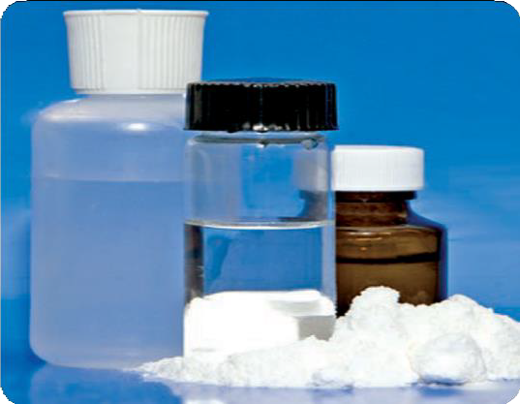GHB

Xyrem® has the potential for diversion and abuse like any other pharmaceutical containing a controlled substance.
GHB has been encountered in nearly every region of the country.

What are common street names?
Common street names include:
- Easy Lay, G, Georgia Home Boy, GHB, Goop, Grievous Bodily Harm, Liquid Ecstasy, Liquid X, and Scoop

What does it look like?
GHB is usually sold as a liquid or as a white powder that is dissolved in a liquid, such as water, juice, or alcohol. GHB dissolved in liquid has been packaged in small vials or small water bottles. In liquid form, GHB is clear and colorless and slightly salty in taste.

How is it abused?
GHB and its analogues are misused for their euphoric and calming effects and because some people believe they build muscles and cause weight loss.

GHB

72 Drugs of Abuse | A DEA Resource Guide: 2020 EDITION

GHB and its analogues are also misused for their ability to increase libido, suggestibility, passivity, and to cause amnesia (no memory of events while under the influence of the substance) — traits that make victims vulnerable to sexual assault and other criminal acts.
GHB misuse became popular among teens and young adults at dance clubs and “raves” in the 1990s and gained notoriety as a date rape drug. GHB is taken alone or in combination with other drugs, such as alcohol (primarily), other depressants, stimulants, hallucinogens, and marijuana.
The average dose ranges from 1 to 5 grams (depending on the purity of the compound, this can be 1-2 teaspoons mixed in a beverage). However, the concentrations of these “home-brews” have varied so much that users are usually unaware of the actual dose they are drinking.

What is its effect on the mind?
GHB occurs naturally in the central nervous system in very small amounts. Use of GHB produces Central Nervous System (CNS) depressant effects including:
- Euphoria, drowsiness, decreased anxiety, confusion, and memory impairment

GHB can also produce both visual hallucinations and
— paradoxically — excited and aggressive behavior. GHB greatly increases the CNS depressant effects of alcohol and other depressants.

What is its effect on the body?
GHB takes effect in 15 to 30 minutes, and the effects last 3 to 6 hours. Low doses of GHB produce nausea.
At high doses, GHB overdose can result in:
- Unconsciousness, seizures, slowed heart rate, greatly
slowed breathing, lower body temperature, vomiting, nausea, coma, and death.

Regular use of GHB can lead to addiction and withdrawal that includes:
- Insomnia, anxiety, tremors, increased heart rate and blood pressure, and occasional psychotic thoughts. Currently, there is no antidote available for GHB intoxication. GHB analogues are known to produce side effects such as:
- Topical irritation to the skin and eyes, nausea, vomiting, incontinence, loss of consciousness, seizures, liver damage, kidney failure, respiratory depression, and death

What are its overdose effects?
GHB overdose can cause coma and death.

Which drugs cause similar effects?
- GHB analogues are often abused in place of GHB. Both GBL and BD metabolize to GHB when taken and produce effects similar to GHB.
- CNS depressants such as barbiturates and methaqualone also produce effects similar to GHB.

What is its legal status in the United States? GHB is a Schedule I controlled substance, meaning that it has a high potential for abuse, no currently accepted medical use in treatment in the United States, and a lack of accepted safety for use under medical supervision. FDA-approved GHB products are Schedule III substances under the Controlled Substances Act. In addition, GBL is a List I chemical.
GHB was placed on Schedule I of the Controlled Substances Act in March 2000. However, when sold as FDA-approved GHB products (such as Xyrem®), it is considered Schedule III, one of several drugs that are listed in multiple schedules.

Drugs of Abuse | A DEA Resource Guide: 2020 EDITION 73

WHAT IS ROHYPNOL?
Rohypnol® is a trade name for flunitrazepam, a central nervous system (CNS) depressant that belongs to a class of drugs known as
benzodiazepines. Flunitrazepam is also marketed as generic preparations and other trade name products outside of the United States.
Like other benzodiazepines, Rohypnol® produces sedative-hypnotic, anti-anxiety, and muscle relaxant effects. This drug has never been approved for medical use in the United States
by the Food and Drug Administration. Outside the United States, Rohypnol® is commonly prescribed to treat insomnia. Rohypnol® is also referred to as a “date rape” drug.

WHAT IS ITS ORIGIN?
Rohypnol® is smuggled into the United States from other countries, such as Mexico.

What are common street names?
Common street names include:
  - Circles, Forget Pill, Forget-Me-Pill, La Rocha, Lunch Money Drug, Mexican Valium, Pingus, R2, Reynolds, Roach, Roach 2, Roaches, Roachies, Roapies, Robutal, Rochas Dos, Rohypnol, Roofies, Rophies, Ropies, Roples, Row-Shay, Ruffies, and Wolfies

What does it look like?
Prior to 1997, Rohypnol® was manufactured as a white tablet (0.5-2 milligrams per tablet), and when mixed in drinks, was colorless, tasteless, and odorless. In 1997, the manufacturer responded to concerns about the drug’s role in sexual assaults by reformulating the drug.
Rohypnol® is now manufactured as an oblong olive green tablet with a speckled blue core that when dissolved in light-colored drinks will dye the
liquid blue. However, generic versions of the drug may not contain the blue dye.

How is it abused?
The tablet can be swallowed whole, crushed and snorted, or dissolved in liquid. Adolescents may abuse Rohypnol® to produce a euphoric effect often described as a “high.” While high,
they experience reduced inhibitions and impaired judgment.
Rohypnol is also used in combination with alcohol to produce an exaggerated intoxication.
In addition, abuse of Rohypnol® may be associated with multiple-substance abuse.
For example, cocaine users may use benzodiazepines such as Rohypnol® to relieve the side effects (e.g., irritability and agitation) associated with cocaine binges.
Rohypnol is also misused to physically and psychologically incapacitate victims targeted for sexual assault. The drug is usually placed

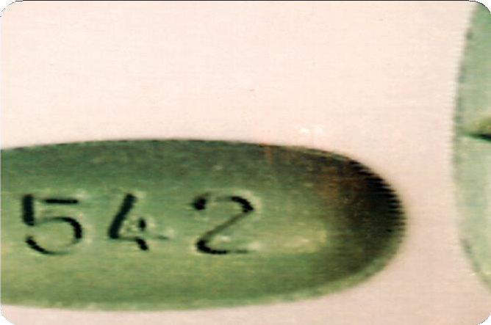
Rohypnol® tablets

Rohypnol ®

74 Drugs of Abuse | A DEA Resource Guide: 2020 EDITION

in the alcoholic drink of an unsuspecting victim to incapacitate them and prevent resistance
to sexual assault. The drug leaves the victim unaware of what has happened to them.

What is its effect on the mind?
Like other benzodiazepines, Rohypnol® slows down the functioning of the CNS producing:
- Drowsiness (sedation), sleep (pharmacological hypnosis), decreased anxiety, and amnesia (no memory of events while under the influence of the substance)
Rohypnol® can also cause:
- Increased or decreased reaction time, impaired mental functioning and judgment, confusion, aggression, and excitability

What is its effect on the body?
Rohypnol® causes muscle relaxation. Adverse physical effects include:
- Slurred speech, loss of motor coordination, weakness, headache, and respiratory depression
Rohypnol® also can produce physical dependence when taken regularly over a period of time.

What are its overdose effects?
High doses of Rohypnol®, particularly when combined with CNS depressant drugs such as alcohol and heroin, can cause severe
sedation, unconsciousness, slow heart rate, and suppression of respiration that may be sufficient to result in death.

Which drugs cause similar effects? Drugs that cause similar effects include GHB (gamma hydroxybutyrate) and other benzodiazepines such as alprazolam (e.g.,
Xanax®), clonazepam (e.g., Klonopin®), and diazepam (e.g., Valium®).

What is its legal status in the United States? Rohypnol® is a Schedule IV substance under the Controlled Substances Act. Rohypnol® is not approved for manufacture, sale, use, or importation to the United States. However, it
is legally manufactured and marketed in other countries. Penalties for possession, trafficking, and distribution involving one gram or more are the same as those of a Schedule I drug.

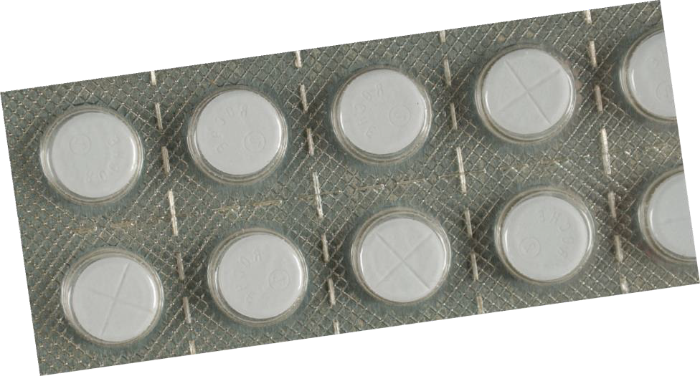

Blister pack of Rohypnol® tablets

Drugs of Abuse | A DEA Resource Guide: 2020 EDITION 75

WHAT ARE HALLUCINOGENS?
Hallucinogens are found in plants and fungi or are synthetically produced and are among the oldest known group of drugs used for their ability to alter human perception and mood.

WHAT IS THEIR ORIGIN?
Hallucinogens can be synthetically produced in illicit laboratories or are found in plants.

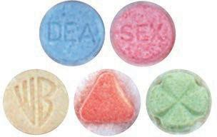
MDMA/Ecstasy

What are common street names?
Common street names include:
- Acid, Blotter, Cubes, Fry, Mind Candy, Mushrooms, Shrooms, Special K, STP, X, and XTC

What do they look like?
Hallucinogens come in a variety of forms. MDMA or ecstasy tablets are sold in many colors with a variety of logos to attract youth. LSD is sold in the form of saturated paper (blotter paper), typically imprinted with colorful graphic designs.

How are they abused?
The most commonly abused hallucinogens among junior and senior high school students are hallucinogenic mushrooms, LSD, and MDMA (ecstasy). Hallucinogens are typically taken orally or can be smoked.

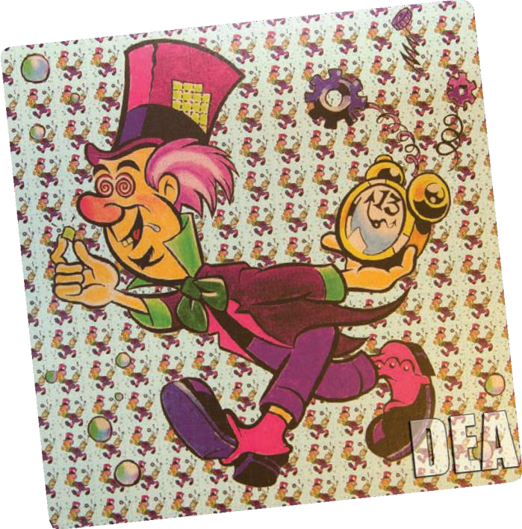What is their effect on the mind?
LSD Blotter Sheet
Sensory effects include perceptual distortions that vary with dose, setting, and mood. Psychic effects include distortions of thought associated with time and space. Time may appear to stand still, and forms and LSD powder and capsules colors seem to change and take on new significance. Weeks or even months after some hallucinogens have been taken, the user may develop an uncommon disorder called Hallucinogen Persisting Perception Disorder (HPPD) or experience “flashbacks.” HPPD can include fragmentary recurrences of certain aspects of the drug experience in the absence of actually taking the drug. The occurrence of HPPD is unpredictable, but may be more likely to occur during times of stress and seems to occur more frequently in younger individuals.

Hallucinogens

76 Drugs of Abuse | A DEA Resource Guide: 2020 EDITION

What is their effect on the body? Physiological effects include elevated heart rate, increased blood pressure, dilated pupils, and often can induce nausea and vomiting.

What are their overdose effects?
Deaths exclusively from acute overdose of LSD, magic mushrooms, and mescaline are extremely rare. Deaths generally occur due to suicide, accidents, and dangerous behavior, or due to the person inadvertently eating poisonous plant material.
A severe overdose of PCP or ketamine can result in:
- Respiratory depression, coma, convulsions, seizures, and death due to respiratory arrest

What is their legal status in the United States?
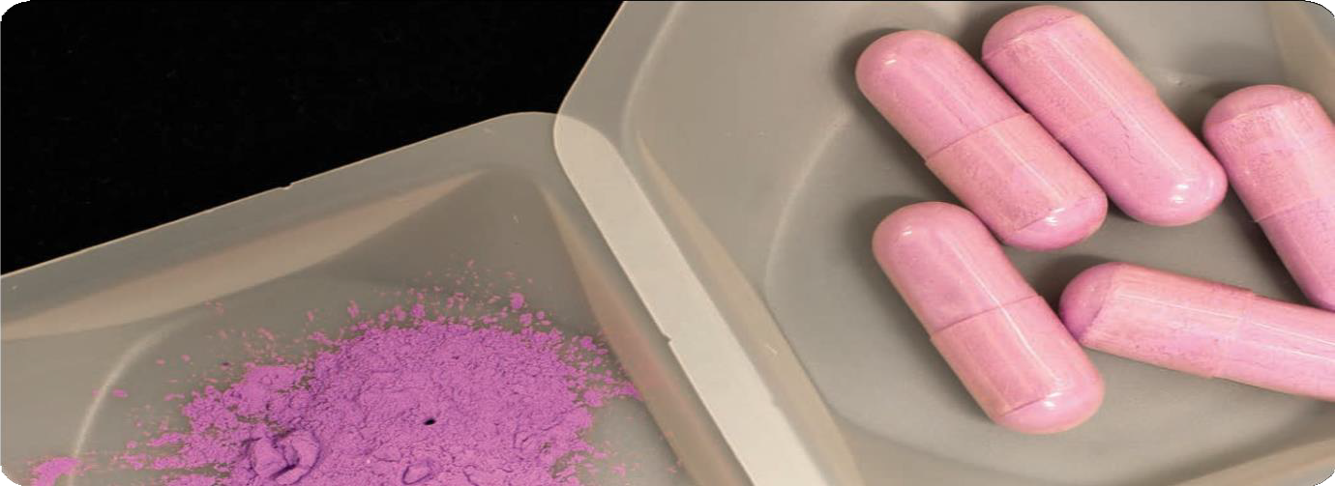Many hallucinogens are Schedule I under the Controlled Substances Act, meaning that they have a high potential for abuse, no currently accepted medical use in treatment in the United States, and a lack of accepted safety for use under medical supervision.

LSD powder and capsules

Drugs of Abuse | A DEA Resource Guide: 2020 EDITION 77

WHAT IS ECSTASY/MDMA?
MDMA acts as both a stimulant and psychedelic, producing an energizing effect, distortions in time and perception, and enhanced enjoyment of tactile experiences.
Adolescents and young adults use it to reduce inhibitions and to promote:
  - Euphoria, feelings of closeness, empathy, and sexuality

Although MDMA is known among users as ecstasy, researchers have determined that many ecstasy tablets contain not only MDMA but also a number of other drugs or drug combinations that can be harmful, such as:
  - Methamphetamine, ketamine, cocaine, cathinones, and
caffeine

In addition, other drugs similar to MDMA, such as MDA or PMA, are often sold as ecstasy, which can lead to overdose and death when the user
takes additional doses to obtain the desired effect.

WHAT IS ITS ORIGIN?
MDMA is a synthetic chemical made in labs. Seized MDMA in the U.S. is primarily manufactured in, and smuggled across U.S.
borders from, clandestine laboratories in Canada and, to a lesser extent, the Netherlands. A small number of MDMA clandestine laboratories have also been identified operating in the U.S.

What are common street names?
Common street names include:
  - Adam, Beans, Clarity, Disco Biscuit, E, Ecstasy, Eve, Go, Hug Drug, Lover’s Speed, MDMA, Peace, STP, X, and XTC

What does it look like?
MDMA is mainly distributed in tablet form. MDMA tablets are often sold with logos, creating brand names for users to seek out. The colorful pills are often hidden among colorful candies. MDMA is also distributed in capsules, powder, and liquid forms.

How is it abused?
MDMA use mainly involves swallowing tablets (50-150 mg), which are sometimes crushed and snorted, occasionally smoked, but rarely injected. MDMA is also available as a powder.
MDMA users usually take MDMA by “stacking” (taking three or more tablets at once) or by “piggy-backing” (taking a series of tablets over
a short period of time). One trend among young adults is “candy flipping,” which is the co-abuse of MDMA and LSD.
MDMA is considered a “party drug.” As with many other drugs of abuse, MDMA is rarely used alone. It is common for users to mix MDMA with other substances, such as alcohol and marijuana.

What is its effect on the mind?
MDMA mainly affects brain cells that use the chemical serotonin to communicate with
each other. Serotonin helps to regulate mood, aggression, sexual activity, sleep, and sensitivity to pain. Clinical studies suggest that MDMA may increase the risk of long-term, perhaps permanent, problems with memory and learning.
MDMA causes changes in perception, including euphoria and increased sensitivity to touch, energy, sensual and sexual arousal, need to be touched, and need for stimulation.

Ecstasy/MDMA

78 Drugs of Abuse | A DEA Resource Guide: 2020 EDITION

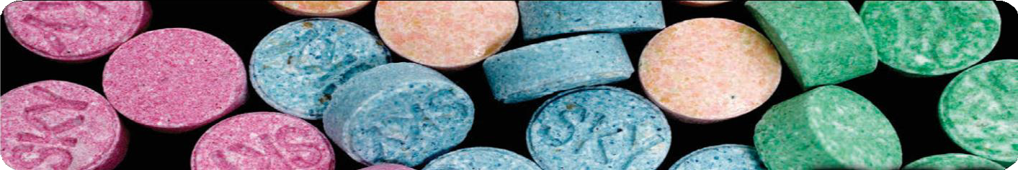

Some unwanted psychological effects include:
- Confusion, anxiety, depression, paranoia, sleep problems, and drug craving

All these effects usually occur within 30 to 45 minutes of swallowing the drug and usually last 4 to 6 hours, but they may occur or last weeks after ingestion.

What is its effect on the body?
Users of MDMA experience many of the same effects and face many of the same risks as users of other stimulants such as cocaine and amphetamines. These include increased motor
activity, alertness, heart rate, and blood pressure. Some unwanted physical effects include:
- Muscle tension, tremors, involuntary teeth clenching, muscle cramps, nausea, faintness, chills, sweating, and blurred vision

Severe dehydration can result from the combination of the drug’s effects and the crowded and hot conditions in which the drug is often taken.
Studies suggest chronic use of MDMA can produce damage to the serotonin system. It is ironic that a drug that is taken to increase pleasure may cause damage that reduces a person’s ability to feel pleasure.
MDMA/Ecstacy pills

What are its overdose effects?
In high doses, MDMA can interfere with the body’s ability to regulate temperature. On occasions, this can lead to a sharp increase in body temperature (hyperthermia), resulting in liver, kidney, and cardiovascular system failure, and death. Because MDMA can interfere with its own metabolism (that is, its breakdown within the body), potentially harmful levels can be reached by repeated drug use within short intervals.

Which drugs cause similar effects?
MDMA produces both amphetamine-like stimulation and mild mescaline-like hallucinations.

Whatisitslegal statusin the United States? MDMA is a Schedule I drug under the Controlled Substances Act, meaning it has a high potential for abuse, no currently accepted medical use
in treatment in the United States, and a lack of accepted safety for use under medical supervision.

Drugs of Abuse | A DEA Resource Guide: 2020 EDITION 79

WHAT IS KETAMINE?
Ketamine is a dissociative anesthetic that has some hallucinogenic effects. It distorts perceptions of sight and sound and makes the user feel disconnected and not in control. It is an injectable, short-acting anesthetic for use in humans and animals. It is referred to as a “dissociative anesthetic” because
it makes patients feel detached from their pain and environment.
Ketamine can induce a state of sedation (feeling calm and relaxed), immobility, relief from pain, and amnesia (no memory of events while under the influence of the drug).
It is abused for its ability to produce dissociative sensations and hallucinations. Ketamine has also been used to facilitate sexual assault.

WHAT IS ITS ORIGIN?
Ketamine is produced commercially in a number of countries, including the United States. Most of the ketamine illegally distributed in the United
States is diverted or stolen from legitimate sources, particularly veterinary clinics, or smuggled into the United States from Mexico.
Distribution of ketamine typically occurs among friends and acquaintances, most often at raves, nightclubs, and at private parties; street sales of ketamine are rare.

How is it abused?
Ketamine, along with the other “club drugs,” has become popular among teens and young adults at dance clubs and “raves.” Ketamine is manufactured commercially as a powder or liquid. Powdered ketamine is also formed from pharmaceutical ketamine by evaporating the liquid using hot plates, warming trays, or microwave ovens, a process that

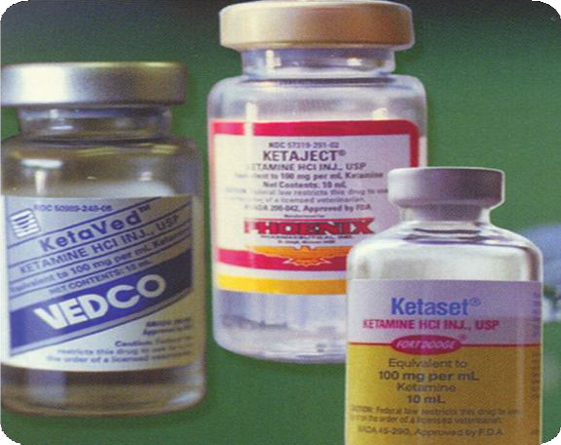Vials containing liquid ketamine

results in the formation of crystals, which are then ground into powder.

What are common street names?
Common street names include:
- Cat Tranquilizer, Cat Valium, Jet K, Kit Kat, Purple, Special K, Special La Coke, Super Acid, Super K, and Vitamin K

What does it look like?
Ketamine comes in a clear liquid and a white or off-white powder. Powdered ketamine (100
milligrams to 200 milligrams) typically is packaged in small glass vials, small plastic bags, and capsules as well as paper, glassine, or aluminum foil folds.
Powdered ketamine is cut into lines known as bumps and snorted, or it is smoked, typically in marijuana or tobacco cigarettes. Liquid ketamine is injected or mixed into drinks. Ketamine is found by itself or often in combination with MDMA, amphetamine, methamphetamine, or cocaine.

Ketamine

80 Drugs of Abuse | A DEA Resource Guide: 2020 EDITION

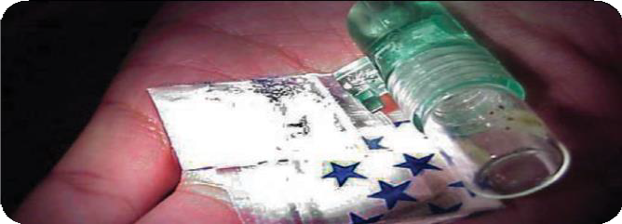What is its effect on the mind?
Ketamine produces hallucinations. It distorts perceptions of sight and sound and makes the user feel disconnected and not in control. A “Special K” trip is touted as better than that of LSD or PCP because its hallucinatory effects are relatively short in duration, lasting approximately 30 to 60 minutes as opposed to several hours.
Slang for experiences related to Ketamine or
effects of ketamine include: What are its overdose effects?

Ketamine in various forms

  - “K-land” (refers to a mellow & colorful experience)
  - “K-hole” (refers to the out-of-body, near death experience)
  - “Baby food” (users sink in to blissful, infantile inertia)
  - “God” (users are convinced that they have met their
maker)

The onset of effects is rapid and often occurs within a few minutes of taking the drug, though taking it orally results in a slightly slower onset of effects.
Hallucinogen Persisting Perception Disorder (HPPD) has been reported several weeks after ketamine is used and may include experiencing the negative side effects that occurred while taking the drug initially.
Ketamine may also cause agitation, depression, cognitive difficulties, unconsciousness, and amnesia.

What is its effect on the body?
A couple of minutes after taking the drug, the user may experience an increase in heart rate and blood pressure that gradually decreases over the next 10 to 20 minutes. Ketamine can make users unresponsive to stimuli. When in this state, users experience:
  - Involuntarily rapid eye movement, dilated pupils, salivation, tear secretions, and stiffening of the muscles
This drug can also cause nausea.
An overdose can cause unconsciousness and dangerously slowed breathing.

Which drugs cause similar effects?
Other hallucinogenic drugs such as LSD, PCP, and mescaline can cause hallucinations. There are also several drugs such as GHB, Rohypnol®, and other depressants that are misused for their amnesiac or sedative properties to facilitate sexual assault.

What is its legal status in the United States?
Since the 1970s, ketamine has been marketed
in the United States as an injectable, short-acting anesthetic for use in humans and animals. In 1999, ketamine, including its salts, isomers and salts
of isomers, became a Schedule III non-narcotic substance under the Controlled Substances Act. It currently has accepted medical uses for short-
term sedation and anesthesia. In addition, in 2019, FDA approved the S(+) enantiomer of ketamine (esketamine) nasal spray version (Spravato®) for treatment-resistant depression that is only available at a certified doctor’s office or clinic. Ketamine has the potential for abuse, which may lead to moderate or low physical dependence or high psychological dependence.

Drugs of Abuse | A DEA Resource Guide: 2020 EDITION 81

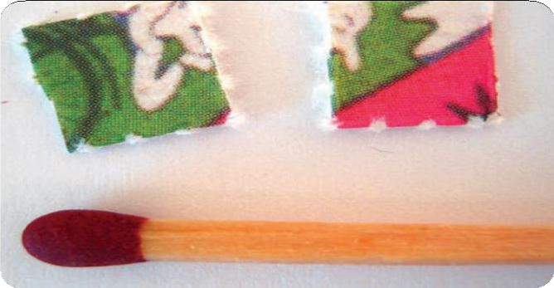WHAT IS LSD?
Image by Erik Fenderson
LSD is a potent hallucinogen that has a high potential for abuse and currently has no accepted medical use in treatment in the United States.

WHAT IS ITS ORIGIN?
LSD is produced in clandestine laboratories in the United States.

What are common street names?
Common names for LSD include:
  - Acid, Dots, Mellow Yellow, and Window Pane

What does it look like?
LSD is an odorless and colorless substance with a slightly bitter taste. LSD is available in saturated absorbent paper (e.g., blotter paper, divided
into small, decorated squares, with each square representing one dose), tablets or “micro dots,” saturated sugar cubes, or in a liquid form.

What is its effect on the body?
The physical effects include:
  - Dilated pupils, higher body temperature, increased heart rate and blood pressure, sweating, loss of appetite, sleeplessness, dry mouth, and tremors

How is it abused?
LSD is abused orally.

What is its effect on the mind?
During the first hour after ingestion, users may experience visual changes with extreme changes in mood. While hallucinating, the user may suffer impaired depth and time perception accompanied by distorted perception of the shape and size of objects, movements, colors, sound, touch, and the user’s own body image.

LSD blotter paper with match for size comparison

The ability to make sound judgments and see common dangers is impaired, making the user susceptible to personal injury. It is possible for users to suffer acute anxiety and depression after an LSD “trip.” Hallucinogen Persisting Perception Disorder, which may include fragmentary recurrences of certain aspects of the drug experience or “flashbacks” have been reported days, and even months, after taking the last dose.

What are its overdose effects?
Longer, more intense “trip” episodes, psychosis, and possible death

Which drugs cause similar effects?
LSD’s effects are similar to other hallucinogens, such as PCP, mescaline, and peyote.

What is its legal status in the United States? LSD is a Schedule I substance under the Controlled Substances Act. Schedule I substances have a high potential for abuse, no currently accepted medical use in treatment in the United States, and a lack of accepted safety for use under medical supervision.

LSD

82 Drugs of Abuse | A DEA Resource Guide: 2020 EDITION

WHAT ARE PEYOTE AND MESCALINE?
Peyote & Mescaline
Peyote is a small, spineless cactus. The active ingredient in peyote is the hallucinogen mescaline.

WHAT IS ITS ORIGIN?
From earliest recorded time, peyote has been used by indigenous peoples in northern Mexico and the southwestern United States as a part of their religious rites. Mescaline can be extracted from peyote or produced synthetically.

What is its effect on the body? Following the consumption of peyote and mescaline, users may experience:
- Intense nausea, vomiting, dilation of the pupils, increased heart rate, increased blood pressure, a rise in body temperature that causes heavy perspiration, headaches, muscle weakness, and impaired motor coordination

Which drugs cause similar effects? Other hallucinogens like LSD, psilocybin (mushrooms), and PCP

What are common street names?
Common street names include:
- Buttons, Cactus, Mesc, and Peyoto

What does it look like?
The top of the peyote cactus is referred to as the “crown” and consists of disc-shaped buttons that are cut off.

How is it abused?
The fresh or dried buttons are chewed or soaked in water to produce an intoxicating liquid. Peyote
buttons may also be ground into a powder that can be placed inside gelatin capsules to be swallowed, or smoked with a leaf material such as cannabis or tobacco.

What is its effect on the mind?
Abuse of peyote and mescaline will cause varying degrees of:
- Illusions, hallucinations, altered perception of space and time, and altered body image

Users may also experience euphoria, which is sometimes followed by feelings of anxiety.

What is its legal status in the United States? Peyote and mescaline are Schedule I substances under the Controlled Substances Act, meaning that they have a high potential for abuse, no currently accepted medical use in treatment in the United States, and a lack of accepted safety for use under medical supervision.
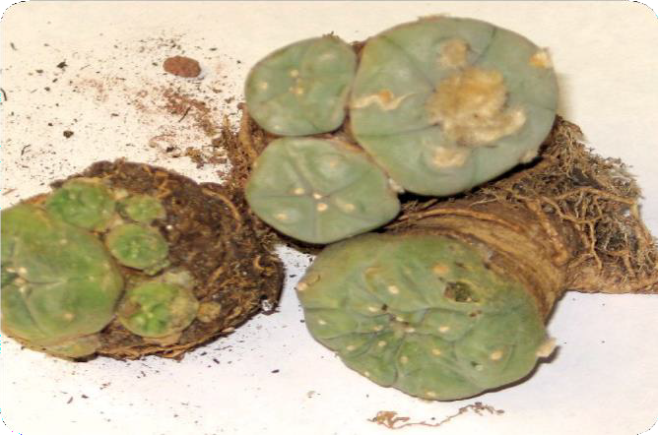
Peyote cactus

Drugs of Abuse | A DEA Resource Guide: 2020 EDITION 83

WHAT IS PSILOCYBIN?
Psilocybin is a chemical obtained from certain types of fresh or dried mushrooms.

WHAT IS ITS ORIGIN?
Psilocybin mushrooms are found in Mexico, Central America, and the United States.

What are common street names?
Common street names include:
  - Magic Mushrooms, Mushrooms, and Shrooms

What does it look like?
Mushrooms containing psilocybin are available fresh or dried and have long, slender stems topped by caps with dark gills on the underside. Fresh mushrooms have white or whitish-gray stems; the caps are dark brown around the edges and light brown or white in the center. Dried mushrooms are usually rusty brown with isolated
areas of off-white. What is its effect on the mind?

Psilocybin mushrooms

How is it abused?
Psilocybin mushrooms are ingested orally. They may also be brewed as a tea or added to other foods to mask their bitter flavor.

What is its effect on the body?
The physical effects include:
  - Nausea, vomiting, muscle weakness, and lack of coordination
The psychological consequences of psilocybin use include hallucinations and an inability to discern fantasy from reality. Panic reactions and a psychotic-like episode also may occur, particularly if a user ingests a high dose.

What are its overdose effects?
Effects of overdose include:
- Longer, more intense “trip” episodes, psychosis, and
possible death

Psilocybin

84 Drugs of Abuse | A DEA Resource Guide: 2020 EDITION

Abuse of psilocybin mushrooms could also lead to poisoning if one of the many varieties of poisonous mushrooms is incorrectly identified as a psilocybin mushroom.

Which drugs cause similar effects?
Psilocybin effects are similar to other hallucinogens, such as mescaline and peyote.

What is its legal status in the United States?
Psilocybin is a Schedule I substance under the Controlled Substances Act, meaning that it has a high potential for abuse, no currently accepted medical use in treatment in the United States, and a lack of accepted safety for use under medical supervision.

Psilocybin mushrooms
Image by Erik Fenderson

Drugs of Abuse | A DEA Resource Guide: 2020 EDITION 85

WHAT ARE STEROIDS?
Anabolic steroids are synthetically produced variants of the naturally occurring male hormone testosterone that are abused in an attempt to promote muscle growth, enhance athletic or other physical performance, and improve physical appearance.
Testosterone, trenbolone, oxymetholone, methandrostenolone, nandrolone, stanozolol, boldenone, and oxandrolone are some of the anabolic steroids that are most commonly encountered by United States law enforcement.

WHAT IS THEIR ORIGIN?
Most illicit steroids are smuggled into the U.S. from abroad. Steroids are also illegally diverted from legitimate sources (theft or inappropriate prescribing). The Internet is the most widely used means of buying and selling anabolic steroids. Steroids are also bought and sold at gyms, bodybuilding competitions, and schools from teammates, coaches, and trainers.

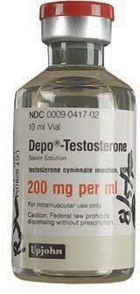
What are common street names?
Common street names include:
- Arnolds, Juice, Pumpers, Roids, Stackers, and Weight Gainers

What do they look like?
Steroids are available in:
- Tablets and capsules, sublingual-tablets, liquid drops, gels, creams, transdermal patches, subdermal implant pellets, and water-based and oil- based injectable solutions

Depo-Testosterone

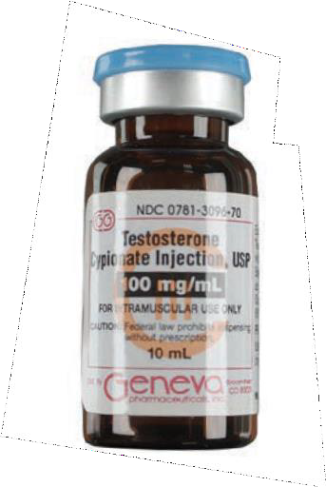The appearance of these products varies depending on the type and manufacturer.

Testosterone Cypionate Injection, USP

How are they abused?
Steroids are ingested orally, injected intramuscularly, or applied to the skin. The doses abused are often 10 to 100 times higher than the approved therapeutic and medical treatment dosages. Users typically take two or more anabolic steroids at the same time in a cyclic manner, believing that this will improve their effectiveness and minimize the adverse effects.

Steroids

86 Drugs of Abuse | A DEA Resource Guide: 2020 EDITION

What is their effect on the mind?
Case studies and scientific research indicate that high doses of anabolic steroids may cause mood and behavioral effects.
In some individuals, anabolic steroid use can cause dramatic mood swings, increased feelings of hostility, impaired judgment, and increased levels of aggression (often referred to as “roid rage”).
When users stop taking steroids, they may experience depression that may be severe enough to lead one to commit suicide.
Anabolic steroid use may also cause psychological dependence and addiction.

What is their effect on the body?
A wide range of adverse effects is associated with the use or abuse of anabolic steroids. These effects depend on several factors including:
- Age, sex, the anabolic steroid used, amount used, and duration of use

In adolescents, anabolic steroid use can stunt the ultimate height that an individual might otherwise achieve.
In boys, anabolic steroid use can cause early sexual development, acne, and stunted growth.
In adolescent girls and women, anabolic steroid use can induce permanent physical changes, such as deepening of the voice, increased facial and body hair growth, menstrual irregularities, male pattern baldness, and lengthening of the clitoris.
In men, anabolic steroid use can cause shrinkage of the testicles, reduced sperm count, enlargement of the male breast tissue, sterility, and an increased risk of prostate cancer.
In both men and women, anabolic steroid use can cause high cholesterol levels, which may
increase the risk of coronary artery disease, strokes, and heart attacks. Anabolic steroid use can also cause acne and fluid retention. Oral preparations of anabolic steroids, in particular, can damage the liver.
Users who inject anabolic steroids run the risk of contracting various infections due to non-sterile injection techniques, sharing of contaminated needles, and the use of steroid preparations manufactured in non-sterile environments. All these factors put users at risk for contracting viral infections such as HIV/AIDS or hepatitis B or C, and bacterial infections at the sight of injection.
Users may also develop endocarditis, a bacterial infection that causes a potentially fatal inflammation of the heart lining.

What are their overdose effects? Anabolic steroids are not associated with overdoses. The adverse effects a user would
experience develop from the use of steroids over time.

Which drugs cause similar effects?
There are several substances that produce effects similar to those of anabolic steroids. These include human growth hormone (hHG), clenbuterol, gonadotropins, and erythropoietin.

What is their legal status in the United States? Anabolic steroids are Schedule III substances under the Controlled Substances Act. Only a small number of anabolic steroids are approved for either human or veterinary use. Anabolic steroids may be prescribed by a licensed physician for
the treatment of testosterone deficiency, delayed puberty, low red blood cell count, breast cancer, and tissue wasting resulting from AIDS.

Drugs of Abuse | A DEA Resource Guide: 2020 EDITION 87

WHAT IS MARIJUANA?
Marijuana is a mind-altering (psychoactive) drug, produced by the Cannabis sativa plant.
Marijuana has over 480 constituents. THC (delta- 9-tetrahydrocannabinol) is believed to be the main ingredient that produces the psychoactive effect.

WHAT IS ITS ORIGIN?
Marijuana is grown in the United States, Canada, Mexico, South America, Caribbean, and Asia.
It can be cultivated in both outdoor and indoor settings.

What are common street names?
Common street names include:
  - Aunt Mary, BC Bud, Blunts, Boom, Chronic, Dope, Gangster, Ganja, Grass, Hash, Herb, Hydro, Indo, Joint, Kif, Mary Jane, Mota, Pot, Reefer, Sinsemilla, Skunk, Smoke, Weed, and Yerba

What does it look like?
Marijuana is a dry, shredded green/brown mix of flowers, stems, seeds, and leaves from the Cannabis sativa plant. The mixture typically is
green, brown, or gray in color and may resemble tobacco.

How is it abused?
Marijuana is usually smoked as a cigarette (called a joint) or in a pipe or bong. It is also smoked in blunts, which are cigars that have been emptied of tobacco and refilled with marijuana, sometimes in combination with another drug. Marijuana is also mixed with foods or brewed as a tea.

What is its effect on the mind?
When marijuana is smoked, the active ingredient THC passes from the lungs and into the bloodstream, which carries the chemical to the organs throughout the body, including the brain. In the brain, THC connects to specific sites called cannabinoid receptors on nerve cells and influences the activity of those cells.
Many of these receptors are found in the parts of the brain that influence:
- Pleasure, memory, thought, concentration, sensory and time perception, and coordinated movement

The short-term effects of marijuana include:
- Problems with memory and learning, distorted perception, difficulty in thinking and problem-solving, and loss of coordination

The effect of marijuana on perception and coordination are responsible for serious impairments in learning, associative processes, and psychomotor behavior (driving abilities).
Long term, regular use can lead to physical dependence and withdrawal following discontinuation, as well as psychological addiction or dependence.
Clinical studies show that the physiological, psychological, and behavioral effects of marijuana vary among individuals and present a list of common responses to cannabinoids, as described in the scientific literature:
- Dizziness, nausea, tachycardia, facial flushing, dry mouth, and tremor initially
- Merriment, happiness, and even exhilaration at high doses

Marijuana/Cannabis

88 Drugs of Abuse | A DEA Resource Guide: 2020 EDITION

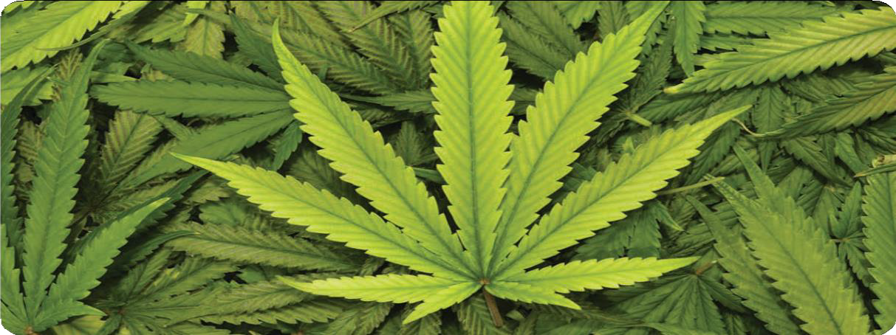
Marijuana Leaves

- Disinhibition, relaxation, increased sociability, and talkativeness
- Enhanced sensory perception, giving rise to increased appreciation of music, art, and touch
- Heightened imagination leading to a subjective sense of increased creativity
- Time distortions
- Illusions, delusions, and hallucinations are rare except at high doses
- Impaired judgment, reduced coordination, and ataxia, which can impede driving ability or lead to an increase in risk-taking behavior
- Emotional lability, incongruity of affect, dysphoria, disorganized thinking, inability to converse logically, agitation, paranoia, confusion, restlessness, anxiety, drowsiness, and panic attacks may occur, especially in inexperienced users or in those who have taken a large dose
- Increased appetite and short-term memory impairment are common

What is its effect on the body?
Short-term physical effects from marijuana use may include:
  - Sedation, bloodshot eyes, increased heart rate, coughing from lung irritation, increased appetite, and increased blood pressure (although prolonged use may cause a decrease in blood pressure).

Marijuana smokers experience serious health problems such as bronchitis, emphysema, and bronchial asthma. Extended use may cause suppression of the immune system. Withdrawal from chronic use of high doses of marijuana causes physical signs including headache, shakiness, sweating, and stomach pains and nausea.
Withdrawal symptoms also include behavioral signs such as:
  - Restlessness, irritability, sleep difficulties, and decreased appetite

Drugs of Abuse | A DEA Resource Guide: 2020 EDITION 89

What are its overdose effects?
No deaths from overdose of marijuana have been reported.

Which drugs cause similar effects? Hashish and hashish oil are drugs made from the cannabis plant that are like marijuana, only stronger.
Hashish (hash) consists of the THC-rich resinous material of the cannabis plant, which is collected, dried, and then compressed into a
variety of forms, such as balls, cakes, or cookie like sheets. Pieces are then broken off, placed in pipes or mixed with tobacco and placed in pipes or cigarettes, and smoked.
The main sources of hashish are the Middle East, North Africa, Pakistan, and Afghanistan.
Hashish oil (hash oil, liquid hash, cannabis oil) is produced by extracting the cannabinoids from the plant material with a solvent. The color and odor of the extract will vary, depending on the solvent used. A drop or two of this liquid on a cigarette is equal to a single marijuana joint.
Like marijuana, hashish and hashish oil are both Schedule I drugs.

What is its legal status in the United States? Marijuana is a Schedule I substance under the Controlled Substances Act, meaning that it has a high potential for abuse, no currently accepted
medical use in treatment in the United States, and a lack of accepted safety for use under medical supervision.
Although some states within the United States have allowed the use of marijuana for
medicinal purpose, it is the U.S. Food and Drug Administration that has the federal authority to approve drugs for medicinal use in the U.S. To date, the FDA has not approved a marketing application for any marijuana product for any clinical indication. Consistent therewith, the FDA and DEA have concluded that marijuana has no federally approved medical use for treatment
in the U.S. and thus it remains as a Schedule I controlled substance under federal law.
Marinol is a synthetic version of THC in a capsule (also referred to as dronabinol, the generic or International Nonproprietary Name given to THC), prescribed for the control of nausea and vomiting caused by
chemotherapeutic agents used in the treatment of cancer and to stimulate appetite in acquired immune deficiency syndrome (AIDS) patients. Marinol is a Schedule III drug under the Controlled Substances Act.
Syndros is an oral dronabinol (THC) solution that is used for the treatment of anorexia associated with weight loss in patients who have failed to respond adequately to conventional antiemetic treatments. Syndros is a Schedule II drug under the Controlled Substances Act.
Epidoloex is an oral solution of cannabidiol (CBd) that has no more that 0.1% THC, used to treat two epilepsy conditions, Dravet syndrome and Lennox-Gestaut syndrome. Epidoloex
is a Schedule V drug under the Controlled Substances Act.

90 Drugs of Abuse | A DEA Resource Guide: 2020 EDITION

WHAT ARE MARIJUANA CONCENTRATES?
Marijuana Concentrates
A marijuana concentrate is a highly potent concentrated form of THC (tetrahydrocannabinol) that is most similar in appearance to either honey or butter, and commonly referred to or known on the street as “honey oil” or “budder.”

WHAT IS ITS ORIGIN?
Marijuana concentrates contain extraordinarily high THC levels that could range from 40 to 80 percent. This form of marijuana can be up to four times higher in THC content than high grade or top shelf marijuana, which normally measures around 20 percent THC levels.
Many methods are utilized to convert or “manufacture” marijuana into marijuana concentrates. One method is the butane extraction process. This process is particularly dangerous because it uses highly flammable butane to extract the THC from the cannabis plant. Given the flammable nature of butane, this

Marijuana concentrate Image by Erik Fenderson
process has resulted in violent explosions. THC extraction labs are being reported nationwide, particularly in the western states and in states where local and state marijuana laws are more relaxed.

What are common street names?
Common street names include:
- 710 (the word “OIL” flipped and spelled backwards), wax, ear wax, honey oil, budder, butane hash oil, butane honey oil (BHO), shatter, dabs (dabbing), black glass, and errl.

What does it look like?
Marijuana concentrates are similar in appearance to honey or butter and are either brown or gold in color

How is it used?
Marijuana concentrates can be mixed with various food or drink products to be consumed orally; however, smoking remains the most popular route of administration by use of water or oil pipes. A disturbing aspect of this emerging threat is the inhalation of concentrates via electronic cigarettes (also known as e-cigarettes) or vaporizers.
Many marijuana concentrate users prefer the e-cigarette/vaporizer because it is smokeless,
sometimes odorless, and easy to hide or conceal. The user takes a small amount of marijuana concentrate, referred to as a “dab,” then heats the substance using the e-cigarette/vaporizer producing vapors that ensures an instant “high” effect upon the user. Using an e-cigarette/ vaporizer to inhale marijuana concentrates is commonly referred to as “dabbing” or “vaping.”

Drugs of Abuse | A DEA Resource Guide: 2020 EDITION 91

What is Vaping?
Vaping is the act of inhaling and exhaling an aerosol or vapor made from a liquid or dry material that is heated in an electronic powered device, called an electronic cigarette, or e-cigarette. The liquid can contain flavoring, nicotine, or marijuana concentrates. Dry herb vape devices can heat dry marijuana without combusting it and without using additional liquid. Generally, the vaping device consists of a battery, a cartridge for containing the
e-liquid or dry marijuana, and a heating component. Vaping devices come in a variety of shapes and sizes, with some resembling USB flash drives, pens,
or other everyday objects that are often difficult for parents and teachers torecognize.

What are common street names?
- Common street names include: E-cigs, e-hookahs, mods, vape pens, vapes, tank systems, and Juuls or Juuling (after the Juul brand of vaping devices).

What are the effects of vaping?
Vaping is not considered safe, especially for teens and young adults, since the adolescent brain is still developing and inhaling any substance through these devices may be harmful. Additionally, some devices might explode, resulting in burns and other injuries. Most vaping devices contain and release a number of potentially toxic substances including metals and volatile organic compounds from the devices and solvents used. Some of these have been linked to cell and DNA damage.
E-pipe
E-cigar
Large-size Medium-sized Disposable
tankdevices tankddevice e-cigarette

Rechargeable e-cigarette

Vaping
Source: National Academies of Sciences, Engineering, and Medicine, 2018. Public Health Consequences of E-Cigarettes.

92 Drugs of Abuse | A DEA Resource Guide: 2020 EDITION

What are the Effects of Using Marijuana Concentrates?
Being a highly concentrated form of marijuana, the effects upon the user may be more psychologically and physically intense than plant marijuana use. To date, long term effects of marijuana concentrate use are not yet fully known; but, the effects of marijuana use are known.
These effects include:
- paranoia, anxiety, panic attacks, and hallucinations. Additionally, the use of plant marijuana increases one’s heart rate and blood pressure, although prolonged use can produce hypotension. Plant marijuana users may also experience withdrawal and addiction problems.

Drugs of Abuse | A DEA Resource Guide: 2020 EDITION 93

WHAT ARE INHALANTS?
Inhalants are invisible, volatile substances found in common household products that produce chemical vapors that are inhaled to induce psychoactive or mind altering effects.

WHAT IS THEIR ORIGIN?
There are more than 1,000 products that are very dangerous when inhaled — things like typewriter correction fluid, air conditioning refrigerant, felt tip markers, spray paint, air freshener, butane, and even cooking spray. See products abused as inhalants at www.inhalants.org/product.htm (National Inhalant Prevention Coalition).

What are common street names?
Common street names include:
  - Gluey, Huff, Rush, and Whippets

What do they look like?
Common household products such as glue, lighter fluid, cleaning fluids, and paint all produce chemical vapors that can be inhaled.

Paint thinner
How are they abused?
Although other abused substances can be inhaled, the term “inhalants” is used to describe a variety of substances whose main common characteristic is that they are rarely, if ever, taken by any route other than inhalation.
Inhalants are breathed in through the nose or the mouth in a variety of ways, such as:
- “Sniffing” or “snorting”
- “Bagging”— sniffing or inhaling fumes from substances sprayed or deposited inside a plastic or paper bag
- “Huffing” from an inhalant-soaked rag stuffed in the mouth, or inhaling from balloons filled with nitrous oxide

Inhalants are often among the first drugs that young children use. About 1 in 5 kids report having used inhalants by the eighth grade. Inhalants are also one of the few substances abused more by younger children than by older ones.

What is their effect on the mind?
Inhalant abuse can cause damage to the parts of the brain that control thinking, moving, vision, and hearing. Cognitive abnormalities can range from mild impairment to severe dementia.

What is their effect on the body?
Inhaled chemicals are rapidly absorbed through the lungs into the bloodstream and quickly distributed to the brain and other organs.
Nearly all inhalants produce effects similar to anesthetics, which slow down the body’s function.
Depending on the degree of abuse, the user can experience slight stimulation, feeling of less inhibition, or loss of consciousness.
Within minutes of inhalation, the user

Inhalants

94 Drugs of Abuse | A DEA Resource Guide: 2020 EDITION

Highlighter markers

experiences intoxication along with other effects similar to those produced by alcohol. These effects may include slurred speech, an inability to coordinate movements, euphoria, and dizziness. After heavy use of inhalants, users may feel drowsy for several hours and experience a lingering headache.
Additional symptoms exhibited by long-term inhalant users include:
- Weight loss, muscle weakness, disorientation, inat- tentiveness, lack of coordination, irritability, depression, and damage to the nervous system and other organs

Some of the damaging effects to the body may be at least partially reversible when inhalant abuse is stopped; however, many of the effects from prolonged abuse are irreversible.
Prolonged sniffing of the highly concentrated chemicals in solvents or aerosol sprays can induce irregular and rapid heart rhythms and lead to heart failure and death within minutes. There is a common link between inhalant use and problems in school — failing grades, chronic absences, and general apathy.
Other signs include:
- Paint or stains on body or clothing; spots or sores around the mouth; red or runny eyes or nose; chemical breath odor; drunk, dazed, or dizzy appearance; nausea; loss of appetite; anxiety; excitability; and irritability

What are their overdose effects?
Because intoxication lasts only a few minutes, users try to prolong the high by continuing to inhale repeatedly over the course of several hours, which is a very dangerous practice. With successive inhalations, users may suffer loss of consciousness and/or death.
“Sudden sniffing death” can result from a single session of inhalant use by an otherwise healthy young person. Sudden sniffing death is particularly associated with the abuse of butane, propane, and chemicals in aerosols.
Inhalant abuse can also cause death by asphyxiation from repeated inhalations, which lead to high concentrations of inhaled fumes displacing the available oxygen in the lungs, suffocation by blocking air from entering the lungs when inhaling fumes from a plastic bag placed over the head, and choking from swallowing vomit after inhaling substances.

Which drugs cause similar effects? Most inhalants produce a rapid high that is similar to the effects of alcohol intoxication.

What is their legal status in the United States?
The common household products that are misused as inhalants are legally available for their intended and legitimate uses. Many state legislatures have attempted to deter youth who buy legal products to get high by placing
restriction on the sale of these products to minors.
Even though some substances are not currently controlled by the Controlled Substances Act, they pose risks to individuals who abuse them.
The following section describes these drugs of concern and their associated risks.

Drugs of Abuse | A DEA Resource Guide: 2020 EDITION 95

of drugs. Synthetic cathinones are central nervous stimulants and are designed to mimic
effects similar to those produced by cocaine, What are common street names?
Bath salts

methamphetamine, and MDMA (ecstasy). These substances are often marketed as “bath salts,” “research chemicals,” “plant food,” “glass cleaner,” and labeled “not for human consumption,” in order to circumvent application of the Controlled Substance Analogue Enforcement Act. Marketing in this manner attempts to hide the true reason
for the products’ existence—the distribution of a psychoactive/stimulant substance for abuse.

WHAT IS THEIR ORIGIN?
Synthetic cathinones are manufactured in East Asia and have been distributed at wholesale levels throughout Europe, North America, Australia, and other parts of the world.
- Bliss, Blue Silk, Cloud Nine, Drone, Energy-1, Ivory Wave, Lunar Wave, Meow Meow, Ocean Burst, Pure Ivory, Purple Wave, Red Dove, Snow Leopard, Stardust, Vanilla Sky, White Dove, White Knight, White Lightning

What does it look like?
Websites have listed products containing these synthetic stimulants as “plant food” or “bath salts,” however, the powdered form is also compressed in gelatin capsules. The synthetic stimulants are sold at smoke shops, head shops, convenience stores, adult book stores, gas stations, and on Internet sites and often labeled “not for human consumption.”

Designer Drugs
Recently, the abuse of clandestinely synthesized drugs has re-emerged as a major worldwide problem. These drugs are illicitly produced with the intent of developing substances that differ slightly from controlled substances in their chemical structure while retaining their pharmacological effects. These substances are commonly known as designer drugs and fall under several drug categories. The following section describes these drugs of concern and their associated risks.
Bath Salts
WHAT ARE “BATH SALTS?”
Synthetic stimulants often referred to as “bath salts” are from the synthetic cathinone class

96 Drugs of Abuse | A DEA Resource Guide: 2020 EDITION

How are they abused?
“Bath salts” are usually ingested by sniffing/ snorting. They can also be taken orally, smoked, or put into a solution and injected into veins.

What is their effect on the mind?
These synthetic substances are abused for their desired effects, such as euphoria and alertness. Other effects that have been reported from the use of these drugs include psychological effects such as confusion, acute psychosis, agitation, combativeness, aggressive, violent, and self- destructive behavior.

What is their effect on the body? Adverse or toxic effects associated with the abuse of cathinones, including synthetic cathinones, include rapid heartbeat; hypertension; hyperthermia; prolonged dilation of the pupil of the eye; breakdown of muscle fibers that leads to release of muscle fiber contents into bloodstream; teeth grinding; sweating; headaches; palpitations; seizures; as well as paranoia, hallucinations, and delusions.

What are their overdose effects?
In addition to effects above, reports of death from individuals abusing drugs in this class indicate the seriousness of the risk users are taking when ingesting these products.
Which drugs cause similar effects? They cause effects similar to those of other stimulants such as methamphetamine, MDMA, and cocaine.

What is their legal status in the United States? In July 2012, the U.S. Government passed Pub.L. 112- 144, the Synthetic Drug Abuse Prevention Act (SDAPA), that classified a number of synthetic substances under Schedule I of the Controlled Substances Act. SDAPA placed these substances in the most restrictive category of controlled substances. Cannabimimetic agents, including
15 synthetic cannabinoid compounds identified by name, two synthetic cathinone compounds (mephedrone and MDPV), and nine synthetic hallucinogens known as the 2C family, were restricted by this law. In addition, methylone and ten (10) synthetic cathinones that were subject to temporary control were permanently controlled by DEA through the administrative process. Another synthetic cathinone, N-ethylbentylone, was temporarily controlled in 2018.
Other synthetic cathinones may be subject to prosecution under the Controlled Substance Analogue Enforcement Act which allows these
dangerous substances to be treated as Schedule I controlled substances if certain criteria can be met.

Drugs of Abuse | A DEA Resource Guide: 2020 EDITION 97

WHAT IS K2?
K2 and Spice are just two of the many trade names or brands for synthetic designer drugs that are intended to mimic THC, the main psychoactive ingredient of marijuana. These designer synthetic drugs are from the synthetic cannabinoid class of drugs that are often marketed and sold under the guise of “herbal incense” or “potpourri.”
Synthetic cannabinoids are not organic, but are chemical compounds created in a laboratory. Since 2009, law enforcement has encountered hundreds of different synthetic cannabinoids that are being sold as “legal” alternatives to marijuana. These products are being abused for their psychoactive properties and are packaged without information as to their health and safety risks.
Synthetic cannabinoids are sold as “herbal incense” and “potpourri” under names like K2 and Spice, as well as many other names, at small convenience stores, head shops, gas stations, and via the Internet from both domestic and international sources. These products are labeled
“not for human consumption” in an attempt to shield the manufacturers, distributors, and retail sellers from criminal prosecution. This type of marketing
is nothing more than a means to make dangerous, psychoactive substances widely available to the public.

WHAT IS ITS ORIGIN?
The vast majority of synthetic cannabinoids are manufactured in Asia without manufacturing requirements or quality control standards. The bulk products are smuggled into the United States typically as misbranded imports and have no legitimate medical or industrial use.

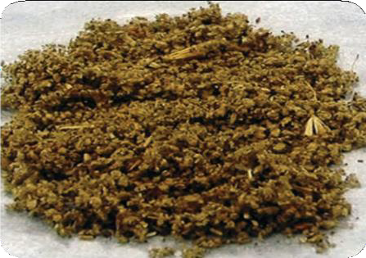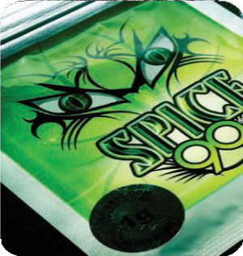K2/Spice

What are common street names?
There are numerous and various street names of synthetic cannabinoids as drug manufacturers try to appeal and entice youth and young adults by labeling these products with exotic and extravagant names. Some of the many street names of K2/Spice synthetic marijuana are:
- “Spice, K2, Blaze, RedX Dawn, Paradise, Demon, Black Magic, Spike, Mr. Nice Guy, Ninja, Zohai, Dream, Genie, Sence, Smoke, Skunk, Serenity, Yucatan, Fire, and Crazy Clown.

What does it look like?
These chemical compounds are generally found in bulk powder form, and then dissolved in solvents, such as acetone, before being applied to dry plant material to make the “herbal incense” products.
After local distributors apply the drug to the dry plant material, they package it for retail distribution, again without pharmaceutical-grade chemical purity standards, as these have no accepted medical use, and ignoring any control mechanisms to prevent contamination or to ensure a consistent, uniform concentration of the powerful and dangerous
drug in each package. The bulk powder can also be dissolved in solution intended to be used in
e-cigarette or other vaping devices.

K2/Spice

98 Drugs of Abuse | A DEA Resource Guide: 2020 EDITION

How is it abused?
Spraying or mixing the synthetic cannabinoids on plant material provides a vehicle for the most common route of administration - smoking (using a pipe, a water pipe, or rolling the drug-laced plant material in cigarette papers). In addition to the cannabinoids laced on plant material and sold as potpourri and incense, liquid cannabinoids have been designed to be vaporized through both disposable and reusable electronic cigarettes.

What are its overdose effects?
Severe adverse effects have been attributed to the abuse of synthetic cannabinoids, including agitation, anxiety, seizures, stroke, coma, and death by heart attack or organ failure. Acute kidney injury requiring hospitalization and dialysis in several patients reportedly having smoked synthetic cannabinoids has also been reported by the Centers for Disease Control and Prevention.

Which drugs cause similar effects? Synthetic cannabinoids are marketed as an alternative to THC, the main psychoactive constituent of marijuana, however they are much more potent and have been shown to cause side effects that are more severe than those reported from THC.

What is its effect on the mind? Acute psychotic episodes, dependence, and withdrawal are associated with use of these
synthetic cannabinoids. Some individuals have suffered from intense hallucinations. Other effects include severe agitation, disorganized thoughts, paranoid delusions, and violence after smoking products laced with these substances.

What is its effect on the body?
State public health and poison centers have issued warnings in response to adverse health effects associated with abuse of herbal incense products containing these synthetic cannabinoids. These adverse effects included tachycardia (elevated heart rate), elevated blood pressure, unconsciousness, tremors, seizures, vomiting, hallucinations, agitation, anxiety, pallor, numbness, and tingling.
This is in addition to the numerous public health and poison centers which have similarly issued warnings regarding the abuse of these synthetic cannabinoids.

What is its legal status in the United States?
These substances have no accepted medical use in the United States and have been reported to produce adverse health effects. Currently, 43 substances are specifically listed as Schedule I substances under the Controlled Substances Act either through legislation or regulatory action. In
addition there are many other synthetic cannabinoids that meet the definition for “cannabimimetic agent” under the Controlled Substances Act and thus are Schedule I substances.
There are many synthetic cannabinoid substances that are being sold as “incense,” “potpourri,” and other products that are not controlled substances.
However, synthetic cannabinoids may be subject to prosecution under the Controlled Substance Analogue Enforcement Act which allows non- controlled drugs to be treated as Schedule I controlled substances if certain criteria can be met. The DEA has successfully investigated and prosecuted individuals trafficking and selling these dangerous substances using the Controlled Substance Analogue EnforcementAct.

Drugs of Abuse | A DEA Resource Guide: 2020 EDITION 99

WHAT ARE SYNTHETIC OPIOIDS?
Synthetic opioids are substances that are synthesized in a laboratory and that act on the same targets in the brain as natural opioids (e.g., morphine and codeine) to produce analgesic (pain relief) effects. In contrast, natural opioids are naturally occurring substances extracted from the
seed pod of certain varieties of poppy plants. Some synthetic opioids, such as fentanyl and methadone, have been approved for medical use.
Clandestinely produced synthetic opioids structurally related to the Schedule II opioid analgesic fentanyl were trafficked and abused on the West Coast in the late 1970s and 1980s. In the 1980s, DEA controlled several of these illicitly produced synthetic opioids such as alpha-
methylfentanyl, 3-methylthiofentanyl, acetyl-alpha- methylfentanyl, beta-hydroxy-3-methylfentanyl, alpha-methylthiofentanyl, thiofentanyl, beta- hydroxyfentanyl, para-fluorofentanyl, and
- methylfentanyl.
As of 2013, there has been a re-emergence in the trafficking and abuse of various clandestinely produced synthetic opioids, including several substances related to fentanyl. Some common illicitly produced synthetic opioids that are currently encountered by law enforcement include, but are not limited to, acetyl fentanyl, butyryl fentanyl, beta- hydroxythiofentanyl, furanyl fentanyl,
- fluoroisobutyryl fentanyl, acryl fentanyl, and U-47700.

WHAT IS THEIR ORIGIN?
Synthetic opioids are believed to be synthesized abroad and then imported into the United States.

What do they look like?
Clandestinely produced synthetic opioids have been encountered in powder form and were identified on bottle caps and spoons, detected within glassine bags, on digital scales, and on sifters which demonstrates the abuse of these substances as replacements for heroin or other opioids. These drugs are also encountered as tablets, mimicking pharmaceutical opioid products. Clandestinely produced synthetic opioids are encountered as a single substance in combination with other opioids (fentanyl, heroin, U-47700) or other substances.

How are they abused?
Abuse of clandestinely produced synthetic opioids parallels that of heroin and prescription opioid analgesics. Many of these illicitly produced synthetic opioids are more potent than morphine
and heroin and thus have the potential to result in a fatal overdose.

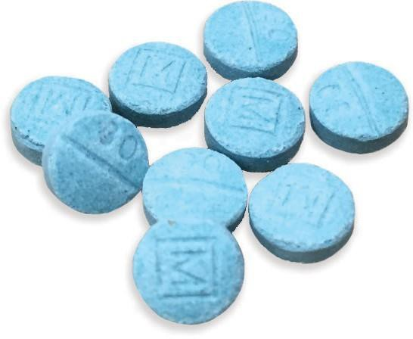
Clandestinely produced counterfeit oxycodone tablets that contain fentanyl.

Synthetic Opioids

100 Drugs of Abuse | A DEA Resource Guide: 2020 EDITION

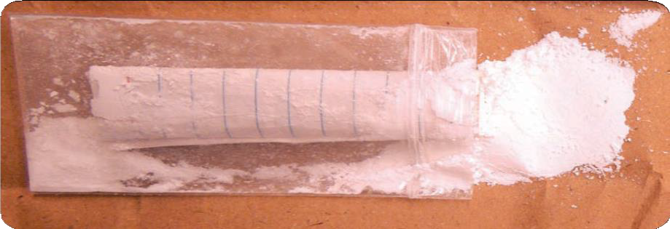
Synthetic Opioid powder U-47700.

What are their effects?
Some effects of clandestinely produced synthetic opioids, similar to other commonly used opioid analgesics (e.g., morphine), may
include relaxation, euphoria, pain relief, sedation, confusion, drowsiness, dizziness, nausea, vomiting, urinary retention, pupillary constriction, and respiratory depression.

What are their overdose effects? Overdose effects of clandestinely produced synthetic opioids are similar to other opioid analgesics. These effects may include stupor, changes in pupillary size, cold and clammy skin, cyanosis, coma, and respiratory failure leading to death. The presence of triad of symptoms such as coma, pinpoint pupils, and respiratory depression are strongly suggestive of opioid poisoning.

Which drugs cause similar effects? Some drugs that cause similar effects include other opioids such as morphine, hydrocodone, oxycodone, hydromorphone, methadone, and heroin.
What is their legal status in the United States? Many synthetic opioids are currently controlled under the Controlled Substances Act. The
DEA temporarily placed U-47700 and several other substances that are structurally related to fentanyl, such as acetyl fentanyl, butyryl fentanyl, beta-hydroxythiofentanyl, and furanyl fentanyl,
in Schedule I of the Controlled Substances Act. In February 2018, the DEA temporarily placed fentanyl-related substances in Schedule I of the CSA. Other synthetic opioid substances may be subject to prosecution under the Controlled Substance Analogue Enforcement Act which allows non-controlled substances to be treated as Schedule I substances if certain criteria are met. The DEA has successfully investigated and prosecuted individuals trafficking and selling
these dangerous substances using the Controlled Substances Analogue Enforcement Act.

Drugs of Abuse | A DEA Resource Guide: 2020 EDITION 101

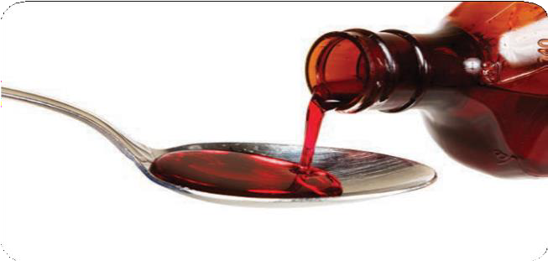WHAT IS DXM?
Dextromethorphan (DXM) is a cough suppressor found in more than 120 over-the- counter (OTC) cold medications, either alone or in combination with other drugs such as analgesics (e.g., acetaminophen), antihistamines (e.g., chlorpheniramine), decongestants (e.g., pseudoephedrine), and/ or expectorants (e.g.,
guaifenesin). The typical adult dose for cough is 15 to 30 mg taken three to four times daily. The cough- suppressing effects of DXM persist for 5 to 6 hours after ingestion. When taken as directed, side effects are rarely observed.

WHAT IS ITS ORIGIN?
DXM users can obtain the drug at almost any pharmacy or supermarket, seeking out the products with the highest concentration of the drug from among all the OTC cough and cold remedies that contain it. DXM products and powder can also be purchased on the Internet.

What are common street names?
Common street names include:
- CCC, Dex, DXM, Poor Man’s PCP, Robo, Rojo, Skittles,
Triple C, and Velvet

What does it look like?
DXM can come in the form of:
- Cough syrup, tablets, capsules, or powder

How is it abused?
DXM is abused in high doses to experience euphoria and visual and auditory hallucinations. Users take various amounts depending on their body weight and the effect they are attempting to achieve. Some users ingest 250 to 1,500 milligrams in a single dosage, far more than the recommended therapeutic dosages described above.
Illicit use of DXM is referred to on the street as “Robo-tripping,” “skittling,” or “dexing,” derived from the products that are most commonly abused, Robitussin and Coricidin HBP. DXM abuse has traditionally involved drinking large volumes
of the OTC liquid cough preparations. More recently, however, abuse of tablet and gel capsule preparations has increased.
These newer, high-dose DXM products have particular appeal for users. They are much easier to consume, eliminate the need to drink large volumes of unpleasant-tasting syrup, and are easily portable and concealed, allowing an abuser to continue to abuse DXM throughout the day, whether at school or work.
DXM powder, sold over the Internet, is also a source of DXM for abuse. (The powdered form of DXM poses additional risks to the user due to the uncertainty of composition and dose.)
DXM is also distributed in illicitly manufactured tablets containing only DXM or mixed with

Even though some substances are not currently controlled by the Controlled Substances Act, they pose risks to individuals who abuse them. The following section describes these drugs of concern and their associated risks.
DXM
Drugs of Concern

102 Drugs of Abuse | A DEA Resource Guide: 2020 EDITION

other drugs such as pseudoephedrine and/ or methamphetamine.
DXM is abused by individuals of all ages, but its abuse by teenagers and young adults is of particular concern. This abuse is fueled by DXM’s OTC availability and extensive “how to” abuse information on various websites.

What is its effect on the mind?
Some of the many psychoactive effects associated with high-dose DXM include:
- Confusion, inappropriate laughter, agitation, paranoia, euphoria, and hallucinations
- Other sensory changes, including the feeling of floating and changes in hearing and touch

Long-term abuse of DXM is associated with severe psychological dependence. Abusers of DXM describe the following three dose-dependent “plateaus”:

DOSE (MG) | BEHAVIORAL EFFECTS
100-200 | Mild Stimulation
200-400 | Euphoria and hallucinations
300-1500 | Distorted visual perceptions Loss of motor coordination Out of body sensations

What is its effect on the body?
DXM intoxication involves:
  - Over-excitability, lethargy, loss of coordination, slurred speech, sweating, hypertension, nausea, vomiting, and involuntary spasmodic movement of the eyeballs

The use of high doses of DXM in combination with alcohol or other drugs is particularly dangerous, and deaths have been reported. Approximately 5-10 percent of Caucasians are poor DXM metabolizers and at increased risk for overdoses and deaths. DXM taken with antidepressants can be life threatening.
OTC products that contain DXM often contain other ingredients such as acetaminophen, chlorpheniramine, and guaifenesin that have their own effects, such as:
- Liver damage, rapid heart rate, lack of coordination, vomiting, seizures, and coma

To circumvent the many side effects associated with these other ingredients, a simple chemical extraction procedure has been developed and published on the Internet that removes most of these other ingredients in cough syrup.

What are its overdose effects?
DXM overdose can be treated in an emergency room setting and generally does not result in severe medical consequences or death. Most DXM- related deaths are caused by ingesting the drug in combination with other drugs. DXM-related deaths also occur from impairment of the senses, which can lead to accidents.
In 2003, a 14-year-old boy in Colorado who abused DXM died when he was hit by two cars as he attempted to cross a highway. State law enforcement investigators suspect that the drug affected the boy’s depth perception and caused him to misjudge the distance and speed of the oncoming vehicles.

Which drugs cause similar effects? Depending on the dose, DXM can have effects similar to marijuana or ecstasy. In moderate to high doses its out-of-body effects are similar to those of ketamine or PCP.

What is its legal status in the United States? DXM is a legally marketed cough suppressant that is neither a controlled substance nor a regulated chemical under the Controlled Substances Act.

Drugs of Abuse | A DEA Resource Guide: 2020 EDITION 103

WHAT IS KRATOM?
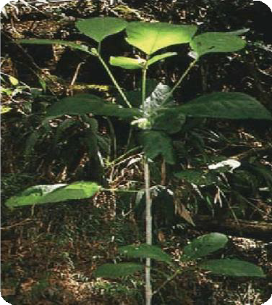Kratom is a tropical tree native to Southeast Asia. Consumption of its leaves produces both stimulant effects (in low doses) and
sedative effects (in high doses), and can lead to psychotic symptoms, and psychological and physiological dependence. Kratom leaves contain two major psychoactive ingredients (mitragynine and
7-hydroxymytragynine). These leaves are crushed and then smoked, brewed with tea, or placed into gel capsules. Kratom has a long history of use in Southeast Asia, where it is commonly known as thang, kakuam, thom, ketum, and biak. In the U.S., the abuse of kratom has increased markedly in recent years.

How is it abused?
Mostly abused by oral ingestion in the form of a tablet, capsule, or extract. Kratom leaves may also be dried or powdered and ingested as a tea, or the kratom leaf may be chewed.

What are the effects?
At low doses, kratom produces stimulant effects with users reporting increased alertness, physical energy, and talkativeness. At high doses, users experience sedative effects. Kratom consumption can lead to addiction.
Several cases of psychosis resulting from use of kratom have been reported, where individuals addicted to kratom exhibited psychotic symptoms, including hallucinations, delusion, and confusion.

What does it do to the body?
Kratom’s effects on the body include nausea, itching, sweating, dry mouth, constipation, increased urination, tachycardia, vomiting, drowsiness, and loss of appetite. Users of kratom have also experienced anorexia, weight loss, insomnia, hepatotoxicity, seizure, and hallucinations.

What is its legal status?

Kratom tree

Leaf of kratom tree

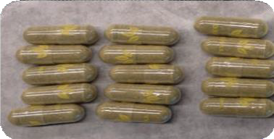
Kratom capsules

Kratom is not controlled under the Controlled Substances Act; however, there may be some state regulations or prohibitions against the possession and use of kratom. The FDA has not approved Kratom for any medical use. In addition, DEA has listed kratom as a Drug and Chemical of Concern.
Kratom

104 Drugs of Abuse | A DEA Resource Guide: 2020 EDITION

WHAT IS SALVIA DIVINORUM?
Salvia Divinorum
Salvia divinorum is a perennial herb in the mint family that is abused for its hallucinogenic effects.

WHAT IS ITS ORIGIN?
Salvia divinorum is native to certain areas of the Sierra Mazaleca region of Oaxaca, Mexico. It is one of several plants that are used by Mazatec Indians for ritual divination. Salvia divinorum plants can be grown successfully outside of this region. They can be grown indoors and outdoors, especially in humid semitropical climates.

What are common street names?
Common street names include:
- Maria Pastora, Sally-D, and Salvia

What does it look like?
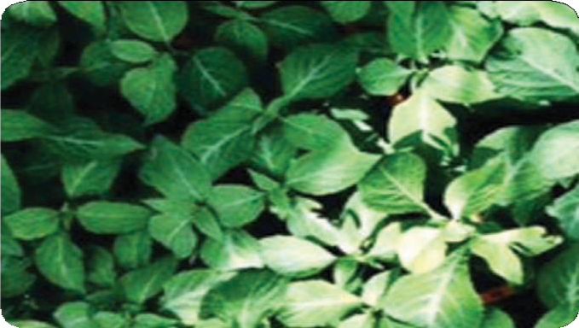The plant has spade-shaped variegated green leaves that look similar to mint. The plants themselves grow to more than three feet high, have large green leaves, hollow square stems, and white flowers with purple calyces.

Leaves of the Salvia divinorum plant

How is it abused?
Salvia can be chewed, smoked, or vaporized.

What is its effect on the mind?
Psychic effects include perceptions of bright lights, vivid colors, shapes, and body movement, as well as body or object distortions. Salvia divinorum may also cause fear and panic, uncontrollable laughter, a sense of overlapping realities, paranoia, and hallucinations.
Users typically experience rapid onset of intense hallucinations that can impair judgment and disrupt sensory and cognitive functions.
Salvinorin A is the principal ingredient responsible for the psychoactive effects of Salvia divinorum.

What is its effect on the body?
Adverse physical effects may include:
  - Loss of coordination, dizziness, and slurred speech

Which drugs cause similar effects?
When Salvia divinorum is chewed or smoked, the hallucinogenic effects elicited are similar to those induced by Scheduled hallucinogenic substances.

What is its legal status in the United States? Neither Salvia divinorum nor its active constituent Salvinorin A has an approved medical use in the United States. Salvia divinorum is not controlled under the Controlled Substances Act. Salvia divinorum is, however, controlled by a number of states. Since Salvia divinorum is not controlled by the CSA, some online botanical companies and drug promotional sites have advertised Salvia as a legal alternative to other plant hallucinogens like mescaline.

Drugs of Abuse | A DEA Resource Guide: 2020 EDITION 105

IV. Resources

RECOVER\'

0r11c;JS

Alcohol Addiction

Resources

DRUG USE PREVENTION RESOURCES
Drug prevention programs are designed and implemented on many levels. The federal government has instituted a number of national drug prevention programs which reach targeted populations through public service announcements, grant programs, educational programs, and the sharing of expertise. State and local governments also have a significant
number of prevention programs that are tailored to address particular problems and needs. Law enforcement and the military have brought
drug prevention expertise into classrooms and communities; businesses have also contributed significantly to drug prevention through sponsored programs, drug-free policies, and corporate support for community initiatives. Other segments of society, including faith-based institutions, civic organizations, and private foundations are also active forces in drug prevention.
On the next page is a partial list of drug prevention agencies and programs. There are many other outstanding efforts which are ongoing across the nation; it is impossible to include
them all. Some programs are aimed at particular populations or specific drugs. Within a given agency, there may be many prevention programs which are aimed at different audiences.

Drugs of Abuse | A DEA Resource Guide: 2020 EDITION 107

FEDERAL DRUG PREVENTION AGENCIES AND PROGRAMS:

Centers for Disease Control and Prevention (CDC):
CDC’s National Center for Injury Prevention and Control helps protect America’s health by tracking injuries and deaths to look for dangerous trends, researching the best ways to prevent injuries
and violence, developing prevention strategies, evaluating effectiveness of prevention strategies, and supporting states in implementing programs. www.cdc.gov/injury

Drug Enforcement Administration (DEA): In addition to dismantling major drug trafficking organizations, DEA is committed to reducing the demand for drugs in America. DEA’s community outreach and prevention support is carried out by employees across the United States who work in communities to share expertise and information on drug trends, emerging problems, the dangers of drugs, and available resources.
www.dea.gov www.deatakeback.com www.JustThinkTwice.com www.GetSmartAboutDrugs.com www.CampusDrugPrevention.gov www.OperationPrevention.com

National Institute on Drug Abuse (NIDA): NIDA conducts and disseminates the results of research about the effects of drugs on the body and the brain. NIDA is an excellent source of information on drug addiction. www.nida.nih.gov
Office of National Drug Control Policy (ONDCP): ONDCP works to reduce drug use and its consequences by leading and coordinating the development, implementation, and assessment of
U.S. drug policy. www.whitehousedrugpolicy.gov

Substance Abuse and MentalHealth Services Administration (SAMHSA):
This agency is responsible for overseeing and administering mental health, drug misuse prevention, and drug addiction treatment programs around the nation. The Center for
Substance Abuse Prevention and the Center for Substance Abuse Treatment are part of SAMHSA. www.samhsa.gov
www.samhsa.gov/prevention

U.S. Department of Education (ED):
ED’s Office of Safe and Healthy Students serves states and school communities by providing resources, direct support, and technical assistance on topics that affect the well-being, health, and safety of the nation’s young people www.ed.gov

108 Drugs of Abuse | A DEA Resource Guide: 2020 EDITION

Other Anti-Drug Organizations:

Community Anti-Drug Coalitions of America (CADCA)
www.cadca.org

National Association of State Alcohol and Drug Abuse Directors (NASADAD) www.nasadad.org

National Crime Prevention Council (NCPC)
www.ncpc.org

National Families in Action (NFIA)
www.nationalfamilies.org

American Council for Drug Education (ACDE)
www.acde.org

Elks Drug Awareness Program
www.elks.org/dap

Center on Addiction
www.centeronaddiction.org

Partnership for Drug-Free Kids
www.drugfree.org

DEA Educational Foundation Youth Dance Program www.deaeducationalfoundation.org
Drug Abuse Resistance Education (DARE)
www.dare.com

Law Enforcement Exploring exploring.learningforlife.org/services/career- exploring/law-enforcement/

Students Against Destructive Decisions (SADD)
www.sadd.org

Young Marines
www.youngmarines.com

National Prevention Network
www.nasadad.org/npn-4

Mentor Foundation USA
www.mentorfoundation.org

Drug Free America Foundation
www.dfaf.org

National Family Partnership
www.nfp.org

Drugs of Abuse | A DEA Resource Guide: 2020 EDITION 109

Drug Enforcement Administration

Community Outreach and Prevention Support Section

8701 Morrissette Drive Springfield, VA22152 202-307-7936
community.outreach@usdoj.gov

