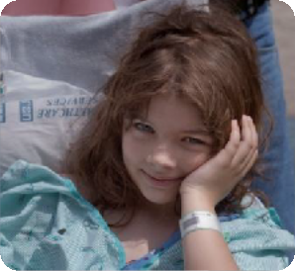

Overview of DSM-5 Changes
Christopher K. Varley, MD

Disclosure to Audience
No one involved in the planning or presentation of this activity has any relevant financial relationships with a commercial interest to disclose

The following are North Star Behavioral Health’s Content Controllers:
Christopher K. Varley, MD - Presenter
Dr. Andy Mayo, CEO
Dr. Ruth Dukoff, System Medical Director
Laura McKenzie, QIRM Director Denise Gleason, CME Coordinator
Evelyn Alsup, Education Resource Manager
Medical Staff:
Dr. Phillip Neuberger Dr. Arom Evans
Dr. Manuel Rodriguez
Dr. Elizabeth Baisi Dr. David Hjellen Dr. Judith Bautista Dr. Jill Abram
Education Committee:
Sabrina Ben, HRD
Carla MacGregor, DRTC Administrator Ron Meier, PRTC Clinical Director Melanie Nelson, DOSS
Brandy Proctor, DON
Sarah Skeel, PRTC Administrator
Business Development Department:
Elke Villegas, Director of Business Development Lindsey Fletcher, Clinical Community Liaison Becky Bitzer, Clinical Community Liaison
Alice Walter, Clinical Community Liaison Sarah Twaddle, Clinical Community Liaison

DSM-IV’s organizational structure failed to reflect shared features or symptoms of related disorders and diagnostic groups (like psychotic disorders with bipolar disorders, or internalizing (depressive, anxiety, somatic) and externalizing (impulse control, conduct, substance use) disorders.
- DSM-5 restructuring better reflects these interrelationships, within and across diagnostic chapters

- DSM-IV does not adequately address the lifespan perspective, including variations of symptom presentations across the developmental trajectory, or cultural perspectives
- DSM-5’s chapter structure, criteria revisions, and text outline actively address age and development as part of diagnosis and classification
- Culture is similarly discussed more explicitly to bring greater attention to cultural variations in symptom presentations

DSM-5 represents an opportunity to better integrate neuroscience and the wealth of findings from neuroimaging, genetics, cognitive research, and the like, that have emerged over the past several decades – all of which are vital to diagnosis and treatment development
  - DSM-5 will be more amenable to updates in psychiatry and neuroscience, making it a “living document” and less susceptible to becoming outdated than its predecessors

- The multiaxial system in DSM-IV is not required to make a mental disorder diagnosis and has not been universally used
- DSM-5 has moved to a nonaxial documentation of diagnosis (formerly Axes I, II, and III), with separate notations for important psychosocial and contextual factors (formerly Axis IV) and disability (formerly Axis V)
- This approach is consistent with established WHO and ICD guidance to consider the individual’s functional status separately from his or her diagnoses or symptom status

Elimination of Multi-Axial Diagnosis
  - Axis IV - psychosocial and environmental factors - are now covered through an expanded set of V codes. V codes allow clinicians to indicate other conditions that may be a focus of clinical attention or affect diagnosis, course, prognosis or treatment of a mental disorder
  - Axis V - CGAS and GAF - are replaced by separate measures of symptoms severity and disability for individual disorders. An eventual change to the World Health Organization Disability Assessment Schedule (WHO DAS 2.0) is anticipated for measurement of disability, however it is not yet recommended for use by APA until it has been studied further.

Clustering of Chapters

  - Neurodevelopmental Disorders
  - Emotional (Internalizing) Disorders
  - Somatic Disorders
  - Externalizing Disorders
  - Neurocognitive Disorders
  - Personality Disorders

Neurodevelopmental Disorders
Schizophrenia Spectrum and Other Psychotic Disorders
Bipolar and Related Disorders Depressive Disorders
Anxiety Disorders
Obsessive-Compulsive and Related Disorders Trauma-and Stressor-Related Disorders Dissociative Disorders
Somatic Symptom Disorders Feeding and Eating Disorders

Elimination Disorders Sleep-Wake Disorders Sexual Dysfunctions Gender Dysphoria
Disruptive, Impulse Control and Conduct Disorders Substance Use and Addictive Disorders Neurocognitive Disorders
Personality Disorders Paraphilic Disorders Other Disorders

  - Not Otherwise Specified (NOS) has been used as a “catch-all” for patients who didn’t fit into the more specific categories. NOS language is eliminated in DSM-5.
  - There will now be an option for designating Not Elsewhere Classified (NEC) which will typically include a list of specifiers as to why the patient’s clinical condition doesn’t meet a more specific disorder.
  - The phrase “general medical condition” is replaced in DSM-5 with “another medical condition” where relevant across all disorders.
  - 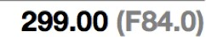These classification changes will help providers with the transition to ICD-10 in October 2014. DSM-5 includes the ICD-10 diagnoses in parentheses.

Intellectual Disability
(Intellectual Developmental Disorder)
  - Diagnostic criteria for intellectual disability (intellectual developmental disorder) emphasize the need for an assessment of both cognitive capacity (IQ) and adaptive functioning. Severity is determined by adaptive functioning rather than IQ score.
  - Despite the name change, the deficits in cognitive capacity beginning in the developmental period, with the accompanying diagnostic criteria, are considered to constitute a mental disorder.
  - No longer use of term “mental retardation.”

Intellectual Disability (Intellectual Developmental Disorder)
- Deficits in intellectual functions, such as reasoning, problem solving, planning, abstract thinking, judgment, academic learning, and learning from experience, confirmed by both clinical assessment and individualized, standardized intelligence testing.
- Deficits in adaptive functioning that result in failure to meet developmental and socio-cultural standards for personal independence and social responsibility. Without ongoing support, the adaptive deficits limit functioning in one or more activities of daily life, such as communication, social participation, and independent living, across multiple environments, such as home, school, work, and community.
- Onset of intellectual and adaptive deficits during the developmental
period.
Specify severity (based on adaptive function, not IQ): Mild, Moderate, Severe, Profound

Global Developmental Delay
Diagnosed reserved for individuals under 5 when clinical severity level cannot be reliably assessed. Diagnosed when an individual fails to meet expected developmental milestones in several areas of intellectual functioning, and applies to individuals who are unable to undergo systematic assessments of intellectual functioning, including children who are too young to participate in standardized testing.
Requires reassessment after a period of time.
Unspecified Intellectual Disability
Diagnosed in individuals over 5 when assessment of the degree of intellectual disability by means of locally available procedures is difficult or impossible because of associated sensory or physical impairments, as in blindness or prelingual deafness; locomotor disability; or presence of severe problem behaviors or co-occurring mental disorder. Should only be used in exceptional circumstances and requires reassessment after a period of time.

Communication Disorders

The DSM-5 communication disorders include new and revised conditions:
  - Language Disorder (which combines DSM-IV expressive and mixed
receptive-expressive language disorders)
  - Speech Sound Disorder (a new name for phonological disorder)
  - Childhood-Onset Fluency Disorder (a new name for stuttering)
  - Social (pragmatic) Communication Disorder, a new condition for persistent difficulties in the social uses of verbal and nonverbal communication (ASD is an obligate rule-out).

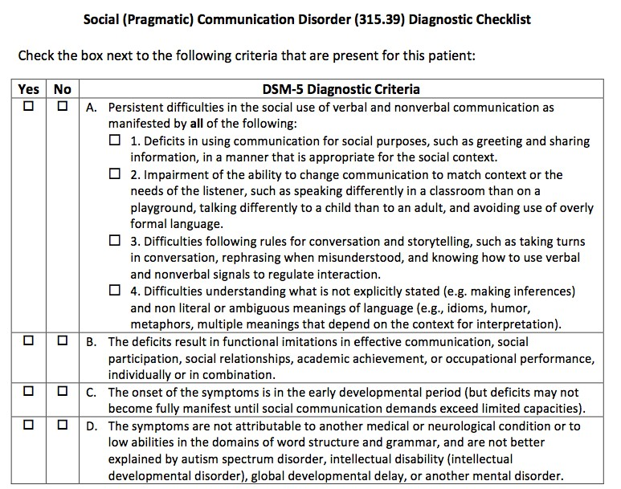

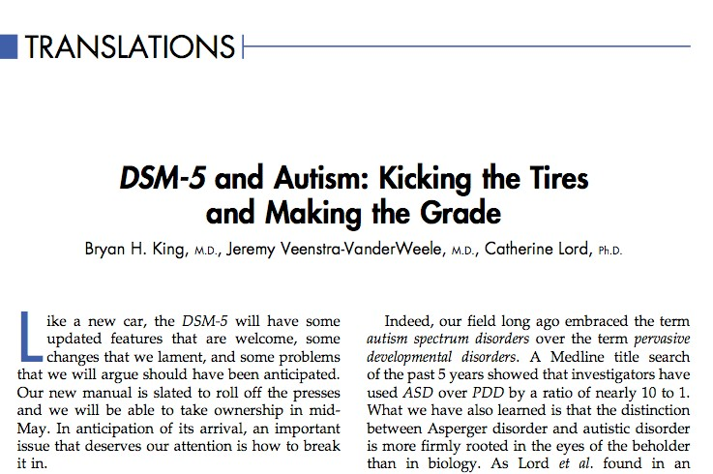

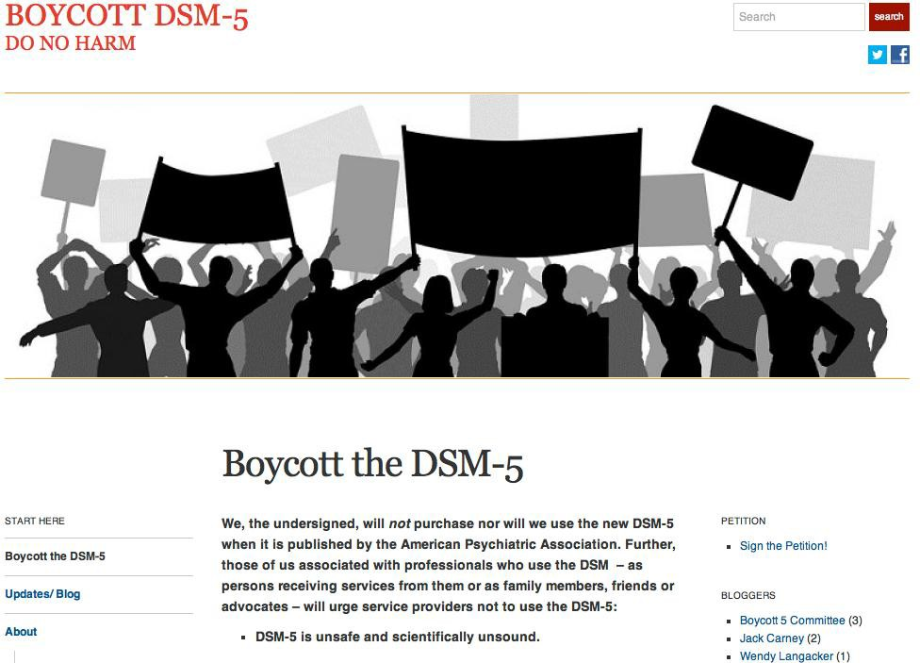

DSM-5:
Autistic Disorder Asperger’s Disorder PDD-NOS CDD

Autism Spectrum Disorder

3 become 2

Restricted, repetitive patterns of behavior, interests, or activities
Deficits in social communication and social interaction

Restricted repetitive and stereotyped patterns of behavior, interests, and activities

Qualitative impairment in communication
Impairment in Social Interaction

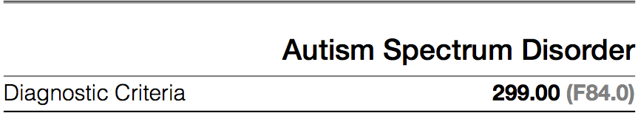

- Persistent deficits in social communication and social interaction across multiple contexts, manifested by the following, currently or by history (examples are illustrative not exhaustive; see text):
- Deficits in social-emotional reciprocity; ranging, for example, from abnormal social approach and failure of normal back-and-forth conversation; to reduced sharing of interests, emotions, or affect; to failure to initiate or respond to social interactions.
- Deficits in nonverbal communicative behaviors used for social interaction, ranging, for example, from poorly integrated verbal and nonverbal communication; to abnormalities in eye contact and body language or deficits in understanding and use of gestures; to a total lack of facial expressions and nonverbal communication.
- Deficits in developing, maintaining, and understanding relationships, ranging, for example, from difficulties adjusting behavior to suit various social contexts; to difficulties in sharing imaginative play or in making friends, to absence of interest in peers.

- Restricted, repetitive patterns of behavior, interests, or activities, as manifested by at least two of the following, currently or by history (examples are illustrative, not exhaustive; see text):

  - Stereotyped or repetitive motor movements, use of objects, or speech (e.g., simple motor stereotypies, lining up toys or flipping objects, echolalia, idiosyncratic phrases).
  - Insistence on sameness, inflexible adherence to routines, or ritualized patterns of verbal or nonverbal behavior (e.g., extreme distress at small changes, difficulties with transitions, rigid thinking patterns, greeting rituals need to take same route or eat same food every day).
  - Highly restricted, fixated interests that are abnormal in intensity or focus (e.g., strong attachment to or preoccupation with unusual objects, excessively circumscribed or perseverative interests).
  - Hyper- or hypo-reactivity to sensory input or unusual interest in sensory aspects of the environment (e.g., apparent indifference to pain/temperature, adverse response to specific sounds or textures, excessive smelling or touching of objects, visual fascination with lights or movement).

- Symptoms must be present in the early developmental period (but may not become fully manifest until social demands exceed limited capacities; or may be masked by learned strategies in later life).

- Symptoms cause clinically significant impairment in social, occupational, or other important areas of current functioning.

- These disturbances are not better explained by intellectual disability (intellectual developmental disorder) or global developmental delay. Intellectual disability and autism spectrum disorder frequently co-occur; to make comorbid diagnoses of autism spectrum disorder and intellectual disability, social communication should be below that expected for general developmental level.

Note: Individuals with a well-established DSM-IV TR diagnosis of Autistic disorder, Asperger’s disorder, or Pervasive Developmental Disorder Not Otherwise Specified should be given the diagnosis of Autism Spectrum Disorder.

Autism Spectrum Disorder: Specifiers
    - With/without accompanying intellectual impairment.
    - With/without accompanying language impairment.
    - Associated with a known medical or genetic condition or environmental factor.
    - Associated with another neurodevelopmental, mental, or
behavioral disorder.
    - With catatonia.

Autism Spectrum Disorder: Severity
      - Severity is based on social communication impairments and restricted, repetitive patterns of behavior (see Table 2 in text).

Severity Level | Social Communication | Restricted, repetitive behaviors
Level 3  ‘Requir | Severe deficits in verbal and nonverbal social communication skills cause severe impairments in functioning; very limited initiation of social interactions and minimal response to social overtures from others. E.g. someone with around 20 words of intelligible speech, rarely initiates interaction, and when does so makes unusual approach to meet needs only, responds to only very direct social approach.  ing very substantial support’ | Inflexibility of behavior, extreme difficulty coping with change, or other restricted/repetitive behaviors markedly interfere with functioning in all spheres. Great distress/difficulty changing focus or action.
Level 2  ‘Requir | Marked deficits in verbal and nonverbal social communication skills; social impairments apparent even with supports in place; limited initiation of social interactions and reduced or abnormal response to social overtures from others. E.g., a person who speaks simple sentences, interaction limited to narrow special interests, markedly odd nonverbal communication.  ing substantial support’ | Inflexibility of behavior, difficulty coping with change, or other restricted/repetitive behaviors appear frequently enough to be obvious to the casual observer and interfere with functioning in a variety of contexts. Distress and/or difficulty changing focus or action.
Level 1  ‘Requir | Without supports in place, deficits in social communication cause noticeable impairments. Has difficulty initiating social interactions and demonstrates clear examples of atypical or unsuccessful responses to social overtures of others. May appear to have decreased interest in social interactions. E.g., a person able to speak in full sentences, engages in communication but to-and-fro of conversation fails, attempts to make friends are odd and typically unsuccessful.  ing support’ | Inflexibility of behavior causes significant interference with functioning in one or more contexts. Difficulty switching between activities. Problems of organization and planning hamper independence.

Attention Deficit/Hyperactivity Disorder
    - Several changes in DSM-5:
    - 1) examples have been added to the criterion items to facilitate application
across the life span;
    - 2) the cross-situational requirement has been strengthened to “several” symptoms in each setting;
    - 3) the onset criterion has been changed from “symptoms that caused impairment were present before age 7 years” to “several inattentive or hyperactive-impulsive symptoms were present prior to age 12”;
    - 4) subtypes have been replaced with presentation specifiers that map
directly to the prior subtypes;
    - 5) a comorbid diagnosis with autism spectrum disorder is now allowed;
    - 6) a symptom threshold change has been made for adults, with the cutoff of five symptoms, instead of six required for younger persons, both for inattention and for hyperactivity/impulsivity.
    - ADHD now falls under the Neurodevelopmental Disorders Chapter

Specific Learning Disorder
    - Specific Learning Disorder combines the DSM-IV TR diagnoses of reading disorder, mathematics disorder, disorder of written expression, and learning disorder not otherwise specified.
    - Because learning deficits in the areas of reading, written expression, and mathematics commonly occur together, coded specifiers for the deficit types in each area are included.

Developmental Coordination Disorder
Stereotypic Movement Disorder Tic Disorders
Tourette’s Disorder
Persistent Motor or Vocal Tic Disorder Provisional Tic Disorder (1 year)
Other Specified Neurodevelopmental Disorder
e.g. Neurodevelopmental disorder associated with prenatal alcohol exposure (section 3).
Unspecified Neurodevelopmental Disorder

    - Two Criterion A symptoms are now required for any
diagnosis of schizophrenia in DSM-5 (cf single bizarre).

    - Also, the individual must have at least one of these three “positive” symptoms: delusions, hallucinations, and disorganized speech.

    - The DSM-IV TR subtypes of schizophrenia (i.e., paranoid, disorganized, catatonic, undifferentiated, and residual types) are eliminated due to their limited diagnostic stability, low reliability, and poor validity.

    - The primary change to schizoaffective disorder is the requirement that a major mood episode be present for a majority of the disorder’s total duration after Criterion A has been met.

    - This change makes schizoaffective disorder a longitudinal instead of a cross-sectional diagnosis—more comparable to schizophrenia, bipolar disorder, and major depressive disorder, which are bridged by this condition.

    - Criterion A for delusional disorder no longer has the requirement that the delusions must be non-bizarre.

    - A specifier for bizarre type delusions provides continuity with DSM-IV TR.

    - The demarcation of delusional disorder from psychotic variants of obsessive-compulsive disorder and body dysmorphic disorder is explicitly noted with a new exclusion criterion, which states that the symptoms must not be better explained by conditions such as obsessive-compulsive or body dysmorphic disorder with absent insight/delusional beliefs.

    - In DSM-5, all contexts require three catatonic symptoms (from a total of 12 characteristic symptoms).

    - In DSM-5, catatonia may be diagnosed as a specifier for depressive, bipolar, and psychotic disorders; as a separate diagnosis in the context of another medical condition; or as an other specified diagnosis.

Bipolar Disorders
To enhance the accuracy of diagnosis and facilitate earlier detection in clinical settings, Criterion A for manic and hypomanic episodes now includes an emphasis on changes in activity and energy as well as mood.

The DSM-IV TR diagnosis of Bipolar I Disorder, mixed episode, requiring that the individual simultaneously meet full criteria for both mania and major depressive episode, has been removed. Instead, a new specifier, “with mixed
features,” has been added that can be applied to episodes of mania or hypomania when depressive features are present, and to episodes of depression in the context of major depressive disorder or bipolar disorder when features of mania/hypomania are present.

Other Specified Bipolar and Related Disorder
DSM-5 allows the specification of particular conditions for other specified bipolar and related disorder, including categorization for individuals with a past history of a major depressive disorder who meet all criteria for hypomania except the duration criterion (i.e., at least 4 consecutive days).

A second condition constituting an other specified bipolar and related disorder is that too few symptoms of hypomania are present to meet criteria for the full bipolar II syndrome, although the duration is sufficient at 4 or more days.

In the chapter on bipolar and related disorders and the chapter on depressive disorders, a specifier for anxious distress is delineated. This specifier is intended to identify patients with anxiety symptoms that are not part of the bipolar diagnostic criteria.

      - To address concerns about potential over diagnosis and overtreatment of bipolar disorder in children, a new diagnosis, Disruptive Mood Dysregulation Disorder, is included for children up to age 18 years who exhibit persistent irritability and frequent episodes of extreme behavioral dyscontrol.
      - What was referred to as Dysthymia in DSM-IV TR now falls under the category of Persistent Depressive Disorder, which includes both chronic major depressive disorder and the previous dysthymic disorder.
      - Premenstrual Dysphoric Disorder is now a distinct diagnosis in the Depressive Disorders chapter.

Disorder
- Severe recurrent temper outbursts manifested verbally and/or behaviorally that are grossly out of proportion in intensity or duration to the situation or provocation.
- The temper outbursts are inconsistent with developmental level.
- The temper outbursts occur, on average, > 3X per week.
- The mood between temper outbursts is persistently irritable or angry most of the day, nearly every day, and as observable by others.
- Criteria A-D have been present for >12 mo. Throughout that time, the individual has not had a period > 3 consecutive months without all of the symptoms in A-D.
- Criteria A and D are present in at least two of three settings and are severe in at least one of these.
- The diagnosis should not be made for the first time before age 6 or
after age 18.

Criteria: Disruptive Mood Dysregulation Disorder (continued)

- By history or observation, the age at onset of Criteria A-E is before 10 years.
- There has never been a distinct period lasting more than one day during which the full symptom criteria, except duration, for a manic or hypomanic episode have been met.
- The behaviors do not occur exclusively during an episode of major depressive disorder and are not better explained by another mental disorder.
- The symptoms are not attributable to the physiological effects of a substance or to another medical or neurological condition.

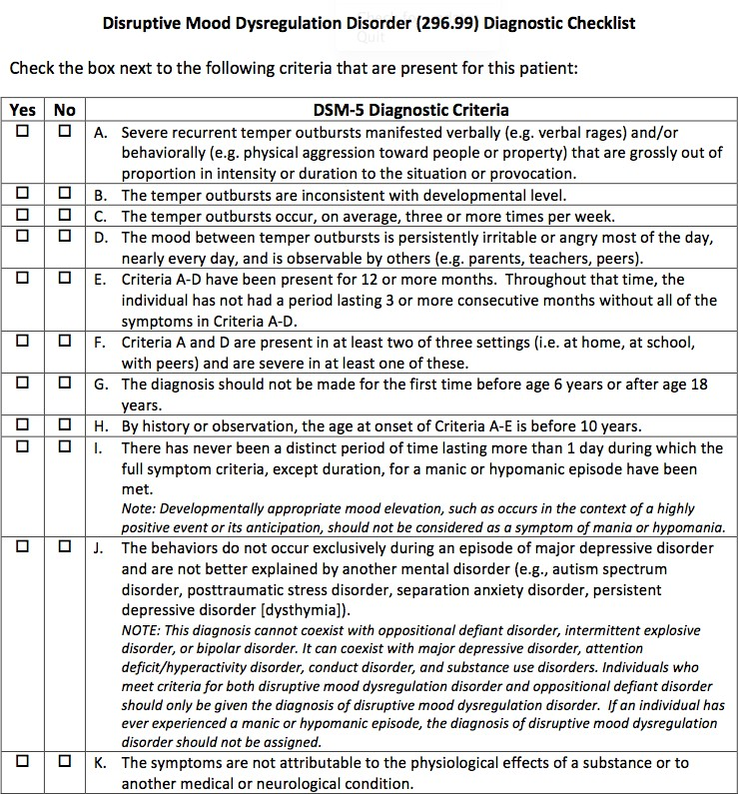

Highlights: Bereavement exclusion for Depression
In DSM-IV TR, there was an exclusion criterion for a major depressive episode that was applied to depressive symptoms lasting less than 2 months following the death of a loved one (i.e., the bereavement exclusion). This exclusion is omitted in DSM-5 to remove the implication that bereavement typically lasts only 2 months when clinicians recognize that the duration is more commonly 1–2 years.

Bereavement is recognized as a severe psychosocial stressor that can precipitate a major depressive episode in a vulnerable individual, generally beginning soon after the loss. Bereavement-related major depression is genetically influenced and is associated with similar personality characteristics, patterns of comorbidity, and risks of chronicity and/or recurrence as non–bereavement-related major depressive episodes.

The depressive symptoms associated with bereavement-related depression respond to the same psychosocial and medication treatments as non–bereavement-related depression.

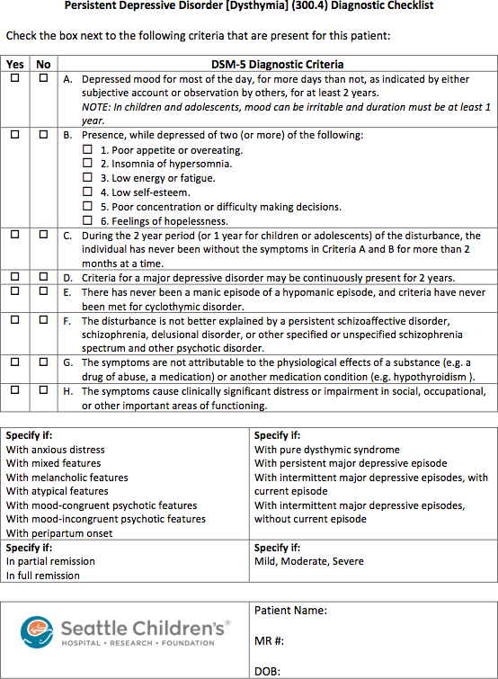

Highlights: Anxiety Disorders
  - Panic Disorder and Agoraphobia are now unlinked in DSM-5 as many patients experience Agoraphobia without panic symptoms
  - For Agoraphobia, Specific Phobia, and Social Anxiety Disorder (Social Phobia):
    - the 6 month duration criterion has been extended to all ages (formerly just individuals under age 18) to minimize over diagnosis of transient fears.
    - The anxiety must be out of proportion to the actual danger or threat, but the requirement that individuals over age 18 years recognize their anxiety as excessive or unreasonable has been eliminated.

Highlights: Anxiety Disorders (continued)
  - Panic attack descriptors have changed to identify “unexpected and expected” panic attacks. Panic attacks function as a prognostic factor for severity of diagnosis, course, and comorbidity across many anxiety and other disorders, and thus can be listed as a specifier that is applicable to all DSM-5 disorders.
  - Separation Anxiety Disorder and Selective Mutism now fall under the Anxiety Disorders chapter instead of the Disorders of Infancy, Childhood or Adolescence (this chapter has been eliminated).
  - Age criteria for Separation Anxiety Disorder have been changed to allow onset after age 18, with a duration criterion added of “typically lasting 6 months or more”.

Related Disorders
  - A new chapter has been developed to include Obsessive-Compulsive Disorder along with four new disorders:
    - Hoarding Disorder
    - Excoriation Disorder (skin picking)
    - Substance-medication induced obsessive-compulsive and related disorder
    - Obsessive-compulsive and related disorder due to another
medical condition
  - Body Dysmorphic Disorder and Trichotillomania now fall under Obsessive-Compulsive and Related Disorders
  - Insight specifiers have been refined to distinguish between levels of insight of patients with these disorders.

  - A new chapter called Trauma- and Stressor- Related Disorders has been made which includes:
    - Reactive Attachment Disorder (emotionally withdrawn/inhibited)
    - New diagnosis of Disinhibited Social Engagement Disorder (formerly the indiscriminately social/disinhibited version of Reactive Attachment Disorder)
    - Posttraumatic Stress Disorder and Acute Stress Disorder (moved from the Anxiety Disorders Chapter)
    - Adjustment Disorders (formerly in a separate chapter)
  - Acute Stress Disorder has a change in stressor criterion being explicit as to whether the traumatic event was experienced directly or indirectly, or witnessed

  - Posttraumatic Stress Disorder has also had changes in the stressor criterion being explicit as to whether the traumatic event was experienced directly or indirectly, or witnessed
  - The criterion for subjective reaction is eliminated.
  - There are now four symptom clusters instead of three because avoidance/numbing is divided into two clusters: avoidance and persistent negative emotional states.
  - Arousal/reactivity cluster includes irritable or aggressive behavior and reckless/self-destructive behavior.
  - Diagnostic thresholds lowered for children/adolescents
and separate criteria for children ages 6 and younger.

  - DSM-5 has reduced the number of somatoform disorders and subcategories to avoid problematic overlap with medical conditions.
  - Diagnoses of somatization disorder, hypochondriasis, pain disorder, and undifferentiated somatoform disorder have been removed.
  - Patients with high health anxiety without somatic symptoms would receive a diagnosis of illness anxiety disorder (unless their anxiety symptoms are better explained by a primary anxiety disorder such as GAD).
  - Patients formerly diagnosed with Pain Disorder may now be diagnosed with Somatic Symptom Disorder with predominant pain.

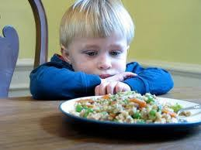

Highlights: Feeding and Eating Disorders
  - Criteria for Pica and Rumination Disorder have been revised for clarity and to indicate that diagnoses can be made for individuals of any age.
  - The diagnosis “Feeding Disorder of Infancy or Early Childhood” has been renamed “Avoidant/Restrictive
Food Intake Disorder” and criteria have been expanded.
  - The requirement of amenorrhea has been eliminated from Anorexia Nervosa for several reasons (e.g. for males, females taking contraceptives)
  - Binge Eating Disorder is a distinct diagnosis and binge eating criteria is at least once weekly for 3 months which is identical to criteria for Bulimia Nervosa.

Highlights: Disruptive, Impulse-Control and Conduct Disorders
  - This is a new chapter for DSM-5 bringing together disorders that fell under two categories in DSM-IV (Disorders of Infancy, Childhood or Adolescence and Impulse-Control Disorders Not Otherwise Specified)
  - These disorders are all characterized by problems in emotional and behavioral self-control.
  - Because of the close association with Conduct Disorder, the diagnosis of Antisocial Personality Disorder now has a dual listing in this chapter and the Personality Disorder chapter.
  - ADHD is frequently co-morbid with disorders in this chapter but is listed with neurodevelopmental disorders

Conduct Disorders (continued)
  - Four refinements are made for Oppositional Defiant Disorder criteria:
    - Symptoms are grouped into three types: angry/irritable mood, argumentative/defiant behavior, and vindictiveness
    - Exclusion criteria for conduct disorder have been removed
    - Because many typically developing children and adolescents have symptoms that fall under this diagnosis, a note has been added about frequency needed for a behavior to be symptomatic of the disorder
    - Severity rating has been added reflecting pervasiveness as an important indicator of severity
  - A minimum age of 6 years has been set for Intermittent Explosive Disorder to distinguish from normal tantrums

Disorders
  - New diagnosis of Gambling Disorder has been added, reflecting research that some behaviors such as gambling activate the brain reward system similar to drugs of abuse.
  - Substance Abuse Disorders will no longer separate out “abuse” versus “dependence” as these disorders occur on a continuum. The categories are described as “substance use disorders” with criteria for intoxication, withdrawal, substance/medication-induced disorders, and unspecified substance-induced disorders.
  - New criterion of craving or strong desire or urge to use.
  - Recurrent legal problems criterion has been deleted.

  - This crosswalk is designed to help providers match the DSM-5 and ICD-9 diagnosis codes which are used currently in billing. Under the Health Insurance Portability and Accessibility Act (HIPPA), insurance companies are only required to accept ICD-9 diagnosis. The descriptions in ICD 9 do not always match directly to descriptions in DSM 5, so options are provided below under ICD 9 Diagnosis Description to help providers choose the best match.
  - Disorders chapters that not included in this crosswalk include Sleep-Wake Disorders, Sexual Dysfunction, Neurocognitive Disorders, Personality Disorders, Paraphilic Disorders, and Other Mental Disorders.

  - This crosswalk is designed to help providers match the DSM-5 and ICD-9 diagnosis codes which are used currently in billing. Under the Health Insurance Portability and Accessibility Act (HIPPA), insurance companies are only required to accept ICD-9 diagnosis. The descriptions in ICD 9 do not always match directly to descriptions in DSM 5, so options are provided below under ICD 9 Diagnosis Description to help providers choose the best match.
  - Disorders chapters that not included in this crosswalk include Sleep-Wake Disorders, Sexual Dysfunction, Neurocognitive Disorders, Personality Disorders, Paraphilic Disorders, and Other Mental Disorders.

Neurodevelopmental Disorders
Intellectual Disabilities

DSM 5 Code | DSM 5 Diagnosis Description | ICD 9 Code | ICD 9 Diagnosis Description
319 | Intellectual Disability (Intellectual | 319 | Unspecified Intellectual Disabilities
(no longer | Developmental Disorder) |  | NO LONGER USE Mental Retardation
use 317, | -specify current severity of mild,
318) | moderate, severe, profound
315.8 | Global Developmental Delay | 315.8 | Other Specified Delays in Development
319 | Unspecified Intellectual Disability | 319
Communication Disorders

DSM 5 Code | DSM 5 Diagnosis Description | ICD 9 Code | ICD 9 Diagnosis Description
315.39 | Language Disorder | 315.39 | Other Developmental Speech Disorder
315.39 | Speech Sound Disorder (previously  Phonological Disorder) | 315.39 | Other Developmental Speech Disorder
315.35 | Childhood Onset Fluency  Disorder(Stuttering) | 315.35
315.39 | Social (Pragmatic) Communication  Disorder | 315.39 | Other Developmental Speech Disorder
307.9 | Unspecified Communication Disorder | 307.9 | Other and Unspecified Special Symptoms or Syndromes, Not Elsewhere  Classified

DSM 5 Code | DSM 5 Diagnosis Description | ICD 9 Code | ICD 9 Diagnosis Description
299.00 (no  longer use 299.80) | Autism Spectrum Disorder | 299.00 | NO LONGER USE Pervasive  Developmental Disorder Not Otherwise Specified, Asperger’s Disorder, Rett’s Disorder, or Childhood Disintegrative  Disorder

Attention-Deficit/Hyperactivity Disorders

DSM 5 Code | DSM 5 Diagnosis Description | ICD 9 Code | ICD 9 Diagnosis Description
314.01  314.00  314.01 | Attention-Deficit/Hyperactivity  Disorder  -combined presentation  -predominantly inattentive  presentation  -Predominantly hyperactive/  impulsive presentation
314.01 | Other Specified Attention-  Deficit/Hyperactivity Disorder
314.01 | Unspecified Attention-Deficit  Hyperactivity Disorder

DSM 5 Code | DSM 5 Diagnosis Description | ICD 9 Code | ICD 9 Diagnosis Description
315.00  315.2  315.1 | Specific Learning Disorder  -with impairment in reading  -with impairment in written expression  -with impairment in mathematics | 315.00  315.2  315.1 | Developmental Reading Disorder,  Unspecified  Written expression disorder Developmental Mathematics Disorder

Motor Disorders

DSM 5 Code | DSM 5 Diagnosis Description | ICD 9 Code | ICD 9 Diagnosis Description
315.4 | Developmental Coordination  Disorder | 315.4 | Motor skills developmental delay
307.3 | Stereotypic Movement Disorder | 307.3
307.23 | Tourette’s Disorder | 307.23
307.22 | Persistent (Chronic) Motor or Vocal  Tic Disorder | 307.22 | Chronic Motor or Vocal Tic Disorder
307.21 | Provisional Tic Disorder | 307.21 | Transient Tic Disorder
307.20 | Other Specified Tic Disorder | 307.20 | Childhood Tic Disorder
307.20 | Unspecified Tic Disorder | 307.20 | Childhood Tic Disorder

DSM 5 Code | DSM 5 Diagnosis Description | ICD 9 Code | ICD 9 Diagnosis Description
315.8 | Other Specified  Neurodevelopmental Disorder | 315.8 | Other Specified Delays in Development
315.9 | Unspecified Neurodevelopmental  Disorder | 315.9 | Unspecified Delay in Development

Schizophrenia Spectrum & Other Psychotic Disorders

DSM 5 Code | DSM 5 Diagnosis Description | ICD 9 Code | ICD 9 Diagnosis Description
301.22 | Schizotypical Personality Disorder (also  found in Personality Disorder chapter) | 301.22
297.1 | Delusional Disorder | 297.1
298.8 | Brief Psychotic Disorder | 298.8
295.40 | Schizophreniform Disorder | 295.40
295.90 | Schizophrenia | 295.90
295.70 | Schizoaffective Disorder (specify Bipolar Type or Depressive Type) | 295.70
293.81  293.82 | Psychotic Disorder Due to Another  Medical Condition  -with delusions  -with hallucinations | 293.81  293.82
293.89 | Catatonia Associated with Another Mental Disorder (Catatonia Specifier) | 293.89 | Catatonic disorder due to known physiological condition
293.89 | Catatonic Disorder Due to Another  Medical Condition | 293.89 | Catatonic disorder in conditions classified  elsewhere
781.99 + 293.89 | Unspecified Catatonia  -code first 781.99 followed by 293.89 | 781.99 + 293.89 | Catatonia  Other Specified Transient Mental Disorders  Due to Conditions Classified Elsewhere
298.8 | Other Specified Schizophrenia Spectrum and Other Psychotic Disorder | 298.8 | Other and Unspecified Reactive Psychosis
298.9 | Unspecified Schizophrenia Spectrum  and Other Psychotic Disorder | 298.9 | Unspecified Psychosis

DSM 5 Code | DSM 5 Diagnosis Description | ICD 9 Code | ICD 9 Diagnosis Description
296.XX  (range from  296.41 to  296.56) | Bipolar I Disorder  -see DSM 5 for specifiers for severity, manic or depressed, psychotic features, and  remission status | 296.XX
296.89 | Bipolar II Disorder | 296.89
301.13 | Cyclothymic Disorder | 301.13
293.83 | Bipolar and Related Disorder Due to Another Medication  Condition | 293.83 | Mood Disorder Due to a General Medical Condition
296.89 | Other Specified Bipolar and  Related Disorder | 296.89 | Other and Unspecified Bipolar  Disorders
296.80 | Unspecified Bipolar and Related  Disorder | 296.80 | Bipolar Disorder, Unspecified

DSM 5 Code | DSM 5 Diagnosis Description | ICD 9 Code | ICD 9 Diagnosis Description
296.99 | Disruptive Mood Dysregulation  Disorder | 296.99 | Other Specified Episodic Mood  Disorder
296.21-  296.26 | Major Depressive Disorder,  Single and Recurrent Episodes | 296.21-  296.26
300.4 | Persistent Depressive Disorder  (Dysthymia) | 300.4 | Dysthymic Disorder
625.4 | Premenstrual Dysphoric Disorder | NOT IN  CIS | NOT IN CIS
293.83 | Depressive Disorder Due to  Another Medical Condition | 293.83 | Mood Disorder Due to a General  Medical Condition
311 | Other Specified Depressive  Disorder | 311 | Depressive Disorder, Not Elsewhere  Classified
311 | Unspecified Depressive Disorder | 311 | Depressive Disorder, Not Elsewhere  Classified

DSM 5 Code | DSM 5 Diagnosis Description | ICD 9 Code | ICD 9 Diagnosis Description
309.21 | Separation Anxiety Disorder | 309.21
313.23 | Selective Mutism | 313.23
300.29 | Specific Phobia  -specify in note the phobic  stimulus | 300.29
300.23 | Social Anxiety Disorder (Social  Phobia) | 300.23
300.01 | Panic Disorder | 300.01
300.22 | Agoraphobia | 300.22
300.02 | Generalized Anxiety Disorder | 300.02
293.84 | Anxiety Disorder Due to Another  Medical Condition | 293.84 | Anxiety Disorder in Conditions  Classified Elsewhere
300.09 | Other Specified Anxiety Disorder | 300.09 | Other Anxiety States
300.0 | Unspecified Anxiety Disorder | 300.00 | Anxiety State, Unspecified

DSM 5 Code | DSM 5 Diagnosis Description | ICD 9 Code | ICD 9 Diagnosis Description
300.3 | Obsessive-Compulsive Disorder | 300.3
300.7 | Body Dysmorphic Disorder | 300.7
300.3 | Hoarding Disorder | 300.3 | Obsessive-Compulsive Disorders
312.39 | Trichotillomania (Hair-Pulling  Disorder) | 312.39
698.4 | Excoriation (Skin-Picking)  Disorder | 698.4 | Excoriation, neurotic
294.8 | Obsessive-Compulsive and  Related Disorder Due to Another  Medical Condition | 294.8 | Other Persistent Mental Disorders  Due to Conditions Classified  Elsewhere
300.3 | Other Specified Obsessive-  Compulsive and Related Disorder | 300.3 | Obsessive-Compulsive Disorders
300.3 | Unspecified Obsessive-  Compulsive and Related Disorder | 300.3 | Obsessive-Compulsive Disorders

DSM 5 Code | DSM 5 Diagnosis Description | ICD 9 Code | ICD 9 Diagnosis Description
313.89 | Reactive Attachment Disorder | 313.89 | Reactive Attachment Disorder of  infancy or early childhood, inhibited  type
313.89 | Disinhibited Social Engagement  Disorder | 313.89 | Reactive Attachment Disorder of  infancy or early childhood,  disinhibited type
309.81 | Posttraumatic Stress Disorder | 309.81
308.3 | Acute Stress Disorder | 308.3
309.0 –  309.9 | Adjustment Disorders | 309.0 –  309.9
309.89 | Other Specified Trauma- and  Stressor- Related Disorder | 309.89 | Other Specified Adjustment  Reactions
309.9 | Unspecified Trauma- and  Stressor- Related Disorder | 309.9 | Unspecified Adjustment Reaction

DSM 5 Code | DSM 5 Diagnosis Description | ICD 9 Code | ICD 9 Diagnosis Description
300.14 | Dissociative Identity Disorder | 300.14
300.12 | Dissociative Amnesia | 300.12
300.6 | Depersonalization/Derealization  Disorder | 300.6
300.15 | Other Specified Dissociative  Disorder | 300.15 | Dissociative Disorder or Reaction,  Unspecified
300.15 | Unspecified Dissociative  Disorder | 300.15 | Dissociative Disorder or Reaction,  Unspecified

DSM 5 Code | DSM 5 Diagnosis Description | ICD 9 Code | ICD 9 Diagnosis Description
300.82 | Somatic Symptom Disorder | 300.82 | Somatoform Disorder
300.7 | Illness Anxiety Disorder | 300.7 | Hypochondriasis
300.11 | Conversion Disorder (Functional  Neurological Symptom Disorder) | 300.11
316 | Psychological Factors Affecting  Other Medical Conditions | 316
300.19 | Factitious Disorder | 300.19
300.89 | Other Specified Somatic  Symptom and Related Disorder | 300.89 | Other Somatoform Disorders
300.82 | Unspecified Somatic Symptom  and Related Disorder | 300.82 | Undifferentiated Somatoform  Disorder

DSM 5 Code | DSM 5 Diagnosis Description | ICD 9 Code | ICD 9 Diagnosis Description
307.52 | Pica | 307.52
307.53 | Rumination Disorder | 307.53
307.59 | Avoidant/Restrictive Food Intake  Disorder | 307.59 | Other Disorders of Eating
307.1 | Anorexia Nervosa | 307.1
307.51 | Bulimia Nervosa | 307.51
307.51 | Binge Eating Disorder | 307.51 | Compulsive overeating
307.59 | Other Specified Feeding and  Eating Disorder | 307.59 | Other Disorders of Eating
307.50 | Unspecified Feeding and Eating  Disorder | 307.50 | Eating Disorder, Unspecified

Elimination Disorders

DSM 5 Code | DSM 5 Diagnosis Description | ICD 9 Code | ICD 9 Diagnosis Description
307.6 | Enuresis | 307.6
307.7 | Encopresis | 307.7
788.39  787.60 | Other Specified Elimination Disorders  -with urinary symptoms  -with fecal symptoms | 788.39  787.60 | Other Urinary Incontinence Incontinence of Feces
788.30  787.60 | Unspecified Elimination Disorder  -with urinary symptoms  -with fecal symptoms | 788.30  787.60 | Incontinence of Urine Incontinence of Feces
Gender Dysphoria

DSM 5 Code | DSM 5 Diagnosis Description | ICD 9 Code | ICD 9 Diagnosis Description
302.6  302.85 | Gender Dysphoria  -in children  -in adolescents and adults | 302.6  302.85 | Gender Identity Disorder of Childhood  Gender Identity Disorder of  Adolescent and Adulthood
302.6 | Other Specified Gender  Dysphoria | 302.6 | Gender Identity Disorder of  Childhood
302.6 | Unspecified Gender Dysphoria | 302.6 | Gender Identity Disorder of  Childhood

Disruptive, Impulse-Control, and Conduct
Disorders

DSM 5 Code | DSM 5 Diagnosis Description | ICD 9 Code | ICD 9 Diagnosis Description
313.81 | Oppositional Defiant Disorder | 313.81
312.34 | Intermittent Explosive Disorder | 312.34
312.81  312.82  312.89 | Conduct Disorder  -Childhood-onset  -Adolescent onset  -Unspecified onset | 312.81  312.82  312.89
301.7 | Antisocial Personality Disorder | 301.7
312.33 | Pyromania | 312.33
312.32 | Kleptomania | 312.32
312.89 | Other Specified Disruptive, Impulse-Control, and Conduct  Disorder | 312.89 | Conduct Disorder of Unspecified Onset
312.9 | Unspecified Disruptive, Impulse-  Control, and Conduct Disorder | 312.9 | Unspecified Disturbance of Conduct

Substance-Related and Addictive Disorders (partial listing)

Alcohol-Related Disorders

DSM 5 Code | DSM 5 Diagnosis Description | ICD 9 Code | ICD 9 Diagnosis Description
305.00  303.90 | Alcohol Use Disorders  -mild  -moderate or severe | 305.00  303.90 | Alcohol Abuse Alcohol Dependence
291.9 | Unspecified Alcohol-Related  Disorder | 291.9 | Alcohol Related Disease or  Syndrome
Cannabis-Related Disorders

DSM 5 Code | DSM 5 Diagnosis Description | ICD 9 Code | ICD 9 Diagnosis Description
305.20  304.30 | Cannabis Use Disorders  -mild  -moderate or severe | 305.20  304.30 | Cannabis Abuse Cannabis Dependence
292.9 | Unspecified Cannabis-Related  Disorder | 292.9 | Cannabis Related Disorder

Cannabis-Related Disorders

DSM 5 Code | DSM 5 Diagnosis Description | ICD 9  Code | ICD 9 Diagnosis Description
319  (no longer use 317,  318) | Intellectual Disability (Intellectual  Developmental Disorder)  -specify current severity of mild,  moderate, severe, profound | 319 | Unspecified Intellectual Disabilities  NO LONGER USE Mental Retardation
315.8 | Global Developmental Delay | 315.8 | Other Specified Delays in Development
319 | Unspecified Intellectual Disability | 319
Other (or Unknown) Substance-Related Disorders

DSM 5 Code | DSM 5 Diagnosis Description | ICD 9  Code | ICD 9 Diagnosis Description
305.90  304.90 | Other or Unknown Substance  Use Disorders  -mild  -moderate or severe | 305.90  304.90 | Other, Mixed, or Unspecified Drug Abuse  Unspecified Drug Dependence
292.9 | Unspecified Other (or Unknown)  Substance-Related Disorder | 292.9 | Unspecified Drug-Induced Mental  Disorder
See DSM-5 for additional substance-related and addictive disorders codes.

Diagnostic Code Changes: Insurance Implications
  - The APA expects that it may take until end of 2013 for insurance companies to make changes in their forms and billing systems to adjust to DSM 5.
  - This means that some insurance companies will still require providers to use the multi-axial diagnosis terminology when requesting authorization, even though it is no longer clinically relevant per DSM-5.

Diagnostic Code Changes: Documentation Implications-
Approach at Seattle Children’s Hospital
  - The Psychiatry Department will be updating forms and templates in the next several months.
  - 3M/Chartscript MD intake template will be updated soon to remove the multi-axial terminology.
  - Providers should update the diagnosis/target symptoms of their notes in 3M to not carry-forward “old” diagnoses or terminology into future notes.
  - Diagnostic checklists will be available on the Sharepoint under Patient Care folder, DSM 5 Roll-Out May 2013 sub-folder to help with the transition.

DSM 5 and ICD 9 interface
  - All new and revised DSM 5 diagnoses had to be mapped to an existing ICD 9 code. So some disorders must share codes for recording and billing purposes.
  - Because there may be several disorders associated with an DSM 5/ICD 9 code, the DSM 5 diagnosis description should always be recorded by name in the medical record in addition to listing the code.

-Approach at Seattle Children’s Hospital
- DSM 5 is now in effect and new criteria should be used in clinical practice. Desk reference manuals have been ordered for all outpatient psychiatry providers.
- We will no longer use the Multi-axial diagnosis. This language will be removed from 3M Templates and providers who dictate should stop using this format.
- Insurance companies and other payers may take several months to get caught up to changes. Only use old terminology if required by a payor.
- Use the DSM 5 – ICD 9 code crosswalk to help with correct coding in CIS for fee sheets.
- Use diagnostic checklists to help with fidelity during the
diagnostic process.

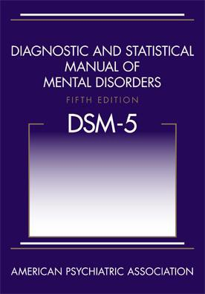
A DSM-5 To-Do List
SUMMARY
  - Acknowledge controversies
  - Focus on evidence & goals
  - Will require frequent communication among & some inservices
  - Will require communication between departments, medical records, clinicians, etc.

NORTH STAR BHS - CME ACTIVITY COURSE EVALUATION FORM

    - Date: 08/21/2013 Starting Time: 12:00 pm Ending Time: 1:00 pm
    - Topic: Overview of the DSM 5 Changes
    - Presenter(s): Christopher K. Varley, MD – University of WA School of Medicine

At the conclusion of this activity, participants should be able to: | Not at All | Slightly | Moderately | Mostly | Completely
Analyze and categorize the significant changes
in the DSM 5 over the prior version.
Cite the major current practice gaps.
Organize an implementation strategy to revise the identified practice gaps in their practice.

Was the presentation commercially biased in any manner? Yes [] No []
Based on this activity, what will you do differently in your practice? Topics of Interest for future Seminars:

Printed Name of CME participant: Signature of CME participant: Agency/Organization:
Email:
Are you on our email distribution list? Yes [ ] No [ ]
If not – do you wish to be added for future CME events? Yes [ ] No [ ]
Physician Yes [ ] No [ ]

